INDIA NATIONAL MARKET PRACTICE GROUP (IN NMPG)
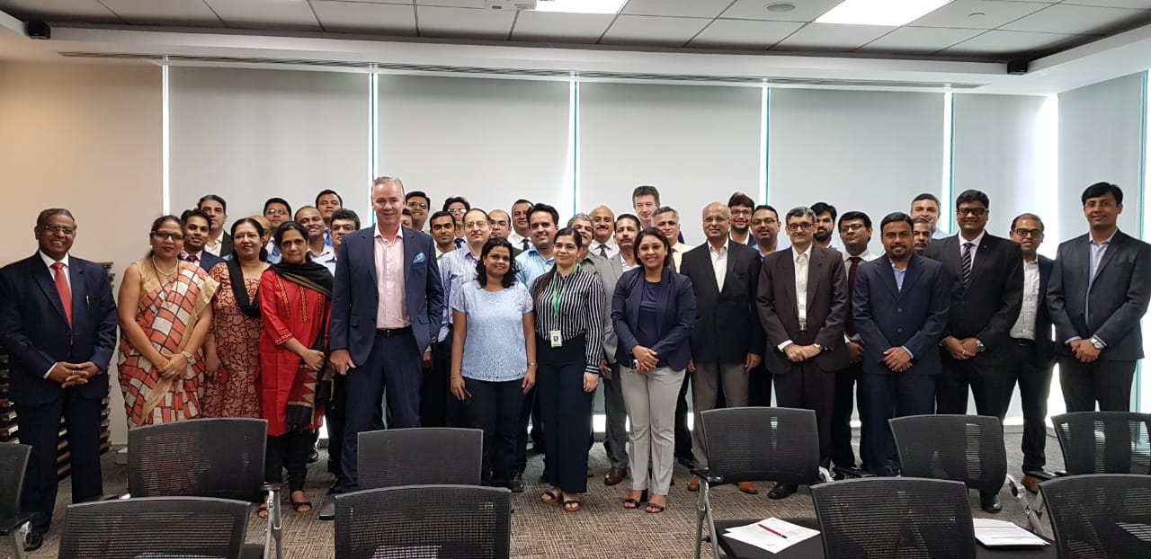
Minutes of Meeting: India NMPG
Date and Time: 23 August 2019, 9 am to 1 pm
Location: BNP Paribas Securities Services, Maker Maxity, Tower 1, Bandra Kurla Complex, bandra East, Mumbai 400051

Participants*:

Sr No | Organisation | Name
1 | BNP Paribas | Anup Menon
2 | BNP Paribas | Dhaval Palany
3 | BNP Paribas | Jayant Jain
4 | BNP Paribas | Vaisshali Babu
5 | BNP Paribas | Zoher Khambati
6 | Citi Bank | Pratik Shah
7 | Citi Bank | Hitesh Lad
8 | Citi Bank | Sambit Joshi
9 | Deustche Bank | Ashwin Muzumdar
10 | Deustche Bank | Deepa Viswanathan
11 | Edelweiss | Sunil V Alur
12 | HDFC Bank | Francis Couto
13 | HSBC | Ganesh Kamath
14 | HSBC | Nikunj Pujara
15 | HSBC | Savak Bharda
16 | ICICI Bank | Eric Kathawalla
17 | ICICI Bank | Lipikar Jena
18 | IHS Markit | Biswendu Das
19 | IHS Markit | Yasha Singh
20 | JP Morgan | Rauf Shaikh
21 | Kotak Mahindra Bank | Sandip Lugade
22 | Kotak Mahindra Bank | Sumit Jayakar
23 | Metropolitan Clearing Corporation of India Limited | A. Sebastian
24 | Metropolitan Clearing Corporation of India Limited | Devidas Gholap
25 | Metropolitan Clearing Corporation of India Limited | Shweta Bhatt
26 | NSDL | Anik Mehta
27 | Phillip Capital | Hanish Jani
28 | Pivot Management Consulting | Viraj Kulkarni
29 | SBI-SG Global Securities Services Pvt. Ltd. | Nicolas Gonzalez
30 | SBI-SG Global Securities Services Pvt. Ltd. | Ravindra Vaidya
31 | SHCIL | Kalpana Joshi
32 | SHCIL | Vineet Potnis
33 | Yes Bank | Abhijeet Tiwari
34 | Yes Bank | Nagesh Srivastava
35 | SWIFT | Amrita Divay
36 | SWIFT | Deepa Lakhwani
37 | SWIFT | Kiran Shetty
38 | SWIFT | Koushik Dutta
39 | SWIFT | Mohan Tanksale
40 | SWIFT | Ruchir Kapoor
41 | SWIFT | Sandeep Kumar
*in alphabetical order

Agenda:

- 09:00 Registration and coffee
- 09:30 Welcoming remarks by Kiran Shetty, CEO SWIFT India
- 09:40 Opening remarks by Mohan Tanksale, Sr. Strategic Advisor, SWIFT India
- 09:50 Photo session
- 09:55 Update on global and regional activities and introduction to SMPG/NMPG
- 10:15 Roundtable discussion on Goals and Objectives of IN NMPG
- 10:35 Convener Elections/Working Group Formation
  - Settlements & Reconciliation
  - Corporate Actions
  - Investment Funds
- 10:45 Coffee Break
- 11:00 Individual Topics for discussion by the participants
- 12:30 Conclusion by Convener and Next Steps on WGs and meeting dates
- 12:40 Close of Session
- 12:45 Refreshments and Networking

Minutes of the Meeting:
- Welcome Remarks: Mr. Kiran Shetty, CEO & Regional Head – SWIFT India welcomed the audience and presented the activities of SWIFT India along with the composition and our work in the securities community in India.
- Mr. Mohan Tanksale, Senior Strategic Advisor, SWIFT India explained to the audience the progress on the SWIFT India trade digitization initiate and our work with Indian Banks on new initiatives like E-Stamping and Invoice Validation.
- An update on SWIFT for securities was provided by Amrita Divay on SWIFT’s activities with securities markets infrastructures and our efforts on standardization of communication in India capital markets. SWIFT updated the audience on the upcoming ISO migration, the E-voting POC with SGX in Singapore and SWIFT-BCG Joint Paper on API for Securities.
- Koushik Dutta, SWIFT, presented details on the concept of SMPG and NMPG, details of the TOR (attached) and frequency of meetings. He also facilitated the NMPG Convenor selections along with the selection of sub-committee chairs. Since market change requests are examined by the Global SMPG in May each year, it was proposed that IN NMPG follow a July/January meeting schedule to ensure that Market Change submissions can be made in a timely manner. Koushik also explained the role of SWIFT as the facilitator of the SMPG and local NMPG.
Convenor/Co-Convenor Appointment:
- The NMPG has unanimously selected the following members as convenors of the India NMPG.
Sr No | Organisation | Name | Position
1 | BNP Paribas | Vaisshali Babu | Convenor
2 | Deutsche bank | Samir Dhamankar | Co-convenor
3 | HSBC | Brij Bhushan | Co-convenor

- Koushik also explained to the audience the roles and responsibilities of the convenor and co-convenors as described in the IN NMPG TOR.
Sub-Committees
- The proposed committees for NMPG were agreed on and it was felt by the audience a new sub-committee for Collateral Management and Clearing be added.
- Accordingly the following sub-committees have been created along with the agreed chairs of each committee.
- It was also agreed that the sub-committee chairs will provide the community a date individually on the first meeting of the sub-committee.
Sr No | Sub-Committee | Chairs
1 | Settlements & Reconciliations (S&R WG) | Deutsche Bank & HSBC
2 | Corporate Actions (CA WG) | Citibank
3 | Market Access/Investment funds (IF WG) | ICICI Bank and Deutsche Bank
4 | Collateral management & Clearing (CCM WG) | Metropolitan Clearing Corporation of India Limited / Edelweiss

- Convenor Remarks:
  - Ms. Vaisshali Babu, BNPSS, as convenor, requested the IN NMPG members to contribute and work towards making the India market more efficient by actively participating in the NMPG activities.
  - She also requested that the sub-committee meetings be held within one month to continue to keep sustained focussed on the issues raised during the IN NMPG.
  - The aim of the IN NMPG is to be a representative group that could present operational best practices to SEBI and the market for improvements and implementation.
Topics of Discussion:
- Citibank presented the following two topics to the audience for further discussion (attached).
  - Eligibility Tag for CA events -Tags in MT565 messages for client confirmation of eligibility conditions
    - It was agreed that the introduction of the eligibility tag be debated in the CA WG.
    - Custodians to examine the contents of the Citibank proposal internally and respond with appropriate comments and views in the CA WG meeting.
  - Settlement Tolerance –Tolerance amount to reflect in a tag for tolerance when MT545 / MT547 settlement message is released to client.
    - It was agreed that the introduction of a tag for settlement tolerance by examined by the SR WG.
    - Custodians to internally discuss the acceptability from their clients on the introduction of such a tag along with the system change implications of the same.

- Ashwin Muzumdar from Deutsche Bank, requested the Investment funds sub-committee to examine how the processing for domestic funds can be improved through the use of SWIFT for settlements related communication. The IF WG to examine if local mutual funds can be invited to the sub-committee meetings to discuss the same.
- It was also agreed to introduce a sub-committee for Collateral Management and Clearing and this has been done.

Actionable from the Meeting

- Sub-committees chairs to decide on dates of first sub-committee meeting by 15 September 2019. Sub Committees to ensure first meeting by 15 October 2019.
- Sub-committee chairs need to provide a list of participants for each group.
- Custodians to internally examine the introduction of the eligibility tag in MT 565 and introduction of a tag for settlement tolerance in MT 545/547 before discussion in the upcoming sub-committee meetings.

For questions/amendments

Koushik Dutta
+91 90041 60290
Koushik.DUTTA@swift.com

Amrita Divay
+91 98205 21186
Amrita.DIVAY@swift.com

