APAC SECURITIES MARKET PRACTICE GROUP
Malaysia: 4 June 2013
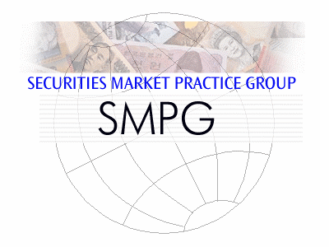 | SWIFT  Corporate Services Centre  Level 18, Tower 3 Avenue 7,  Bangsar South,  No. 8 Jalan Kerinchi,  59200 Kuala Lumpur,  Malaysia
Sponsored by
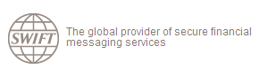
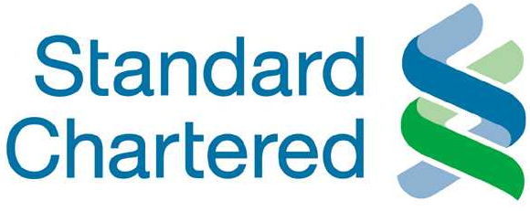

Tuesday, 4 June 2013
Afternoon
 | 12:00 – 13:00 | Welcome lunch and registration
 | 13:00 – 15:00 | - APAC RMPG Activities since June 2012  - APAC CA WG status update  - April Global SMPG outcome update and discussions  - ABMF Status update  - Update on Offshore-CNY  - Status on standardisation and market practice update per APAC market  (round the room)
 | 15:00 – 15:15 | Break
 | 15:15 – 16:15 | APAC RMPG requested topics discussion
 | 16:15 – 17:00 | ISO 20022 adoption status and plan for next 12 months
 | 17:00 – 17:30 | Conclusion
 | 17:30 | Happy Hour Networking Event (hosted by Standard Chartered Bank)

APAC SMPG MEETING REGISTRATION FORM
Deadline for registration is 20 May 2013.
Late registration requests will be accepted if room permits.
Please return your registration form to cindy.foo@swift.com
NAME:
Country:
Institution:
E-Mail address:
Tel:

Please tick the box besides the event that you are attending:
I will attend the APAC SMPG session (from 12:00 – 17:30)
I will attend the Happy Hour Networking Event (hosted by Standard Chartered Bank)

Additional Remarks
Dress code will be business casual.

