APAC SECURITIES MARKET PRACTICE GROUP
Hong Kong: 26 November 2014
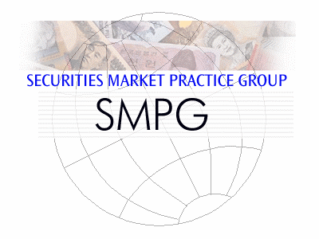 | SWIFT  3201-09 32/F,  One Island East,  18 Westlands Road,  Island East,  Hong Kong  Meeting Rooms:  Peony, Bauhinia, Orchid
Sponsored by
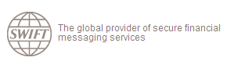

Wednesday, 26 November 2014
 | 09:00 – 09:15 | Registration
 | 09:15 – 10.45 | - Opening remarks and updates on SMPG/RMPG  - ABMF Status Update  - ASIFMA: Partnering to develop Asia's capital markets  - JASDEC’s ISO 20022 and SWIFTNet Introduction Project
 | 10:45 – 11:00 | Break
 | 11:00 – 11:30 | - Shanghai-HK Stock Connect Project
 | 11:30 – 12:00 | - Update on Offshore-CNY Bond / Capital Market developments
 | 12:00 – 12:45 | APAC RMPG Discussion  - Setting APAC RMPG’s objectives for 2015  - Round-the-room updates by participants  - AOB
 | 12:45 – 13:00 | Meeting Wrap-up
 | 13:00 – 14:00 | Buffet Lunch

APAC SMPG MEETING REGISTRATION FORM
Deadline for registration is 24 October 2014.
Late registration requests will be accepted if room permits.
Please return your registration form to cindy.foo@swift.com
NAME:
Country:
Institution:
E-Mail address:
Tel:

Please tick the box besides the event that you are attending:
I will attend the APAC SMPG session (from 09:00 – 13:00)
I will attend the buffet lunch (13:00 – 14:00)

Additional Remarks
Dress code will be business casual.

