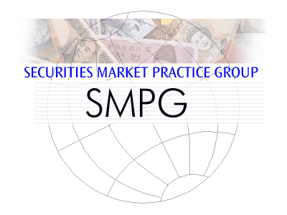
Explanation of Collateral Management Processing and Messaging Market Practices
At the request of the multiple industry groups, the purpose of this document is to clarify the messaging market practice documents in various stages of completion addressing cash and security collateral. This includes the following:
Market Practice Title | Description | Current Status | Document Updates Owner
Initial Collateral Negotiation, Substitution and Reporting | The processes by which two parties negotiate and manage collateral positions to protect one party against the credit risk of another party. These processes encompass the Collateral Claim, the Collateral Substitution, the Collateral Recall, the Collateral Reporting and the Collateral Interest Payment. Original Business Justification can be found on the attached URL:  http://www.iso20022.org/documents/BJ/BJ049/ISO20022BJ_CollateralManagement_v4_with_comments.pdf | ISO20022 messages have been modeled working with ISDA (FpML), FIX (FPL), SWIFT and ISITC and are currently under review within an evaluation team of the ISO SEG. | SWIFT Standards – Message Definition Report
Bi-lateral Collateral Market Practice | ISO15022 messaging recommendations for bi-lateral security and cash collateral movements between Account Owner and Account Servicer | Finalized within ISITC Settlements, but reshuffle into SMPG and incorporation of bi-lateral cash collateral still underway. | SMPG S&R WG
Security and Cash Segregated Collateral Market Practice | ISO15022 messaging recommendations for cash and security collateral movements between main custody account and segregated collateral account serviced by a segregated collateral custodian. Pledger and Secured Party pledge/ recall and Secured Party release authorization messaging with the segregated collateral custodian. | Updated draft of market practice to be reviewed with ISDA, AMF, ISITC and SMPG WGs. | SMPG S&R WG
Tri Party Collateral Management Market Practice | ISO15022 messaging recommendations for collateral management between Account Owner and Tri Party Agent | SMPG has decided not to endorse as a market practice due to lack of adoption by the tri party agent community. This document will remain posted as a usage guideline created by SWIFT. Potentially converted into a SWIFT MUG document | SWIFT – Alexandre Hotat

Coordinators/Facilitators of the various industry working groups discussing aspects of the above mentioned collateral market practice documents include:
Industry Working Group | Contact | Email
ISITC Settlements WG | Jason Brasile | jbrasile@statestreet.com
SIFMA AMF Collateral WG | Elisa Nuottajarvi | enuottajarvi@sifma.org
ISDA Collateral Steering Cmte | Vanessa Melia | VMeli@isda.org
SMPG Settlements and Reconciliation WG | Evelyne Piron | Evelyne.PIRON@swift.com
ISO20022 Securities SEG | Mireia Guisado-Parra | Mireia.GUISADO-PARRA@swift.com
SWIFT Standards | Alex Hotat | Alexandre.HOTAT@swift.com

