SMPG Zurich meeting
September 21 – 23, 2016

Hosted and sponsored by:
Sponsored by:
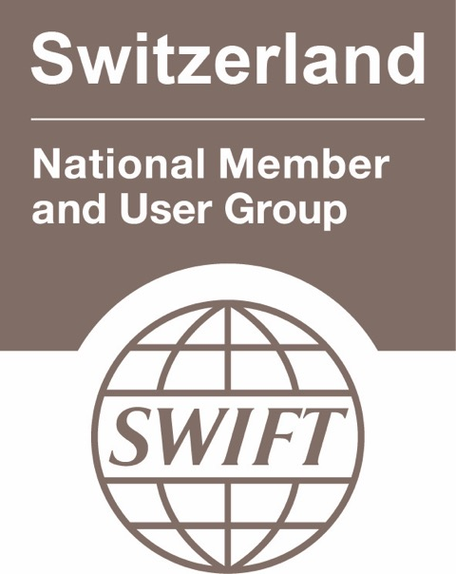

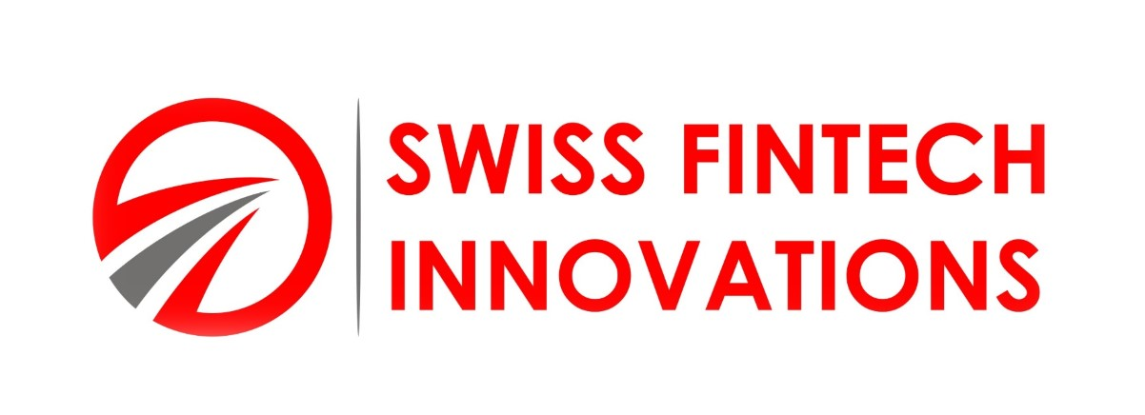
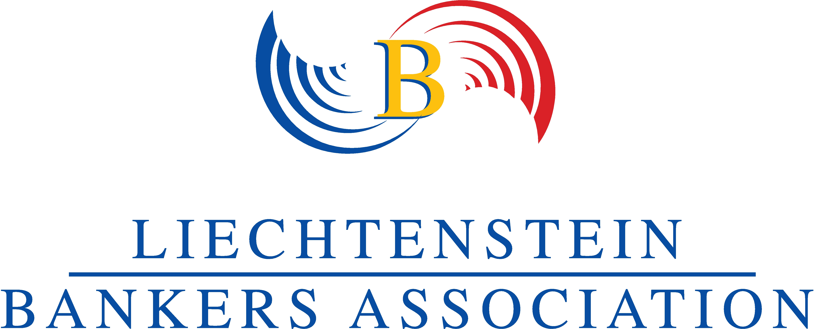
Meeting Venue:
Zürcher Kantonalbank
Josefstrasse 222
8005 Zurich, CH
Dress Code:
Meeting: Smart Business casual
Wedn. Evening Event: Business Attire !

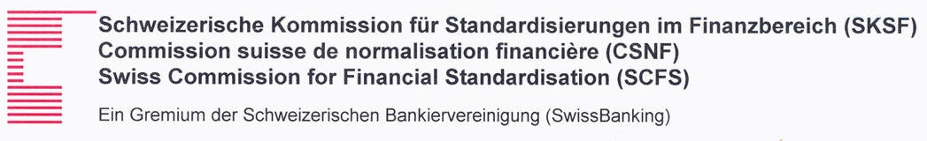

Meeting Global Agenda

Wednesday 21st of September
 |  |  | 9:00 – 9:30 |  |  | Arrival & Check-in at Zürcher Kantonalbank premises and Welcome Coffee
Morning Session
 |  |  | 9:30 |  |  | Plenary Session
 |  |  | 9:30 – 11:00 |  |  | Plenary Session DRAFT Agenda  - SMPG Welcome Address (Karla Mc Kenna, SMPG Chair, ISITC) – 5’  - Welcome Address by Host (Name, Title, Zürcher Kantonalbank) – 5’  - Global Meeting Schedule (Jacques Littré, SMPG General Secretary) – 5‘  - Presentation Title (Speaker Name, Title, Incentage) – 25’ - TBC  - Presentation Title (Speaker Name, Title, Swiss Fintech) – 25’ - TBC  - Presentation Title (Speaker Name, Title, ESMA) – 25’ - TBC
 |  |  | 11:00 – 11:30 |  |  | Coffee Break
 |  |  | 11:30 – 12:30 |  |  | - Presentation Title (Speaker Name, Title, SWIFT User Group) – 15’ - TBC  - Presentation Title (Blockchain Expert, Title, Swiss Finance Institute) – 45’ - TBC
 |  |  | 12:30 – 13:30 |  |  | Lunch
Afternoon Session
 |  | 13:30 – 14:00 |  |  | 9. ISO 20022 Harmonisation Framework Update(SWIFT) – 30’ - TBC
 |  | 14:00 |  |  | End of Plenary Session
 |  | 14:00 – 15:30 |  |  | Corporate Action WG |  | Investment Funds WG | Settlement and Reconciliation WG
 |  | 15:30 - 15:45 |  |  | Coffee Break
 |  | 15:45 – 16:45 |  |  | Corporate Action WG |  | Investment Funds WG | Settlement and Reconciliation WG
Evening
 | 16:45 – 22:30 |  |  | Lichtenstein Banking Association – Banking Day  Leave Zurich in bus/coach to Liechtenstein and attend LBA Banking Day  Please indicate your participation in the meeting registration form !  Dress Code: Business attire
 | 22:30 |  |  | Back at the hotels

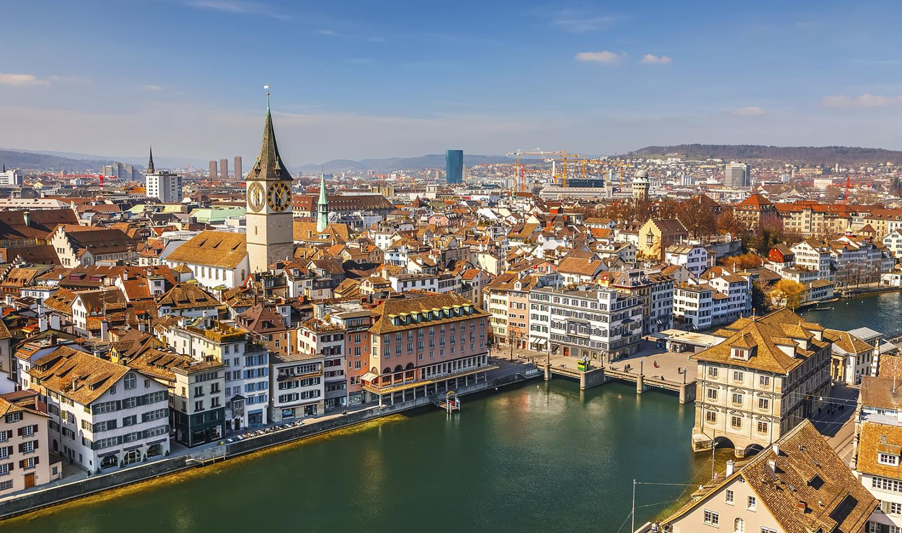

Thursday 22nd of September
 | 8:30 – 9:00 | Arrival & Check-in at Zürcher Kantonalbank premises
Morning Session
 | 09:00 – 10:45 | Corporate Action WG | Investment Funds WG | Settlement and Reconciliation WG
 | 10:45 – 11:00 | Coffee Break
 | 11:00 – 12:30 | Corporate Action WG | Investment Funds WG | Settlement and Reconciliation WG
 | 12:30 – 13:30 | Lunch
Afternoon Session
 | 13:30 – 15:30 | Corporate Action WG | Investment Funds WG | Settlement and Reconciliation WG
 | 15:30 – 15:45 | Coffee Break
 | 15:45 – 17:15 | Corporate Action WG | Investment Funds WG | Settlement and Reconciliation WG
Evening
 | 17:30 – 22:30 | SMPG Event  Meeting Point: Entrance of the meeting venue  Please indicate your participation in the meeting registration form !
 | 22:30 | End of Event

Friday 23rd of September
 |  | 8:30 – 9:00 | Arrival & Check-in at Zürcher Kantonalbank premises
Morning Session
 |  | 9:00 – 9:30 |  | Presentation Title (Speaker Name, Title, Liechtensteiner bankers association) – 30’
 |  | 9:30 – 10:45 |  | Corporate Action WG | Investment Funds WG | Settlement and Reconciliation WG
 |  | 10:45 – 11:00 |  | Coffee Break
 |  | 11:00 – 12:30 |  | Corporate Action WG | Investment Funds WG | Settlement and Reconciliation WG
 |  | 12:30 – 13:30 |  | Lunch (Please indicate in the registration form if you stay for lunch)
 | 13:30 |  |  | End of meeting

S&R Meeting Agenda
Wednesday – 21st September (ONLY 2h30 of meeting)
- Welcome note
- Previous meeting minutes – Review open action items
  - Partial settlement - to make sure that proposal is accepted by the whole group.
- SMPG discussion point allegement reminder - new message in ISO 20022 (Karine Taquet)
- ISITC update (Jason)
- Asia pacific update (to be confirmed)

Thursday 22nd September (T2S/Regulation Day)

- Victor Abbeloos (SWIFT) to explain the board paper on ISO 20022. (in a nutshell, moving to ISO20022)
- T2S migration update
- Follow up on topic 11 of Helsinki agenda: Market practice usage within Delta Reporting
The T2S Sub-group on Message Standardisation would like to present more details on the current T2S functionality regarding Delta Reporting.
For this we have a question: we have a template for the SMPG Market Practice Guide document available which focusses on ISO15022. Do you have a similar template which is based on ISO20022? This could be used to provide the information already in the known format.
- Topic 17 of Helsinki agenda: LEI for the client of the CSD participant
We would leave it up to you to decide if we shall give an update about current usage of LEI in T2S, as discussed in the last call.
- Topic 7 of Helsinki agenda: ‘Transaction activity mapping’
Ton van Andel has recently raised a related Change Request towards T2S, but it has not yet been prioritised for any of the upcoming T2S releases. We would leave it up to you to decide if we shall inform SMPG about this.
- Topic 8 of Helsinki agenda: ‘Consistent transaction codes across MX messages’
A related Change Request was raised at T2S level and at ISO level to align at least those ISO Transaction Codes which are required by the T2S community. As optional requirement the ISO CR requests a general alignment of all ISO Transaction Codes, independent from current usage. The CR is still pending on ISO level. We would leave it up to you to decide if we shall inform SMPG about this.
- Exact time/event to change from PEND to PENF status.
https://www.ecb.europa.eu/paym/t2s/progress/pdf/tg/crg/crg77/04.t2s_0609_sys.pdf

On page 1 there is some background given.
On page 2 the requested change is described. In particular we request clarification from SMPG regarding the following sentence in case of DvP settlement (top of page 2):
‘A new settlement status3 ‘PENF’ must be reported by T2S for failing settlement instructions, i.e. settlement instructions, for which settlement at the ISD is no longer possible, at the end of the business day.’

In T2S the settlement cut-off time for DvP instructions is 16:00. The end of day, which is also the cut-off for FoP is 18:00.
Recommendation from SWIFT is that T2S should report the status change PENDà PENF for DvP transactions at 16:00. We ask SMPG for confirmation.
- LEI or/and regulation
- Regulations: e.g. Spanish reform progress (common session) or CSDR: flows, buy-in, penalty management/communication, T2S perspective (penalties, buy-in (cr’s to do?), settlement finality timestamp, Message usages (clearing?))

Friday 23rd September (SR2017 Day)
- SR2017 maintenance status update - CR and maintenance update (Alex)
- Change request forum update
- ISO20022 and ISO15022 release discrepancy related to standard releases (Axelle)
- MP ISO20022 updates illustration
- Transformation business flow - reference question (KT + Bernard Lenelle)
- End of SMPG meeting and request for subject for the next meeting.

