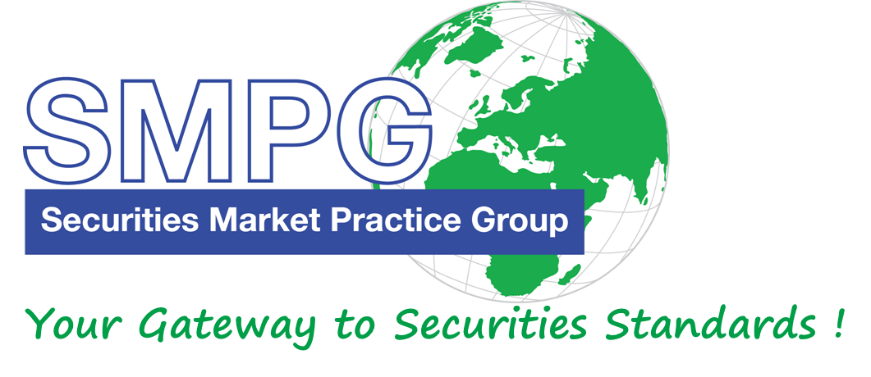

**SMPG Helsinki meeting**

**April 20 – 22, 2016**

**Sponsored by:**

**Hosted by:**

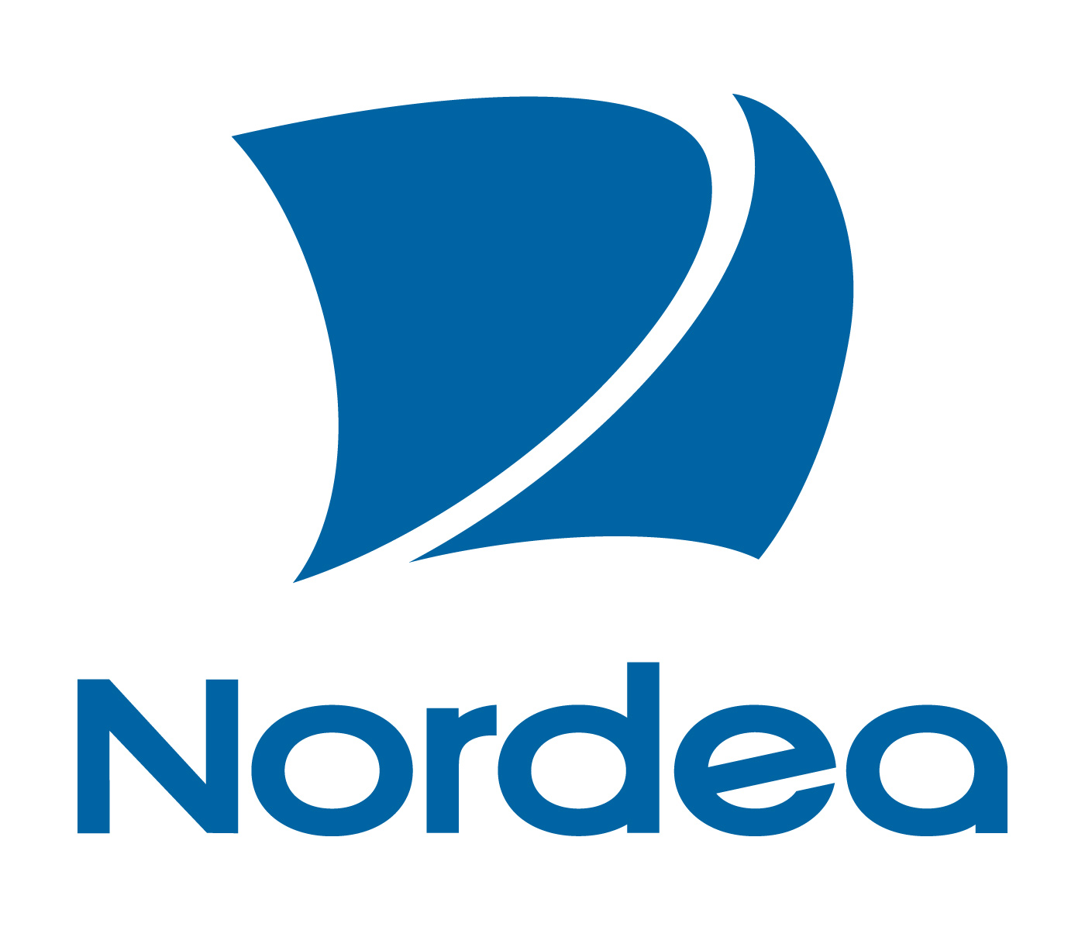

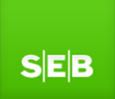****

**Meeting Venue 19, 20 & 22 April:**

**Nordea Vallila campus,**

**Aleksis Kiven katu 7**

**Meeting Venue 21 April:**

**Pohjola Bank, Teollisuuskatu 1b**

**Dress Code**: **Smart Business casual**



# Meeting Global Agenda

|  |  |  |  |  |  |
| --- | --- | --- | --- | --- | --- |
| **Tuesday 19th of April *Venue:* *Nordea Vallila campus, Aleksis Kiven katu 7***  ***Meeting room U1A18*** | | | | |  |
|  | **9:00 – 17:30** |  | Investment Funds WG Meeting  **(only for IFWG members – please refer to the specific IF WG agenda)** |  |

|  |  |  |  |  |  |  |  |
| --- | --- | --- | --- | --- | --- | --- | --- |
| **Wednesday 20th of April *Venue:* *Nordea Vallila campus, Aleksis Kiven katu 7*** | | | | | | |  |
|  | | **9:00 – 9:30** | | Arrival & Check-in at Nordea premises and Welcome Coffee | | |
| **Morning Session** | | | | | | |  |
|  | | **9:30** | | **Plenary Session** | | |
|  | | **9:30 – 11:00** | | **Plenary Session Agenda**   1. SMPG Welcome Address (Karla Mc Kenna – SMPG Chair, ISITC) – 5’ 2. Welcome Address by Host (Sari Rask – NMPG Finland Chair Nordea) – 5’ 3. Global Meeting Schedule (Jacques Littré) – 5‘ 4. First Speaker (Hanna Vainio, CEO Euroclear Finland) – 40’ 5. Second Speaker (TBD) – 40’ | | |
|  | | **11:00 – 11:20** | | **Morning Tea Break** | | |
|  | | **11:20 – 12:30** | | 1. EMEA Regional Updates – 20’ 2. Americas Regional Updates – 20’ 3. APAC Regional Updates – 20’ 4. AOB – 10’ | | |
|  | | **12:30 – 13:30** | | **Lunch** | | |
| **Afternoon Session** | | | | | | |  |
|  | **13:30 – 14:00** | | 10. SMPG Steering Committee Members Elections | | | |
|  | **14:00** | | **End of Plenary Session** | | | |
|  | **14:00 – 15:30** | | Corporate Action WG | | Investment Funds WG | Settlement and Reconciliation WG |
|  | **15:30 - 15:45** | | **Coffee Break** | | | |
|  | **15:45 – 17:30** | | Corporate Action WG | | Investment Funds WG | Settlement and Reconciliation WG |
|  |  | | **Free evening** | | | |



|  |  |  |  |  |
| --- | --- | --- | --- | --- |
| **Thursday 21st of April *Venue: Pohjola Bank, Teollisuuskatu 1b*** | | | | |
|  | **8:30 – 9:00** | Arrival & Check-in at Pohjola Bank premises | | |
| **Morning Session** | | | | |
|  | **09:00 – 10:45** | Corporate Action WG | Investment Funds WG | Settlement and Reconciliation WG |
|  | **10:45 – 11:00** | **Coffee Break** | | |
|  | **11:00 – 12:30** | Corporate Action WG | Investment Funds WG | Settlement and Reconciliation WG |
|  | **12:30 – 13:30** | **Lunch** | | |
| **Afternoon Session** | | | | |
|  | **13:30 – 15:30** | Corporate Action WG | Investment Funds WG | Settlement and Reconciliation WG |
|  | **15:30 – 15:45** | **Coffee Break** | | |
|  | **15:45 – 17:30** | Corporate Action WG | Investment Funds WG | Settlement and Reconciliation WG |
| **Evening** | | | | |
|  |  |  | | |
|  | **19:00 – 21:00** | **SMPG Event (Sponsored by Euroclear Finland)**  ***Address: Urho Kekkosen katu 5 C (3 minutes walk from the hotel)***  **Please indicate your participation in the meeting registration form** | | |
|  | **21:00** | **End of Event** | | |

|  |  |  |  |  |  |  |
| --- | --- | --- | --- | --- | --- | --- |
| **Friday 22nd of April *Venue:* *Nordea Vallila campus, Aleksis Kiven katu 7*** | | | | | | |
|  | | **8:30 – 9:00** | Arrival & Check-in at Nordea premises | | | |
| **Morning Session** | | | | | | |
|  | | **9:00 – 10:45** | | Corporate Action WG |  | Settlement and Reconciliation WG |
|  | | **10:45 – 11:00** | | **Coffee Break** | | |
|  | | **11:00 – 12:30** | | Corporate Action WG |  | Settlement and Reconciliation WG |
|  | | **12:30 – 13:30** | | **Lunch** | | |
|  | **13:30** | | | **End of meeting** | | |

**Meeting Agenda**

**Wednesday – 20th April/ Friday 22 April**

1. Welcome note
2. Previous meeting minutes – Review open action items
3. CSDR Update (Marcin)
4. Financial Transaction Tax - Update (Axelle)
5. REPO Market Practice – Update (Axelle and Jason)
6. Spanish Reform – Update (TBC)
7. Transaction activity mapping:

“In the semt.017 (Statement of Transactions) and semt.018 (Securities Transaction Pending Report), T2S is currently supporting SETT only as a Transaction Activity (cf usage guidelines published on MyStandards). None of the codes BOLE, CLAI, CORP, COLL is supported. All codes allowed for “Settlement transaction types” (eg TRAD, COLI, COLO, SECL, SECB…) are however all supported in that message.

DCPs and CSDs have requested T2S to allow in the future the usage of these 4 codes BOLE, CLAI, CORP, COLL above for field Transaction Activity. Similarly the SMPG is requested to validate the mapping/business correlation between the” Settlement transaction type” and the “Transaction Activity”.

* Cf attached excel sheet – 07 Transaction activity mapping.xls

1. Consistent transaction codes across MX messages (4CBs/T2S):

*“The T2S community is in favour of aligning the data type for the ISO transaction type across settlement messages in which it is used, because it being different message to message is causing issues in processing, e.g. sometimes a particular transaction code is available in an input message but not in an output message in ISO or vice versa. Fixing these cases one by one as they appear takes several years due to the ISO change timing and necessitates the use of suboptimal workarounds in the meantime. It is not apparent to the T2S community why the transaction code needs to have different valid values across messages used for settlement and there is a call for harmonisation of this data type”*

* Cf attached excel sheet – 08 Securities Transaction Types across T2S messages

1. T2S Statement of Transactions in case of partial settlement – follow up on action item after Singapore meeting – T2S is requesting alignment in semt.016 with what was agreed for semt.017 (MT536 MP). (4CBs/T2S)

* Discussed during conference called on January 27th -> cf slides shared with SMPG (attached)
* Open question to the group: Do we create an MT538/semt.016 MP? What would be the exact scope of that Market Practice?
* SWIFT: Could we just add a note in Partial settlement MP?

1. Case sensitiveness of Reference and Ids (topic covered in Singapore): **Need to re-open the debate at next SMPG meeting in Helsinki: “***In preparation of such revisiting of the topic I would recommend that each market representative uses the time to check with their national groups as we will do in T2S. Currently we have two big players both joining T2S next year with very different views on this topic, one of them clearly saying that abc123 is not the same as ABC123 and they are not willing to change view as this is long practice already*.” (Request from Gunnar).

* See attached file: 10_ Clarification Note on Common Trade Reference Matching_case-sensitiveness.pdf)(4CBs/T2S)

1. Delta reporting in T2S: This topic is a follow up of the Singapore meeting where ECB were requested to provide an overview of the T2S delta report functionality. (4CBs/T2S)

* Cf attached document 11_Delta Reports

1. Place Of trade (topic discussed during previous meeting and Marcin is requesting other’s feedback).
2. ISITC Updates (Jason): (**Relevant documents will be sent closer to conference to ensure most up to date**)
   1. Bi-lateral Repo SMPG MP – high level update of alignment discussions between ISITC and FR NMPG on rollover/renewal scenarios
   2. Tri-party Repo SMPG MP – ISITC market practice update completed aligning with European best practice of splitting wire nettings from repo contract instruction to custodian/fund accountant.  Open to discuss possible consolidation of ISITC and UK NMPG market practices into a single SMPG document if there is interest or put on hold until later demand requires.
   3. Market/CSD Impacts to global custodians and Inv. Mgrs – updated tracking matrix to be presented
   4. PSET BIC11 Listings – T2S markets – updated tracking matrix to be presented
   5. Securities Related Payments SMPG MP – ISITC MP update and ISO external code list approval update
   6. Segregated Cash and Security Collateral ISITC MP – third party custodian segregation vs. tri party agent segregation.

-> Need for a global SMPG MP or ISITC to continue to maintain US specific third party custodian segregation market practice?

1. ISO15022 and ISO20022 Market Practices on MyStandards (Evelyne)
2. ISO15022: SMPG Validation/comments on migrated MPs (aligned with SR2015)
3. ISO20022: Harmonisation Charter/Need to have SMPG Global MPs posted on MyStandards/ SMPG Validation/comment for all MPs that have been posted:
   * Auto Registration Reporting
   * Block_Bulk Trade Settlement
   * Book Transfer
   * Cash Securities Split Settlement
   * Balance Custody And Accounting Report
   * Securities Settlement Transaction Posting Report
   * Pair off
   * Partial Settlement
   * Receiving Delivering Depository - PSET PSAF
   * Securities Settlement Transaction Pending Report
   * Securities Settlement Allegement
   * Common Elements (including reference to Financial Instrument Id MP)
   * Split Settlement

* Please note that you need to access the Collections through the SMPG group page. If you are logged in with e.g., your NMPG profile, since the Collections are still in private mode, you will not see them.

1. Status of SMPG global MPs – Missing 20022 illustrations in existing SMPG MPs

* Need to share the work with SMPG members.

1. Common Elements MP -> Pls review ISO 20022 illustrations

* Cf attached document 14_d – Common Element MP (V4_3)

1. Cash Securities/split Settlement -> Pls review corrections done in document attached:
   * Removal of split indicator on free of payment confirmations (ISO20022 illustrations)
   * Change of message type from MT540/MT542 to MT541/MT543 on the flow diagrams

* Cf attached document 14_e – Cash Securities Split Settlement

1. Partial Settlement -> Pls review corrections done in document attached:
   * Section “Partial Settlement within T2S (Target 2 Securities)”

* Cf attached document 14_f – Partial Settlement 4_8

1. Best practices on LEI usage for SnR ISO20022 messages (Alex H)

* Cf attached document _LEI_Regulation_Overview:
  + That document provides a summary of all the known/published regulations (EU and US) summarizing the business scope, the compulsory aspect of the LEI usage and the timeline in terms of implementation.
  + Update on the work done by the SnR sub-group will be shared with all members

1. INBC Code: “*Provision of information when a pool becomes complete to those T2S actor who had earlier received an INBC code*.” (topic requested to be discussed - 4CBs/T2S)
2. Client of CSD participant: “*Due to the difficulty to agree on a single international standard for the usage of this optional matching field in T2S, the T2S Advisory Group has agreed instead on a best market practice in form of a prioritisation method when populating the field. We were asked to check with the SMPG whether it would be possible to standardise a single identifier for retail clients. We will provide a brief presentation on this*. “ (4CBs/T2S request)

* Cf attached document 17_Client of the CSD Participant – T2S MP
* Question from SWIFT “Why not the BIC with optionally the LEI”?

1. T2S – Partial Settlement – *Clarification on how to cancel outstanding trades from a partial settlement (ie when one part is settled and a client wants to cancel the remaining part of the cancel). Nothing in the Partial Settlement SMPG document and T2S requires the cancellation message to contain the original quantity of the settlement instruction even though that’s not what is being cancelled*. SMPG feedback?
2. T2S Portfolio Transfer – Update (Paola)
3. SWIFT Best-Practice validation capabilities –BPVC - (Jonathan)

Presentation on a SWIFT Industry consultation on BPVC and gather feedback from SMPG members (this session will be replicate within each WG)

1. WG Co-Chair election – reminder ( Karla)
2. SettlementStatusAndMatchedRule in sese.024 (T2S)

*****************************************************************************************************