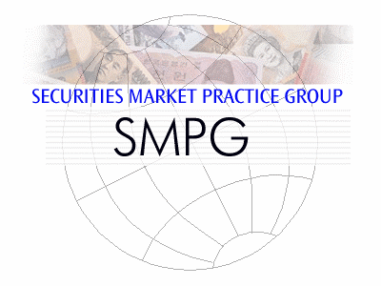
SMPG Boston meeting

Sept. 24 - 26, 2014
Meeting Venue
Brown Brother Harriman
50 Post Office Square
Boston, MA 02110, US
SPONSORS
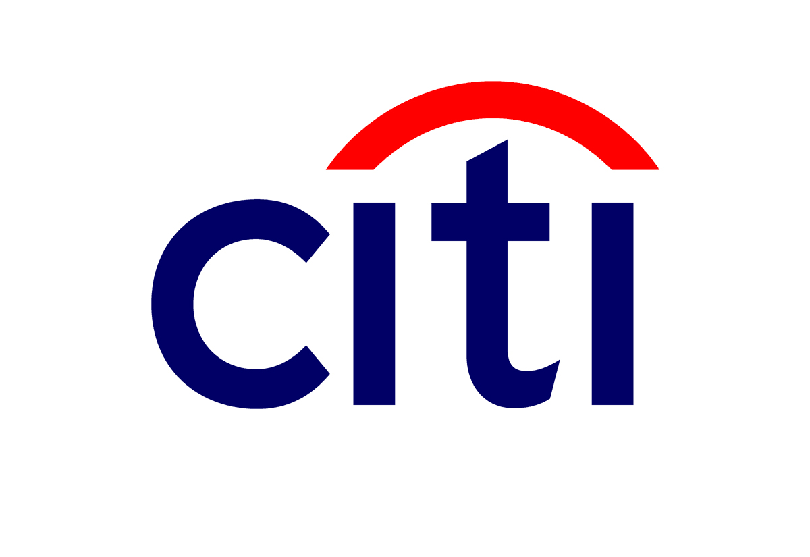 | 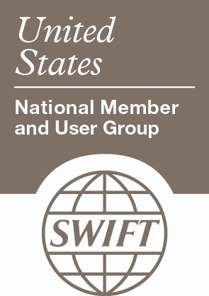  0
 | 1
Dress Code: Business Casual

Wednesday 24th of September
Afternoon
 | 12:30 - 13:00 |  |  | Members registration and welcome coffee
 | 13:00 – 15:30 |  |  | General Session  1. Welcome address (Karla Mc Kenna – SMPG Chair, ISITC)  2. Welcome address (BBH)  3. Meeting schedule overview (Evelyne Piron)  4. Regional Updates  5. By-Laws updates Review (Karla Mc Kenna – SMPG Chair)  6. Business Topics Presentations:  (To be communicated later)
 | 15:30 – 16:00 |  |  | Coffee Break
 |  | 16:00 – 18:00 | Corporate Action WG |  | Settlement and Reconciliation WG

Thursday 25th of September
Morning
 | 09:00 – 10:45 | Corporate Action WG | Settlement and Reconciliation WG
 | 10:45 – 11:00 | Coffee Break
 | 11:00 – 12:30 | Corporate Action WG | Settlement and Reconciliation WG
 | 12:30 – 13:30 | Lunch
Afternoon
 | 13:30 – 15:15 | Corporate Action WG | Settlement and Reconciliation WG
 | 15:15 – 15:30 | Coffee Break
 | 15:30 – 16:30 | Corporate Action WG | Settlement and Reconciliation WG
 | 16:30 – 17:00 | Free Time
Evening
 | 17:00 | Meet at the pick-up point for the Evening Event
 | 17:00 – 22:00 | Evening Event and Dinner

Friday 26th of September
Morning
 | 09:00 – 10:45 | Corporate Action WG | Settlement and Reconciliation WG
 | 10:45 – 11:00 | Coffee Break
 | 11:00 – 12:30 | Corporate Action WG | Settlement and Reconciliation WG
 | 12:30 – 13:30 | Lunch
 | 13:30 – 14:30 | Corporate Action WG | Settlement and Reconciliation WG

End of Meeting at 2:30 PM on Friday

Meeting Agenda
Preliminary notes: Co-chair – Open position
- APAC
  - IPO – Final review for approval (Evelyne) - (see doc attached)
- Global SMPG MPs and T2S (Jason & Armin)
  - This topic is a continuity of a discussion that started in April during our London meetings. For more information pls refer to the London meeting minutes.
  - See attached doc prepared by Helle (as a starting point for further and more detailed discussions on this topic).
- SMPG Market Practices (Status) – (Evelyne)
  - Review of list of MPs still to be reshuffled (Evelyne) - (see doc attached)
  - Automatic Registration (Re-shuffled version) (Evelyne & Armin) - (see doc attached) OK
    - SMPG Status Processing Advice (MT548) MP - High level discussion on progress of MP and scope (Jason) (see doc attached) OK Comment from Ton:
Status & Processing Advice MP
Do we really need to distinquish between PEND and PENF status. Currently the usage of the 2 codes is very inconsistent. E.g T2S is not going to use the PENF at all, ESES is using PENF and PEND
You can only derive in a correct way that a transaction is failing by checking the Intended Settlement Date and the time of day.
My proposal would be to eliminate the PENF from the market practice documents and in due time delete it from the message standards.
PENF will not be removed – used by ISITC
  - SMPG Bi-lateral Repo MP consolidation of ISITC MP – Detailed review of updated MP (Jason) (see doc attached)
  - SMPG Cash and Securities Segregated Collateral MPs – (Jason) (see doc attached)
    - Comment from Ton:
SMPG Cash and Security Segregated Collateral MP
The secured party is not part of the settlement chain, so should not be put in the REAG or DEAG.
Within the Other Parties there are options to provide Broker, Exchange or Trade Regulator. Wouldn't this be sufficient?
STCO//TRIP Triparty segregation of collateral, typically requested by an IM to their custodian to comply with a no delivery of collateral regulation
This definition indicates that there is a segregation without delivery. This MP describes a situation where stock is delivered to a segregated account, so there is a real delivery, although it is within the same custodian. Either the definition of TRIP needs to be revised or an other code word should be used.
  - Cash Securities Split Settlement (Robin) - Draft of updated document to be reviewed + open questions from UK/IE NMPG
- Specifics from ISITC (Jason) – Updates
    - Non Deliverable Forwards – Update from ISITC
- SR2015 (Evelyne) (see slides attached)
  - High level overview of approved change requests
  - Review of topic discussed during the MWG meeting in August (Rejection of CRs with a recommendation to address the BC at SMPG level)
    - Addition of codes for registration basis in direct holding countries
      - Comment from Ton:
Please find attached a file with transaction codes used within the French Registration
NB: On the direct holding systems it is generally allowed for foreign entities to hold their securities with their custodian within a omnibus account. The obligation for segregation (at least in Europe) is limited to domestic retail clients.
Unless Direct Holding countries are willing to give up the Direct Holding model (and change their legislation), there is not much choice than to accept these changes in the Settlement messages. Whether this should be by changing transaction codes or any other codes needs to be discussed. I do not have a strong opinion on this.
    - Addition of references MITI, ASFR, PCTI and RREF in MTs to align with ISO20022
    - Clarification on usage of COLI/COLO/TRIP code words
- Markets Practices on MyStandards – (Evelyne)
  - Presentation of all MPs that have posted on MS
    - Review open questions for Securities Lending/Borrowing MP
    - Review open questions for Processing Transaction Command MP
    - Review PSET/PSAF MP Fx Order And Confirmation
  - Individual NMPG next steps – using SMPG guidelines as the base line for individual NMPG recommendations where differences need documented (Jason)
- LEI update (Paul Janssens/ Axelle)
- AOB
  - Common item for CA and SnR - Question from Clearstream (Evelyne & Jacques)

“Could you investigate internally whether there is a MP or SWIFT recommendation about the fact that references in SEME/RELA etc should take into account upper and lower case?
In other words, if, in a settlement inx, we send ABC123 to a counterparty and he quotes abc123 in his RELA, is it the same reference or a different one?”

  - Question from Omgeo: what qualifier should be used for the GST (Goods and Services Tax) that will be implemented in Malaysia from April 1st 2015? (Evelyne)
  - Question from support: MT535 (Why is the C sequence repetitive?)
    - Sequence C is optional and repetitive
    - Within sequence C, field 19a is optional and repetitive
    - All qualifiers available for field 19a are not repetitive (see below)
Order | M/O | Qualifier | R/N | CR | Options | Qualifier Description
1 | O | HOLP | N |  | A | Total Holdings Value of Page
2 | O | HOLS | N |  | A | Total Holdings Value of Statement
3 | O | TOVA | N |  | A | Total Eligible Collateral Value
Questions:
- If more than one sequence C is present, usage of qualifier needs clarification.
- More than one HOLS does not make sense unless in different currencies?
- HOLP could not be present more than once in same page/message
  - Glossary Creation (Jo’Burg meeting follow up)

Co-chairs: Axelle Wurmser
Facilitator: Evelyne Piron SWIFT

Countries represented

Denis Andrejew (DA) | denis.andrejew@db.com | Germany
Jason Brasile (JB) | Jbrasile@statestreet.com | US / ISITC
Armin Borries (AB) | Armin.borries@clearstream.com | Germany
Robin Leary (RL) | Robin.leary@citi.com | UK & Ireland
Pillay Kumaran (PK) | kumaranp@strate.co.za | South Africa
Rei Kanechiku (JP) | r-kanechiku@jasdec.com | Japan/Jasdec
Annemie Loose (AL) | annemie.loose@euroclear.com | ICSD
Taketoshi Mori (TM) | Taketoshi_mori@mufg.jp | Japan
Axelle Wurmser (AW) | axelle.wurmser@bnpparibas.com | France
Marcin Zawitowski | Marcin.Zawistowski@kdpw.pl | Poland
Evelyne Piron (EP) | evelyne.piron@swift.com | SWIFT
Christine Jozet (CJ) | christine.jozet@ecb.int | ECB/T2S
Christian Pinetz | Christian.pinetz@oekb.at | AT
Observers (ISITC)
Christopher Blow | Christopher.Blow@bbh.com | US / ISITC
Erica Choinski | erica.choinski@bbh.com | US / ISITC
Krista Scharfenberger | krista.scharfenberger@bnymellon.com | US / ISITC
Roger Cowie | Roger.Cowie@jpmorgan.com | US / ISITC

Meeting Minutes

General Session: Wednesday September 24th (see slides attached)

- Introduction and welcome address by SMPG chair (Karla) and Hosts (Genevy)
- DTCC Key Initiatives – Matthew Goad, Director, DTCC
- T+2 and the impact on global custodians and investment managers – Robert Stewart,
Senior Vice President, Brown Brothers Harriman
- Regional Updates
- Americas Updates (Jason Brasile –SMPG Americas Regional Director)
- Asia Pacific Updates (Taketoshi Mori – SMPG Japan Regional Director)

Update from the Steering Committee on the SMPG By-Laws Updates: (Karla Mc Kenna – Armin Borries, EMEA Regional Director):
- Comments from London taken into account - paragraphs rephrased
- Still work in progress regarding WG chairs elections and terms
- Steering committee has now only one vote for Chair/Vice Chair and Regional Directors - Chair / Vice Chair will only vote in case of tie.
- Document will be sent out a month in advance for final comments
- Voting should take place at the April meeting.

Settlement and reconciliation SMPG – Wednesday 24th till 26th September.
Summary of discussions

Preliminary topic discussed: Replacement of Ton as Co-chair:

We are pleased to announce that Marcin Zawitowski, representing Poland, has kindly accepted the open position as co-chair. This application has been endorsed by the SMPG WG on Wednesday 24th. The candidature of Marcin Z. is unanimously accepted by the group.

We take that opportunity to congratulate Marcin in this new role.

- Overview of the agenda and introduction of guests to these meetings.
- APAC - IPO and Bidding processes - Update (Evelyne)
  - Overview of comments received by Helle. Most of them in the illustrations are related to the fact that missing data will only be available in the context of SR2014. Cindy to review other comments on “SETT Parties” in illustrations and other detailed comments related to formats, typos etc.
  - “Local sub custodian” must be replaced by “local custodian”
  - The group discussed the fact that the flows described in the document include reference to FIX messages. The illustrations though do not show any FIX illustrations. This could lead to confusion or misunderstanding from a reader perspective. The group then agreed to add a note in the scope of the document and to refer the reader to www.fixtradingcomunity.org as well as Investment Roadmap prepared by Standards Coordination Committee.In the flow diagrams it was also agreed to have FIX between brackets.

- Action Item Cindy: Review Helle’s comments + make the above changes into the document.
- Action Item Cindy: Confirm any progress made on the Bidding Process MP since last meeting in April 2014.

- Global SMPG MPs and T2S (Jason & Armin)
  - A summary of the discussions that took place in London was provided to the group.
  - Document prepared by Helle was highly appreciated as a good start for further work.
  - It was explained to the group that two options are possible to address the issue related to the impact of T2S on the current SMPG MPs:
    - either a separate document (that would be local per CSD or regional) is created that will document the business requirements/data that differ from the current MPs,
    - Or update the current global MPs to highlight the T2S specificities.
  - The majority of the SMPG members was in favour of a separate document for the following reasons:
    - Differences in business requirements all documented in one single document (should not be a translation document)
    - Document should focus on commonalities/common business processes. Core elements could also be described at a later stage.
    - T2S being a MI, this should be a local/ regional separate document
    - Updating currents MPs for T2S (that is dominant in EU) would create a precedent for any other MI (in Asia or the US) wishing to also have their specificities documented in the global MPs
    - A separate document will be easier to maintain
    - Some T2S processes require clarification since there is room of individual interpretations; therefore there is a need to document these processes and avoid mis-interpretation in future. SMPG could then make recommendations.
    - Other markets need a summary that documents the T2S processes and how to deal with them.
  - Some members of the group also had different view: Japan said that at this stage, it was not easy for them to understand the debate and its objective, and Poland said that being all together not in T2S, but being in Europe puts this country in a specific situation as far as the debate is open.
  - Some concerns were also raised: Exceptions will need to be documented. Indeed, CSDs and global custodians will prepare (or already have published) their own T2S guidelines for their respective customers; local specific requirements will still exist even in T2S countries.
  - After a long debate, it has been agreed to first work at the level of our existing global MPs and to identify the differences with T2S processes. Helle has already created a summary sheet that lists the MPs that should potentially be updated. Some SMPG members volunteered to work on some of those MPs (see excel sheet attached with also Ton’s comments). Each of them will make an analysis of the document and will provide a “delta” document to the group. If the differences identified can be easily documented, an addendum will be added to each impacted MP. On the contrary, if it appears that the differences are too complex, the group may then decide to create a separate document.
  - The analysis by each SMPG member will be discussed at next SMPG meeting in 2015. To ensure consistency of different parts of a document, Helle suggested we should start with one chapter that could serve as a template for the remaining parts. It was also agreed that if one of the owners of such analysis needs help from the group, a conference call will be organised by the SMPG facilitator.
- Action Item (each MP owner): Prepare analysis (Delta doc between T2S and current MPs) and present his/her work at next spring meeting. As a start below members will work on some MPs:
  - Transaction Processing Command - Denis
  - Linkages – Denis
  - Partial settlements - Armin
  - Hold/Release and Modifications - Helle
  - MT548 status messaging – ISITC/Jason

- SMPG Market Practices (Status) – (Evelyne)
- Review of list of MPs still to be reshuffled (Evelyne) - (see doc attached)
Securities collateral MP: done.
Cancellation MP: real value mostly for MX (for MT it is the same instruction with function CANC). On the other hand cancellation is not just a message but sometimes a complex process that needs to be described.
- Action Item (ISITC): Karine will be asked about draft document. Jason will also check the draft status.
- Action Item (ISITC): MP factored Securities will need to be updated to include 95a::INTE as well as 97E IBAN usage+ typo in the cash party sequence recommendations on a receipt (PAYE instead of BENM in format Q)
- Automatic Registration (Re-shuffled version) (Evelyne & Armin) - (see doc attached)
Doubts were raised around intra-position movement from status REGO to UNRG. Code UNRG means failure of registration (e.g. due foreign ownership limits) rather than de-registration. Another question is about status AWAS, that T2S will use instead of AVAI.
Handling of registered securities varies from market to market. In Germany it is possible to sell registered securities, but they must be de-registered before settlement. In France it is not allowed to sell registered securities. Spain has restrictive regulations around registered securities trading. This will be mentioned in the MP.

- Action Item (Evelyne): Send out final DRAFT version for final review and approval before publication.

- SMPG Status Processing Advice (MT548) MP - High level discussion on progress of MP and scope (Jason) (see doc attached)
  - Comment from Ton (email): Status & Processing Advice MP
Do we really need to distinguish between PEND and PENF status. Currently the usage of the 2 codes is very inconsistent. E.g T2S is not going to use the PENF at all, ESES is using PENF and PEND
You can only derive in a correct way that a transaction is failing by checking the Intended Settlement Date and the time of day.
My proposal would be to eliminate the PENF from the market practice documents and in due time delete it from the message standards.
  - Group agreed that PENF will not be removed – used by ISITC
  - Helle has provided comments back that need to be incorporated into document.
  - T2S discussion items to be incorporated into document once agreed at April, 2015 meeting
- Action Item: Jason to work through draft version by end of year and provide to SMPG SnR for comment early 2015 for April meeting agenda item.

- SMPG Bi-lateral Repo MP consolidation of ISITC MP – Detailed review of updated MP (Jason) (see doc attached) OK
- If the repo contract is allowed to mature it does not need to be cancelled. Rollovers should not require a cancellation since the repo contract is allowed to mature.
- Substitutions currently recommend a cancellation because the cancellation allows the collateral being substituted back into the account, while the new repo substitution requires a new delivery of collateral.
- Repo collateral top up or withdrawals do not require a cancellation since there is no contract impact. But, a question of if the 22F::SETR should identify as a REPU vs. a COLI/COLO if only a collateral movement.
However, the repo contract needs to be noted in the Seq. D to identify what contract the collateral is changing for. Agreed with group that the 22F::SETR//COLI and COLO
- Rehypothecation needs to be discussed further within ISITC.
- Action item : End of year MP to be ready for SMPG review (ISITC)

- SMPG Cash and Securities Segregated Collateral MPs – (Jason) (see doc attached)
- Comment from Ton (email): The secured party is not part of the settlement chain, so should not be put in the REAG or DEAG. Within the Other Parties there are options to provide Broker, Exchange or Trade Regulator. Wouldn't this be sufficient?
STCO//TRIP Triparty segregation of collateral, typically requested by an IM to their custodian to comply with a no delivery of collateral regulation
This definition indicates that there is a segregation without delivery. This MP describes a situation where stock is delivered to a segregated account, so there is a real delivery, although it is within the same custodian. Either the definition of TRIP needs to be revised or another code word should be used.
- Document is mostly related to Dodd-Frank regulations in the US.
- ISITC will finish the document by the end of year for final review as a SMPG MP with remark that it is related to US market.
- Final comments are expected to be sent within one month period to allow final publication in April 2015.

- Action item (ISITC) : Jason to go back to Ton on this comment
- Action Item (ISTIC): document to be updated and ready for review by end of year. Voting will occur within SMPG to determine if appropriate for global MP

- Cash Securities Split Settlement (Robin) - Draft of updated document to be reviewed + open questions from UK/IE NMPG

- Question to know whether we should add the illustration of “Receipt of Money”
    - Agreement to add a note in scope section to refer to Payment MP.
- Question about the usage of the IBAN?? how to ensure compliance?
    - Agreement to refer to PMPG and Common Element MP in scope section.
- Question about having a DVP confirmation message rather than FOP + Cash confirmation messages but the group voted against.
- Question about adding a cash status reporting but the group voted against as there is no cash status message.
- Correction also done in illustration of confirmation to show correct settlement parties.
- ISO20022 illustrations have been added and document is sent for review by the group (see attached document).
- Final open question: do we add illustration of Payment message or not? This should be re-discussed at next meeting.
- Action item (SMPG members) : Review updated draft and send comments to Robin

- Specifics from ISITC (Jason) – Updates OK
    - Non Deliverable Forwards – Update from ISITC

The group agreed that this document is an ISITC specific MP covering US regulatory requirements only.

It was agreed that it may be considered/expanded once EMIR regulation on cleared FX forwards is known or, when any other regulatory jurisdiction is applicable.

- SR2015 (Evelyne) (see slides attached)
  - High level overview of approved change requests
    - Review of all accepted SR2015 Change requests – no comment from the group, except that some SMPG members who are also part of the MWG requested SWIFT to reconsider having physical meetings. It was also proposed to have two meetings: the first one covering a walk through the topics to better understand the business cases, and a second one after consultations with the market.
  - Review of topic discussed during the MWG meeting in August (Rejection of CRs with a recommendation to address the BC at SMPG level)
    - Addition of codes for registration basis in direct holding countries
1. Comment from Ton VA (email): Please find attached a file with transaction codes used within the French Registration.
NB: On the direct holding systems it is generally allowed for foreign entities to hold their securities with their custodian within an omnibus account. The obligation for segregation (at least in Europe) is limited to domestic retail clients.
Unless Direct Holding countries are willing to give up the Direct Holding model (and change their legislation), there is not much choice than to accept these changes in the Settlement messages. Whether this should be by changing transaction codes or any other codes needs to be discussed. I do not have a strong opinion on this.
2. The group believes that these codes are currently specific to the communications between EOC and their customers and on the FIN markets. The group believes that the business case is not strong enough and makes similar recommendation to what the MWG proposed (see slide 7).
    - Addition of references MITI, ASFR, PCTI and RREF in MTs to align with ISO20022
      - Addition of MITI (slide 10): The group recognises that this qualifier may be required in the future when T2S is live; however they also believe that adding this qualifier may lead to a misuse of this.
Since it has been agreed to further analyse the impact of T2S on current global MPs (see item 2 above), the group decided to postpone their decision on this specific request until their get clarification on what should be recommended for populating the MI reference in settlement instructions messages.
      - Addition of ASFR in MT540-543 (slide11): The group agreed with SWIFT recommendation on usage of the qualifier RELA.
      - Addition of ASFR in MT544-547 (slide12-14): The group agreed that the request may be relevant in the future. They however propose that the submitter (EOC Finland) attends the next spring meeting (In April – location to be confirmed) to clarify with them the business case. They also mentioned that it will be interesting to see how other CSDs will document their processes. In the meantime, the group agrees with SWIFT recommendation (using PREV).
      - Addition of RREF in MT544-548 (slide15-17): The group discussed to clarify this qualifier reference and agreed that it is a T2S reference. The group believes that the business case is unclear and does not understand why that reference should be propagated by CSDs to their customers. In any case, if required, such reference can always be populated in field 20C in the sequence E Settlement parties (or even in field 20C in Sequence F). This is already applied in markets such as Germany or UK (for the CSD ref or MITI reference).
    - Clarification on usage of COLI/COLO/TRIP code words
Addition of Code “PLED” for Collateral Pledge in STCO (in MT54x and MT54y). The group agreed on the principles described on slides 18 and 19 regarding the usage of code words COLI and COLO. Regarding SWIFT proposal for supporting ISITC business case, it was agreed that it will be discussed at ISITC level and Jason will come back with a new BJ at the next spring meeting.
- Markets Practices on MyStandards – (Evelyne)
  - Presentation of all MPs that have posted on MS
    - Review open questions for Securities Lending/Borrowing MP
Sequence D Two leg Transaction in opening leg, do we keep it or not? Yes as optional element and this is valid for both instructions and confirmation
- Action item: EP to publish updated version on MS
    - Review open questions for Processing Transaction Command MP
- Currently only Accepted and Rejected codes are allowed in the MP. Should other codes be available as well, ie DEND, MODC, MOPN? Yes, the remaining codes should be kept as optional.
- Same for reason codes should only be the reason codes linked to qualifier in field 25D. NVR aligns status ad reason codes anyway.
- For additional information a link to collection describing MT548 will be added.
- Action item: EP/MM to publish updated version on MS
    - Review Fx Order And Confirmation
No comments on this Collection.
- Action item: EP/MM to publish this Collection as public document.
    - Review PSET/PSAF Collection
Will be reviewed at next call on Wed October 15th. SMPG facilitator reminds all to attend the call to ensure the highest quality of the collections on MS.
  - Individual NMPG next steps – using SMPG guidelines as the base line for individual NMPG recommendations where differences need documented (Jason)
Apart from discussion on the S&R workgroup level, Marc Delbaere from SWIFT gave a presentation for the plenary describing feature of MyStandards platform. A strong suggestion was made to publish local MPs on MyStandards even if they are not in a final form.
- LEI update (Paul Janssens/ Axelle) – see slides
Paul provided a comprehensive update on LEI initiative, including existing status and development plans for the future.
- AOB
  - Common item for CA and SnR - Question from Clearstream (Evelyne & Jacques)

“Could you investigate internally whether there is a MP or SWIFT recommendation about the fact that references in SEME/RELA etc should take into account upper and lower case?
In other words, if, in a settlement inx, we send ABC123 to a counterparty and he quotes abc123 in his RELA, is it the same reference or a different one?”

The open item suggests to create a common market practice (as it is already the case in the IF WG) to recommend that the references and identifications be not treated as case sensitive so as to avoid confusions when 2 references/identifications would only differ by case sensitiveness.

It seems that the situation in terms of case sensitiveness of Ref and Ids is very different in different countries, eg. it is processed as case sensitive in DK and DE, and always ALL CAPS in some others.
The group concludes that this kind of recommendation however does not constitute a market practice case.

- Action: SWIFT will further investigate if a global “usage guideline” could be added into the UHB or into the Message Usage Guidelines document

  - Question from Omgeo: what qualifier should be used for the GST (Goods and Services Tax) that will be implemented in Malaysia from April 1st 2015? (Evelyne)
    - Qualifier for GST should be defined on the local market practice level.
    - LADT (country specific tax) is suggested by SMPG
  - Question from support: MT535 (Why is the C sequence repetitive?)
    - Sequence C is optional and repetitive
    - Within sequence C, field 19a is optional and repetitive
    - All qualifiers available for field 19a are not repetitive (see below)

Order | M/O | Qualifier | R/N | CR | Options | Qualifier Description
1 | O | HOLP | N |  | A | Total Holdings Value of Page
2 | O | HOLS | N |  | A | Total Holdings Value of Statement
3 | O | TOVA | N |  | A | Total Eligible Collateral Value
Questions:
If more than one sequence C is present, usage of qualifier needs clarification.
More than one HOLS does not make sense unless in different currencies?
HOLP could not be present more than once in same page/message
  - The group discussed and checked the UHB.
      - Qualifier 19a is repetitive to allow providing the amounts in multiple currencies. Therefore it is possible to have both HOLP and HOLS in one sequence C but it is not allowed to have two or more HOLP’s or HOLS’s.
      - Therefore, to specify two holdings per page, one in EUR and one in USD, for example, sequence C is repeated to have the two HOLP’s present for the two different currencies.
      - HOLS may be cumulative over pages or it may only appear on the last page. The last page though would be the complete statement.
      - Sequence C is repeatable to allow a scenario with multiples MERE’s specified in one message (if for some reason same message is sent to two or more parties and message must specify each message recipient). Qualifier MERE is not repetitive and therefore the sequence C must be present more than once.

Common S&R and CA session
- Presentation from Marc Delbaere, SWIFT, Head of MyStandards on ““How can MyStandards help creation and propagation of market practices” and a second part on the CA283 open item (MP on the case-sensitiveness of references and identifications elements in the messages).
- MyStandards presentation:
- This was followed by a Q&A session with Marc Delbaere. The following items have been raised by the group as SMPG/NMPGs concerns about the usage of MyStandards for their UGs:
  - A new restriction should be created specifically for the SMPG/NMPGs UGs to be able to specify that an element is “Not recommended” (to be present) although it is not forbidden (“removed”) either. The perception is that there is a missing status between showing the element as removed and leaving it simply optional.
  - The concept of inheritance between a “parent” UG in a collection and children UGs should be created in the MyStandards Editor so that a sort of generic UG template could be more easily created and maintained and its characteristics inherited automatically in the children UGs.
  - IT should be possible to repeat the occurrence of a sequence in a message in the Editor as in CA, this would enable to specify the different CA options sequences (CASH, SECU) more clearly.
  - The documentation generated from MyStandards is usually considered as too voluminous compared to the actual information present (Excel and PDF). The documentation should be more streamlined.
  - For the SMPG/NMPGs MyStandards users licence, there are legal restrictions on the distribution of the generated Excel documentation to the NMPG members. This is very annoying since it changes the way the NMPGs are used to work today to exchange comments/annotation on the MPs/UGs. The SMPG/NMPGs would like to see those restrictive conditions released.

------------------ End -------------------------------------------------------------------------------------------------------

