FRANKFURT Germany - SMPG meeting: Apr. 23 – 25, 2013
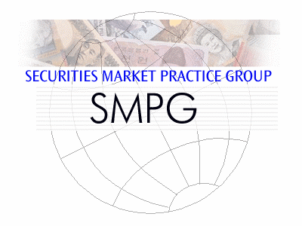
Meeting Venue:

European Central Bank
Eurotower room CI 36th floor
Kaiserstraße 29
Frankfurt am Main, Germany
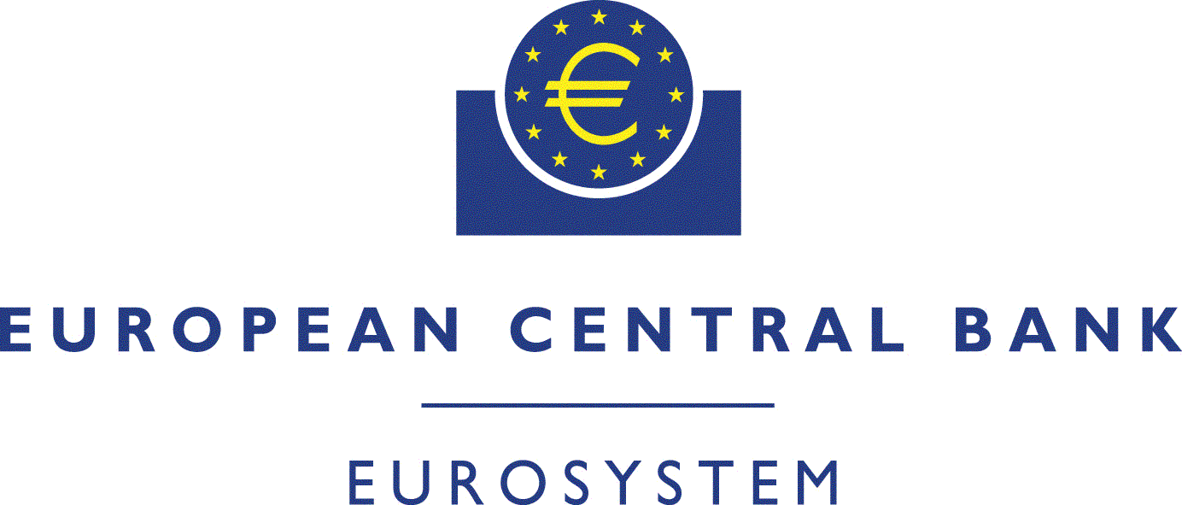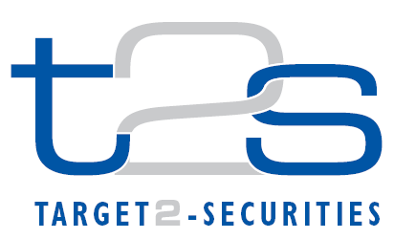

Dress Code: Business Casual

Tuesday 23rd of April
Morning
 |  | 08:30 – 09:30 |  | Registration at ECB ground floor
 |  | 09:30 – 10:45 |  | General Session (Room CI 36th floor)  1. Welcome address (Karla Mc Kenna – Citi, SMPG Chair & Marc Bayle - ECB, T2S Programme Manager)  2. Meeting schedule overview (Jacques Littré – General Secretary)  3. Regional Updates  - T2S – Status update/harmonisation progresses (Marc Bayle - ECB, T2S Programme Manager)  - CA JWG and General Meetings principles/market practices and E-MIG progress (Christine Strandberg – SEB, SMPG EMEA Regional Director)  - New Financial Transaction Taxes, operational challenges from an SMPG perspective (Axelle Wurmser - BP2S & Rudolf Siebel – BVI, SMPG Vice-Chair)
 |  | 10:45 – 11:00 |  | Coffee Break
 |  | 11:00 – 12:30 |  | General Session (Continued)  SMPG Steering Committee members election for Vice-Chair, EMEA, Americas, and APAC regional Directors
 | 12:30 – 14:00 |  |  | Lunch (Foyer CI 36th floor)
Afternoon
 |  | 14:00 – 15:15 |  | Investment Funds WG  (Room MCG05 - Ground floor) |  | Corporate Action WG  (Room CI – 36th floor) |  | Settlement and Reconciliation WG  (Room MCG07 - Ground floor)
 |  | 15:15 – 15:30 |  | Coffee Break
 |  | 15:30 – 17:30 |  | Investment Funds WG |  |  | Corporate Action WG |  | Settlement and Reconciliation WG
Evening
 |  |  | 18:00 – 20:00 |  | - SMPG Event Ebbelwoi-Expreß -  Offered by Clearstream

Wednesday 24th of April
Morning
 | 09:00 – 10:45 | Investment Funds WG  (Room CVI.2 - 2nd floor) | Corporate Action WG  (Room CVI.1 - 2nd floor) | Settlement and Reconciliation WG  (Room CI - 36th floor)
 | 10:45 – 11:00 | Coffee Break
 | 11:00 – 12:30 | Investment Funds WG | Corporate Action WG | Settlement and Reconciliation WG
 | 12:30 – 13:30 | Lunch (Foyer CI 36th floor)
Afternoon
 | 13:30 – 15:15 | Investment Funds WG | Corporate Action WG | Settlement and Reconciliation WG
 | 15:15 – 15:30 | Coffee Break
 | 15:30 – 17:30 | Investment Funds WG | Corporate Action WG | Settlement and Reconciliation WG

Thursday 25th of April
Morning
 | 09:00 – 10:45 | Investment Funds WG (Room MCG02 - Ground floor) | Corporate Action WG  Room CI - 36th floor | Settlement and Reconciliation WG Room MCG07 -  Ground floor
 | 10:45 – 11:00 | Coffee Break
 | 11:00 – 12:30 | Investment Funds WG | Corporate Action WG | Settlement and Reconciliation WG
 | 12:30 – 13:30 | Lunch (Foyer CI 36th floor)
 |  | End of meeting

Meeting Agenda
- IPO and DPR processes (C.Foo)
- MT54x/MX cash amount qualifier usage matrix (see draft attached)
- Summary Matrix – field95a DEAG/REAG (Usage of BIC vs Local Code) (see draft attached)
- Financial Transaction tax (All) – Dedicated qualifier?
- Field 97a Option A and Option E (Evelyne)
- MT 535 Business Case for discussion (see attached)
- Market Practices (Status)
  - Review of list of MPs still to be reshuffled
  - SMPG Buy Sell Back MP for global approval (see attached)
- Specifics from ISITC (Jason)
  - MT 396 FX status MUG – Conversion into SMPG MP?
  - SMPG Security Collateral MP – Discuss consolidation of bi-lateral vs. tri party segregated collateral MP documents
  - SMPG MT304 Spot/Forward FX MP – Draft document presented Summer, 2012. Discuss consolidation of NDF MUG document vs. breaking out into own document
  - SMPG securities payments MPs – Discuss consolidation of MT202/210/103 and MX equivalents into one document instead of MT202/210/MX equivalent vs. MT103 doc
  - Indian Bidding Process
- Markets Practices on MyStandards (Evelyne)
- Translation Rules (Evelyne)
- AOB
  - Market Practices in the “T2S world” (Helle)
  - Repo/Reverse Repo Market Practice Matrix (Simon)

Co-chairs: Angela Katopodi, Ton Van Andel

Facilitator: Evelyne Piron SWIFT

Countries represented (based on current registration list)

Axelle Wurmser (AW) | axelle.wurmser@bnpparibas.com | France
Simon Burke (SB) | Simon.T.Burke@jpmorgan.com | UK & Ireland
Denis Andrejew (DA) | denis.andrejew@db.com | Germany
Helle Soe-Jensen (HSJ) | hsj@vp.dk | Denmark
Evelyne Piron (EP) | Evelyne.PIRON@swift.com | Swift
Angela Katapodi (AK) | a.katapodi@ttbank.gr | Greece
Annemie Loose (AL) | Annemie.loose@euroclear.com | ICSD
Jason Brasile (JB) | Jbrasile@statestreet.com | US / ISITC
Armin Borries (AB) | Armin.borris@clearstream.com | Germany
Taketoshi Mori (TM) | Taketoshi_mori@mufg.jp | Japan
Christine Jozet (CJ) | Christine.jozet@ecb.int | ECB
Marc Bayle (MB) | Marc.bayle@ecb.int | ECB
Cindy Foo (CF) | Cindy.foo@swift.com | Swift
Unno Shunichiro (US) | s-unno@jasdec.com | Jasdec
Sim Eng Thiam (AS) | anthony.sim@sc.com | Singapore
Priscilla Ferri de Barros (PB) | pbarros@bvmf.com.br | Brasil
Brian Edward Du Plessy (BD) | briand@jse.co.za | South Africa
Christian Pinetz (CP) | christian.pinetz@oekb.at | Austria
Marco Santos (MS) | msantos@gruposantander.com | Spain
Marcin Zawistowski (MZ) | drs@kdpw.pl | Poland

Meeting Minutes

