II.17 Sese.033, sese.035 and sese.36, changes in the QuantityAndAccountDetails, SecuritiesFinancingDetails and TradeDetails message components

A. Origin of request
A.1 Submitter:
ANBIMA – Brazilian Financial and Capital Markets Association
Avenida das Nações Unidas, 8501 - 21º andar
São Paulo, SP - Brazil
A.2 Contact person:
Liliane Dutra/Luciana Dias
e-mail: liliane.dutra@anbima.com.br; luciana.dias@anbima.com.br; padronizacao.sistemagalgo@anbima.com.br
tel: 55 11 3032-3838
A.3 Sponsors:
ANBIMA is the Brazilian Financial and Capital Markets Association and it represents 325 associated institutions like commercial, multiple and investment banks, asset managers, brokers, securities and exchange distributors and investment consultants.
B. Related Messages
SecuritiesFinancingInstruction - sese.033.001.01
SecuritiesFinancingModificationInstruction - sese.036.001.01
SecuritiesFinancingConfirmation – sese.035.001.01
C. Description of the Change request
- Message SecuritiesFinancingInstruction
- Existing Message building block “QuantityAndAccountDetails”
- Proposal is to make message element SafekeepingAccount optional:
As the message will be sent by the Manager to request a securities lending contract to the Broker, he may not have this information at that moment. The Manager can send the allocation to the Broker later in the process. This is the reason this element should be optional.

Swift Standards recommends to keep the Safekeeping account mandatory. If the safekeeping account is not available then value UNKNOWN can be used instead.
- Existing Message building block “SecuritiesFinancingDetails”:
- Proposal is to add the element “Reversible/CallBackCode as optional:
When the Borrower or the Lender ask the Broker for a Securities Lending, they must indicate if the contract will be Reversible, i.e. if the counterpart can ask for call back before the termination date. The contract can be reversible only for the Lender, only for the Borrower, or to none of them. For this reason, it cannot be a “YesOrNoIndicator”, it should be a choice between the following values:
- Reversible (the contract can be called back only by the Borrower)
- Reversible to the Lender (the contract can be called back only by the Lender)
- Fixed (the contract cannot be called back by any party).

- Proposal is to add the element “Minimum DateForCallBack” as optional:
When the Securities Lending contract is reversible, “MinimumDateForCallBack” is the date from which the contract can be called back. This date is determined by the Lender.
Sometimes the contract is reversible and it doesn’t have a Minimum Date for Call Back, in this case, it can be called back any day from the first day. For this reason, the element “MinimumDateForCallBack” should be optional. Data format will be date or date/time to be in line with all the other date/time fields.
For example, if a securities lending contract is traded on 1st July, it is reversible, and there is no Minimum Date for Call Back, it can be called back from 2nd July.
- Proposal is to add the element “RollOverIndicator: Yes/No” in the as optional:
“RollOverIndicator” is used to indicate whether the contract is renewable or not. This condition is determined by the Lender. As a “YesOrNoIndicator”, the possible values would be:
Yes: indicates that the Borrower can renew the securities lending contract in its termination date
No: indicates that the Borrower cannot renew the securities lending contract in its termination date
- Proposal is to add the element “Periodic Payment” as optional:
“PeriodicPayment” indicates if the payment of the Securities Lending fee occurs periodically during the contract or only in the termination date. As this element would be a “YesOrNoIndicator’, the possible values would be:
Yes: indicates that the amount that the Borrower must pay to the Lender will be paid periodically during the contract.
No: indicates that the amount that the Borrower must pay to the Lender will be paid only in the end of the contract (in the termination date or in the call back date).
- Proposal is to add “MarginCredit/ Yes/No” as optional
Margin Credit indicates if the contract requires margin credit by the Borrower and it is defined by the Lender in the beginning of the contract. The element that exists in the message is “StockLoanMargin”, which is used to inform the percentage of the total amount deposited by the Borrower. As this message is sent by the Manager to ask a new securities lending to the Broker, he doesn’t have this information before the deal is closed. As this message element would be a “YesOrNoIndicator”, the possible values would be:
Yes: indicates that the securities lending contract requires a margin deposit by the Borrower
No: indicates that the securities lending contract requires no margin deposit by the Borrower.

- Proposal is to add Message Element: “CommissionCalculationDate typed by a DateTime, "Date" only, i.e. no time information required, as optional
As the element “CommissionCalculationDate” indicates the date in which the price to calculate the commission is based. The commission can be calculated based on the average price of the share in the initial date or termination date. As this date is only a reference to know the price of the share, there’s no information about the time. For this reason, the type of this element should be only “Date”, instead of “Date” or “Date/Time”. Even if there is no information about the time the date/time format can still be used. Data format will be date or date/time to be in line with all the other date/time fields.
- Proposal is to add “SecuritiesLendingFees” with a data type “Percentage” as optional
“Securities Lending Fee” is the fee that the Borrower will pay to the Lender. In the beginning of the contract, only the fee (as a percentage) is known. The amount will be known only in the termination date or when any party requests call back, because the price for settlement must be known to calculate the amount that the Borrower must pay to Lender. As this message will be used when the Manager asks the Broker for a new lending, in this moment, the amount is unknown.

- SecuritiesFinancingModificationInstruction
- Existing Message building block “TradeDetails"
- Proposal is to add a Message Element “Broker Commission” typed by an amount, as optional
Broker Commission is what the Manager pays to the Broker for each securities lending transaction. Sometimes the Manager, as Lender or Borrower, doesn’t pay anything to the Broker. In case the Manager is the Lender, he will only receive the fee paid by the Borrower, with no discount. In case the Manager is the Borrower, he will only pay the fee to the Lender with no increment. For this reason, the element “BrokerCommission” should be optional. SWIFT Standards: this data might be added to another place in the message. To be discussed.

- Proposal is to add Message Element “CommissionCalculationDate typed by a Date/Time "Date" only, i.e. no time information required, as optional
As the element “CommissionCalculationDate” indicates the date in which the price to calculate the commission is based. The commission can be calculated based on the average price of the share in the initial date or termination date. As this date is only a reference to know the price of the share, there’s no information about the time. For this reason, the type of this element should be only “Date”, instead of “Date” or “Date/Time”. SWIFT Standards: this data might be added to another place in the message. To be discussed.

- Existing Message building block “SecuritiesFinancingAdditionalDetails”:
Definition and justification for the changes below are similar as changes requested for the Securities Financing Instruction
- Proposal is to add the element “Reversible/CallBackCode” as optional
- Proposal is to add the element “Minimum Date for CallBack” as optional
- Proposal is to add the element “RollOverIndicator: Yes/No” as optional
- Proposal is to add the element “Periodic Payment” as optional
- Proposal is to add “MarginCredit/Yes/No” as optional
- Proposal is to add “SecuritiesLendingFees” with a data type “Percentage” , as optional

D. Purpose of the change
Presently, in the Brazilian market, no standard message is used in the communication between Managers, Brokers, Controllers and Custodians regarding securities lending transactions. This communication is made mainly by telephone or e-mail.
The usage of ISO 20022 by the Brazilian players would result in a considerable gain in terms of more scalability and operational risk reduction.
The community of users will be:
- Fund Managers, whether in the role of Borrower or Lender, will use this message to:
  - Instruct Brokers about the characteristics of a desired securities lending contract. Nowadays, this communication is made through non-standardized forms, such as telephone or e-mail.
  - Send a request for settlement authorization to the Fund Controller. As one Fund Manager may have several funds and each one of them may have a different Controller, for each Fund, the Manager must send a securities lending message using a different lay-out.
  - Communicate the Fund Custodian of the characteristics of a new securities lending contract. As one Fund Manager may have several funds and each one of them can have a different Custodian, for each Fund, the Manager must send a securities lending message using a different lay-out.
- Brokers, who will receive securities lending instructions through a secure and standardized way.
- Fund Controllers, who will receive the request for settlement authorization sent by the Manager in a standardized form.
- Fund Custodians, who will receive the characteristics of the new securities lending contract and send its confirmation to Managers, Brokers and Controllers.
Nowadays, this communication is made through non-standardized forms, as each Custodian or Controller have their own proprietary system.

E. Urgency of the request
We request the SEG to consider this change request for the next maintenance cycle, 2010/2011, once we are planning to implement these messages for the Securities Lending service in March/April 2011.

F. Business examples
N/A
G. Standards illustration

A- ISO 15022

Note: Should there be a need for interoperability with ISO 15022, Swift Standards suggests the following solution to minimize the impact.

MT540-547
Optional Sequence D Two Leg Transaction Details
M | 16R |  |  | Start of Block | REPO | 54
----->
O | 98a | 4!c | Date/Time | (see qualifier description) | A, B, or C | 55
-----|
----->
O | 22F | 4!c | Indicator | (see qualifier description) | :4!c/[8c]/4!c | 56
-----|
----->
O | 20C | 4!c | Reference | (see qualifier description) | :4!c//16x | 57
-----|
----->
O | 92a | 4!c | Rate | (see qualifier description) | A or C | 58
-----|
----->
O | 99B | 4!c | Number Count | (see qualifier description) | :4!c//3!n | 59
-----|
----->
O | 19A | 4!c | Amount | (see qualifier description) | :4!c//[N]3!a15d | 60
-----|
O | 70C | SECO | Narrative | Second Leg Narrative | :4!c//4*35x | 61
M | 16S |  |  | End of Block | REPO | 62
End of Sequence D Two Leg Transaction Details

MT540-543

55. Field 98a: Date/Time

FORMAT
Option A | :4!c//8!n | (Qualifier)(Date)
Option B | :4!c/[8c]/4!c | (Qualifier)(Data Source Scheme)(Date Code)
Option C | :4!c//8!n6!n | (Qualifier)(Date)(Time)

PRESENCE
Optional in optional sequence D

QUALIFIER
(Error code(s): T89)
Order | M/O | Qualifier | R/N | CR | Options | Qualifier Description
1 | O | TERM | N |  | A, B, or C | Closing Date/Time
2 | O | RERA | N |  | A or C | Rate Change Date/Time
3 | O | CALL | N |  | A or C | Minimum Call Back Date/Time
4 | O | COMM | N |  | A or C | Commission Calculation Date/Time

DEFINITION
This qualified generic field specifies:
RERA | Rate Change Date/Time | Date/Time at which rate change has taken place.
TERM | Closing Date/Time | Closing date/time or maturity date/time of the transaction.
CALL | Minimum Call Back Date/Time | Minimum date/time for the contract to be called back.

COMM | Commission Calculation Date/Time | Data/time of the price used too calculate the commission

56. Field 22F: Indicator

FORMAT
Option F | :4!c/[8c]/4!c | (Qualifier)(Data Source Scheme)(Indicator)

PRESENCE
Optional in optional sequence D

QUALIFIER
(Error code(s): T89)
Order | M/O | Qualifier | R/N | CR | Options | Qualifier Description
1 | O | RERT | N |  | F | Rate Type
…
7 | O | CALL | N |  | F | Call Back Indicator
8 | O | ROLL | N |  | F | Rollover Indicator
9 | O | PPAY | N |  | F | Periodic Payment Fees Indicator
10 | O | MGCR | N |  | F | Margin Credit

DEFINITION
This qualified generic field specifies:
….
CALL | Call Back Indicator | Specifies whether a call back can be done prior the termination date.
ROLL | Rollover Indicator | Specifies whether a rollover can be done prior or on termination date.
PPAY | Periodic Payment Fees Indicator | Indicates whether the Securities Financing fees occur periodically or only on termination date.
MGDP | Margin Deposit | Specifies whether the borrower must deposit a percentage of the total amount.

CODES
If Qualifier is CALL and Data Source Scheme is not present, Indicator must contain one of the following codes (Error code(s): K22):
CALY | Call Back | Call back is allowed prior the termination date.
CALN | No Call Back | Call back is not allowed prior the termination date.

CODES
If Qualifier is ROLL and Data Source Scheme is not present, Indicator must contain one of the following codes (Error code(s): K22):
ROLY | Rollover | Rollover is allowed prior or on termination date.
ROLN | No Rollover | Rollover is not allowed prior or on termination date.

CODES
If Qualifier is PPAY and Data Source Scheme is not present, Indicator must contain one of the following codes (Error code(s): K22):
PPYY | Periodic Payment | Periodic payment of the securities financing fees.
PPYN | No Periodic Payment | Securities financing fees are paid on termination date.

CODES
If Qualifier is MGDP and Data Source Scheme is not present, Indicator must contain one of the following codes (Error code(s): K22):
MGDY | Margin Deposit | The borrower must deposit a margin of the total amount.
MGDN | No Margin Deposit | The borrower must not deposit a margin of the total amount.

For the Securities Lending fees SWIFT Standards suggests that field 92B rate in Sequence D is used to include this price rate information. On termination date the actual securities financing fees will be included in sequence E3, Amount, field 19A, qualifier CHAR, Charges/Fees.

58. Field 92a: Rate

FORMAT
Option A | :4!c//[N]15d | (Qualifier)(Sign)(Rate)
Option C | :4!c/[8c]/24x | (Qualifier)(Data Source Scheme)(Rate Name)

PRESENCE
Optional in optional sequence D

QUALIFIER
(Error code(s): T89)
Order | M/O | Qualifier | R/N | CR | Options | Qualifier Description
1 | O | VASU | N |  | C | Variable Rate Support
2 | O | REPO | N |  | A | Repurchase Rate
3 | O | RSPR | N |  | A | Spread Rate
4 | O | PRIC | N |  | A or C | Pricing Rate
5 | O | SLMG | N |  | A | Stock Loan Margin
6 | O | SHAI | N |  | A | Securities Haircut
7 | O | CHAR | N |  | A | Charge/Fee Rate

DEFINITION
This qualified generic field specifies:
CHAR | Charge/Fee Rate | Charge/Fee rate that will be paid based on the settlement amount.
PRIC | Pricing Rate | Interest rate to be paid on the transaction amount, as agreed between the counterparties.
REPO | Repurchase Rate | Repurchase rate used to calculate the repurchase amount.
RSPR | Spread Rate | Margin over or under an index that determines the repurchase rate.
SHAI | Securities Haircut | Haircut or valuation factor on the security expressed as a percentage.
SLMG | Stock Loan Margin | Percentage mark-up on a loan consideration used to reflect the lender's risk.
In option C, Rate Name specifies the reference rate or basis rate on which a variable rate is based (ex: EONIA, EURIBOR, LIBOR, FEFUND, EURREPO).

NETWORK VALIDATED RULES
The integer part of Rate must contain at least one digit. A decimal comma is mandatory and is included in the maximum length (Error code(s): T40,T43).
The integer part of Amount must contain at least one digit. A decimal comma is mandatory and is included in the maximum length (Error code(s): T40,T43).
When Sign is present, Rate must not be zero (Error code(s): T14).
Currency Code must be a valid ISO 4217 currency code (Error code(s): T52).

USAGE RULES
Sign must be present when Rate is negative.
Except if notified differently in the rate definition, when used with format option A (:4!c//[N]15d), the rate must be expressed as a percentage, not as a decimal fraction (12% must be identified by 12, and not 0,12).

- ISO 20022

Sese.033.001.001 and sese.035.001.001

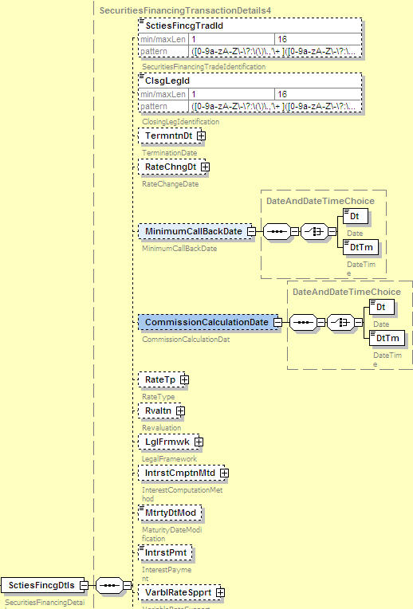

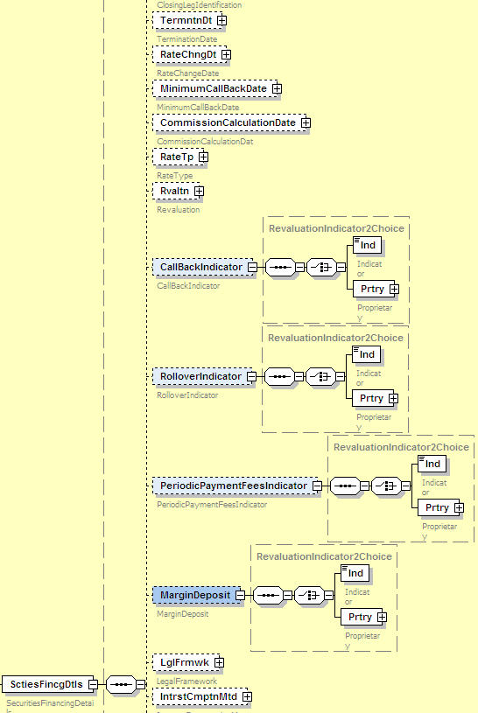

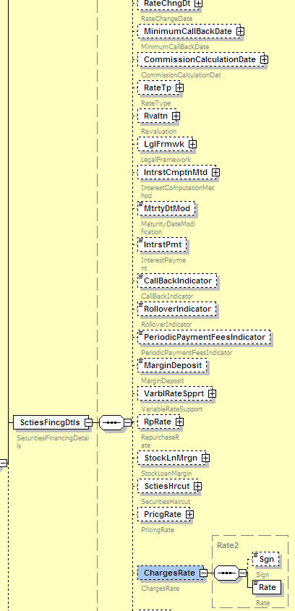

Sese.033.001.01
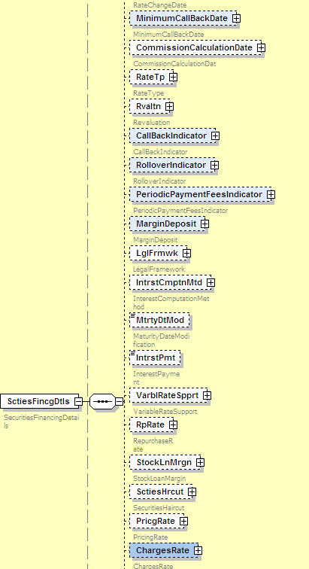

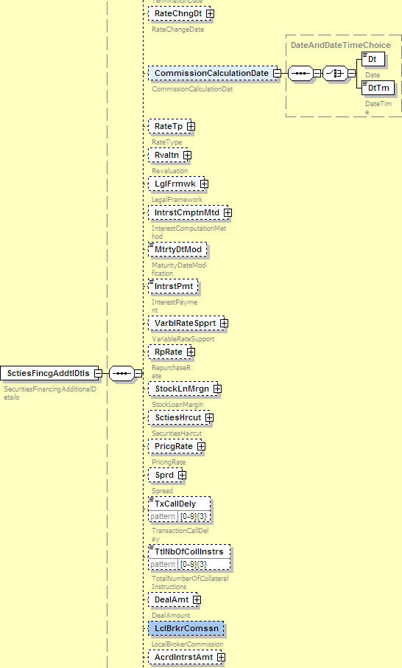

Minutes table
Discussion:

The group acknowledges the business case but considers it is not mature enough.

The group would like to have a better understanding on why this is information should not be included only at a confirmation level (SLA level). Should this information be included also in the settlement messages what would the recipient do with this information for future processing? Would this information improve STP? If the request is rejected what is the impact on the reporting (i.e. reason codes).

Should these requirements apply to both securities lending/borrowing and repo./reverse repo processing?

The group believes this Cr can be re-discussed this at the SMPG in Amsterdam in October.
The workaround will be to use the “supplementary data” message component that allows the users to populate information not included in the message in a structured narrative.

Decision: Rejected

Impacted Messages | Volume | Global or Local impact | Urgency | Back Office impact | Impact on standard | Discussion
 |  |  | Regulatory OR Market Infrastructure OR Other (with details) |  | Eg fields, optionality, validation rules etc | Green

