ISO 20022 Change request number # CR0036
CR Title: Standardisation of the financial instrument identification
- Origin of the request:
A.1 Submitter:
Japan Securities Depository Center, Inc. (JASDEC)
International Securities Association for Institutional Trade Communication (ISITC)
A.2 Contact person:
Shunichiro Unno, Director, Post-trade Services, JASDEC (E-mail: s-unno@jasdec.com, Tel: +81-3-3661-7196)
Erica Choinski, ISITC (E-mail: Erica.Choinski@bbh.com, Tel: +1-617-772-1437)

- Related messages:
All Settlement, Reconciliation and Corporate Action Messages that contain a Financial Instrument Identification.

- Description of the change request:
Change the usage of ISIN and OtherIdentification of “SecurityIdentification11” for the relevant messages listed above so that ISIN and OtherIdentification may be set concurrently.
The change would lead to allowing the providing of:
- one ISIN,
- one ISIN and one or more OtherIds,
- one or more OtherIds,
- the above + a description
- a description only as a last resort when no identifier exists.
For the identification of the OtherIds, the proposal is to simplify and standardise the way “non ISIN” identifiers are provided by the use of an ISO 20022 external code list for the provision of the type of OtherId (Sedol, Cusip, RIC, OCC, etc.) or proprietary (for ids temporarily created by institutions for some instruments). See examples for details.
This proposed component design enables the Financial Instrument Identification component to be reusable across the whole securities trade life cycle (the same way 35B is reusable in ISO 15022). It is acknowledged that in some business areas, some additional restrictions might be needed and the design allows for it.
Considering this request impacts the whole securities industry, we would like to propose that this request be discussed during a dedicated Securities SEG conference call to be organised in September.
- Purpose of the change:

In the US Market, the ISITC Reconciliation working group is requesting multiple security identifier functionality within reconciliation messages. While the working group supports the use of ISIN, there are scenarios where more than one identifier would increase automation of reconciliation processes as noted in the business justification section. There is no risk in having additional security Identifiers where ISIN is recommended and additional security identifiers where local ID could be used as needed simultaneously. The US Market currently utilizes the functionality today in that firms choose any security identifier or multiple IDs as bilaterally agreed upon between messaging partners. Typically the hierarchy is defined between two parties. If the concern is risk, market practice has defined ISIN as the recommendation and the sender of the message is responsible for sending the appropriate security identifier in the messages. After additional analysis, ISITC Settlements and Corporate Actions have identified business cases where having the ability to provide more than one security identifier is beneficial within specific business processes noted below.

ISITC believes that it is in the best interest from a standards perspective to harmonize the security identifier structure throughout the trade lifecycle, from pre-trade/trade, settlements, reconciliation, corporate actions, and all messages with security identifier in use. Further, ISITC would like to amend the use of primary identifier to be optional as the ability to provide other identifiers is adequate and consistent with how we currently utilize the securities messages in the US.

In Japan, JASDEC provides the central matching service (Pre-Settlement Matching System: PSMS) and PSMS permits its users to use either ISIN or the local code for financial instruments identification when they send the messages to PSMS. PSMS does cross matching of the financial instruments identification and it enriches missing financial instrument identification code when it sends out allegement and matching status to the counterparty/both parties or redirects a settlement instruction to a third party as a copy, etc. Also, JASDEC’s book-entry transfer system (BETS) for stocks permits its users to use either ISIN or the local code when they send the messages to BETS. BETS uses the local code for internal processing and enriches ISIN when it sends out settlement confirmation, etc. to the settlement parties. Thus JASDEC needs to set both ISIN and local code concurrently in one message.

- Urgency of the request:
The request should be reflected by SR 2011.

- Business examples:
ISITC Case 1:
In some reconciliation reporting, there is no industry financial instrument identifier available. In these cases the Asset Manager sends a proprietary ID. In some cases the Identifier may become available or assigned following settlement. In which case, it is helpful to provide both the proprietary ID and the newly issued identifier to allow for STP in reconciliation.

ISITC Case 2:
In the US, several organizations offer reconciliation processing as a product. In this service model, there is no visibility to the trade instructions, the source of the data, or linking to a security master database. The firm providing the reconciliation service receives in Custodian/Accounting Agent reconciliation statement messages and the corresponding Asset Servicers reconciliation messages to produce an exception report. It is beneficial in this service model to have the ability to receive more than one identifier to increase the ability to match positions and reduce the exceptions on the report. Again, the senders of the messages would be responsible for the data within the messages.

Business Diagram:

ISITC Case 3:
The ISITC Reconciliation working group supports adding more than one identifier as there are currently Service Level Agreements between organizations to support sending multiple security identifiers. As a result, messaging standards should accommodate a business processing request that has already been contractually agreed upon. To avert utilizing free format fields, a structured field is preferred by the US.
Example of format used today between messaging partners:
Tag 35B:
:35B:ISIN GB00B127GF29
/GB/B127GF2/US/CB127GF26
CORUS GROUP PLC ORD GBP0.5

ISITC Case 4:
The ISITC Settlements working group has identified a few short term instruments that do not always have standard identifiers at the time they are traded. Some examples include: Certificates of Deposit, Commercial Papers, and Money Market accounts. This also applies to some TBAs as well. In these scenarios the Investment Manager has sent a dummy security identifier for a holding since there was no market identifier available. When the security identifier is assigned, the next time Investment Manager is buying or selling the same security, the Investment Manger will need to communicate to the Custodian both identifiers to allow the Custodian to link the security identifiers together on the new buy or sell transaction. Custodian would report back on reconciliation statement the new market security identifier and their previously used dummy identifier to report the entire holding for the instrument.

ISITC Case 5:
ISITC has also determined that the ability to provide multiple security identifiers is applicable in Corporate Actions for rights where the initial announcement may utilize a dummy security identifier and an ISIN is issued following the notification of the event. In this case having the ability to provide both security identifiers will link the dummy identifier to the market identifier when one is available.

JASDEC Case 1: Multiple Systems at participant level
There are multiple systems at participant level, and each of them uses different identifiers.
A local code is often an identification key in front systems such as OMS (Order Management System), trading system, etc. On the other hand, ISIN code is an identification key in back-office systems such as customer reporting system, settlement system, etc.
Therefore, PSMS and BETS provide 2 kinds of identifications so that each participant can establish connections among its multiple systems easily. In the case of PSMS, this post-trade matching system communicates with the front office trading system (local code) and back-office settlement systems (ISIN) of the same client and it is important that both identifiers are provided in the reporting.

For example, one broker administers the result of trading (including the instruction to PSMS and trade status reporting back) in its trading system and the transmission of the settlement matching status and settlement confirmation status in its back-office system. (See above) When the status messages or the confirmation messages are received from PSMS or BETS, an ISIN code is used as identification key and the above mentioned status are updated in its back-office system. Besides, a local code is captured as one of financial attributes in its back-office system at this moment. When these data in its back-office system are transmitted to its trading system, a local code is used as an identification key in its trading system for reconciliation between the trading result and progress in PSMS and BETS.

JASDEC Case 2: Preference of participant’s customer
As each customer of the participant prefers different identifications in its reports, it is necessary for some participants to use the preferred identification for each of their account. Therefore, PSMS provides, as a service to its customers, 2 kinds of identifications so that each participant can establish, using data coming directly from the market, its reporting system based on customer’s preference. In this case, it is insufficient to specify the preference identification per each participant in PSMS. (See below.)
Examples (for illustration purposes)
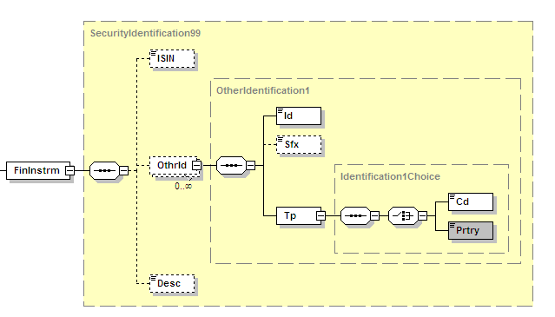
Example 1. (ISIN + Local ID + Description)
<FinInstrmId>
<ISIN>JP3435000009</ISIN> ISIN
<OthrId>
<Id>67580</Id> ID code
<Tp>
<Cd>SICC</Cd> ISO 20022 External Code (SICC)
</Tp>
</OthrId>
<Desc>SONY CORPORATION</Desc> Description
</FinInstrmId>

Example 2 (ISIN + Local ID + Description)
<FinInstrmId>
<ISIN>GB00B127GF29</ISIN>
<OthrId>
<Id>CB127GF26</Id>
<Tp>
<Cd>CUSP</Cd> ISO 20022 External Code (CUSIP)
</Tp>
</OthrId>
<Desc>CORUS GROUP PLC ORD GBP0.5</Desc>
</FinInstrmId>

Example 3 (Two other IDs + Description)
<FinInstrmId>
<OthrId>
<Id>CB127GF26</Id>
<Tp>
<Cd>CUSP</Cd> ISO 20022 External Code (CUSIP)
</Tp>
</OthrId>
<OthrId>
<Id>B127GF2</Id>
<Tp>
<Cd>SEDO</Cd> ISO 20022 External Code (SEDOL)
</Tp>
</OthrId>
<Desc>CORUS GROUP PLC ORD GBP0.5</Desc>
</FinInstrmId>

Example 4 (Proprietary dummy ID + Description)
<FinInstrmId>
<OthrId>
<Id>ABCDEF123</Id>
<Tp>
<Prtry>CUST</Prtry> Type of ID (dummy custodian ID)
</Tp>
</OthrId>
<Desc>COMMERCIAL PAPER ABCD</Desc>
</FinInstrmId>

Example 5 (ISIN + Description)
<FinInstrmId>
<ISIN>FR0000133308</ISIN>
<Desc>FRANCE TELECOM</Desc>
</FinInstrmId>

Example 6 (Two proprietary dummy IDs + Description)
<FinInstrmId>
<OthrId>
<Id>XYZ09876</Id>
<Tp>
<Prtry>CUSTDUMC</Prtry> Type of ID (dummy cusip custodian)
</Tp>
</OthrId>
<OthrId>
<Id>ABCDEF123</Id>
<Tp>
<Prtry>IMMIDUMS</Prtry> Type of ID (dummy sedol IM)
</Tp>
</OthrId>
<Desc>COMMERCIAL PAPER ABCD</Desc>
</FinInstrmId>

- SEG recommendation:
This section is not to be taken care of by the submitter of the change request. It will be completed in due time by the SEG(s) in charge of the related ISO 20022 messages.

Consider |  | Y | Timing
 |  |  | - Next yearly cycle: 2010/2011  (the change will be considered for implementation in the yearly maintenance cycle which starts in 2010 and completes with the publication of new message versions in the spring of 2011) |  |  | Priority:  high  medium  low
 |  |  | - At the occasion of the next maintenance of the messages  (the change will be considered for implementation, but does not justify maintenance of the messages in its own right – will be pending until more critical change requests are received for the messages) |  | Y
- Urgent unscheduled
(the change justifies an urgent implementation outside of the normal yearly cycle)
 |  |  | - Other timing:
Comments:
Approve, to be implemented at message set level organically, but at latest within 3 years.

Reject
Reason for rejection:
- Impact analysis:
All messages where Message Component SecurityIdentification11 is used.
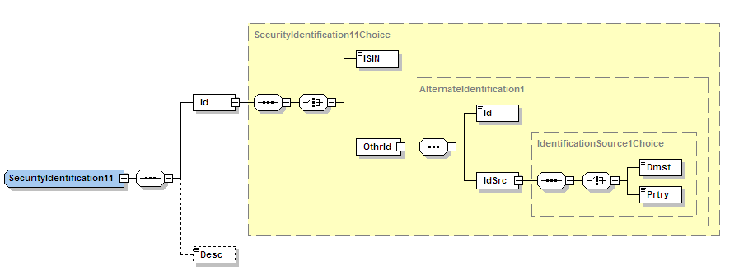
- Limited impact on players using ISIN.
- Medium impact on players using domestic local identifiers.
- Medium-High impact on players using proprietary identifiers.
- No impact on users using description.
- Proposed implementation:
This design aims at being simple and reusable in all securities messages. Reusability of such an important securities component would indeed be a tremendous standards achievement.
ISIN remains the preferred identifier (mentioned on its own at the top of the component, guideline on its preferred usage).
But the design acknowledges the fact that for many instruments (such as short term money market instruments, derivatives…) or processes, an ISIN does not always exists or has not been issued yet at the time it is needed.
It allows for multiple identifiers to be provided (see approved business case above) in a standards way.
It standardise the way local/proprietary identifier types are identified through the usage of an ISO 20022 external code list (that can be updated on a quarterly basis).
It enables the use of a description alone for the unfortunate but existing case where no identifier exists or has been issued yet. But it restricts its sole usage to last resort through a usage rule.
In terms of business functionalities, it is in line with what is technically possible with field 35B in ISO 15022 and with instrument identifiers tags of other standards (eg, FIX).
Rules (that can be validated by a network) are included to prevent that no identifier is provided by the sender.
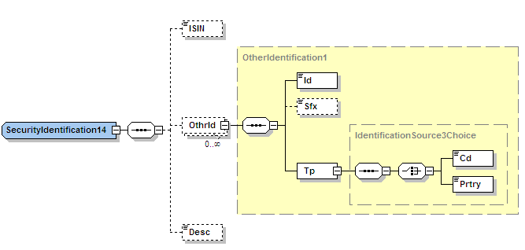
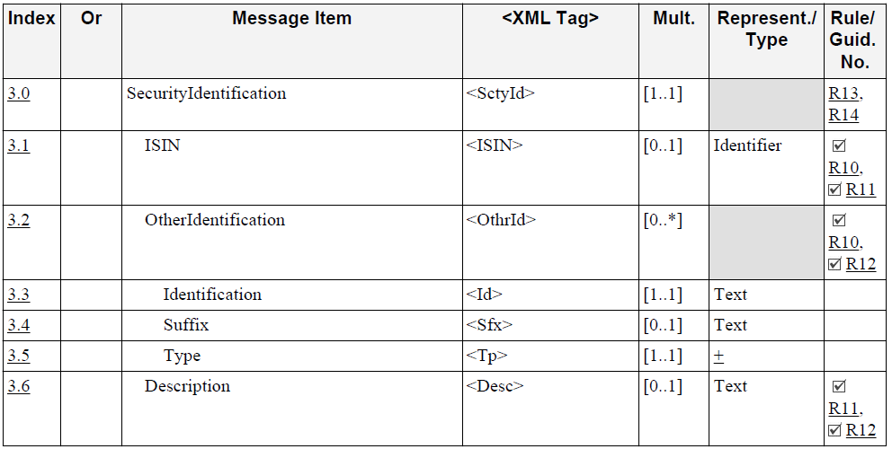

3.0 SecurityIdentification <SctyId>
Presence: [1..1]
Definition: Identification of the financial instrument.
Type: The SecurityIdentification block is composed of the following SecurityIdentification14 element(s):
Standards MX

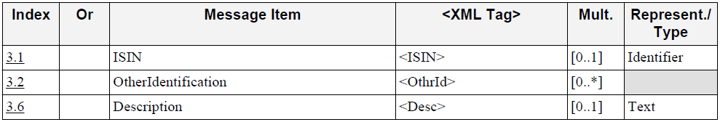

Rule(s):
- DescriptionPresenceRule
If Description is not present then either ISIN or at least one occurence of OtherIdentification must be present.
(Fatal) Error Code: Sw.Stds.X00192

- DescriptionUsageRule
Description must be used alone as the last resort.

- ISINGuideline
When a ISIN code exist. It is strongly recommended that the ISIN be used.

- ISINPresenceRule
If ISIN is not present then either Description or at least one occurence of OtherIdentification must be present.
(Fatal) Error Code: Sw.Stds.X00194

- OtherIdentificationPresenceRule
If OtherIdentification is not present then either ISIN or Description must be present.
(Fatal) Error Code: Sw.Stds.X00193

3.1 ISIN <ISIN>
Presence: [0..1]
Definition: International Securities Identification Number (ISIN). A numbering system designed by the United
Nation's International Organisation for Standardisation (ISO). The ISIN is composed of a 2-character
prefix representing the country of issue, followed by the national security number (if one exists), and a
check digit. Each country has a national numbering agency that assigns ISIN numbers for securities in that
country.
Data Type: ISINIdentifier
Format: [A-Z0-9]{12,12}

3.2 OtherIdentification <OthrId>
Presence: [0..*]
Definition: Identification of a security by proprietary or domestic identification scheme.
Type: This message item is composed of the following OtherIdentification1 element(s):
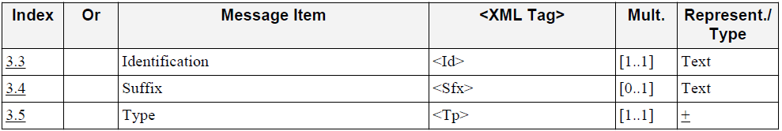

3.3 Identification <Id>
Presence: [1..1]
Definition: Identification of a security.
Data Type: Max35Text
Format: maxLength: 35
minLength: 1

3.4 Suffix <Sfx>
Presence: [0..1]
Definition: Identifies the suffix of the security identification.
Data Type: Max16Text
Format: maxLength: 16
minLength: 1

3.5 Type <Tp>
Presence: [1..1]
Definition: Type of the identification.
Type: This message item is composed of one of the following IdentificationSource3Choice element(s):
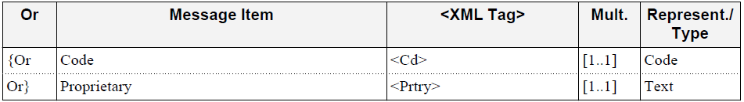

3.5.0 Code <Cd>
Presence: [1..1]
Definition: Unique and unambiguous identification source, as assigned via a pre-determined code list.
Data Type: ExternalFinancialInstrumentIdentificationType1Code
Format: maxLength: 4
minLength: 1

3.5.1 Proprietary <Prtry>
Presence: [1..1]
Definition: Unique and unambiguous identification source using a proprietary identification scheme.
Data Type: Max35Text
Format: maxLength: 35
minLength: 1

3.6 Description <Desc>
Presence: [0..1]
Impacted by: R11, R12
Definition: Textual description of a security instrument.
Data Type: Max140Text
Format: maxLength: 140
minLength: 1

ExternalFinancialInstrumentIdentificationType1Code
The list below has been created based on researches and comments from the requestors FIX and market players. Comments from the SEG are welcome to complete the list.
Once approved, it can be updated on a quarterly basis as per ISO 20022 rules regarding external code lists.

Code Value | Name | Definition
BELC | Code SRW (Secretariaat voor Roerende Waarden) or SVM (Secrétariat des Valeurs mobilières) | National securities identification number for BE issued by the National Numbering Association SIX Telekurs Belgium.
VALO | VALOR | National securities identification number for CH and LI issued by the National Numbering Association SIX Telekurs Ltd.
WKNR | Wertpapierkennummer (WKN) | National securities identification number for DE issued by the National Numbering Association WM Datenservice.
SEDL | Stock Exchange Daily Official List (SEDOL) | National securities identification number for GB issued by the National Numbering Association London Stock Exchange.
COMM | Common Code | National securities identification number for ICSDs issued by the National Numbering Association Clearstreaam and Euroclear.
SICC | Securities Identification Code Committee | National securities identification number for JP issued by the National Numbering Association 6 Stock Exchanges and JASDEC (Securities Identification Ticker-like code Committee)
CUSP | Committee on Uniform Security Identification Procedures (CUSIP) | National securities identification number for US and CA issued by the National Numbering Association Standard & Poor´s - CUSIP Global Services.
CCCD | Other National Securities Identification Number | National Securities Identification Number issued by the National Numbering Association for a country for which no specific financial instrument identification type code already yet. The first two letters of the code represents the coutry code (for example, EGDC for Egyptian NSIN). To be used only until the code is added to the ISO ExternalFinancialInstrumentIdentificationType1Code list.
TIKR | Ticker Symbol (TS) | Ticker Code assigned by an exchange to identify financial instruments.
BLOM | Bloomberg | Ticker-like code assigned by Bloomberg to identify financial instruments.
LCHD | LCH-Clearnet | Ticker-like code assigned by LCH to identify listed-derivatives instruments.
RCMD | Markit Red Code | Ticker-like code assigned by Markit to identify listed-derivatives instruments.
CMED | Chicago Mercantil Exchange (CME) | Ticker-like code assigned by the Chicago Mercantile Exchange to identify listed-derivatives instruments.
CTAC | Consolidated Tape Association (CTA) | Ticker-like code assigned by the Consolidated Tape Association to identify financial instruments.
OCCS | Options Clearing Corp (OCC) | Ticker-like code assigned by the Options Clearing Corporation to identify financial instruments.
OPRA | Options Price Reporting Authority (OPRA) | Ticker-like code assigned by the Options Price Reporting Authority to identify financial instruments.
RICC | Reuters Instrument Code (RIC) | Ticker-like code assigned by Thomson Reuters to identify financial instruments.
ISDU | ISDA/FpML Product URL (URL in SecurityID) | URL in Description to identify OTC derivatives instruments.
ISDX | ISDA/FpML Product Specification (XML in EncodedSecurityDesc) | XML in Description to identify OTC derivatives instruments.

- Proposed timing:
SWIFT confirms that it can implement the requested change and submit valid updated models to the RA by 1 December 2010. We believe it is the good timing for implementing this change before these messages are implemented by more institutions.

- Final decision of the SEG:
This section is not to be taken care of by the submitting organization. It will be completed in due time by the SEG in charge of the related ISO 20022 messages.

Approve
Comments:

Reject
Reason for rejection:

No local identifier type has been provided for FR and NL as those markets have migrated to ISIN only.

