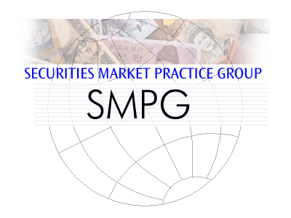

10 November 2014

Investment Funds Market Practice –
Sweden NMPG
Since the adoption of the MyStandards platform for the specification and publication of market practice, all new global market practice for Swedish funds market practice is specified on MyStandards. This document explains what is available on MyStandards and how to access MyStandards.
1. Market Practices available For Sweden on MyStandards 1
2. Register to MyStandards 1
3. Using MyStandards 2
4. Other useful key search words 6
5. Publication Status on MyStandards 6
6. SMPG IF and NMPG IF Groups 7
7. Contact Information 7

Market Practices available For Sweden NMPG IF on MyStandards
The following funds Swedish market practices are available on MyStandards.
 | Name of Market Practice on MyStandards | Sharing Status
1 | NMPG - Statement of Holdings - V1 - WIP 29 Aug 2014 | Private
2 | NMPG SE IF - Order Processing - V1 - FINAL September 2013 | Public
3 | NMPG SE IF - Statement of Investment Fund Transactions - V1 - WIP 3 Oct 2014 | Private

Register to MyStandards
It is not necessary to be a SWIFT institution or a BIC in order to make use of the MyStandards platform.
[1] Go to www.swift.com/MyStandards
[2] Select ‘Login to MyStandards’ at the top right of the screen.
[3] Select ‘create new account’
[4] Complete the registration details:
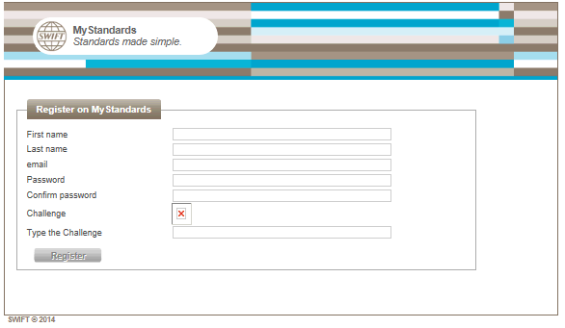
[5] An e-mail will be sent with a link. Click on the link (or copy to the internet explorer). This will complete the registration process

Using MyStandards
[1] Access MyStandards - www.swift.com/MyStandards --> Login to MyStandards
[2] On entering MyStandards for the first time, you will be asked to enter a security question and answer.
[3] Terms of Use – click the check box to acknowledge the terms of use and click Accept (this only happens when entering MyStandards for the very first time).

[4] You will arrive at the MyStandards Home Page.
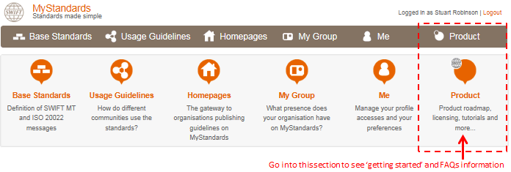
On this screen is displayed the latest news and an explanation of the different functional areas of the MyStandards Platform. Within the section ‘Product’ is useful ‘getting started’ information.
[5] If you are not a member of any of the groups listed above, the best way to find the SMPG or NMPG market practice is to use the search function.
[4.1] Click on Usage Guidelines
[4.2] To search for a market practice on, for example, the order process, type in for example, ‘order’. You can narrow the search by unchecking ‘MT’.

[6] This is an example of search results:
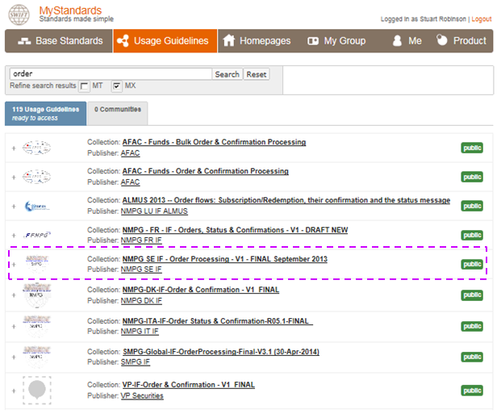

[7] Clicking on ‘SMPG-Global-IF-OrderProcessing-Final-V3.1 (30-Apr-2014)’, for example, shows this screen:
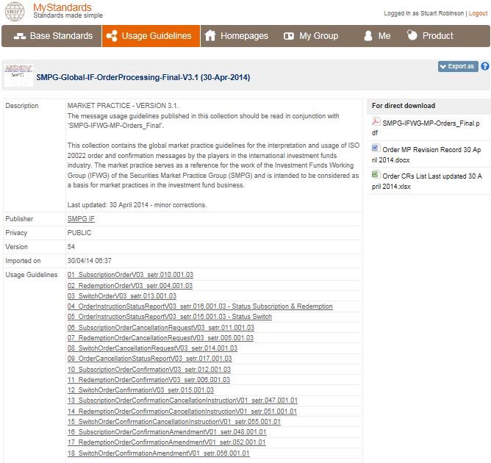
SMPG IF has defined an ‘order process’ document as well as message usage guidelines for eighteen messages.

[8] Clicking on ’01 SubscriptionOrderV03 setr.010.001.03)’, for example, and then on the tab ‘Content’, and then on the message element ‘MultipleOrder Details’ shows this screen:
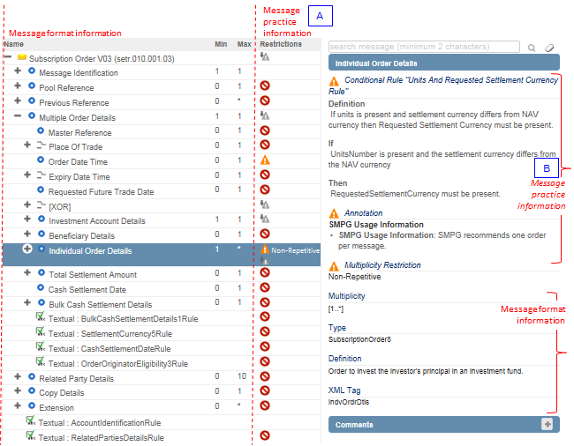
The above diagram illustrates the market practice at the level of each field at high level (A) and then at a mode detailed field level (B) when that field is selected.

Other useful key search words
NMPG | SMPG | NMPG IT | NMPG DK | Price | Account

Publication Status on MyStandards
[1] Restricted Status - 1
A market practice collection may have a restricted status, but is visible because it has been shared to a community that is open.
[2] Restricted Status - 2
A market practice collection may have a restricted status, but is not shared in an open community. This means that the market practice can be viewed by those that have membership to the group in which it is posted. For those SMPG market practices that have a restricted status, it is the intention of SMPG to make these market practices public in the near future.

SMPG IF and NMPG IF Groups
SMPG IF | NMPG LU IF ALMUS | NMPG DK IF | NMPG GB IF | NMPG NO IF
NMPG BR IF | NMPG CH IF SCFS | NMPG FR IF | NMPG DE IF | NMPG SE IF
NMPG AU NZ IF | NMPG IT IF | ABI Lab IT IF | Findel LU IF | AFAC

Contact Information
For any general questions about MyStandards, please send an e-mail to Mystandards@swift.com
For questions about specific market practices on MyStandards:
SMPG IF | Ms. Janice Chapman  Mr. Charles Boniver  Ms. Nadine Muhigiro | Janice.Chapman@swift.com  Charlesraymond.Boniver@RBCDexia.com  Nadine.Muhigiri@Euroclear.com
NMPG BR IF | Ms Ana Abidor | ana.abidor@anbima.com.br
NMPG CH IF SCFS | Mr. Rainer Vogelgesang | rainer.vogelgesang@six-group.com
NMPG DK IF | Mr. Niels Hougaard  Mr.Henrik Kjærbye | nwh@vp.dk  hk@vp.dk
NMPG FR IF | Ms. Valerie Vaudel | valerie.vaudel@bnpparibas.com
NMPG GB IF | Mr. David Broadway * | dbroadway@investmentuk.org
NMPG IT IF | Mr. Andrea Milanesio | amilanesio@pine3consulting.com
NMPG LU IF ALMUS | Mr. Charles Boniver | Charlesraymond.Boniver@RBCDexia.com
Findel LU IF | Mr. Charles Boniver | Charlesraymond.Boniver@RBCDexia.com
NMPG NO IF | Mr. Svein R. Borgersen | srb@vps.no
NMPG SE IF | Mr. Henrick Staffas | henrik.staffas@skandia.se
(* - this name will be updated in the near future)

