Investment Account Management (amct) Usage Guidelines Collection
Migration from V05 to V06 of the messages – Comments and Notes For Discussion
[1] In Investment Account / Fund Details and Savings Investment Plan / Security Details / Financial Instrument – the only element allowed is ISIN
In Investment Account / Reinvestment Details / Fund Details – all elements permitted. This suggests an error and the elements of Fund Details were forgotten about.
OUTCOME
Investment Account / Reinvestment Details / Fund Details has been made consistent with Investment Account / Fund Details
5 April 2016 Review Meeting:
It is suggested that the global MP the Investment Account sequence should not include investment plan and therefore Funds Details or Financial Instrument
[2] Cash Settlement Details – inconsistencies between Cash Settlement within Savings/Withdrawal Investment Plan and Cash Settlement at ‘root’ of messages. In some cases, no restrictions defined at all. It is assumed that this was a mistake and corrected in the 2016 UG.
[3] Usage of Bankers Draft seems inconsistent. This was made consistent, that is, set to ‘do not use’.
[4] Instruction Details & Confirmation Details – SMPG Usage Information Annotations on Client Reference and Counterparty Reference now redundent with the enhancement of the element definitions and so have been removed.
[5] The Account Modification Instruction acmt.003, is sent to add static data to the account that was not known at the time of the account opening, such as a tax identification number, or a cash account for redemption proceeds. So the global MP for acmt.003 should conform to acmt.001 to some extent.
However, the Account Modification Instruction is also sent to change operatational parameters, for example, to indicate the account is blocked. Currently in the UG, the Blocked Status element is not allowed! This has been changed to ‘allowed’.
SMPG may need to consider the use of the acmt.003 and the MP in a little more depth. For example, is there information about the account that CANNOT be modified?
[1] Investment Account / Ownership Type was wrongly mandatory in acmt.003. For SR 2016, this has been made optional. In the usage guidelin, this has been set to ‘allowed’

The images that follow are views of acmt.001.001.03 taken from the usage guideline editor to show the specification of the restrictions.
acmt.001.001.06
Instruction Details
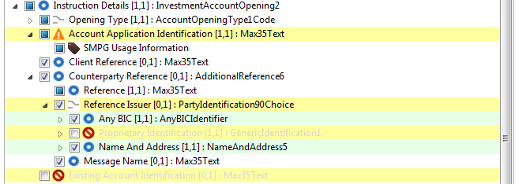

Investment Account
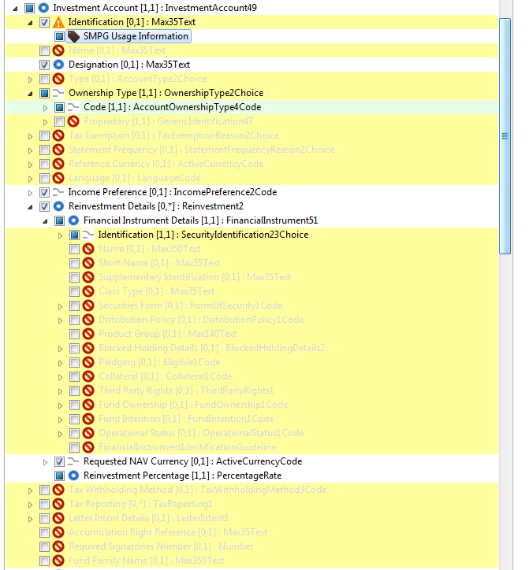

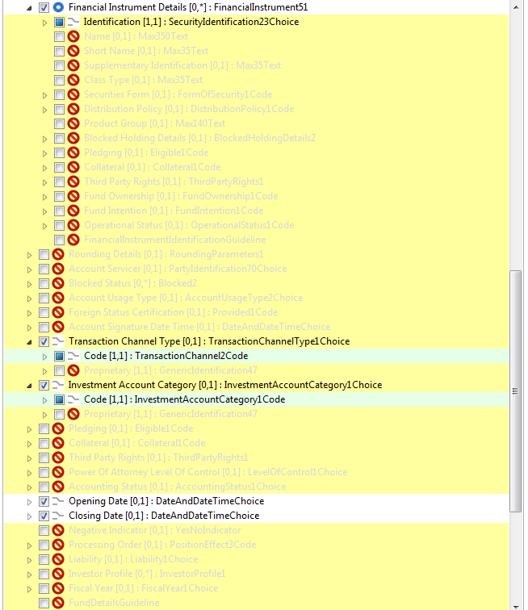

Party Sequences
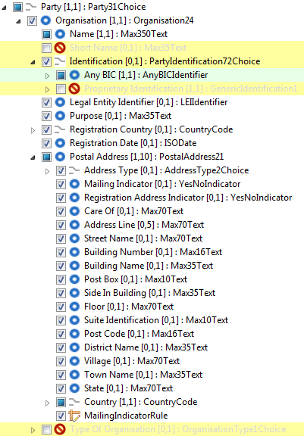

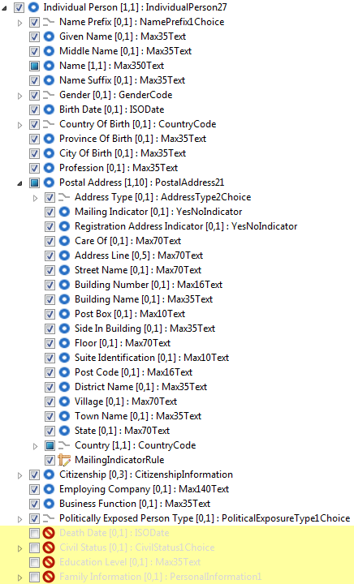

Common to both Organisation abd Individual
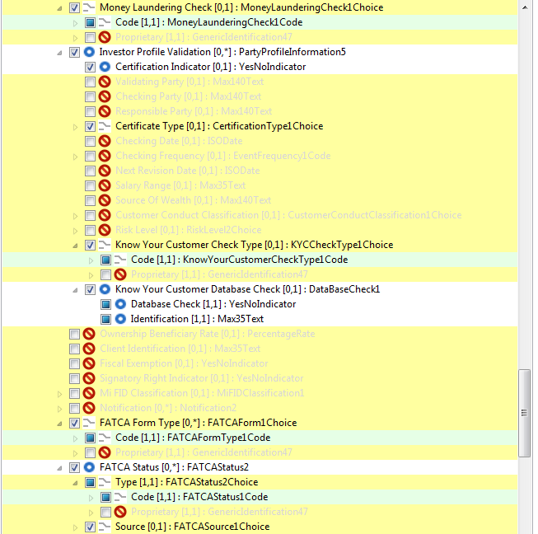
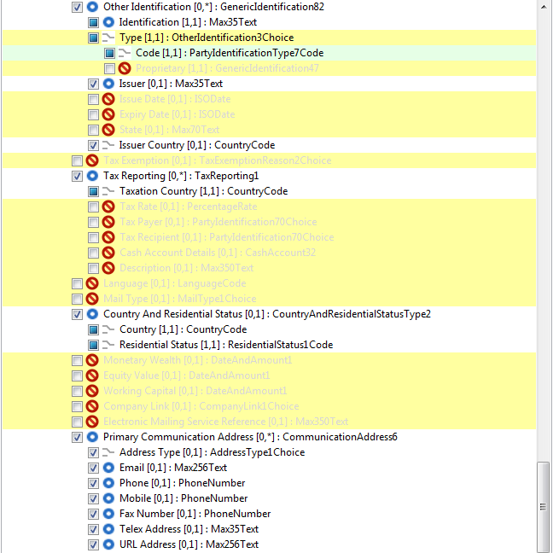
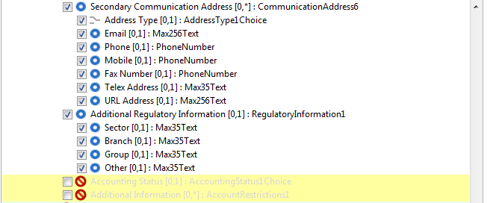

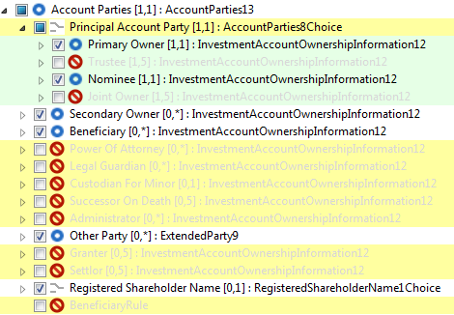

Savings Investment Plan
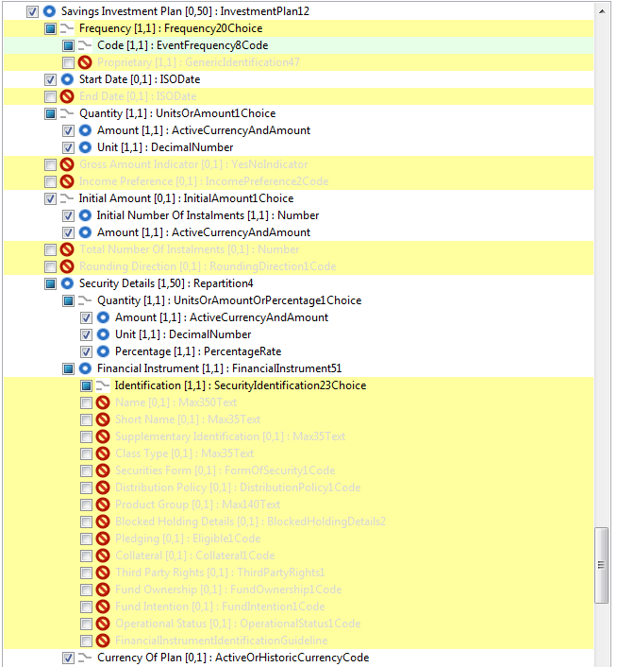

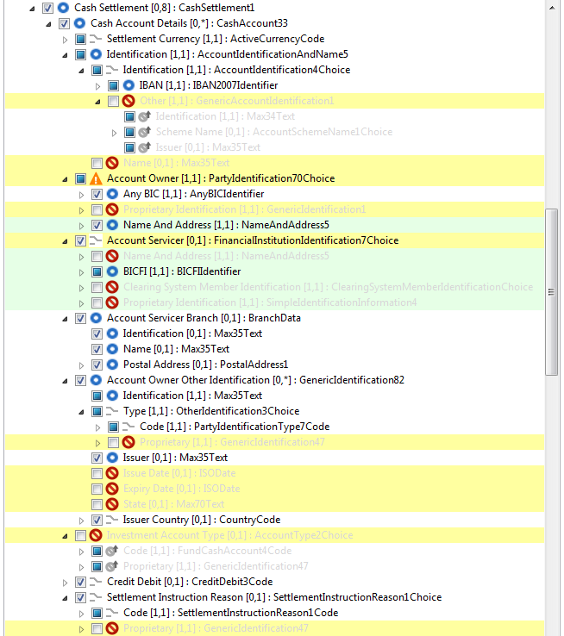

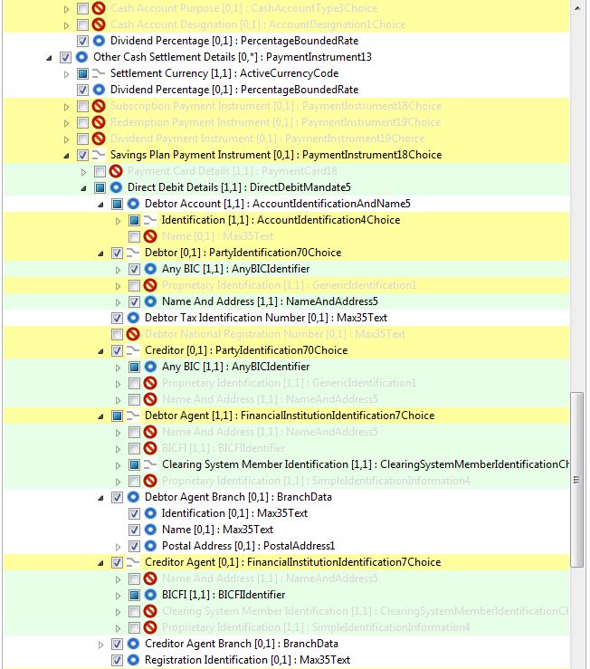
In the 2015 MP, we said that for Subscription Payment Instrument and Redemption Payment Instruement only cash account is allowed. As cash accoubt has been moved out of Subscription Payment Instrument and Redemption Payment Instruement have both been set to ‘do not use’.
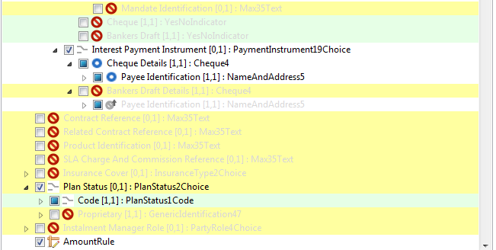

Withdrawal Investment Plan
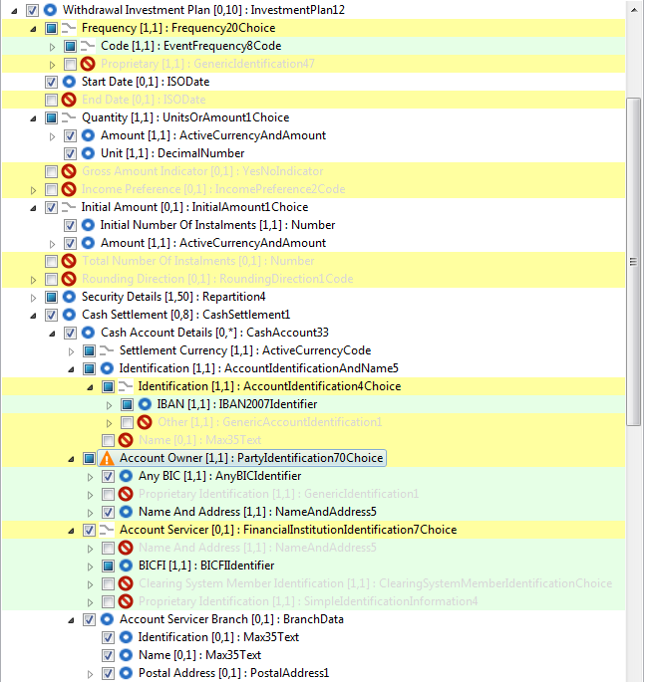

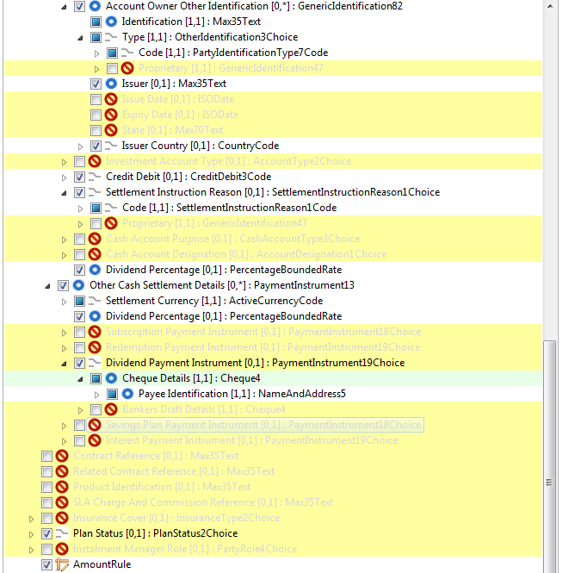

In the 2015 MP, we said that for Subscription Payment Instrument and Redemption Payment Instruement only cash account is allowed. As cash accoubt has been moved out of Subscription Payment Instrument and Redemption Payment Instruement have both been set to ‘do not use’.

Cash Settlement (at root)

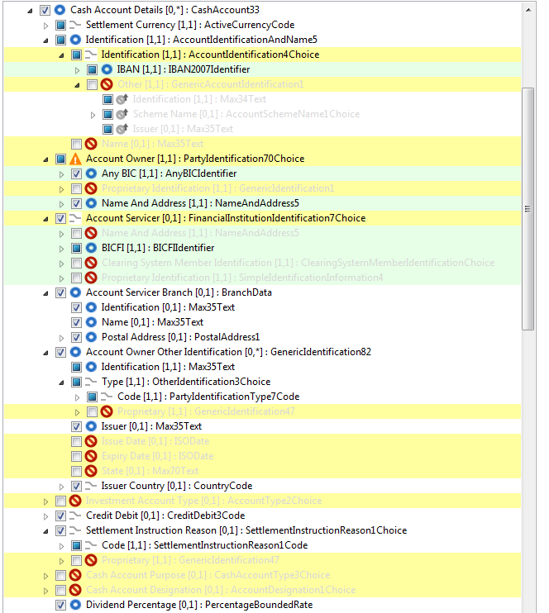

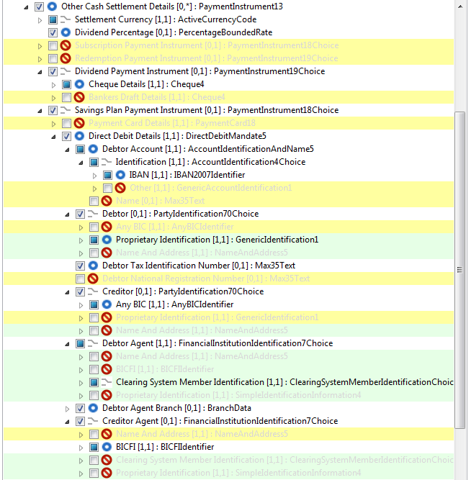
In the 2015 MP, we said that for Subscription Payment Instrument and Redemption Payment Instruement only cash account is allowed. As cash accoubt has been moved out of Subscription Payment Instrument and Redemption Payment Instruement have both been set to ‘do not use’.
