Maintenance Change Request
for the update of ISO 20022 financial repository items
Note: the purpose of this document is to give guidelines to submitting organisations that will develop a new version of existing ISO 20022 messages based on change requests screened by the Standards Evaluation Group(s). Such development is subject to the approval of a Maintenance Change Request which must include a detailed description of the impact of each change on the related messages. The Maintenance Change Request must start with a general chapter covering topics related to the whole maintenance effort and a specific chapter for each change request, as described below. Please consult the iso20022.org website for additional details on the maintenance process.
The Maintenance Change Requests for this ISO 20022 maintenance will follow the fast track process and will be sent to iso20022ra@iso20022.org by June 14 2019.

- Name of the request:
Proxy Voting Messages Maintenance for year 2019/2020
- Submitting organization(s):
SWIFT, SMPG
- Related messages:
Under this project, all the following ISO 20022 Proxy Voting messages would be maintained:
 | Message Name | Identifier
1 | MeetingNotificationV05 | seev.001.001.05
2 | MeetingCancellationV05 | seev.002.001.05
3 | MeetingEntitlementNotificationV05 | seev.003.001.05
4 | MeetingInstructionV05 | seev.004.001.05
5 | MeetingInstructionCancellationRequestV05 | seev.005.001.05
6 | MeetingInstructionStatusV05 | seev.006.001.05
7 | MeetingVoteExecutionConfirmationV05 | seev.007.001.05
8 | MeetingResultDisseminationV05 | seev.008.001.05
- Commitments of the submitting organization:
SWIFT and SMPG confirm that it can and will:
- undertake the development of the new version of the candidate ISO 20022 message models that it will submit to the RA for compliance review and evaluation by August 15, 2019.
- provide a new version of part 1 of the Message Definition Report (MDR) by October 1, 2019 and new examples of valid message instances of each message by October 1 at the latest.
- address any queries related to the description of the new models and messages as published by the RA on the ISO 20022 website.
SWIFT confirms that it intends to organize the actual implementation of the new version of the messages on its SWIFTNet network once the related documentation has been published by the RA.

The submitting organisations confirm their knowledge and acceptance of the ISO 20022 Intellectual Property Rights policy for contributing organisations, as follows.
“Organisations that contribute information to be incorporated into the ISO 20022 Repository shall keep any Intellectual Property Rights (IPR) they have on this information. A contributing organisation warrants that it has sufficient rights on the contributed information to have it published in the ISO 20022 Repository through the ISO 20022 Registration Authority in accordance with the rules set in ISO 20022. To ascertain a widespread, public and uniform use of the ISO 20022 Repository information, the contributing organisation grants third parties a non-exclusive, royalty-free license to use the published information”.

- Contact persons:
Christine Strandberg – christine.strandberg@seb.se – phone: +46 8 763 6074
Mari Fumagalli – mariangela.fumagalli@bnpparibas.com – phone: +44 207 595 4988
Jacques Littré – jacques.littre@swift.com – phone: +32 2 655 43 35
ISO 20022 Proxy Voting Messages Maintenance 2019/2020

Table of Contents

1 CR1: Add new elements required by the SRD2 Directive in the Meeting Notification 4
2 CR2: Add AttendanceConditions in Meeting Sequence 11
3 CR3: Remove Date Status Quorum and Cancelled in MeetingDetails 14
4 CR4: Add new element Voting Rights Threshhold in Resolution 17
5 CR5: Remove element Entitlement in EntitlementSpecification sequence 20
6 CR6: Remove all STP Deadlines 23
7 CR7: Move All Elements from EntitlementSpecification sequence to the Meeting sequence 27
8 CR8: PromoteCourt Meeting from Meeting Classification Type to Meeting Type 31
9 CR9: Remove Vote InstructionType in Vote Sequence 34
10 CR10: Align Amendments with Meeting Notification Type and Status with the CA Notification Design 37
11 CR11: Align Meeting Linkages with CA Notification Linkages 40
12 CR12: Add new elements required by the SRD2 Directive in the Meeting Entitlement Notification 43
13 CR13: Change Elements as Mandatory in Meeting EntitlementNotification 49
14 CR14: Add new elements required by the SRD2 Directive in the Meeting Instruction 52
15 CR15: Align Vote Instruction Type Codes Between the Meeting Notification and Instruction 59
16 CR16: Rename PreviousReference in Meeting Instruction Cancellation Request 64
17 CR17: Enable Cancellation of a Single Instruction within an Instruction Message 67
18 CR18: Add new elements required by the SRD2 Directive in the Meeting Instruction Status 70
19 CR19: Add new Pending Status in the Meeting Instruction Status Message and Align Other Status/reason Codes With CA Statuses 74
20 CR20: Add new elements required by the SRD2 Directive in the Meeting Vote Execution Confirmation 77
21 CR21: Set StandingInstructionOrder Optional in the Meeting Vote Execution Confirmation 82
22 CR22: Align the Meeting Result Dissemination Message Design with Similar Changes in Other Messages 85
23 CR23: Replace All Obsolete Components with New or Latest Version 89
24 CR24: Align all RightsHolder Identification Data type in all Messages 93
25 CR25: Amend Message Definitions Scope And Usage 96

CR1: Add new elements required by the SRD2 Directive in the Meeting Notification
- Origin of the request:
A.1 Submitter: SWIFT, SMPG
A.2 Contact person:
Christine Strandberg – christine.strandberg@seb.se – phone: +46 8 763 6074
Mari Fumagalli – mariangela.fumagalli@bnpparibas.com – phone: +44 207 595 4988
Jacques Littré – jacques.littre@swift.com – phone: +32 2 655 43 35
A.3 Sponsors: N/A

- Related messages:
List of ISO 20022 Proxy Voting messages which would be impacted by the change:
seev.001.001.05 MeetingNotificationV05

- Description of the change request:
- In MeetingDetails sequence, add an optional and non-repeatable URLAddress as a virtual address for general meetings.
- (IR table 3.C item 4 in implementation regulation)
- In the Meeting sequence, add the new optional and repeatable sequence “Attendance“ containing the new mandatory element “AttendanceMethod”, the new mandatory element “IssuerDeadlineForVoting” and the existing optional elements AttendanceConfirmationDeadline and AttendanceConfirmationMarketDeadline. The attendance method must contain the values: Virtual participation, in person, through Proxy, by correspondence, participation in person but not voting.
- (IR table 3.D items 1 and 3 in implementation regulation)
- In the Resolution sequence, add a new optional non-repeatable URLAddress element.
- (IR table 3.E item 3 in implementation regulation)
- In the Resolution sequence, add a new optional and non-repeatable element VoteType after the element “ForInformationOnly” in order to specify if it is a binding vote or an advisory vote.
- (IR table 3.E item 4 in implementation regulation)
- In the Resolution and Vote sequences, for the VoteInstructionType element, in the VoteInstructionCode, add a new vote instruction type codes “BLNK (Blank)” (vote is cast as “empty” but the vote is counted) and “Other” paired with a narrative element and amend the definition of the “NoAction” code.
- (IR table 3.E item 5 in implementation regulation)
- Purpose of the change:
This change is required by the European Commission Shareholders Rights Directive implementing regulation (EU) 2018/1212 of 3 September 2018 (see regulation table references in the description above).
- Urgency of the request:
This maintenance change request for the proxy-voting messages follows the ISO 20022 fast track maintenance process so as to publish a new version of those messages around end of Q3 2019.
- Business examples:
NA
- SEG recommendation:
This section is not to be taken care of by the submitter of the change request. It will be completed in due time by the SEG(s) in charge of the related ISO 20022 messages.

Consider |  |  | Timing
 |  |  | - Next yearly cycle: 2019/2020  (the change will be considered for implementation in the yearly maintenance cycle which starts in 2019 and completes with the publication of new message versions in the spring of 2020) |  |  | Priority:  high  medium  low
- At the occasion of the next maintenance of the messages
(the change will be considered for implementation, but does not justify maintenance of the messages in its own right – will be pending until more critical change requests are received for the messages)
 |  |  | - Urgent unscheduled  (the change justifies an urgent implementation outside of the normal yearly cycle) |  | X
 |  |  | - Other timing:
Comments:

Reject
Reason for rejection:

- Impact analysis:
This change request impacts the following messages:
seev.001.001.05 MeetingNotificationV05
- Proposed implementation:

- Add URL Address in Meeting Details
In the seev.001 (MENO – MeetingNotification) message, in the MeetingDetails sequence, add a new optional and non-repeatable element URLAddress typed by Max256Text as illustrated below:
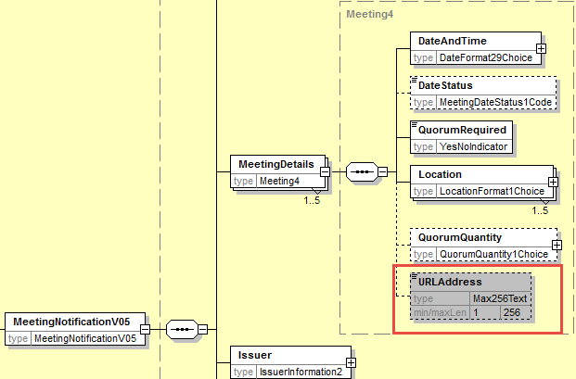

- Add new Attendance component in the Meeting sequence
In the seev.001 (MENO – MeetingNotification) message, in the Meeting sequence, add a new optional and repeatable element Attendance typed by a component containing:
- a new mandatory element AttendanceMethod typed by a code with the values: Virtual participation, in person, through Proxy, by correspondence, participation in person but not voting and a proprietary element.
- a new optional and non-repeatable element IssuerDeadlineForVoting typed by DateFormat29Choice
- the existing optional AttendanceConfirmationDeadline element typed by DateFormat29Choice (from the Meeting sequence).
- the existing optional AttendanceConfirmationMarketDeadline element typed by DateFormat29Choice (from the Meeting sequence).
as illustrated below:
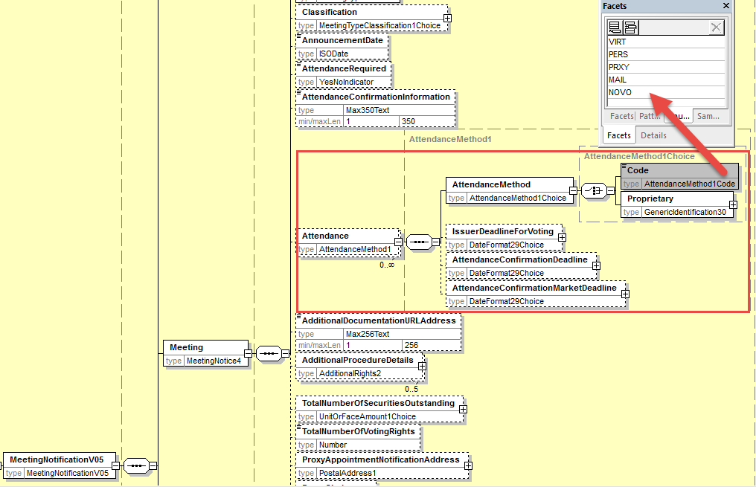

- Add URL address in Resolution sequence
In the seev.001 (MENO – MeetingNotification) message, in the Resolution sequence, add a new optional and non-repeatable element URLAddress typed by Max256Text as illustrated below:
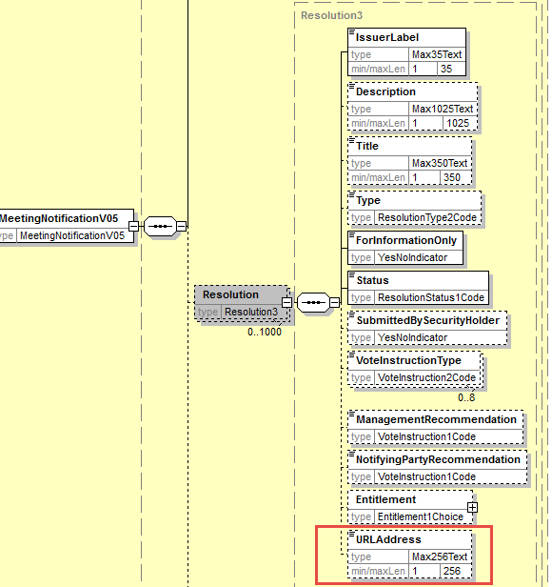
- Add Vote Type in Resolution
In the seev.001 (MENO – MeetingNotification) message, in the Resolution sequence, add a new optional and non-repeatable element VoteType typed by a code with values “Binding Vote” and “Advisory Vote” as illustrated below in e).

- Add new code value to VoteInstructionCode
In the seev.001 (MENO – MeetingNotification) message, in the Resolution and in the Vote sequences, for the element VoteInstructionType, replace the data type by a choice between
- a predefined code list typed by VoteInstruction2code and add the new code values “BLNK (Blank)” (vote is cast as “empty” but the vote is counted) and amend the definition of the “NoAction” code to read “Indicates an intention of not casting a vote.”.
- and a proprietary code value to cover the other type of votes.
- Set the multiplicity of the VoteInstructionType in the Vote sequence to [0..n]
- Also add a narrative element to explain what the proprietary code is all about if used and add a cross element rule so that AdditionalInformation may only be present if a proprietary vote instruction type code is provided.
as illustrated below:
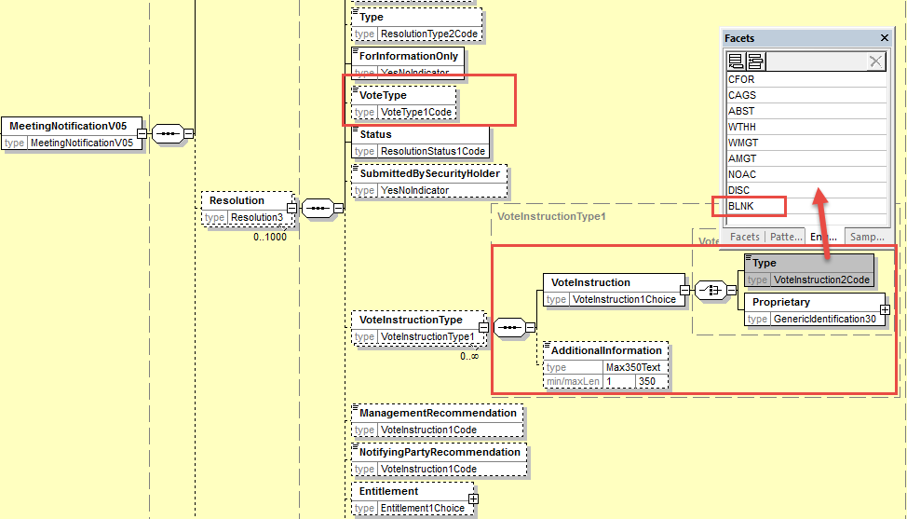
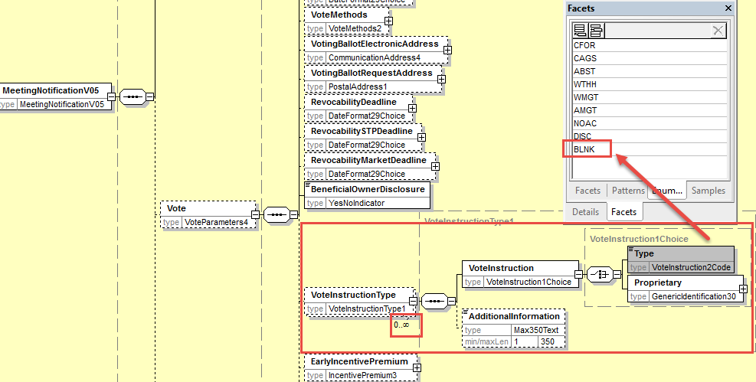
- Proposed timing:
The submitting organization confirms that it can implement the requested changes in the requested timing

Timing | - As requested

- Final decision of the SEG(s):

Approve
Comments:

Reject
Reason for rejection:

CR2: Add AttendanceConditions in Meeting Sequence
- Origin of the request:
A.1 Submitter: SWIFT, SMPG
A.2 Contact person:
Christine Strandberg – christine.strandberg@seb.se – phone: +46 8 763 6074
Mari Fumagalli – mariangela.fumagalli@bnpparibas.com – phone: +44 207 595 4988
Jacques Littré – jacques.littre@swift.com – phone: +32 2 655 43 35
A.3 Sponsors: N/A

- Related messages:
List of ISO 20022 Proxy Voting messages which would be impacted by the change:
seev.001.001.05 MeetingNotificationV05

- Description of the change request:
Add a new optional and repeatable element AttendanceAdmissionConditions in the Meeting sequence with predefined code values and a narrative part.
The predefined code values are:
- MALR - Meeting attendance allowed - attendees will be placed on a attendee list or issued with a Letter of Representation, and must bring photographic ID with them.
- MAAL - Meeting attendance allowed – attendees will be placed on a attendee list and must bring photographic ID with them.
- MATK - Meeting attendance allowed – attendees will be issued an admission ticket and must bring photographic ID with them.
- MAHI - Meeting attendance allowed - attendees must request proof of holding and register for attendance directly with Issuer.
- MAPO - Meeting attendance allowed - attendees acting on behalf of registered holder must have a valid PoA and/or proof of holding.
- MASH - Meeting attendance allowed but any attendee must be a shareholder themselves.
- MANP - Meeting attendance is not possible.

- Purpose of the change:
There is a need to specify what are the attendance admission conditions with predefined values and the possibility to give a narrative description as well.
- Urgency of the request:
This maintenance change request for the proxy-voting messages follows the ISO 20022 fast track maintenance process so as to publish a new version of those messages around end of Q3 2019.
- Business examples:
N/A
- SEG recommendation:
This section is not to be taken care of by the submitter of the change request. It will be completed in due time by the SEG(s) in charge of the related ISO 20022 messages.

Consider |  |  | Timing
 |  |  | - Next yearly cycle: 2019/2020  (the change will be considered for implementation in the yearly maintenance cycle which starts in 2019 and completes with the publication of new message versions in the spring of 2020) |  |  | Priority:  high  medium  low
- At the occasion of the next maintenance of the messages
(the change will be considered for implementation, but does not justify maintenance of the messages in its own right – will be pending until more critical change requests are received for the messages)
 |  |  | - Urgent unscheduled  (the change justifies an urgent implementation outside of the normal yearly cycle) |  | X
 |  |  | - Other timing:
Comments:

Reject
Reason for rejection:

- Impact analysis:
This change request impacts the following messages:
seev.001.001.05 MeetingNotificationV05

- Proposed implementation:
In the seev.001 (MENO – MeetingNotification) message, in the Meeting sequence, add a new optional and repeatable element AttendanceAdmissionConditions typed by a component with a choice of code values or a narrative as illustrated below:
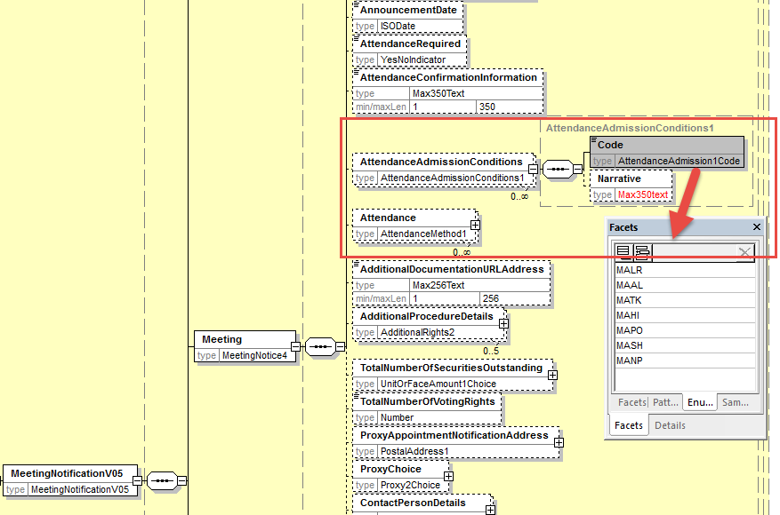

- Proposed timing:
The submitting organization confirms that it can implement the requested changes in the requested timing

Timing | - As requested

- Final decision of the SEG(s):

Approve
Comments:

Reject
Reason for rejection:

CR3: Remove Date Status Quorum and Cancelled in MeetingDetails
- Origin of the request:
A.1 Submitter: SWIFT, SMPG
A.2 Contact person:
Christine Strandberg – christine.strandberg@seb.se – phone: +46 8 763 6074
Mari Fumagalli – mariangela.fumagalli@bnpparibas.com – phone: +44 207 595 4988
Jacques Littré – jacques.littre@swift.com – phone: +32 2 655 43 35
A.3 Sponsors: N/A

- Related messages:
List of ISO 20022 Proxy Voting messages which would be impacted by the change:
seev.001.001.05 MeetingNotificationV05

- Description of the change request:
The code values NoQuorum (NOQO) and Cancelled (CANC) are inappropriate at this stage in the DateStatus and should be removed from the MeetingDateStatus1Code in the element MeetingDetails/DateStatus.
- Purpose of the change:
The code values NoQuorum (NOQO) appears already as a cancellation reason in the cancellation message (seev.002) and the Cancelled (CANC) status is inappropriate as it is the role of the cancellation message itself.
- Urgency of the request:
This maintenance change request for the proxy-voting messages follows the ISO 20022 fast track maintenance process so as to publish a new version of those messages around end of Q3 2019.
- Business examples:
N/A
- SEG recommendation:
This section is not to be taken care of by the submitter of the change request. It will be completed in due time by the SEG(s) in charge of the related ISO 20022 messages.

Consider |  |  | Timing
 |  |  | - Next yearly cycle: 2019/2020  (the change will be considered for implementation in the yearly maintenance cycle which starts in 2019 and completes with the publication of new message versions in the spring of 2020) |  |  | Priority:  high  medium  low
- At the occasion of the next maintenance of the messages
(the change will be considered for implementation, but does not justify maintenance of the messages in its own right – will be pending until more critical change requests are received for the messages)
 |  |  | - Urgent unscheduled  (the change justifies an urgent implementation outside of the normal yearly cycle) |  | X
 |  |  | - Other timing:
Comments:

Reject
Reason for rejection:

- Impact analysis:
This change request impacts the following messages:
seev.001.001.05 MeetingNotificationV05

- Proposed implementation:
In the seev.001 (MENO – MeetingNotification) message, in the MeetingDateStatus1Code the data type of the element MeetingDetails/DateStatus, remove the code values NOQO and CANC as illustrated below:
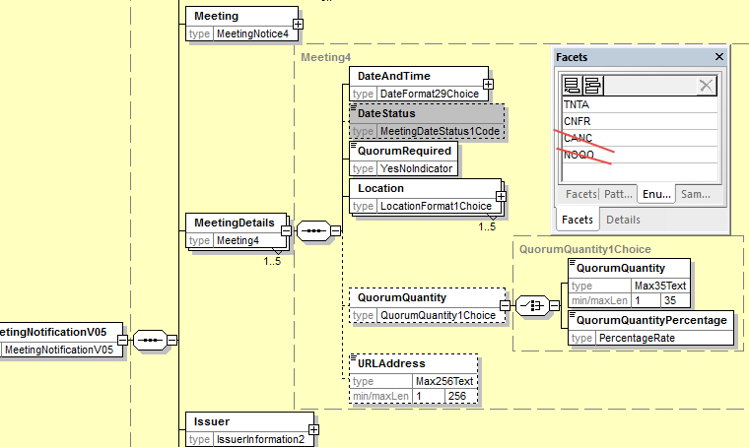

- Proposed timing:
The submitting organization confirms that it can implement the requested changes in the requested timing

Timing | - As requested

- Final decision of the SEG(s):

Approve
Comments:

Reject
Reason for rejection:

CR4: Add new element Voting Rights Threshhold in Resolution
- Origin of the request:
A.1 Submitter: SWIFT, SMPG
A.2 Contact person:
Christine Strandberg – christine.strandberg@seb.se – phone: +46 8 763 6074
Mari Fumagalli – mariangela.fumagalli@bnpparibas.com – phone: +44 207 595 4988
Jacques Littré – jacques.littre@swift.com – phone: +32 2 655 43 35
A.3 Sponsors: N/A

- Related messages:
List of ISO 20022 Proxy Voting messages which would be impacted by the change:
seev.001.001.05 MeetingNotificationV05

- Description of the change request:
In the Resolution sequence, add a new optional non repeatable element VotingRightsThresholdForApproval in quantity or percentage.

- Purpose of the change:
Providing the possibility to specify for each resolution the voting rights threshold required in percentage or in quantity to have the resolution approved.

- Urgency of the request:
This maintenance change request for the proxy-voting messages follows the ISO 20022 fast track maintenance process so as to publish a new version of those messages around end of Q3 2019.
- Business examples:
NA
- SEG recommendation:
This section is not to be taken care of by the submitter of the change request. It will be completed in due time by the SEG(s) in charge of the related ISO 20022 messages.

Consider |  |  | Timing
 |  |  | - Next yearly cycle: 2019/2020  (the change will be considered for implementation in the yearly maintenance cycle which starts in 2019 and completes with the publication of new message versions in the spring of 2020) |  |  | Priority:  high  medium  low
- At the occasion of the next maintenance of the messages
(the change will be considered for implementation, but does not justify maintenance of the messages in its own right – will be pending until more critical change requests are received for the messages)
 |  |  | - Urgent unscheduled  (the change justifies an urgent implementation outside of the normal yearly cycle) |  | X
 |  |  | - Other timing:
Comments:

Reject
Reason for rejection:

- Impact analysis:
This change request impacts the following messages:
seev.001.001.05 MeetingNotificationV05
- Proposed implementation:
In the seev.001 (MENO – MeetingNotification) message, in the Resolution sequence, add a new optional and non-repeatable element VotingRightsThresholdForApproval typed by a choice component between a percentage and an absolute number as illustrated below:
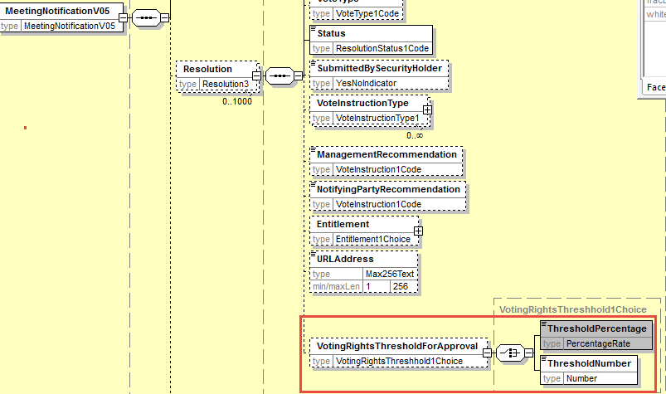

- Proposed timing:
The submitting organization confirms that it can implement the requested changes in the requested timing

Timing | - As requested

- Final decision of the SEG(s):

Approve
Comments:

Reject
Reason for rejection:

CR5: Remove element Entitlement in EntitlementSpecification sequence
- Origin of the request:
A.1 Submitter: SWIFT, SMPG
A.2 Contact person:
Christine Strandberg – christine.strandberg@seb.se – phone: +46 8 763 6074
Mari Fumagalli – mariangela.fumagalli@bnpparibas.com – phone: +44 207 595 4988
Jacques Littré – jacques.littre@swift.com – phone: +32 2 655 43 35
A.3 Sponsors: N/A

- Related messages:
List of ISO 20022 Proxy Voting messages which would be impacted by the change:
seev.001.001.05 MeetingNotificationV05

- Description of the change request:
In the EntitlementSpecification sequence, remove the optional element Entitlement.

- Purpose of the change:
The exact same element and data types are already present in the Resolution sequence, the element is therefore fully redundant and can be deleted.

- Urgency of the request:
This maintenance change request for the proxy-voting messages follows the ISO 20022 fast track maintenance process so as to publish a new version of those messages around end of Q3 2019.
- Business examples:
NA
- SEG recommendation:
This section is not to be taken care of by the submitter of the change request. It will be completed in due time by the SEG(s) in charge of the related ISO 20022 messages.

Consider |  |  | Timing
 |  |  | - Next yearly cycle: 2019/2020  (the change will be considered for implementation in the yearly maintenance cycle which starts in 2019 and completes with the publication of new message versions in the spring of 2020) |  |  | Priority:  high  medium  low
- At the occasion of the next maintenance of the messages
(the change will be considered for implementation, but does not justify maintenance of the messages in its own right – will be pending until more critical change requests are received for the messages)
 |  |  | - Urgent unscheduled  (the change justifies an urgent implementation outside of the normal yearly cycle) |  | X
 |  |  | - Other timing:
Comments:

Reject
Reason for rejection:

- Impact analysis:
This change request impacts the following messages:
seev.001.001.05 MeetingNotificationV05
- Proposed implementation:
In the seev.001 (MENO – MeetingNotification) message, in the EntitlementSpecification sequence, remove the optional element Entitlement typed by a choice component between EntitlementRatio and EntitlementDescription as illustrated below:

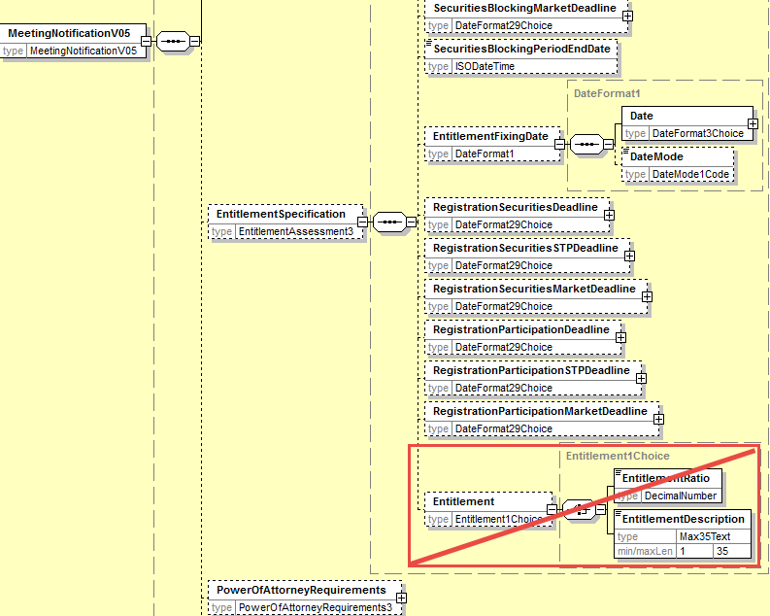
- Proposed timing:
The submitting organization confirms that it can implement the requested changes in the requested timing

Timing | - As requested

- Final decision of the SEG(s):

Approve
Comments:

Reject
Reason for rejection:

CR6: Remove all STP Deadlines
- Origin of the request:
A.1 Submitter: SWIFT, SMPG
A.2 Contact person:
Christine Strandberg – christine.strandberg@seb.se – phone: +46 8 763 6074
Mari Fumagalli – mariangela.fumagalli@bnpparibas.com – phone: +44 207 595 4988
Jacques Littré – jacques.littre@swift.com – phone: +32 2 655 43 35
A.3 Sponsors: N/A

- Related messages:
List of ISO 20022 Proxy Voting messages which would be impacted by the change:
seev.001.001.05 MeetingNotificationV05

- Description of the change request:
Remove the following STP deadline elements from the meeting notification message:
- AttendanceConfirmationSTPDeadline,
- STPDeadline (in ProxyChoice)
- VoteSTPDeadline,
- RevocabilitySTPDeadline,
- VoteWithPremiumSTPDeadline,
- SecuritiesBlockingSTPDeadline,
- RegistrationSecuritiesSTPDeadline,
- RegistrationParticipationSTPDeadline
And remove the two following deadlines because there are redundant with the SecuritiesBlockingPeriodEndDate:
- SecuritiesBlockingDeadline,
- SecuritiesBlockingMarketDeadline,

- Purpose of the change:
It is confusing and potentially misleading to make a difference between STP deadlines and non-STP deadlines in the message. To avoid confusion, we recommend to remove the STP deadlines that are redundant with the non-STP deadlines.
- Urgency of the request:
This maintenance change request for the proxy-voting messages follows the ISO 20022 fast track maintenance process so as to publish a new version of those messages around end of Q3 2019.
- Business examples:
NA
- SEG recommendation:
This section is not to be taken care of by the submitter of the change request. It will be completed in due time by the SEG(s) in charge of the related ISO 20022 messages.

Consider |  |  | Timing
 |  |  | - Next yearly cycle: 2019/2020  (the change will be considered for implementation in the yearly maintenance cycle which starts in 2019 and completes with the publication of new message versions in the spring of 2020) |  |  | Priority:  high  medium  low
- At the occasion of the next maintenance of the messages
(the change will be considered for implementation, but does not justify maintenance of the messages in its own right – will be pending until more critical change requests are received for the messages)
 |  |  | - Urgent unscheduled  (the change justifies an urgent implementation outside of the normal yearly cycle) |  | X
 |  |  | - Other timing:
Comments:

Reject
Reason for rejection:

- Impact analysis:
This change request impacts the following messages:
seev.001.001.05 MeetingNotificationV05
- Proposed implementation:
In the seev.001 (MENO – MeetingNotification) message, remove the following elements with STP deadlines:
- AttendanceConfirmationSTPDeadline - in Meeting sequence
- STPDeadline - in Meeting/ProxyChoice/Proxy sequence
- VoteSTPDeadline - in Vote sequence
- RevocabilitySTPDeadline - in Vote sequence
- VoteWithPremiumSTPDeadline - in Vote sequence
- SecuritiesBlockingSTPDeadline - in EntitlementSpecification sequence
- RegistrationSecuritiesSTPDeadline - in EntitlementSpecification sequence
- RegistrationParticipationSTPDeadline - in EntitlementSpecification sequence
- SecuritiesBlockingDeadline – in EntitlementSpecification sequence
- SecuritiesBlockingMarketDeadline - in EntitlementSpecification sequence

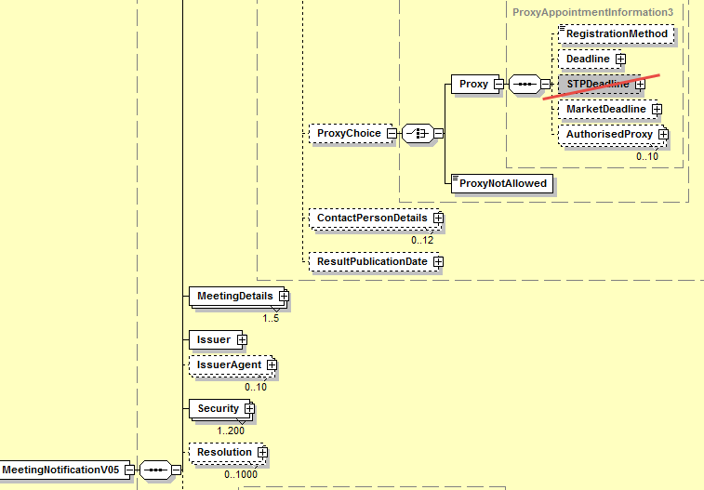
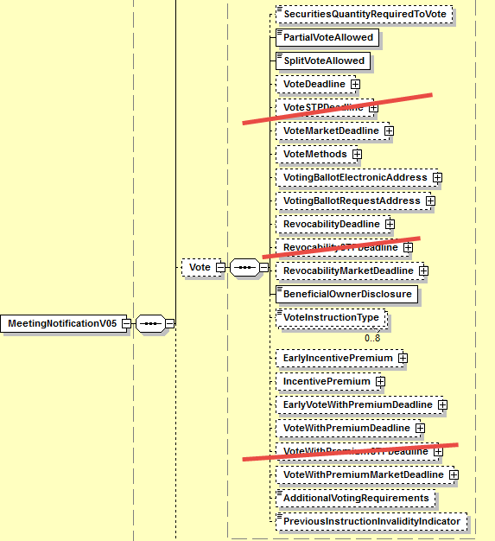

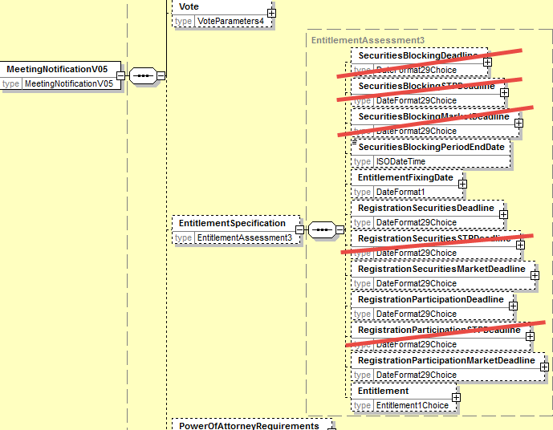

- Proposed timing:
The submitting organization confirms that it can implement the requested changes in the requested timing

Timing | - As requested

- Final decision of the SEG(s):

Approve
Comments:

Reject
Reason for rejection:

CR7: Move All Elements from EntitlementSpecification sequence to the Meeting sequence
- Origin of the request:
A.1 Submitter: SWIFT, SMPG
A.2 Contact person:
Christine Strandberg – christine.strandberg@seb.se – phone: +46 8 763 6074
Mari Fumagalli – mariangela.fumagalli@bnpparibas.com – phone: +44 207 595 4988
Jacques Littré – jacques.littre@swift.com – phone: +32 2 655 43 35
A.3 Sponsors: N/A

- Related messages:
List of ISO 20022 Proxy Voting messages which would be impacted by the change:
seev.001.001.05 MeetingNotificationV05

- Description of the change request:
In the EntitlementSpecification sequence, move all elements to the Meeting sequence and delete EntitlementSpecification.

- Purpose of the change:
If the “Entitlement” element of the EntitlementSpecification sequence is removed (via one of the preceding change request), most of the remaining elements in the EntitlementSpecification sequence are more related to general meeting information than to Entitlement. Therefore it would make more sense to regroup all detailed meeting information at the same place in the same sequence and remove that sequence.

- Urgency of the request:
This maintenance change request for the proxy-voting messages follows the ISO 20022 fast track maintenance process so as to publish a new version of those messages around end of Q3 2019.
- Business examples:
NA
- SEG recommendation:
This section is not to be taken care of by the submitter of the change request. It will be completed in due time by the SEG(s) in charge of the related ISO 20022 messages.

Consider |  |  | Timing
 |  |  | - Next yearly cycle: 2019/2020  (the change will be considered for implementation in the yearly maintenance cycle which starts in 2019 and completes with the publication of new message versions in the spring of 2020) |  |  | Priority:  high  medium  low
- At the occasion of the next maintenance of the messages
(the change will be considered for implementation, but does not justify maintenance of the messages in its own right – will be pending until more critical change requests are received for the messages)
 |  |  | - Urgent unscheduled  (the change justifies an urgent implementation outside of the normal yearly cycle) |  | X
 |  |  | - Other timing:
Comments:

Reject
Reason for rejection:
- Impact analysis:
This change request impacts the following messages:
seev.001.001.05 MeetingNotificationV05
- Proposed implementation:
In the seev.001 (MENO – MeetingNotification) message, in the EntitlementSpecification sequence, move all elements to the Meeting sequence and remove the EntitlementSpecification sequence itself as illustrated below:

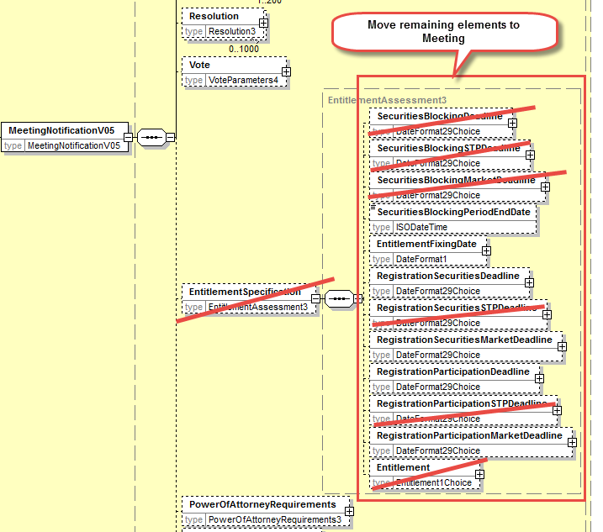

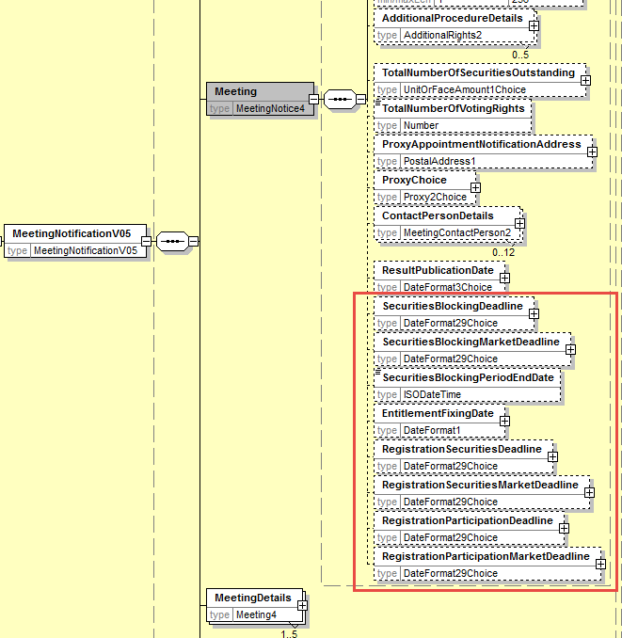
- Proposed timing:
The submitting organization confirms that it can implement the requested changes in the requested timing

Timing | - As requested

- Final decision of the SEG(s):

Approve
Comments:

Reject
Reason for rejection:

CR8: PromoteCourt Meeting from Meeting Classification Type to Meeting Type
- Origin of the request:
A.1 Submitter: SWIFT, SMPG
A.2 Contact person:
Christine Strandberg – christine.strandberg@seb.se – phone: +46 8 763 6074
Mari Fumagalli – mariangela.fumagalli@bnpparibas.com – phone: +44 207 595 4988
Jacques Littré – jacques.littre@swift.com – phone: +32 2 655 43 35
A.3 Sponsors: N/A
- Related messages:
List of ISO 20022 Proxy Voting messages which would be impacted by the change:
seev.001.001.05 MeetingNotificationV05
seev.002.001.05 MeetingCancellationV05
seev.003.001.05 MeetingEntitlementNotificationV05
seev.004.001.05 MeetingInstructionV05
seev.005.001.05 MeetingInstructionCancellationRequestV05
seev.006.001.05 MeetingInstructionStatusV05
seev.007.001.05 MeetingVoteExecutionConfirmationV05
seev.008.001.05 MeetingResultDisseminationV05

- Description of the change request:
Move the “Court Meeting” (CORT) code value from the meeting “Classification” type code to the meeting Type code.
- Purpose of the change:
The Court meeting must be considered as one of the main types of shareholder meeting and not as a classification type of another meeting type.
- Urgency of the request:
This maintenance change request for the proxy-voting messages follows the ISO 20022 fast track maintenance process so as to publish a new version of those messages around end of Q3 2019.
- Business examples:
NA
- SEG recommendation:
This section is not to be taken care of by the submitter of the change request. It will be completed in due time by the SEG(s) in charge of the related ISO 20022 messages.

Consider |  |  | Timing
 |  |  | - Next yearly cycle: 2019/2020  (the change will be considered for implementation in the yearly maintenance cycle which starts in 2019 and completes with the publication of new message versions in the spring of 2020) |  |  | Priority:  high  medium  low
- At the occasion of the next maintenance of the messages
(the change will be considered for implementation, but does not justify maintenance of the messages in its own right – will be pending until more critical change requests are received for the messages)
 |  |  | - Urgent unscheduled  (the change justifies an urgent implementation outside of the normal yearly cycle) |  | X
 |  |  | - Other timing:
Comments:

Reject
Reason for rejection:

- Impact analysis:
This change request impacts the following messages:
seev.001.001.05 MeetingNotificationV05
seev.002.001.05 MeetingCancellationV05
seev.003.001.05 MeetingEntitlementNotificationV05
seev.004.001.05 MeetingInstructionV05
seev.005.001.05 MeetingInstructionCancellationRequestV05
seev.006.001.05 MeetingInstructionStatusV05
seev.007.001.05 MeetingVoteExecutionConfirmationV05
seev.008.001.05 MeetingResultDisseminationV05
- Proposed implementation:
In the seev.001 (MENO – MeetingNotification) message, in the data type MeetingType3Code of the Meeting/Type/code element and of the MeetingReference/Type element in all other seev.002 to seev.008 messages, add the code value “Court Meeting” (CORT) and delete the same “Court Meeting” (CORT) code value from the MeetingTypeClassification1Code data type of the element Code in the MeetingReference/Classification sequence as illustrated below:

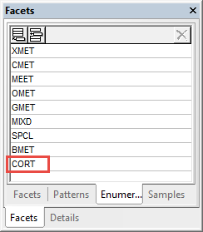

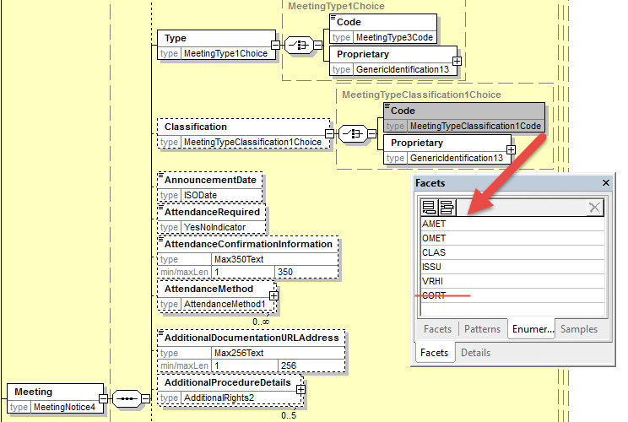

- Proposed timing:
The submitting organization confirms that it can implement the requested changes in the requested timing

Timing | - As requested

- Final decision of the SEG(s):

Approve
Comments:

Reject
Reason for rejection:

CR9: Remove Vote InstructionType in Vote Sequence
- Origin of the request:
A.1 Submitter: SWIFT, SMPG
A.2 Contact person:
Christine Strandberg – christine.strandberg@seb.se – phone: +46 8 763 6074
Mari Fumagalli – mariangela.fumagalli@bnpparibas.com – phone: +44 207 595 4988
Jacques Littré – jacques.littre@swift.com – phone: +32 2 655 43 35
A.3 Sponsors: N/A
- Related messages:
List of ISO 20022 Proxy Voting messages which would be impacted by the change:
seev.001.001.05 MeetingNotificationV05
- Description of the change request:
Remove the element optional and repeatable VoteInstructionType in the sequence Vote.
- Purpose of the change:
Fully redundant with VoteInstructionType in the sequence Resolution.
- Urgency of the request:
This maintenance change request for the proxy-voting messages follows the ISO 20022 fast track maintenance process so as to publish a new version of those messages around end of Q3 2019.
- Business examples:
NA
- SEG recommendation:
This section is not to be taken care of by the submitter of the change request. It will be completed in due time by the SEG(s) in charge of the related ISO 20022 messages.

Consider |  |  | Timing
 |  |  | - Next yearly cycle: 2019/2020  (the change will be considered for implementation in the yearly maintenance cycle which starts in 2019 and completes with the publication of new message versions in the spring of 2020) |  |  | Priority:  high  medium  low
- At the occasion of the next maintenance of the messages
(the change will be considered for implementation, but does not justify maintenance of the messages in its own right – will be pending until more critical change requests are received for the messages)
 |  |  | - Urgent unscheduled  (the change justifies an urgent implementation outside of the normal yearly cycle) |  | X
 |  |  | - Other timing:
Comments:

Reject
Reason for rejection:

- Impact analysis:
This change request impacts the following messages:
seev.001.001.05 MeetingNotificationV05
- Proposed implementation:
In the seev.001 (MENO – MeetingNotification) message, delete the optional and non-repeatable Vote/VoteInstructionType element as illustrated below:
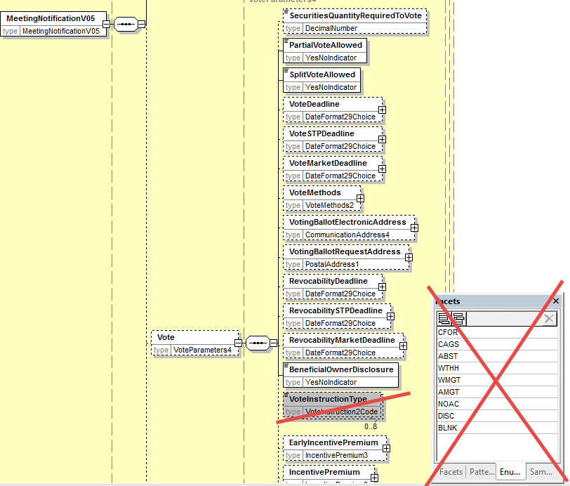
- Proposed timing:
The submitting organization confirms that it can implement the requested changes in the requested timing.

Timing | - As requested

- Final decision of the SEG(s):

Approve
Comments:

Reject
Reason for rejection:

CR10: Align Amendments with Meeting Notification Type and Status with the CA Notification Design
- Origin of the request:
A.1 Submitter: SWIFT, SMPG
A.2 Contact person:
Christine Strandberg – christine.strandberg@seb.se – phone: +46 8 763 6074
Mari Fumagalli – mariangela.fumagalli@bnpparibas.com – phone: +44 207 595 4988
Jacques Littré – jacques.littre@swift.com – phone: +32 2 655 43 35
A.3 Sponsors: N/A
- Related messages:
List of ISO 20022 Proxy Voting messages which would be impacted by the change:
seev.001.001.05 MeetingNotificationV05

- Description of the change request:
Add a new mandatory and non-repeatable sequence NotificationGeneralInformation” and add a new mandatory element “NotificationType” with codes New, Reminder and Replacement.
Move the element NotificationStatus from the root of the message to the new NotificationGeneralInformation sequence and add a status on the completeness (complete/incomplete) of the notification in addition to the Confirmation status similarly to what exist already in the seev.031 CA Notification message.
Rename “Amendment” as NotificationUpdate.
- Purpose of the change:
Align the proxy voting meeting notification with the CA notifications for notification types (New and Replacement).
- Urgency of the request:
This maintenance change request for the proxy-voting messages follows the ISO 20022 fast track maintenance process so as to publish a new version of those messages around end of Q3 2019.
- Business examples:
NA
- SEG recommendation:
This section is not to be taken care of by the submitter of the change request. It will be completed in due time by the SEG(s) in charge of the related ISO 20022 messages.

Consider |  |  | Timing
 |  |  | - Next yearly cycle: 2019/2020  (the change will be considered for implementation in the yearly maintenance cycle which starts in 2019 and completes with the publication of new message versions in the spring of 2020) |  |  | Priority:  high  medium  low
- At the occasion of the next maintenance of the messages
(the change will be considered for implementation, but does not justify maintenance of the messages in its own right – will be pending until more critical change requests are received for the messages)
 |  |  | - Urgent unscheduled  (the change justifies an urgent implementation outside of the normal yearly cycle) |  | X
 |  |  | - Other timing:
Comments:

Reject
Reason for rejection:

- Impact analysis:
This change request impacts the following messages:
seev.001.001.05 MeetingNotificationV05
- Proposed implementation:
In the seev.001 (MENO – MeetingNotification) message, add a new mandatory and non-repeatable sequence NotificationGeneralInformation” and add a new mandatory element “NotificationType” with codes New, Reminder and Replacement.
Move the element NotificationStatus from the root of the message to the new NotificationGeneralInformation sequence.
In the NotificationStatus sequence add a new EventStatus1 component with the new mandatory and non-repeatable element EventConfirmationStatus typed by EventConfirmationStatus1Code with code values Confirmed (CONF) and Unconfirmed (UCON) - so that code values are identical to those defined in the CA Notification seev.031 message - and the new mandatory and non-repeatable element EventCompletenessStatus typed by EventCompletenessStatus1Code with code values Complete (COMP) and Incomplete (INCO).
Rename “Amendment” sequence as NotificationUpdate and rename its element PreviousReference as PreviousNotificationIdentification as illustrated below.
Add also a new cross element rule at the root of the message in order to condition the presence of the element NotificationUpdate/PrevioustNotificationIdentification when NotificationGeneralInformation/NotificationType value is REPL (Replacement).

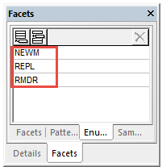
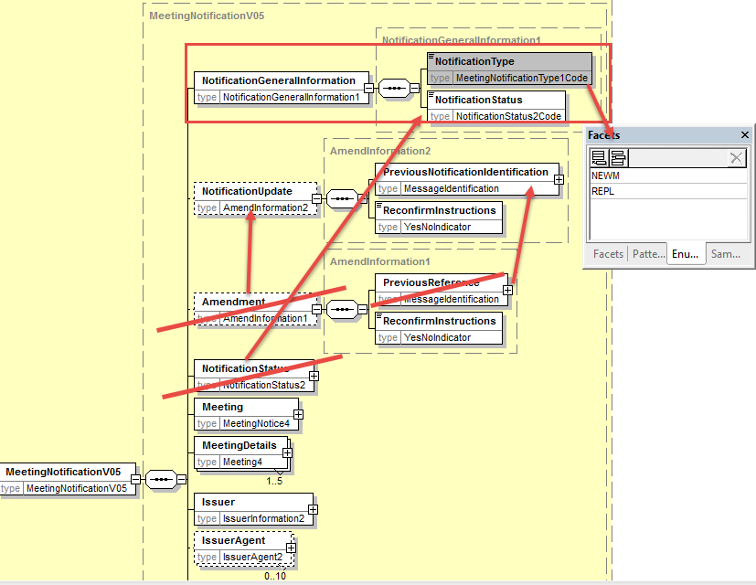
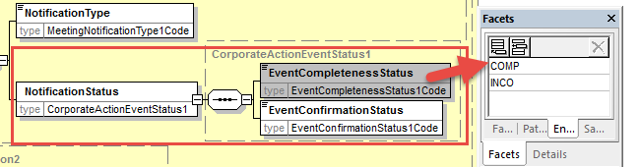
- Proposed timing:
The submitting organization confirms that it can implement the requested changes in the requested timing
Timing | - As requested

- Final decision of the SEG(s):
Approve
Comments:

Reject
Reason for rejection:

CR11: Align Meeting Linkages with CA Notification Linkages
- Origin of the request:
A.1 Submitter: SWIFT, SMPG
A.2 Contact person:
Christine Strandberg – christine.strandberg@seb.se – phone: +46 8 763 6074
Mari Fumagalli – mariangela.fumagalli@bnpparibas.com – phone: +44 207 595 4988
Jacques Littré – jacques.littre@swift.com – phone: +32 2 655 43 35
A.3 Sponsors: N/A

- Related messages:
List of ISO 20022 Proxy Voting messages which would be impacted by the change:
seev.001.001.05 MeetingNotificationV05

- Description of the change request:
Add a new linkages sequence in the meeting notification - similarly to what is done in the corporate action notification message (seev.031) - with an identification of linked meeting identification or a linked Issuer meeting identification.
- Purpose of the change:
Align the proxy voting meeting notification with the CA notifications for linkages as there are no Linkages capabilities in the current message.
- Urgency of the request:
This maintenance change request for the proxy-voting messages follows the ISO 20022 fast track maintenance process so as to publish a new version of those messages around end of Q3 2019.
- Business examples:
NA
- SEG recommendation:
This section is not to be taken care of by the submitter of the change request. It will be completed in due time by the SEG(s) in charge of the related ISO 20022 messages.

Consider |  |  | Timing
 |  |  | - Next yearly cycle: 2019/2020  (the change will be considered for implementation in the yearly maintenance cycle which starts in 2019 and completes with the publication of new message versions in the spring of 2020) |  |  | Priority:  high  medium  low
- At the occasion of the next maintenance of the messages
(the change will be considered for implementation, but does not justify maintenance of the messages in its own right – will be pending until more critical change requests are received for the messages)
 |  |  | - Urgent unscheduled  (the change justifies an urgent implementation outside of the normal yearly cycle) |  | X
 |  |  | - Other timing:
Comments:

Reject
Reason for rejection:

- Impact analysis:
This change request impacts the following messages:
seev.001.001.05 MeetingNotificationV05
- Proposed implementation:
In the seev.001 (MENO – MeetingNotification) message, add a new optional and repeatable sequence EventsLinkages with a mandatory and non-repeatable element EventIdentification typed by a Choice component with the elements LinkedIssuerMeetingIdentification and LinkedMeetingIdentification both typed by Max35Text.
The EventsLinkages sequence contain also an optional and non-repeatable element LinkageType typed by the code ProcessingPosition3Codes with the four values, After, Before, With and Information.
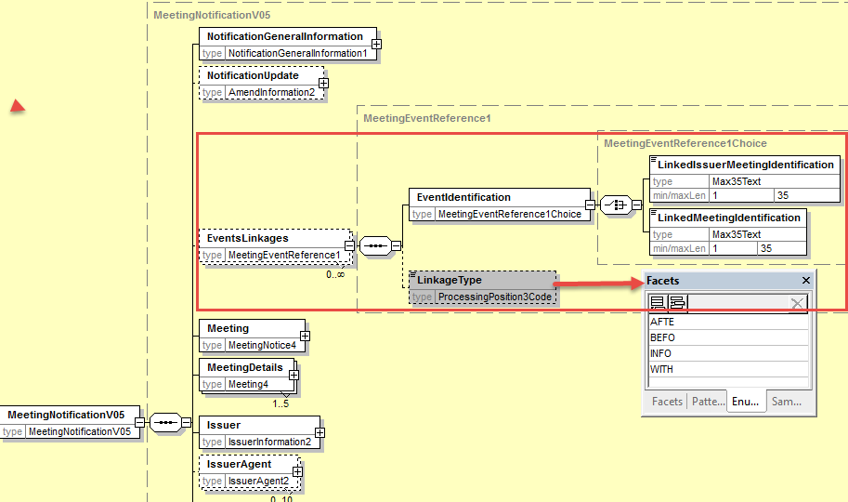

- Proposed timing:
The submitting organization confirms that it can implement the requested changes in the requested timing

Timing | - As requested

- Final decision of the SEG(s):

Approve
Comments:

Reject
Reason for rejection:

CR12: Add new elements required by the SRD2 Directive in the Meeting Entitlement Notification
- Origin of the request:
A.1 Submitter: SWIFT, SMPG
A.2 Contact person:
Christine Strandberg – christine.strandberg@seb.se – phone: +46 8 763 6074
Mari Fumagalli – mariangela.fumagalli@bnpparibas.com – phone: +44 207 595 4988
Jacques Littré – jacques.littre@swift.com – phone: +32 2 655 43 35
A.3 Sponsors: N/A

- Related messages:
List of ISO 20022 Proxy Voting messages which would be impacted by the change:
seev.003.001.05 MeetingEntitlementNotificationV05
- Description of the change request:
- Add the new mandatory and non-repeatable element “Issuer” in the message (same as the one in meeting notification) right before the “Security” element.
(IR table 4.A item 2 in implementation regulation)
- Add a new mandatory element “NotificationType” with codes New and Replacement at the root of the message before RelatedReference and rename RelatedReference as “PreviousEntitlementNotificationIdentification”.
(IR table 4.A item 4 in implementation regulation)
- Add new mandatory non-repeatable element “AccountHolder” after the Eligibility element with identification and name of either a legal or a natural person (as defined in the ShareholderIdentificationDisclosureResponse message.
(IR table 4.C item 1 and 2 in implementation regulation)
- Adapt the data type of the RightsHolder Identification element to the Identification specifications required in the IR Table 4.C.
(IR table 4.C item 1 and 2 in implementation regulation)
- Add new optional and non-repeatable elements “MeetingAttendee” and “Proxy” after the Eligibility element with identification and name of either a legal or a natural person (as defined in the ShareholderIdentificationDisclosureResponse message.
(IR table 4.C item 3 and 4 in implementation regulation)

- Purpose of the change:
This change is required by the European Commission Shareholders Rights Directive implementing regulation (EU) 2018/1212 of 3 September 2018 (see regulation table references in the description above).
- Urgency of the request:
This maintenance change request for the proxy-voting messages follows the ISO 20022 fast track maintenance process so as to publish a new version of those messages around end of Q3 2019.
- Business examples:

- SEG recommendation:
This section is not to be taken care of by the submitter of the change request. It will be completed in due time by the SEG(s) in charge of the related ISO 20022 messages.

Consider |  |  | Timing
 |  |  | - Next yearly cycle: 2019/2020  (the change will be considered for implementation in the yearly maintenance cycle which starts in 2019 and completes with the publication of new message versions in the spring of 2020) |  |  | Priority:  high  medium  low
- At the occasion of the next maintenance of the messages
(the change will be considered for implementation, but does not justify maintenance of the messages in its own right – will be pending until more critical change requests are received for the messages)
 |  |  | - Urgent unscheduled  (the change justifies an urgent implementation outside of the normal yearly cycle) |  | X
 |  |  | - Other timing:
Comments:

Reject
Reason for rejection:

- Impact analysis:
This change request impacts the following messages:
seev.003.001.05 MeetingEntitlementNotificationV05

- Proposed implementation:

- Add Issuer Identification
In the seev.003 (MENT – MeetingEntitlementNotification) message, add a new mandatory and non-repeatable element IssuerIdentification typed by the same PartyIdentificationChoice component used in the MeetingNotification message as illustrated below:
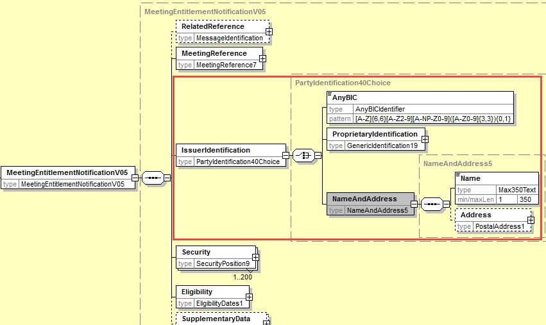

- Add Notification Type
In the seev.003 (MENT – MeetingEntitlementNotification) message, add at the root of the message as a first element, a new mandatory and non-repeatable element NotificationType typed by the code list MeetingNotificationType1Code used in the MeetingNotification message and rename also the RelatedReference element as PreviousEntitlementNotificationIdentification as illustrated below:
Add also a new cross element rule at the root of the message in order to condition the presence of the element PreviousEntitlementNotificationIdentification when NotificationType value is REPL (Replacement).
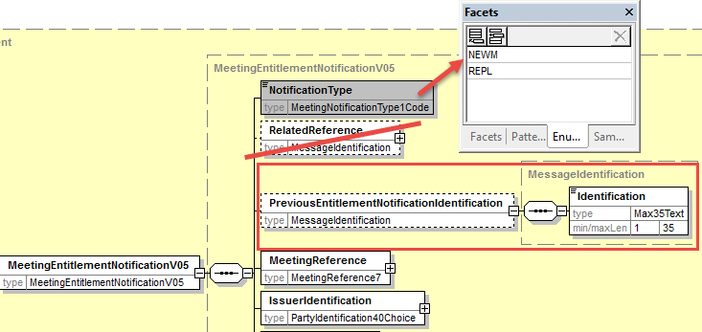

- Add Account Holder Identification
In the seev.003 (MENT – MeetingEntitlementNotification) message, add at the root of the message after the Eligibility element a new mandatory and non-repeatable element AccountHolder typed with the PartyIdentification for a Legal and a natural person as defined in the ShareholderIdentificationDisclosureResponse message and as illustrated below:

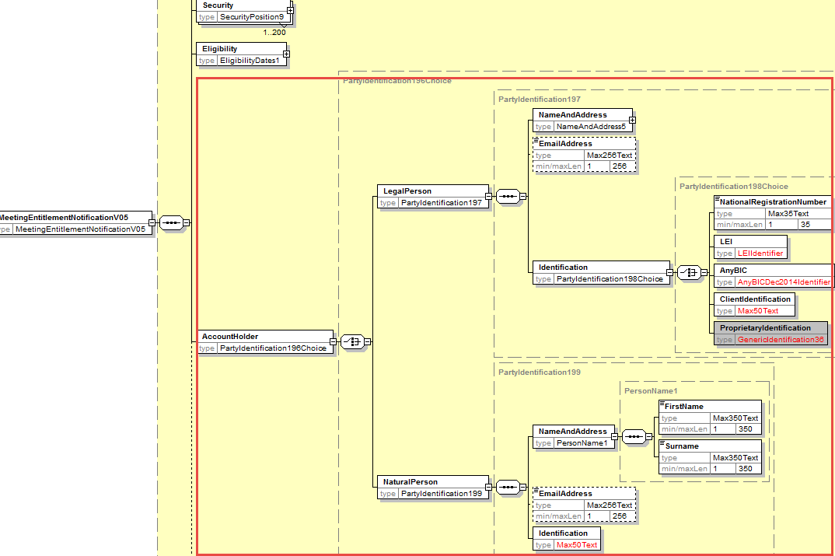

- Adapt RightsHolder Identification
Change the current Data type PartyIdentification40Choice of the element Security/Position/RightHolder/Identification by the same Data type PartyIdentification196Choice used to identify the AccountHolder and Proxy.
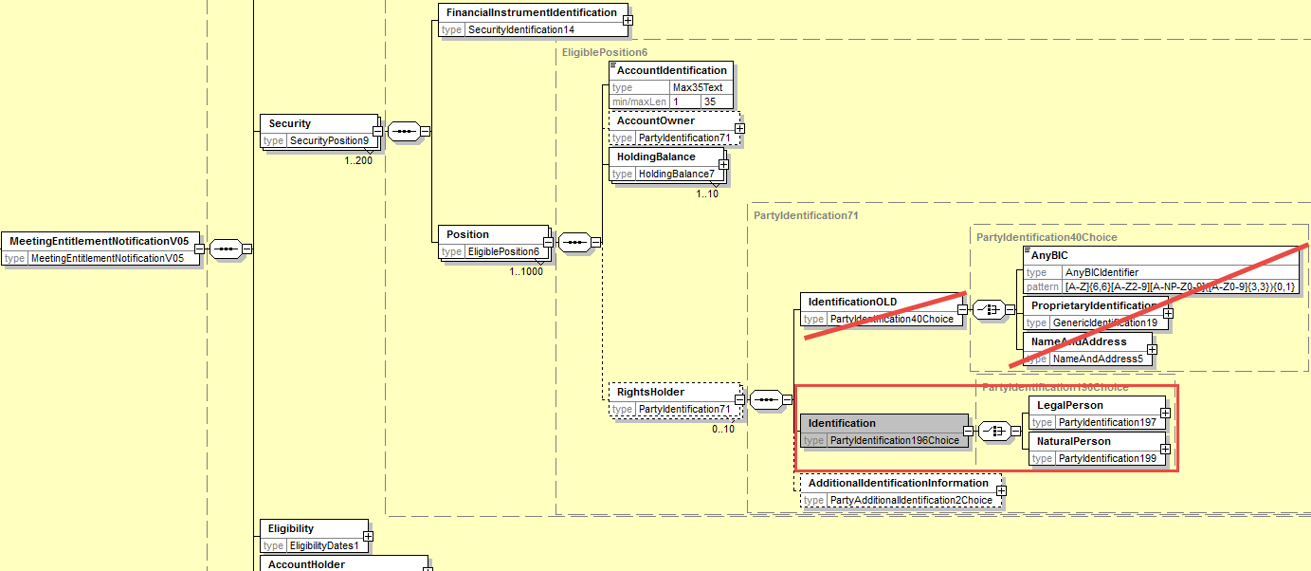

- Add Proxy and MeetingAttendee Identification
In the seev.003 (MENT – MeetingEntitlementNotification) message, add at the root of the message after the Eligibility element the new optional and non-repeatable elements MeetingAttendee and Proxy typed with the PartyIdentification for a Legal and a natural person as defined in the ShareholderIdentificationDisclosureResponse message and as illustrated below:
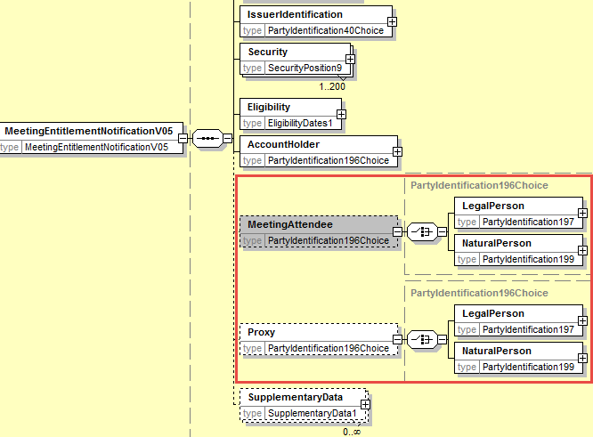

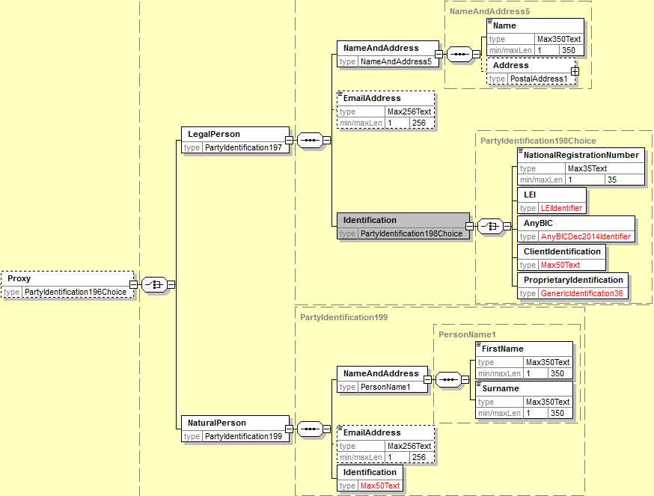

- Proposed timing:
The submitting organization confirms that it can implement the requested changes in the requested timing

Timing | - As requested

- Final decision of the SEG(s):

Approve
Comments:

Reject
Reason for rejection:

CR13: Change Elements as Mandatory in Meeting EntitlementNotification
- Origin of the request:
A.1 Submitter: SWIFT, SMPG
A.2 Contact person:
Christine Strandberg – christine.strandberg@seb.se – phone: +46 8 763 6074
Mari Fumagalli – mariangela.fumagalli@bnpparibas.com – phone: +44 207 595 4988
Jacques Littré – jacques.littre@swift.com – phone: +32 2 655 43 35
A.3 Sponsors: N/A

- Related messages:
List of ISO 20022 Proxy Voting messages which would be impacted by the change:
seev.003.001.05 MeetingEntitlementNotificationV05

- Description of the change request:
The following path and element in the message must be made mandatory:
- Security / Position / HoldingBalance / Balance
- Security / Position / AccountIdentification
- Security / Position / HoldingBalance / BalanceType ?
as those elements should always be present in the message.
Add a new textual rule on the “HoldingBalance” sequence to require the presence of the “Eligible” code in BalanceType in one occurrence if several occurrences are present.
- Purpose of the change:
Sending an entitlement message without a balance and identification of the account is not consistent.
- Urgency of the request:
This maintenance change request for the proxy-voting messages follows the ISO 20022 fast track maintenance process so as to publish a new version of those messages around end of Q3 2019.
- Business examples:

- SEG recommendation:
This section is not to be taken care of by the submitter of the change request. It will be completed in due time by the SEG(s) in charge of the related ISO 20022 messages.

Consider |  |  | Timing
 |  |  | - Next yearly cycle: 2019/2020  (the change will be considered for implementation in the yearly maintenance cycle which starts in 2019 and completes with the publication of new message versions in the spring of 2020) |  |  | Priority:  high  medium  low
- At the occasion of the next maintenance of the messages
(the change will be considered for implementation, but does not justify maintenance of the messages in its own right – will be pending until more critical change requests are received for the messages)
 |  |  | - Urgent unscheduled  (the change justifies an urgent implementation outside of the normal yearly cycle) |  | X
 |  |  | - Other timing:
Comments:

Reject
Reason for rejection:
- Impact analysis:
This change request impacts the following messages:
seev.003.001.05 MeetingEntitlementNotificationV05
- Proposed implementation:
In the seev.003 (MENT – MeetingEntitlementNotification) message, set the following eleemnts and paths as mandatory as illustrated below:
- Security / Position / HoldingBalance / Balance
- Security / Position / AccountIdentification
- Security / Position / HoldingBalance / BalanceType (need To be confirmed to have it mandatory)
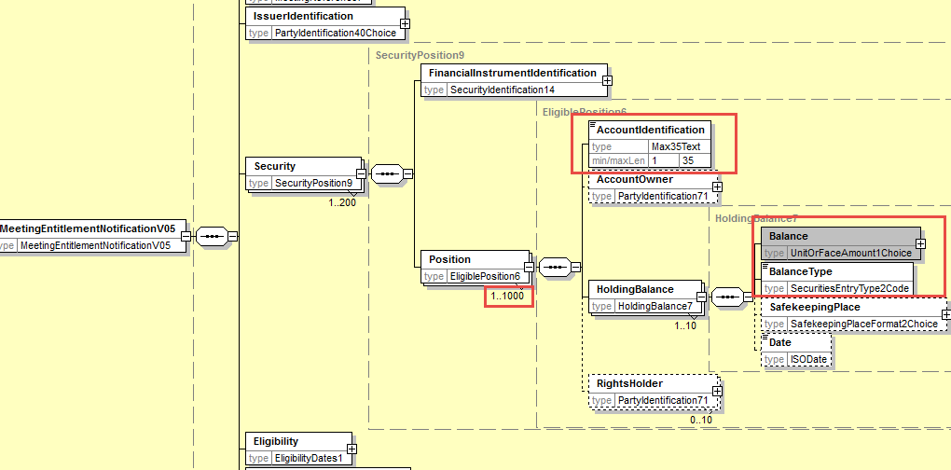
In the Security/Position/HoldingBalance sequence, add the following HoldingBalanceType() textual rule:
In all occurrences of HoldingBalance, one and only one BalanceType element must have a balance type code value equal to ELIG (Eligible).

- Proposed timing:
The submitting organization confirms that it can implement the requested changes in the requested timing

Timing | - As requested

- Final decision of the SEG(s):

Approve
Comments:

Reject
Reason for rejection:

CR14: Add new elements required by the SRD2 Directive in the Meeting Instruction
- Origin of the request:
A.1 Submitter: SWIFT, SMPG
A.2 Contact person:
Christine Strandberg – christine.strandberg@seb.se – phone: +46 8 763 6074
Mari Fumagalli – mariangela.fumagalli@bnpparibas.com – phone: +44 207 595 4988
Jacques Littré – jacques.littre@swift.com – phone: +32 2 655 43 35
A.3 Sponsors: N/A

- Related messages:
List of ISO 20022 Proxy Voting messages which would be impacted by the change:
seev.004.001.05 MeetingInstructionV05
- Description of the change request:
- In the Instruction/SpecificInstructionRequest sequence, replace the ParticipantRegistration indicator element by the new optional and repeatable AttendanceMethod with the code values: Virtual participation, in person, through Proxy, by correspondence, participation in person but not voting (same as the one defined in the meeting notification message).
Add a rule so that the Instruction/Proxy and Instruction/MeetingAttendee are only used if the Instruction/SpecificInstructionRequest/AttendanceMethod specifies Proxy or InPerson.
(IR table 5.B items 1 in implementation regulation)
- In element Instruction/MeetingAttendee, align the identification of the meeting attendee with the AccountHolder Legal or Natural person names and identifications defined in the ShareholderIdentificationDisclosureResponse message.
(IR table 5.B items 2, 3(a) and 3(b) in implementation regulation)
- In element Instruction/Proxy/PersonDetails align the name and identification of the Proxy with the AccountHolder Legal or Natural person names and identifications defined in the ShareholderIdentificationDisclosureResponse message.
(IR table 5.B items 2, 3(a) and 3(b), 4 and 5 in implementation regulation)
- In the Instruction/VoteDetails/ VoteInstructionForAgendaResolution and VoteInstructionForMeetingResolution sequences, , add a new vote instruction element “BLNK (Blank)” (vote is cast as “empty” but the vote is counted) and a new element Proprietary so as to be able to provide the number of votes for the proprietary vote code defined and amend the definition of the “NoAction” element.
(IR table 3.E item 5 in implementation regulation)

- Purpose of the change:
This change is required by the European Commission Shareholders Rights Directive implementing regulation (EU) 2018/1212 of 3 September 2018 (see regulation table references in the description above).
- Urgency of the request:
This maintenance change request for the proxy-voting messages follows the ISO 20022 fast track maintenance process so as to publish a new version of those messages around end of Q3 2019.
- Business examples:
NA
- SEG recommendation:
This section is not to be taken care of by the submitter of the change request. It will be completed in due time by the SEG(s) in charge of the related ISO 20022 messages.

Consider |  |  | Timing
 |  |  | - Next yearly cycle: 2019/2020  (the change will be considered for implementation in the yearly maintenance cycle which starts in 2019 and completes with the publication of new message versions in the spring of 2020) |  |  | Priority:  high  medium  low
- At the occasion of the next maintenance of the messages
(the change will be considered for implementation, but does not justify maintenance of the messages in its own right – will be pending until more critical change requests are received for the messages)
 |  |  | - Urgent unscheduled  (the change justifies an urgent implementation outside of the normal yearly cycle) |  | X
 |  |  | - Other timing:
Comments:

Reject
Reason for rejection:

- Impact analysis:
This change request impacts the following messages:
seev.004.001.05 MeetingInstructionV05
- Proposed implementation:
- Add AttendanceMethod in the Instruction
In the seev.004 (MEIN – MeetingInstruction) message, rename the element Instruction/SpecificInstructionRequest/ParticipationRegistration as AttendanceMethod and make the element repeatable and change the current data type “YesNoIndicator” by the code list AttendanceMethod1Choice as with a code element with 5 code values as follows (Virtual participation, in person, through Proxy, by correspondence, participation in person but not voting) and a proprietary code as illustrated below:
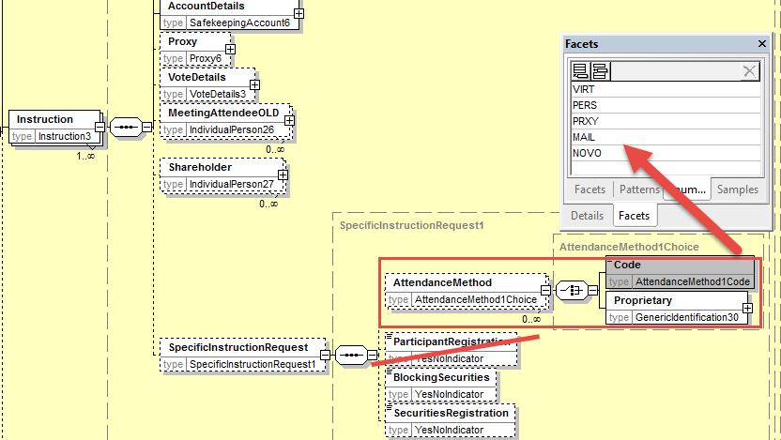

- Align MeetingAttendee Identification with the ShareholderIdentificationDisclosureResponse message
In the seev.004 (MEIN – MeetingInstruction) message, in the sequence Instruction/MeetingAttendee, replace the elements Birthname, GivenName, Identification and Address by the mandatory element Identification typed with the PartyIdentificationChoice component used in the ShareholderIdentificationDisclosureResponse message for AccountHolder to identify a legal and natural person as illustrated below:
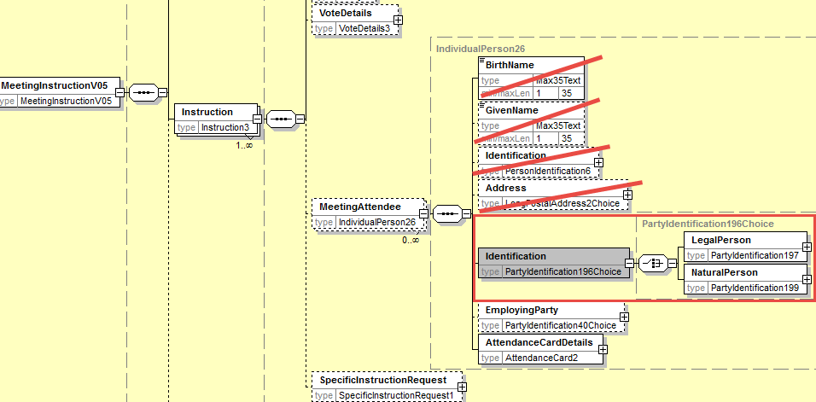
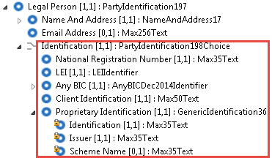
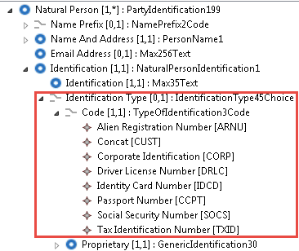

- Align Proxy Identification with the ShareholderIdentificationDisclosureResponse message
In the seev.004 (MEIN – MeetingInstruction) message, in the sequence Instruction/Proxy, replace the elements Birthname, GivenName, Identification and Address by the mandatory element Identification typed with the PartyIdentificationChoice component used in the ShareholderIdentificationDisclosureResponse message for AccountHolder to identify a legal and natural person (however, with the Identification element of both the LegalPerson and NaturalPerson being optional) as illustrated below:
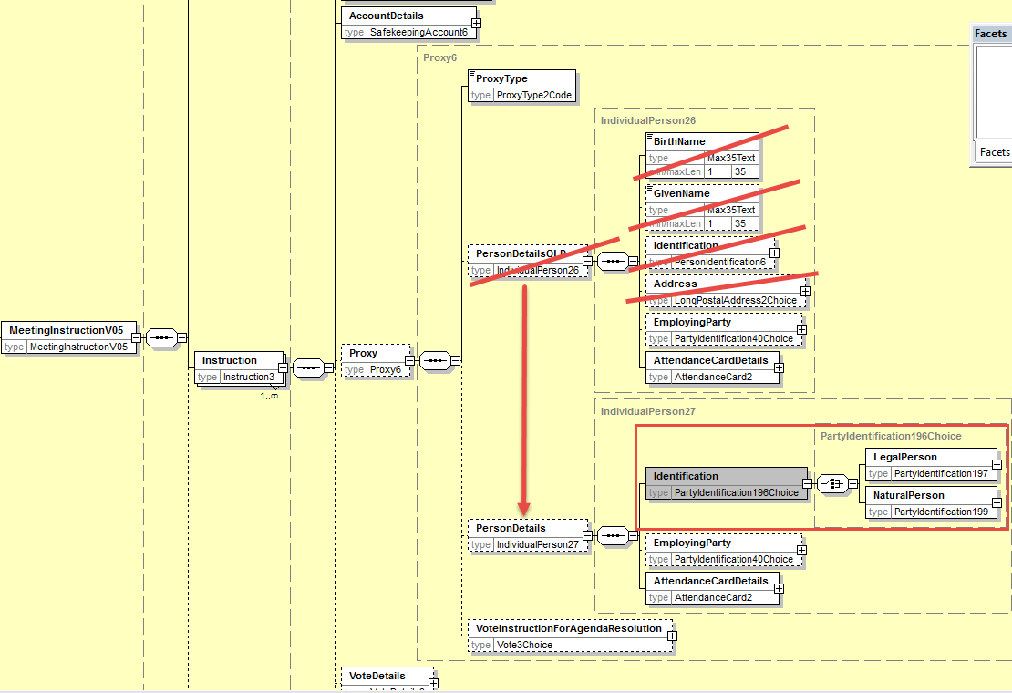

- Add rule on
Add a cross element rule in Instruction component so that the Instruction/Proxy and/or Instruction/MeetingAttendee are only present if the Instruction/SpecificInstructionRequest/AttendanceMethod specifies respectively Proxy and/or In Person.
- Add new Vote Instruction Blank in all sequence where VoteInstruction is present
In the seev.004 (MEIN – MeetingInstruction) message, in the Instruction/VoteDetails/VoteInstructionForAgendaResolution/VoteInstruction sequence, amend the definition of the “NoAction” element to read “Do not vote” and add the new optional and non-repeatable element “Blank” typed by “Number” data type and add a new optional and repeatable sequence “Proprietary” with a mandatory element VoteCode typed by Exact4AlphaNumericText and the mandatory element Number as illustrated below:
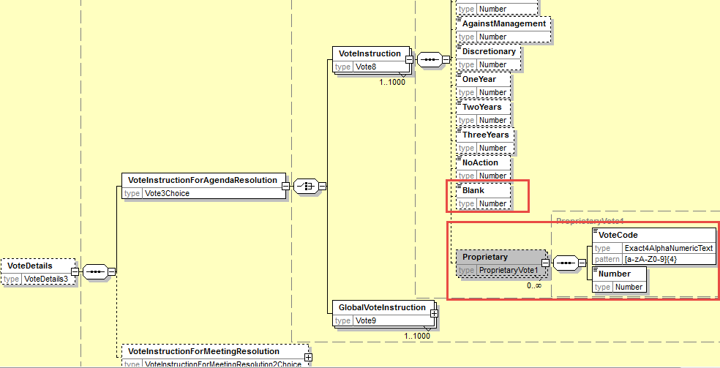

In the seev.004 (MEIN – MeetingInstruction) message, in the Instruction/VoteDetails/VoteInstructionForAgendaResolution/GlobalVoteInstruction, replace the data type of the VoteOption element by a choice component with a choice between the Vote with a code to which the “Blank” vote has been added and a proprietary code code as illustrated below:
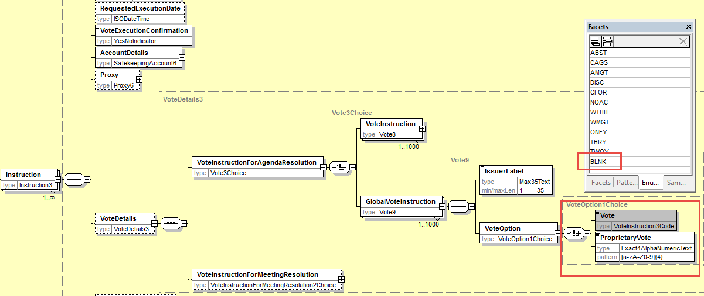

In the seev.004 (MEIN – MeetingInstruction) message, in the Instruction/VoteDetails/VoteInstructionForMeetingResolution sequence, replace the data type of the VoteIndication element by a choice component with a choice between the Vote with a code to which the “Blank” vote has been added and a proprietary code code as illustrated below:

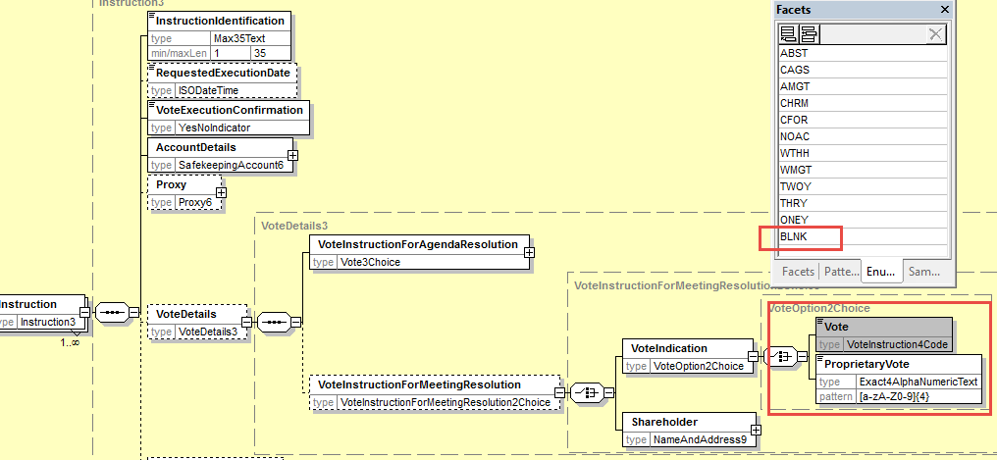

- Proposed timing:
The submitting organization confirms that it can implement the requested changes in the requested timing

Timing | - As requested

- Final decision of the SEG(s):

Approve
Comments:

Reject
Reason for rejection:

CR15: Align Vote Instruction Type Codes Between the Meeting Notification and Instruction
- Origin of the request:
A.1 Submitter: SWIFT, SMPG
A.2 Contact person:
Christine Strandberg – christine.strandberg@seb.se – phone: +46 8 763 6074
Mari Fumagalli – mariangela.fumagalli@bnpparibas.com – phone: +44 207 595 4988
Jacques Littré – jacques.littre@swift.com – phone: +32 2 655 43 35
A.3 Sponsors: N/A

- Related messages:
List of ISO 20022 Proxy Voting messages which would be impacted by the change:
seev.001.001.05 MeetingNotificationV05
seev.004.001.05 MeetingInstructionV05

- Description of the change request:
In the MeetingNotification and MeetingInstruction messages, replace the data type codes VoteInstruction2Code and VoteInstruction3Code and VoteInstruction4Code by a new code list consolidating all code values and change VoteInstruction1Code by a new code list similar to VoteInstruction4Code but without the WMGT, AMGT and DISC code values.
- Purpose of the change:
In 20022, there are 4 VoteInstructionCode lists that can be used to list the voting options in the 2 messages as follows (code differences are coloured in red):
- “VoteInstruction1Code” – CFOR, CAGS, ABST, WTHH, NOAC (used in seev.001 for the elements Resolution/ManagementRecommendation and ResolutionNotyfyingPartyRecommendation)
- “VoteInstruction2Code” – CFOR, CAGS, ABST, WTHH, WMGT, AMGT, NOAC, DISC (used in seev.001 for VoteInstructionType)
- “VoteInstruction3Code” – ABST, CAGS, AMGT, DISC, CFOR, NOAC, WTHH, WMGT, ONEY, THRY, TWOY (Used in seev.004 for Proxy/GlobalVoteInstruction)
- “VoteInstruction4Code” – ABST, CAGS, AMGT, CHRM, CFOR, NOAC, WTHH, WMGT, ONEY, THRY, TWOY (Used in seev.004 in VoteDetails/VoteForMeetingResolution)
We have not found a business justification to have a difference between the last 3 code lists therefore it is proposed to align/merge these last 3 codes on VoteInstruction4Code consolidating all voting types.
The code list VoteInstruction1Code should however contain all other code values except WMGT, AMGT and DISC used as management recommendations.
- Urgency of the request:
This maintenance change request for the proxy-voting messages follows the ISO 20022 fast track maintenance process so as to publish a new version of those messages around end of Q3 2019.
- Business examples:
N/A
- SEG recommendation:
This section is not to be taken care of by the submitter of the change request. It will be completed in due time by the SEG(s) in charge of the related ISO 20022 messages.

Consider |  |  | Timing
 |  |  | - Next yearly cycle: 2019/2020  (the change will be considered for implementation in the yearly maintenance cycle which starts in 2019 and completes with the publication of new message versions in the spring of 2020) |  |  | Priority:  high  medium  low
- At the occasion of the next maintenance of the messages
(the change will be considered for implementation, but does not justify maintenance of the messages in its own right – will be pending until more critical change requests are received for the messages)
 |  |  | - Urgent unscheduled  (the change justifies an urgent implementation outside of the normal yearly cycle) |  | X
 |  |  | - Other timing:
Comments:

Reject
Reason for rejection:

- Impact analysis:
This change request impacts the following messages:
seev.001.001.05 MeetingNotificationV05
seev.004.001.05 MeetingInstructionV05
- Proposed implementation:
In the seev.001 (MENO – MeetingNotification) message, in Resolution/ManagementRecommendation and ResolutionNotyfyingPartyRecommendation replace the VoteInstruction1Code data type by a new VoteInstruction5 Code containing the following code values CFOR, CAGS, ABST, WTHH, NOAC, CHRM, ONEY, TWOY, THRY and BLANK as illustrated below :

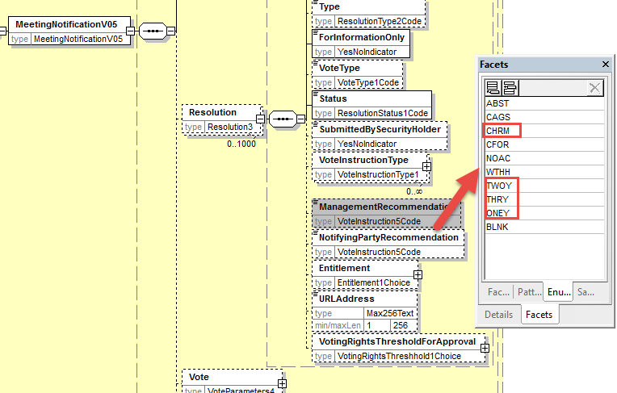

In the seev.001 (MENO – MeetingNotification) message, in Resolution/VoteInstructionType/VoteInstruction/Type, replace the VoteInstruction2Code data type by a new VoteInstruction6Code containing the following code values CFOR, CAGS, ABST, WTHH, NOAC, WMGT, AMGT , DISC, CHRM, ONEY, TWOY, THRY and BLANK as illustrated below :

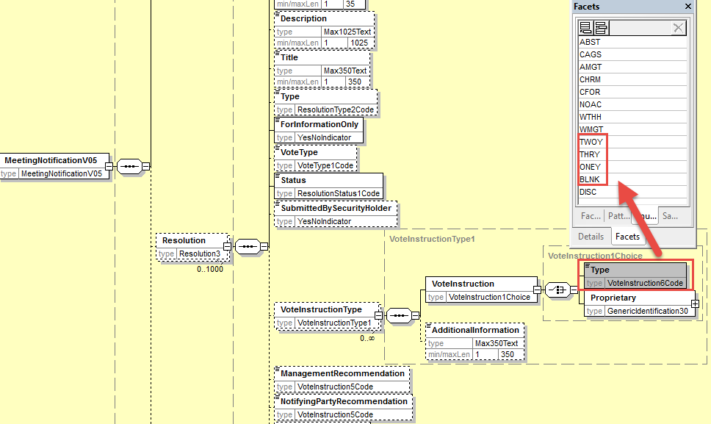

In the seev.004 (MEIN – MeetingInstruction) message, in the element Instruction/Proxy/VoteInstructionForAgendaResolution/GlobalVoteIntruction/VoteOption/Vote, replace the VoteInstruction3Code data type by a new VoteInstruction6 Code containing the following code values CFOR, CAGS, ABST, WTHH, NOAC, WMGT, AMGT , DISC, CHRM, ONEY, TWOY, THRY and BLANK as illustrated below :
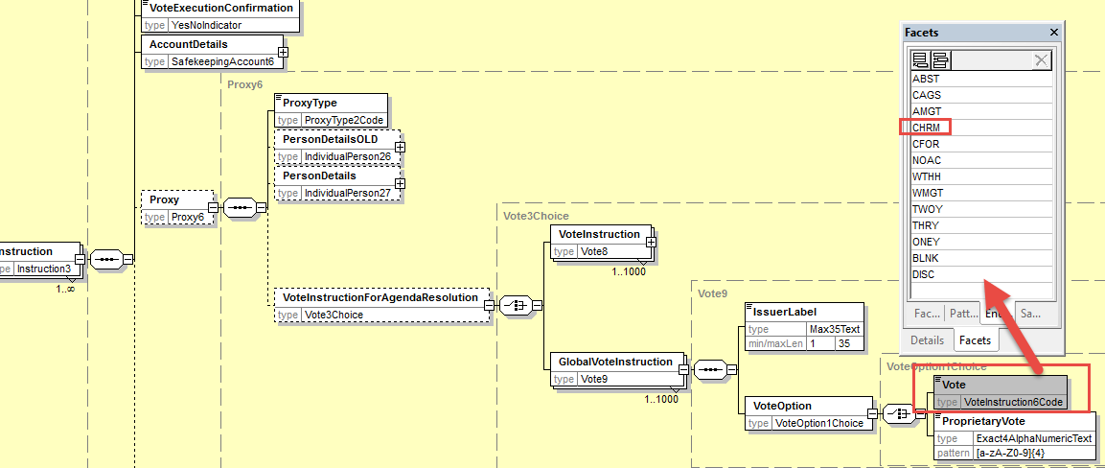

In the seev.004 (MEIN – MeetingInstruction) message, in the element Instruction/VoteDetails/VoteInstructionForAgendaResolution/GlobalVoteIntruction/VoteOption/Vote, and in the element Instruction/VoteDetails/VoteInstructionForMeetingResolution/VoteIndication/Vote replace the VoteInstruction4Code data type by a new VoteInstruction6 Code containing the following code values CFOR, CAGS, ABST, WTHH, NOAC, WMGT, AMGT , DISC, CHRM, ONEY, TWOY, THRY and BLANK as illustrated below :
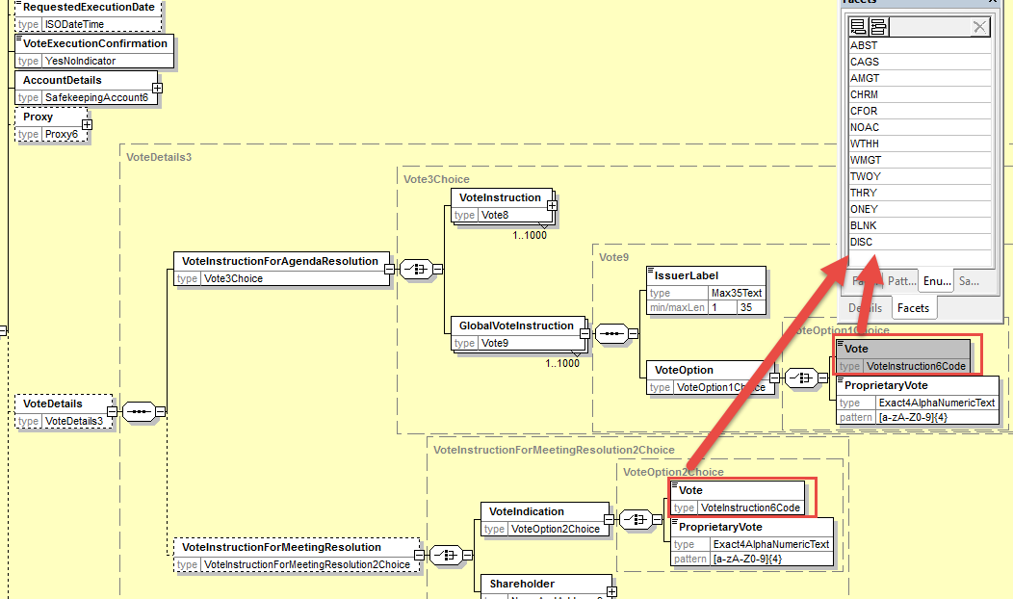

- Proposed timing:
The submitting organization confirms that it can implement the requested changes in the requested timing

Timing | - As requested

- Final decision of the SEG(s):

Approve
Comments:

Reject
Reason for rejection:

CR16: Rename PreviousReference in Meeting Instruction Cancellation Request
- Origin of the request:
A.1 Submitter: SWIFT, SMPG
A.2 Contact person:
Christine Strandberg – christine.strandberg@seb.se – phone: +46 8 763 6074
Mari Fumagalli – mariangela.fumagalli@bnpparibas.com – phone: +44 207 595 4988
Jacques Littré – jacques.littre@swift.com – phone: +32 2 655 43 35
A.3 Sponsors: N/A

- Related messages:
List of ISO 20022 Proxy Voting messages which would be impacted by the change:
seev.005.001.05 MeetingInstructionCancellationRequestV05
- Description of the change request:
Rename the message element PreviousReference as MeetingInstructionIdentification.
- Purpose of the change:
Align the naming of the reference to the previously sent MeetingInstruction message that is being cancelled with the ISO 20022 naming principles for message references.
- Urgency of the request:
This maintenance change request for the proxy-voting messages follows the ISO 20022 fast track maintenance process so as to publish a new version of those messages around end of Q3 2019.
- Business examples:
NA
- SEG recommendation:
This section is not to be taken care of by the submitter of the change request. It will be completed in due time by the SEG(s) in charge of the related ISO 20022 messages.

Consider |  |  | Timing
 |  |  | - Next yearly cycle: 2019/2020  (the change will be considered for implementation in the yearly maintenance cycle which starts in 2019 and completes with the publication of new message versions in the spring of 2020) |  |  | Priority:  high  medium  low
- At the occasion of the next maintenance of the messages
(the change will be considered for implementation, but does not justify maintenance of the messages in its own right – will be pending until more critical change requests are received for the messages)
 |  |  | - Urgent unscheduled  (the change justifies an urgent implementation outside of the normal yearly cycle) |  | X
 |  |  | - Other timing:
Comments:

Reject
Reason for rejection:

- Impact analysis:
This change request impacts the following messages:
seev.005.001.05 MeetingInstructionCancellationRequestV05
- Proposed implementation:
Rename the element PreviousReference at the root of the message as MeetingInstructionIdentification and change the date type Identification by Max35Text.

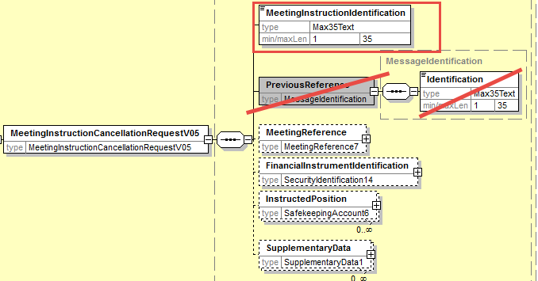
- Proposed timing:
The submitting organization confirms that it can implement the requested changes in the requested timing

Timing | - As requested

- Final decision of the SEG(s):

Approve
Comments:

Reject
Reason for rejection:

CR17: Enable Cancellation of a Single Instruction within an Instruction Message
- Origin of the request:
A.1 Submitter: SWIFT, SMPG
A.2 Contact person:
Christine Strandberg – christine.strandberg@seb.se – phone: +46 8 763 6074
Mari Fumagalli – mariangela.fumagalli@bnpparibas.com – phone: +44 207 595 4988
Jacques Littré – jacques.littre@swift.com – phone: +32 2 655 43 35
A.3 Sponsors: N/A

- Related messages:
List of ISO 20022 Proxy Voting messages which would be impacted by the change:
seev.005.001.05 MeetingInstructionCancellationRequestV05

- Description of the change request:
In the instruction cancellation request message, add the possibility to cancel one or more individual instructions sent in an instruction message when the instruction message contained several individual instructions.
- Purpose of the change:
The instruction message allows to send several single individual instructions simultaneously in the same message whilst the cancellation message (seev.005) only allows to cancel a previously sent instruction message, not individual instructions. On the other hand, the meeting status message (seev.006) allows also to either sending a confirmation at global (message) or single instruction level.
This change request will allow to align the instruction cancellation message with the instruction and instruction status messages in terms of being able to manage individual instructions.
- Urgency of the request:
This maintenance change request for the proxy-voting messages follows the ISO 20022 fast track maintenance process so as to publish a new version of those messages around end of Q3 2019.
- Business examples:
NA
- SEG recommendation:
This section is not to be taken care of by the submitter of the change request. It will be completed in due time by the SEG(s) in charge of the related ISO 20022 messages.

Consider |  |  | Timing
 |  |  | - Next yearly cycle: 2019/2020  (the change will be considered for implementation in the yearly maintenance cycle which starts in 2019 and completes with the publication of new message versions in the spring of 2020) |  |  | Priority:  high  medium  low
- At the occasion of the next maintenance of the messages
(the change will be considered for implementation, but does not justify maintenance of the messages in its own right – will be pending until more critical change requests are received for the messages)
 |  |  | - Urgent unscheduled  (the change justifies an urgent implementation outside of the normal yearly cycle) |  | X
 |  |  | - Other timing:
Comments:

Reject
Reason for rejection:

- Impact analysis:
This change request impacts the following messages:
seev.005.001.05 MeetingInstructionCancellationRequestV05
- Proposed implementation:
In the seev.005, create a new optional and repeatable “ToBeCancelledInstruction” sequence containing the new optional and non-repeatable element SingleInstructionIdentification and the optional and non-repeatable sequence InstructedPosition moved from the root of the message to the ToBECancelledInstruction sequence as illustrated here below:
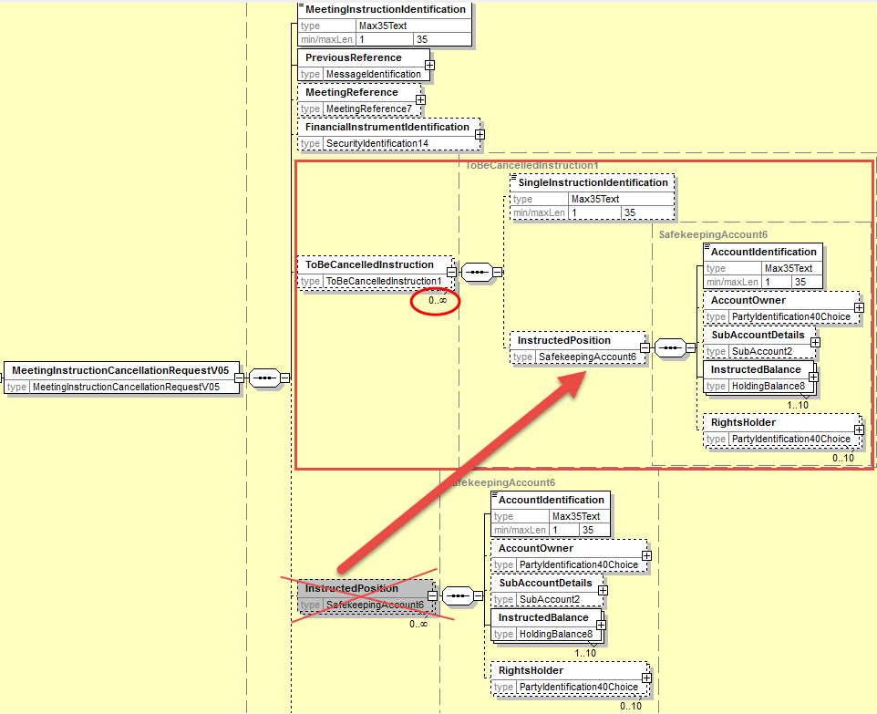
- Proposed timing:
The submitting organization confirms that it can implement the requested changes in the requested timing

Timing | - As requested

- Final decision of the SEG(s):

Approve
Comments:

Reject
Reason for rejection:

CR18: Add new elements required by the SRD2 Directive in the Meeting Instruction Status
- Origin of the request:
A.1 Submitter: SWIFT, SMPG
A.2 Contact person:
Christine Strandberg – christine.strandberg@seb.se – phone: +46 8 763 6074
Mari Fumagalli – mariangela.fumagalli@bnpparibas.com – phone: +44 207 595 4988
Jacques Littré – jacques.littre@swift.com – phone: +32 2 655 43 35
A.3 Sponsors: N/A

- Related messages:
List of ISO 20022 Proxy Voting messages which would be impacted by the change:
seev.006.001.05 MeetingInstructionStatusV05

- Description of the change request:
- add a new mandatory non-repeatable element IssuerName at the root of the message to provide the name of the issuer.
(IR table 6 item 6 in implementation regulation)
- add a new mandatory non-repeatable element ConfirmingParty at the root of the message to provide the name (legal or natural person name) of the ConfirmingParty.
(IR table 6 item 7 in implementation regulation)
- add a new mandatory non-repeatable element VoteCastingParty at the root of the message to provide the name (legal or natural person name) of the VoteCastingParty.
(IR table 6 item 8 in implementation regulation)
- add a new optional non-repeatable element RightsHolder at the root of the message to provide the name (legal or natural person name) of the Shareholder.
(IR table 6 item 9 in implementation regulation)
- Modify the status codes of the Status element in the sequence InstructionTypeStatus/InstructionStatus/GlobalInstructionStatus/ProcessingStatus and in sequence InstructionTypeStatus/InstructionStatus/DetailedInstructionStatus/InstructionStatus/ProcessingStatus as follows:
  - Add the new status code: “Accepted And Sent Along the Chain”
  - Remove statuses: “Completed” (COMP) and “NotReceived” (NOIN)
(IR Article 9.5 in implementation regulation)
- Purpose of the change:
This change is required by the European Commission Shareholders Rights Directive implementing regulation (EU) 2018/1212 of 3 September 2018 (see regulation table references in the description above).
- Urgency of the request:
This maintenance change request for the proxy-voting messages follows the ISO 20022 fast track maintenance process so as to publish a new version of those messages around end of Q3 2019.
- Business examples:
NA
- SEG recommendation:
This section is not to be taken care of by the submitter of the change request. It will be completed in due time by the SEG(s) in charge of the related ISO 20022 messages.

Consider |  |  | Timing
 |  |  | - Next yearly cycle: 2019/2020  (the change will be considered for implementation in the yearly maintenance cycle which starts in 2019 and completes with the publication of new message versions in the spring of 2020) |  |  | Priority:  high  medium  low
- At the occasion of the next maintenance of the messages
(the change will be considered for implementation, but does not justify maintenance of the messages in its own right – will be pending until more critical change requests are received for the messages)
 |  |  | - Urgent unscheduled  (the change justifies an urgent implementation outside of the normal yearly cycle) |  | X
 |  |  | - Other timing:
Comments:

Reject
Reason for rejection:

- Impact analysis:
This change request impacts the following messages:
seev.006.001.05 MeetingInstructionStatusV05
- Proposed implementation:

- Add new party Identifications

In the seev.006 (MEIS – MeetingInstructionStatus) message, add a new mandatory and non-repeatable element IssuerIdentification typed by the same PartyIdentificationChoice component used in the MeetingNotification message and a new mandatory and non-repeatable element ConfirmationParty, a new mandatory and non-repeatable element VoteCastingParty and a new optional and non-repeatable element RightsHolder typed by the same PartyIdentificationChoice component used to identify a legal and a natural person as illustrated below:
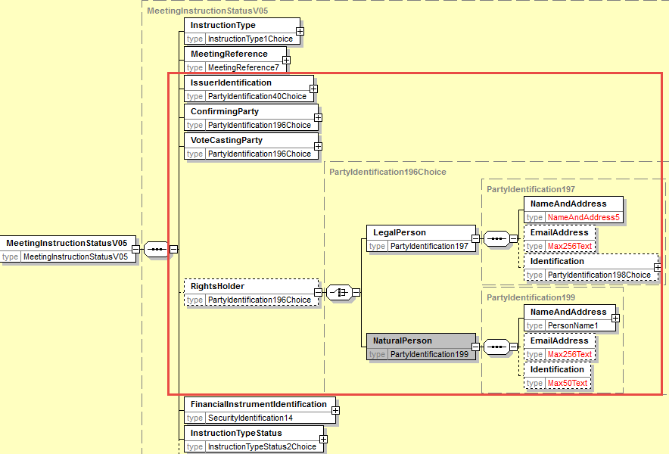

- Amend the ProcessingStatus code values
In the seev.006 (MEIS – MeetingInstructionStatus) message, in the status code of the Status element in the sequence InstructionTypeStatus/InstructionStatus/GlobalInstructionStatus/ProcessingStatus and in sequence InstructionTypeStatus/InstructionStatus/DetailedInstructionStatus/InstructionStatus/ProcessingStatus, remove the code values NotReceived (NOIN) and Completed (COMP) and add the values “Accepted and sent along the chain” (FRWD) and review the definition between PACK and FRWD.Amend the definition of the RCIS (ReceivedByIssuerOrRegistrar) status reason code to read “Instruction has been received by the issuer, equivalent to the confirmation of receipt of votes cast electronically.”

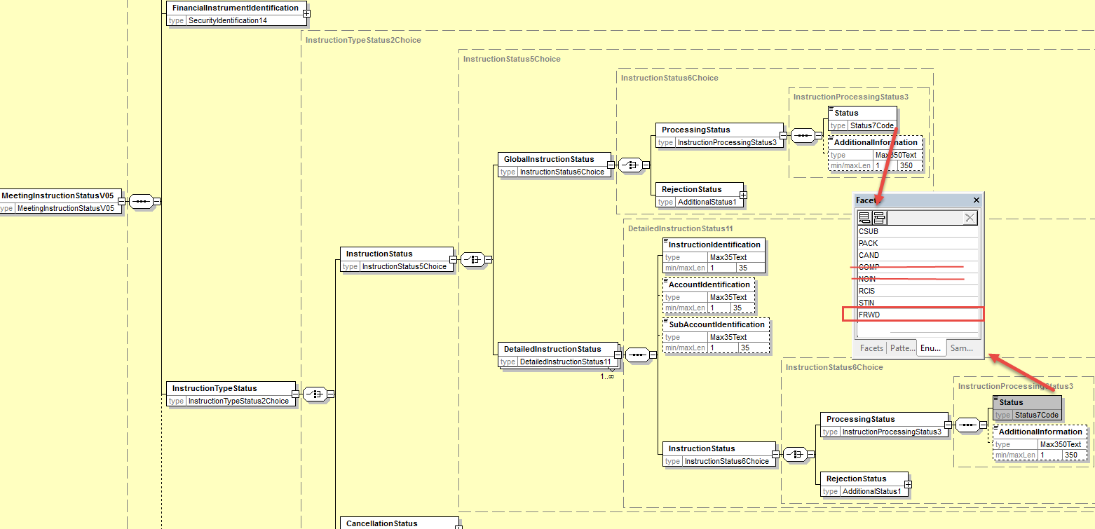
- Proposed timing:
The submitting organization confirms that it can implement the requested changes in the requested timing

Timing | - As requested

- Final decision of the SEG(s):

Approve
Comments:

Reject
Reason for rejection:

CR19: Add new Pending Status in the Meeting Instruction Status Message and Align Other Status/reason Codes With CA Statuses
- Origin of the request:
A.1 Submitter: SWIFT, SMPG
A.2 Contact person:
Christine Strandberg – christine.strandberg@seb.se – phone: +46 8 763 6074
Mari Fumagalli – mariangela.fumagalli@bnpparibas.com – phone: +44 207 595 4988
Jacques Littré – jacques.littre@swift.com – phone: +32 2 655 43 35
A.3 Sponsors: N/A

- Related messages:
List of ISO 20022 Proxy Voting messages which would be impacted by the change:
seev.006.001.05 MeetingInstructionStatusV05

- Description of the change request:
Add a new pending Status in the MeetingInstructionStatus Message with reason codes similar those used in CA Instruction Status message and align status reason codes of rejection status with those existing in CA Instruction Status message.
- Purpose of the change:
Pending Status is missing and alignment with CA statuses and reason codes.
- Urgency of the request:
This maintenance change request for the proxy-voting messages follows the ISO 20022 fast track maintenance process so as to publish a new version of those messages around end of Q3 2019.
- Business examples:
N/A
- SEG recommendation:
This section is not to be taken care of by the submitter of the change request. It will be completed in due time by the SEG(s) in charge of the related ISO 20022 messages.

Consider |  |  | Timing
 |  |  | - Next yearly cycle: 2019/2020  (the change will be considered for implementation in the yearly maintenance cycle which starts in 2019 and completes with the publication of new message versions in the spring of 2020) |  |  | Priority:  high  medium  low
- At the occasion of the next maintenance of the messages
(the change will be considered for implementation, but does not justify maintenance of the messages in its own right – will be pending until more critical change requests are received for the messages)
 |  |  | - Urgent unscheduled  (the change justifies an urgent implementation outside of the normal yearly cycle) |  | X
 |  |  | - Other timing:
Comments:

Reject
Reason for rejection:

- Impact analysis:
This change request impacts the following messages:
seev.006.001.05 MeetingInstructionStatusV05
- Proposed implementation:
In the seev.006 (MEIS – MeetingInstructionStatus) message, in the sequence InstructionTypeStatus/InstructionStatus/GlobalInstructionStatus and in sequence InstructionTypeStatus/InstructionStatus/DetailedInstructionStatus/InstructionStatus, add a new PendingStatus sequence with a specific reason code list and proprietary reason codes together with an optional and non-repeatable AdditionalInformation element as illustrated below:
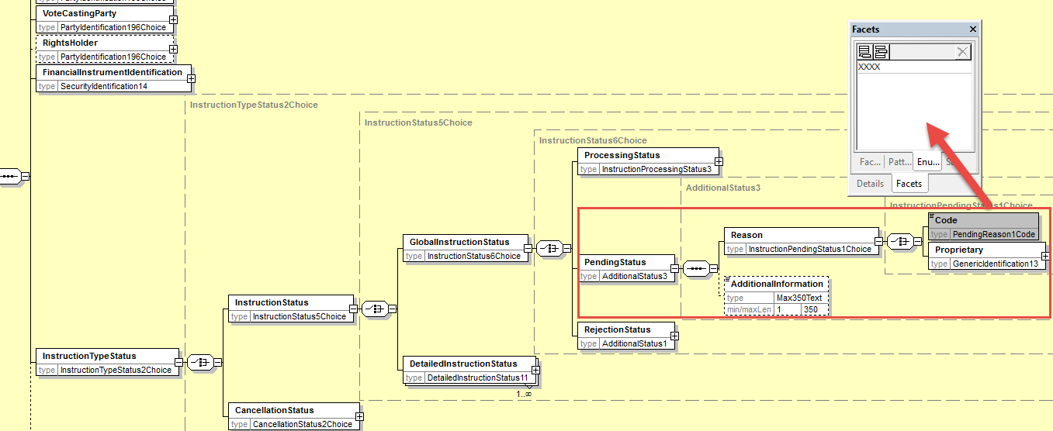
The following pending status reason codes coming from CA messages (seev.034) will be added: OTHR, ADEA, LATE, DQUA, FULL, LACK, PENR.
In the sequence InstructionTypeStatus/InstructionStatus/GlobalInstructionStatus/RejectionStatus and in sequence InstructionTypeStatus/InstructionStatus/DetailedInstructionStatus/InstructionStatus/ RejectionStatus, add a new reason code “OTHR”.

- Proposed timing:
The submitting organization confirms that it can implement the requested changes in the requested timing

Timing | - As requested

- Final decision of the SEG(s):

Approve
Comments:

Reject
Reason for rejection:

CR20: Add new elements required by the SRD2 Directive in the Meeting Vote Execution Confirmation
- Origin of the request:
A.1 Submitter: SWIFT, SMPG
A.2 Contact person:
Christine Strandberg – christine.strandberg@seb.se – phone: +46 8 763 6074
Mari Fumagalli – mariangela.fumagalli@bnpparibas.com – phone: +44 207 595 4988
Jacques Littré – jacques.littre@swift.com – phone: +32 2 655 43 35
A.3 Sponsors: N/A

- Related messages:
List of ISO 20022 Proxy Voting messages which would be impacted by the change:
seev.007.001.05 MeetingVoteExecutionConfirmationV05

- Description of the change request:
- add a new mandatory non-repeatable element IssuerIdentification at the root of the message to provide the name of the issuer.
(IR table 7 item 6 in implementation regulation)
- Adapt the element VoteInstructions/RightsHolder to provide the name (legal or natural person name) of the Shareholder.
(IR table 7 item 7 in implementation regulation)
- add a new optional non-repeatable element or Proxy party (Third Party nominated by the shareholder) in the sequence VoteInstructions to provide the name (legal or natural person name) of the third party nominated by the shareholder.
(IR table 7 item 8 in implementation regulation)
- add a new mandatory non-repeatable element ModalityOfCounting in the sequence VoteInstructions to provide the modality through which the votes that have been recorded and counted were received by the issuer i.e. Paper vote ahead of the meeting, Electronic ahead of the meeting, Electronic at the meeting, Physical at the meeting
(IR table 7 item 9 in implementation regulation)
- add a new optional and non-repeatable element VoteReceiptDateAndTime in the sequence VoteInstructions to provide the date and time at which the votes that have been recorded and counted were received.
(IR table 7 item 10 in implementation regulation)

- Purpose of the change:
This change is required by the European Commission Shareholders Rights Directive implementing regulation (EU) 2018/1212 of 3 September 2018 (see regulation table references in the description above).
- Urgency of the request:
This maintenance change request for the proxy-voting messages follows the ISO 20022 fast track maintenance process so as to publish a new version of those messages around end of Q3 2019.
- Business examples:
NA
- SEG recommendation:
This section is not to be taken care of by the submitter of the change request. It will be completed in due time by the SEG(s) in charge of the related ISO 20022 messages.

Consider |  |  | Timing
 |  |  | - Next yearly cycle: 2019/2020  (the change will be considered for implementation in the yearly maintenance cycle which starts in 2019 and completes with the publication of new message versions in the spring of 2020) |  |  | Priority:  high  medium  low
- At the occasion of the next maintenance of the messages
(the change will be considered for implementation, but does not justify maintenance of the messages in its own right – will be pending until more critical change requests are received for the messages)
 |  |  | - Urgent unscheduled  (the change justifies an urgent implementation outside of the normal yearly cycle) |  | X
 |  |  | - Other timing:
Comments:

Reject
Reason for rejection:

- Impact analysis:
This change request impacts the following messages:
seev.007.001.05 MeetingVoteExecutionConfirmationV05
- Proposed implementation:

- Add Issuer Identification
In the seev.007 (MECO – MeetingVoteExecutionConfirmation) message, in the root of the message, add a new mandatory and non-repeatable element IssuerIdentification typed by the same PartyIdentificationChoice component used in the MeetingNotification message as illustrated below:
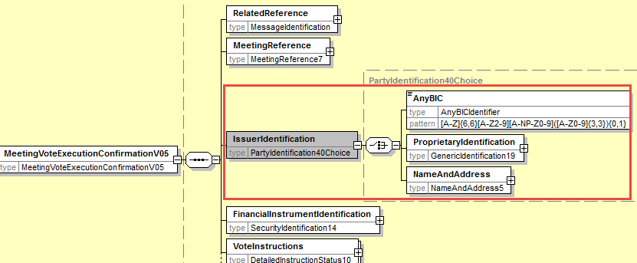

- Amend the RightsHolder Identification component
In the seev.007 (MECO – MeetingVoteExecutionConfirmation) message, in the VoteInstructions sequence, change the data type of the RightHolder element so as to identify a legal or a natural person with a PartyIdentificationChoice component as illustrated below:
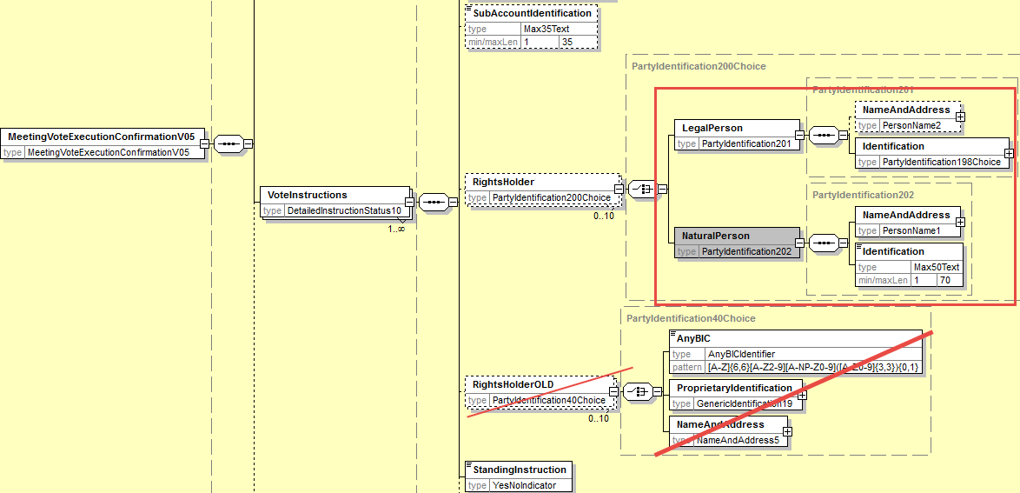

- Add a new (Proxy Party Component
In the seev.007 (MECO – MeetingVoteExecutionConfirmation) message, in the VoteInstruction sequence, add a new optional and non-repeatable element Proxy typed by PartyIdentificationChoice to provide the name of a legal or natural person as illustrated below:
Reuse same component as the one used in the Instruction message for Proxy with Identification elements as optional.
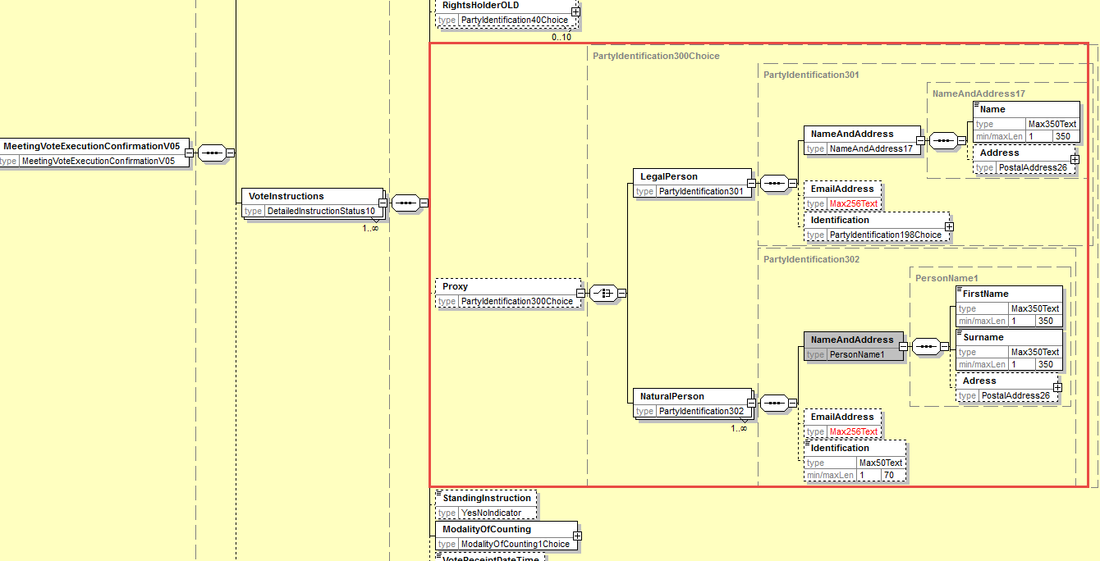

- Add new element ModalityOfCounting
In the seev.007 (MECO – MeetingVoteExecutionConfirmation) message, in the sequence VoteInstruction, add a new mandatory non-repeatable element ModalityOfCounting typed by a Choice between a proprietary Identification and a new code list with the 4 following code values: Paper vote ahead of the meeting (PVBM), Electronic vote before the meeting (EVBM) , Electronic vote at the meeting (EVAM) , Physical vote at the meeting (PVAM) as illustrated below:
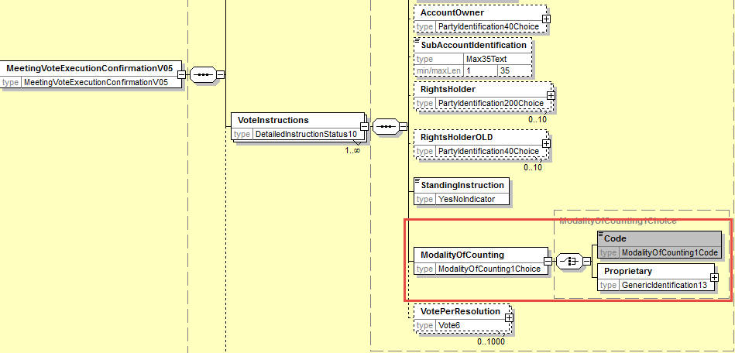

- Add new element VoteReceiptDateTime
In the seev.007 (MECO – MeetingVoteExecutionConfirmation) message, in the sequence VoteInstruction, add a new optional and non-repeatable element VoteReceiptDateTime typed by a ISODateTime data type as illustrated below:
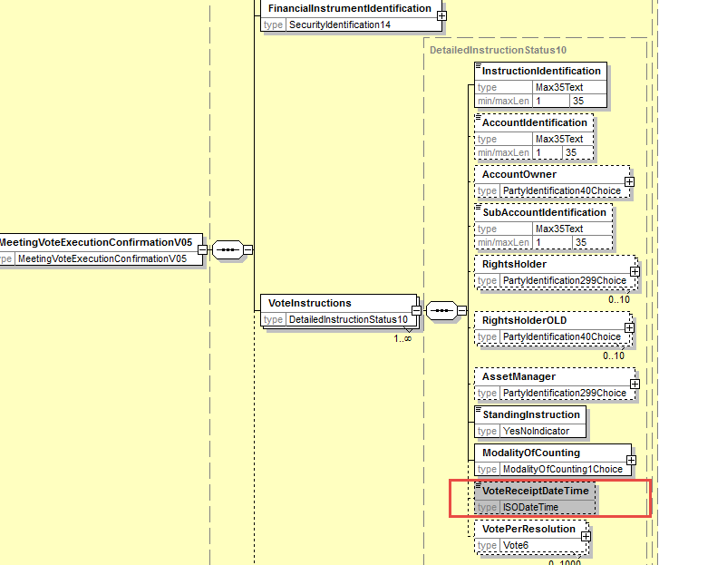

- Proposed timing:
The submitting organization confirms that it can implement the requested changes in the requested timing

Timing | - As requested

- Final decision of the SEG(s):

Approve
Comments:

Reject
Reason for rejection:

CR21: Set StandingInstructionOrder Optional in the Meeting Vote Execution Confirmation
- Origin of the request:
A.1 Submitter: SWIFT, SMPG
A.2 Contact person:
Christine Strandberg – christine.strandberg@seb.se – phone: +46 8 763 6074
Mari Fumagalli – mariangela.fumagalli@bnpparibas.com – phone: +44 207 595 4988
Jacques Littré – jacques.littre@swift.com – phone: +32 2 655 43 35
A.3 Sponsors: N/A

- Related messages:
List of ISO 20022 Proxy Voting messages which would be impacted by the change:
seev.007.001.05 MeetingVoteExecutionConfirmationV05

- Description of the change request:
In the VoteInstruction sequence, set the StandingInstruction indicator element as optional instead of mandatory.
- Purpose of the change:
Having the standing instruction indicator mandatory does not make sense at this stage of the process.
- Urgency of the request:
This maintenance change request for the proxy-voting messages follows the ISO 20022 fast track maintenance process so as to publish a new version of those messages around end of Q3 2019.
- Business examples:
NA
- SEG recommendation:
This section is not to be taken care of by the submitter of the change request. It will be completed in due time by the SEG(s) in charge of the related ISO 20022 messages.

Consider |  |  | Timing
 |  |  | - Next yearly cycle: 2019/2020  (the change will be considered for implementation in the yearly maintenance cycle which starts in 2019 and completes with the publication of new message versions in the spring of 2020) |  |  | Priority:  high  medium  low
- At the occasion of the next maintenance of the messages
(the change will be considered for implementation, but does not justify maintenance of the messages in its own right – will be pending until more critical change requests are received for the messages)
 |  |  | - Urgent unscheduled  (the change justifies an urgent implementation outside of the normal yearly cycle) |  | X
 |  |  | - Other timing:
Comments:

Reject
Reason for rejection:

- Impact analysis:
This change request impacts the following messages:
seev.007.001.05 MeetingVoteExecutionConfirmationV05
- Proposed implementation:
In the seev.007 (MECO – MeetingVoteExecutionConfirmation) message, change the multiplicity of the element VoteInstructions/StandingInstruction to optional as illustrated below:
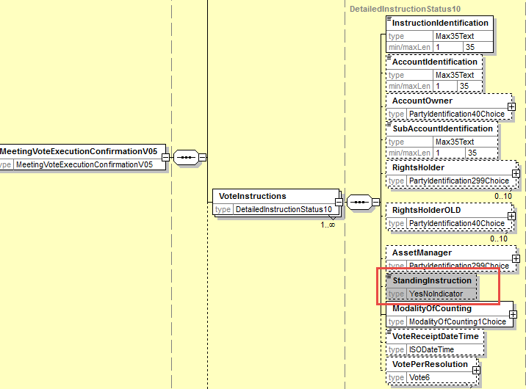
- Proposed timing:
The submitting organization confirms that it can implement the requested changes in the requested timing

Timing | - As requested

- Final decision of the SEG(s):

Approve
Comments:

Reject
Reason for rejection:

CR22: Align the Meeting Result Dissemination Message Design with Similar Changes in Other Messages
- Origin of the request:
A.1 Submitter: SWIFT, SMPG
A.2 Contact person:
Christine Strandberg – christine.strandberg@seb.se – phone: +46 8 763 6074
Mari Fumagalli – mariangela.fumagalli@bnpparibas.com – phone: +44 207 595 4988
Jacques Littré – jacques.littre@swift.com – phone: +32 2 655 43 35
A.3 Sponsors: N/A

- Related messages:
List of ISO 20022 Proxy Voting messages which would be impacted by the change:
seev.008.001.05 MeetingResultDisseminationV05

- Description of the change request:
Align the Amendments component with the similar change in the MeetingNotificationType in the MeetingNotification message.
Align the list of vote instruction types in the vote results with the additional vote instruction types “Blank” and Proprietary vote updated in the MeetingNotification and MeetingInstruction.
- Purpose of the change:
Align the messages with similar changes and updates done in the other Meeting messages.
- Urgency of the request:
This maintenance change request for the proxy-voting messages follows the ISO 20022 fast track maintenance process so as to publish a new version of those messages around end of Q3 2019.
- Business examples:
N/A
- SEG recommendation:
This section is not to be taken care of by the submitter of the change request. It will be completed in due time by the SEG(s) in charge of the related ISO 20022 messages.

Consider |  |  | Timing
 |  |  | - Next yearly cycle: 2019/2020  (the change will be considered for implementation in the yearly maintenance cycle which starts in 2019 and completes with the publication of new message versions in the spring of 2020) |  |  | Priority:  high  medium  low
- At the occasion of the next maintenance of the messages
(the change will be considered for implementation, but does not justify maintenance of the messages in its own right – will be pending until more critical change requests are received for the messages)
 |  |  | - Urgent unscheduled  (the change justifies an urgent implementation outside of the normal yearly cycle) |  | X
 |  |  | - Other timing:
Comments:

Reject
Reason for rejection:

- Impact analysis:
This change request impacts the following messages:
seev.008.001.05 MeetingResultDisseminationV05
- Proposed implementation:
Align Amendment Component
In the seev.008 (MERD– MeetingResultDissemination) message, at the root of the message, add a new mandatory element “ResultDisseminationGeneralInformation” typed by a new component ResultDisseminationGeneralInformation1containing:
- a new mandatory and non-repeatable element MeetingResultDisseminationType typed with a code list with values New and Replacement;
- a new optional and non-repeatable element named PreviousMeetingResultDisseminationIdentification typed by the Message Identification data type.
- a cross element rule in order to condition the presence of the element PreviousMeetingResultDisseminationIdentification when MeetingResultDisseminationType value is REPL (Replacement).
Remove the “Amendment” sequence.
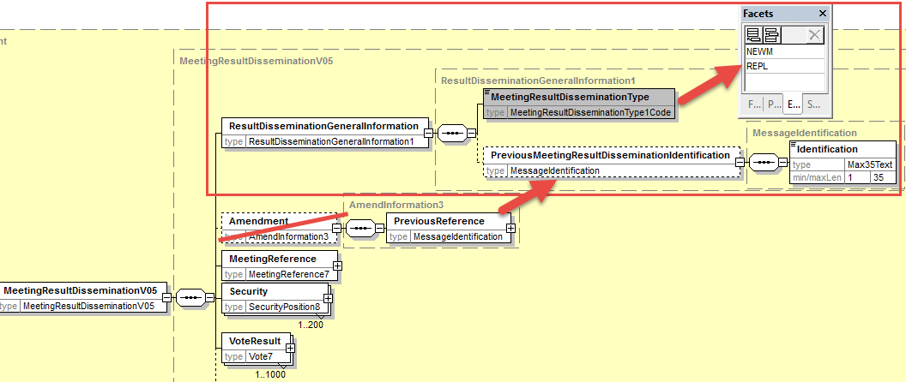
Align Vote Instruction Types
In the seev.008 (MERD– MeetingResultDissemination) message, in VoteResult sequence, add the new optional and non-repeatable element “Blank” typed by the data type Number and a new optional and repeatable element Proprietary typed by ProprietaryVote1 as illustrated below:
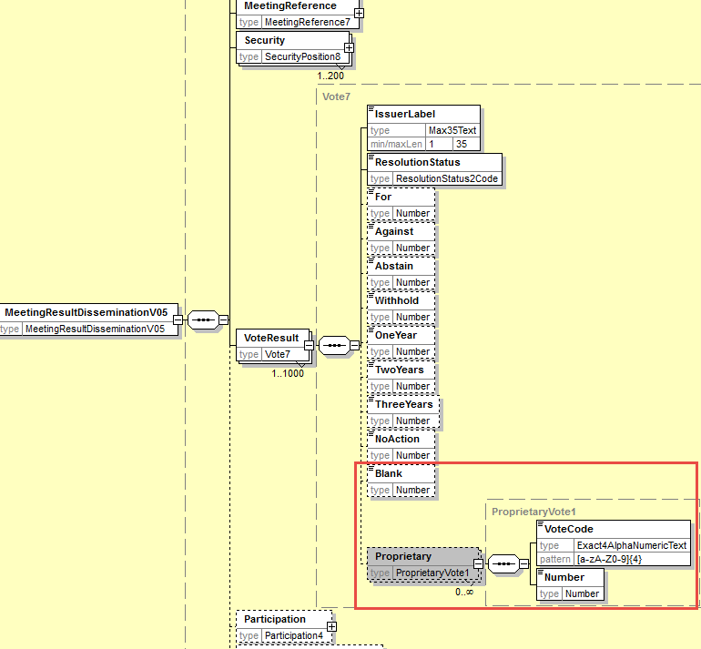

- Proposed timing:
The submitting organization confirms that it can implement the requested changes in the requested timing

Timing | - As requested

- Final decision of the SEG(s):

Approve
Comments:

Reject
Reason for rejection:

CR23: Replace All Obsolete Components with New or Latest Version
- Origin of the request:
A.1 Submitter: SWIFT, SMPG
A.2 Contact person:
Christine Strandberg – christine.strandberg@seb.se – phone: +46 8 763 6074
Mari Fumagalli – mariangela.fumagalli@bnpparibas.com – phone: +44 207 595 4988
Jacques Littré – jacques.littre@swift.com – phone: +32 2 655 43 35
A.3 Sponsors: N/A

- Related messages:
List of ISO 20022 Proxy Voting messages which would be impacted by the change:
seev.001.001.05 MeetingNotificationV05
seev.002.001.05 MeetingCancellationV05
seev.003.001.05 MeetingEntitlementNotificationV05
seev.004.001.05 MeetingInstructionV05
seev.005.001.05 MeetingInstructionCancellationRequestV05
seev.006.001.05 MeetingInstructionStatusV05
seev.007.001.05 MeetingVoteExecutionConfirmationV05
seev.008.001.05 MeetingResultDisseminationV05

- Description of the change request:
Replace the obsolete message components and data types as follows in all related messages:

Obsolete Component | To be replaced with | Messages impacted
AnyBICIdentifier | AnyBICDec2014Identifier | All except seev.006
DateAndDateTimeChoice | DateAndDateTime2Choice | see.001
ISINIdentifier | ISINOct2015Identifier | All
AdditionalRights2 | New to be created | seev.001
DateFormat29Choice | New to be created | see.001
DetailedInstructionStatus10 | New to be created | seev.007
EligiblePosition5 | New to be created | seev.001,002,008
EligiblePosition6 | New to be created | seev.003
EntitlementAssessment3 | New to be created | seev.001
GenericIdentification19 | GenericIdentification36 | All except seev.006
GenericIdentification20 | GenericIdentification30 | All except seev.006, 007
GenericIdentification21 | GenericIdentification78 | All except seev.006, 007
HoldingBalance7 | New to be created | All except seev.004, 005, 006, 007
HoldingBalance8 | New to be created | seev.004, 005
IncentivePremium3 | New to be created | seev.001
IndividualPerson25 | New to be created | seev.001
IndividualPerson26 | New to be created | seev.004
Instruction3 | New to be created | seev.004
IssuerAgent2 | New to be created | seev.001
IssuerInformation2 | New to be created | seev.001
Meeting4 | New to be created | seev.001
MeetingContactPerson2 | New to be created | seev.001
MeetingNotice4 | New to be created | seev.001
PartyIdentification40Choice | PartyIdentification120Choice | All except seev.006
PartyIdentification71 | New to be created | Seev.001
PowerOfAttorneyRequirements3 | New to be created | Seev.001
PriceRateOrAmountChoice | PriceRateOrAmount3Choice | Seev.001
Proxy2Choice | New to be created | Seev.001
Proxy5 | New to be created | Seev.001
Proxy6 | New to be created | Seev.004
ProxyAppointmentInformation3 | New to be created | Seev.001
SafekeepingAccount6 | New to be created | Seev.004, 005
SafekeepingPlaceFormat2Choice | SafekeepingPlaceFormat28Choice | All except seev.006, 007
SafekeepingPlaceTypeAndText2 | SafekeepingPlaceTypeAndText6 | All except seev.006, 007
SecurityIdentification14 | SecurityIdentification19 | All
SecurityPosition8 | New to be created | Seev.001,002,008
SecurityPosition9 | New to be created | Seev.003
VoteParameter4 | New to be created | Seev.001

- Purpose of the change:
Replace all ISO 20022 Message components and data types which have become “Obsolete” in the ISO 20022 repository with the latest version/evolution of the component in the repository or a new one if a new version is not available.
- Urgency of the request:
This maintenance change request for the proxy-voting messages follows the ISO 20022 fast track maintenance process so as to publish a new version of those messages around end of Q3 2019.
- Business examples:

- SEG recommendation:
This section is not to be taken care of by the submitter of the change request. It will be completed in due time by the SEG(s) in charge of the related ISO 20022 messages.

Consider |  |  | Timing
 |  |  | - Next yearly cycle: 2019/2020  (the change will be considered for implementation in the yearly maintenance cycle which starts in 2019 and completes with the publication of new message versions in the spring of 2020) |  |  | Priority:  high  medium  low
- At the occasion of the next maintenance of the messages
(the change will be considered for implementation, but does not justify maintenance of the messages in its own right – will be pending until more critical change requests are received for the messages)
 |  |  | - Urgent unscheduled  (the change justifies an urgent implementation outside of the normal yearly cycle) |  | X
 |  |  | - Other timing:
Comments:

Reject
Reason for rejection:

- Impact analysis:
This change request impacts the following messages:
seev.001.001.05 MeetingNotificationV05
seev.002.001.05 MeetingCancellationV05
seev.003.001.05 MeetingEntitlementNotificationV05
seev.004.001.05 MeetingInstructionV05
seev.005.001.05 MeetingInstructionCancellationRequestV05
seev.006.001.05 MeetingInstructionStatusV05
seev.007.001.05 MeetingVoteExecutionConfirmationV05
seev.008.001.05 MeetingResultDisseminationV05
- Proposed implementation:
For each obsolete component, replace it with the existing latest version or a new one to be created as per the table list here above.
- Proposed timing:
The submitting organization confirms that it can implement the requested changes in the requested timing

Timing | - As requested

- Final decision of the SEG(s):

Approve
Comments:

Reject
Reason for rejection:

CR24: Align all RightsHolder Identification Data type in all Messages
- Origin of the request:
A.1 Submitter: SWIFT, SMPG
A.2 Contact person:
Christine Strandberg – christine.strandberg@seb.se – phone: +46 8 763 6074
Mari Fumagalli – mariangela.fumagalli@bnpparibas.com – phone: +44 207 595 4988
Jacques Littré – jacques.littre@swift.com – phone: +32 2 655 43 35
A.3 Sponsors: N/A

- Related messages:
List of ISO 20022 Proxy Voting messages which would be impacted by the change:
seev.001.001.05 MeetingNotificationV05
seev.002.001.05 MeetingCancellationV05
seev.003.001.05 MeetingEntitlementNotificationV05
seev.004.001.05 MeetingInstructionV05
seev.005.001.05 MeetingInstructionCancellationRequestV05
seev.006.001.05 MeetingInstructionStatusV05
seev.008.001.05 MeetingResultDisseminationV05

- Description of the change request:
Align the way of identifying “RightsHolder” in all remaining messages as already specified in the IR table 4 C.1 and C2 for the MeetingEntitlementNotification message.
- Purpose of the change:
Ensure all identification for the same element be the same across the PV messages.
- Urgency of the request:
This maintenance change request for the proxy-voting messages follows the ISO 20022 fast track maintenance process so as to publish a new version of those messages around end of Q3 2019.
- Business examples:
NA
- SEG recommendation:
This section is not to be taken care of by the submitter of the change request. It will be completed in due time by the SEG(s) in charge of the related ISO 20022 messages.

Consider |  |  | Timing
 |  |  | - Next yearly cycle: 2019/2020  (the change will be considered for implementation in the yearly maintenance cycle which starts in 2019 and completes with the publication of new message versions in the spring of 2020) |  |  | Priority:  high  medium  low
- At the occasion of the next maintenance of the messages
(the change will be considered for implementation, but does not justify maintenance of the messages in its own right – will be pending until more critical change requests are received for the messages)
 |  |  | - Urgent unscheduled  (the change justifies an urgent implementation outside of the normal yearly cycle) |  | X
 |  |  | - Other timing:
Comments:

Reject
Reason for rejection:

- Impact analysis:
This change request impacts the following messages:
seev.001.001.05 MeetingNotificationV05
seev.002.001.05 MeetingCancellationV05
seev.003.001.05 MeetingEntitlementNotificationV05
seev.004.001.05 MeetingInstructionV05
seev.005.001.05 MeetingInstructionCancellationRequestV05
seev.006.001.05 MeetingInstructionStatusV05
seev.008.001.05 MeetingResultDisseminationV05

- Proposed implementation:
In all seev.001 to seev.008 messages except for seev.007) , Change the current data type PartyIdentification40Choice of RightsHolder by PartyIdengtification196Choice as illustrated below::
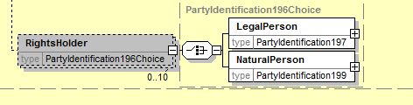

- Proposed timing:
The submitting organization confirms that it can implement the requested changes in the requested timing

Timing | - As requested

- Final decision of the SEG(s):

Approve
Comments:

Reject
Reason for rejection:

CR25: Amend Message Definitions Scope And Usage
- Origin of the request:
A.1 Submitter: SWIFT, SMPG
A.2 Contact person:
Christine Strandberg – christine.strandberg@seb.se – phone: +46 8 763 6074
Mari Fumagalli – mariangela.fumagalli@bnpparibas.com – phone: +44 207 595 4988
Jacques Littré – jacques.littre@swift.com – phone: +32 2 655 43 35
A.3 Sponsors: N/A

- Related messages:
List of ISO 20022 Proxy Voting messages which would be impacted by the change:
seev.001.001.05 MeetingNotificationV05
seev.002.001.05 MeetingCancellationV05
seev.003.001.05 MeetingEntitlementNotificationV05
seev.004.001.05 MeetingInstructionV05
seev.005.001.05 MeetingInstructionCancellationRequestV05
seev.006.001.05 MeetingInstructionStatusV05
seev.007.001.05 MeetingVoteExecutionConfirmationV05
seev.008.001.05 MeetingResultDisseminationV05

- Description of the change request:
Amend the message definitions of all proxy voting messages to align them with the ISO 20022 style using the passive voice for the description of the scope and update the usage sections in order to align them with the changes in message flows required by the Shareholder Rights implementing regulation.
Amend also the usage of the seev.006 message to specify that the message can also be used to confirm that the related vote instruction sent is cast.
Amend also the scope of the seev.007 message to specify that the message originates from the issuer as a confirmation of the vote execution and is forwarded by the intermediaries.
Please refer to the proposed implementation section T below for an illustration of the changes.
- Purpose of the change:
Adapt the definition and scope / usage of the messages to the updated message functionalities required by the European Commission Shareholders Rights Directive implementing regulation (EU) 2018/1212 of 3 September 2018 (see regulation table references in the description above).
For the MeetingVoteExecutionConfirmation messgage, clarify the exact usage of the message and confirm that the vote execution confirmation originates directly from the issuer.

- Urgency of the request:
This maintenance change request for the proxy-voting messages follows the ISO 20022 fast track maintenance process so as to publish a new version of those messages around end of Q3 2019.
- Business examples:
N/A
- SEG recommendation:
This section is not to be taken care of by the submitter of the change request. It will be completed in due time by the SEG(s) in charge of the related ISO 20022 messages.

Consider |  |  | Timing
 |  |  | - Next yearly cycle: 2019/2020  (the change will be considered for implementation in the yearly maintenance cycle which starts in 2019 and completes with the publication of new message versions in the spring of 2020) |  |  | Priority:  high  medium  low
- At the occasion of the next maintenance of the messages
(the change will be considered for implementation, but does not justify maintenance of the messages in its own right – will be pending until more critical change requests are received for the messages)
 |  |  | - Urgent unscheduled  (the change justifies an urgent implementation outside of the normal yearly cycle) |  | X
 |  |  | - Other timing:
Comments:

Reject
Reason for rejection:

- Impact analysis:
This change request impacts the following messages:
seev.001.001.05 MeetingNotificationV05
seev.002.001.05 MeetingCancellationV05
seev.003.001.05 MeetingEntitlementNotificationV05
seev.004.001.05 MeetingInstructionV05
seev.005.001.05 MeetingInstructionCancellationRequestV05
seev.006.001.05 MeetingInstructionStatusV05
seev.007.001.05 MeetingVoteExecutionConfirmationV05
seev.008.001.05 MeetingResultDisseminationV05
- Proposed implementation:
The following textual changes are proposed on the message definitions:
- Proposed timing:
The submitting organization confirms that it can implement the requested changes in the requested timing

Timing | - As requested

- Final decision of the SEG(s):

Approve
Comments:

Reject
Reason for rejection:

