Based on previous discussions at the SMPG Tax Working Group, we have identified two methods used by account servicers to collect tax breakdown information after (tax refund scenario) an income distribution:
- Using a WTRC event, linked to the tax refund event;
- Including multiple options, one per tax rate, in the tax refund event.
Account owners can provide a tax breakdown using a MT565 message, whose content depends on the event type that was used in the breakdown request.

In those source investment countries that allow for a tax refund procedure (e.g. Austria), when submitting a tax refund application to the account servicer, where the account owner has an omnibus segregated account (OSA), it has to inform the account servicer of how the eligible balance should be broken down amount all end investors, to process the tax refund applications.
We have provided an overview of the way the tax breakdown should be managed according to both methods described above:
- In scenario 1:
  - the account servicer will:
    - announce a mandatory tax refund event (TREC);
    - for account owners having an OSA, a WTRC voluntary event will also be announced with a link to the tax refund event. The WTRC event will have a NOAC and a OTHR option to request the tax rates to be used to pay the income proceeds (e.g. statutory rate, DTT rates, etc)
  - the account owner will send the tax breakdown via MT565 quoting the details (CAEV, CORP, etc) of the WTRC event;
  - based on the SLA in place between the account servicer and account owner, the receipt of the instruction will be confirmed via MT567;
  - if and when the tax refund has been paid by the tax authorities, the account servicer will pay the refund. The credit of the proceeds will be confirmed via a MT566 reporting the TREC event details.
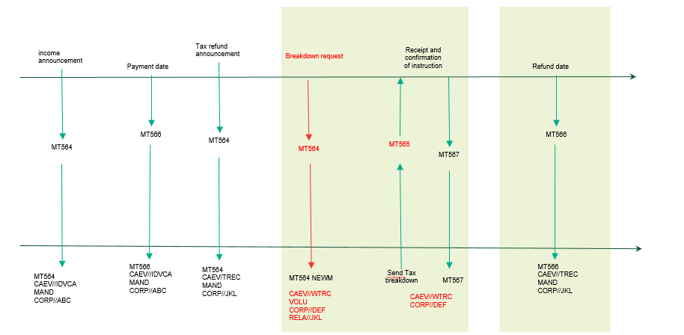

- In scenario 2:
  - the account servicer will announce a voluntary tax refund event (TREC) with as many CASH options as the tax rates that can be used to pay the refund (e.g. statutory rate, DTT rates, etc);
  - the account owner will send the tax breakdown via MT565 quoting the details (CAEV, CORP, etc) of the tax refund event;
  - based on the SLA in place between the account servicer and account owner, the receipt of the instruction will be confirmed via MT567;
  - if and when the tax refund has been paid by the tax authorities, the account servicer will pay the refund. The credit of the proceeds will be confirmed via a MT566 reporting the TREC event details.

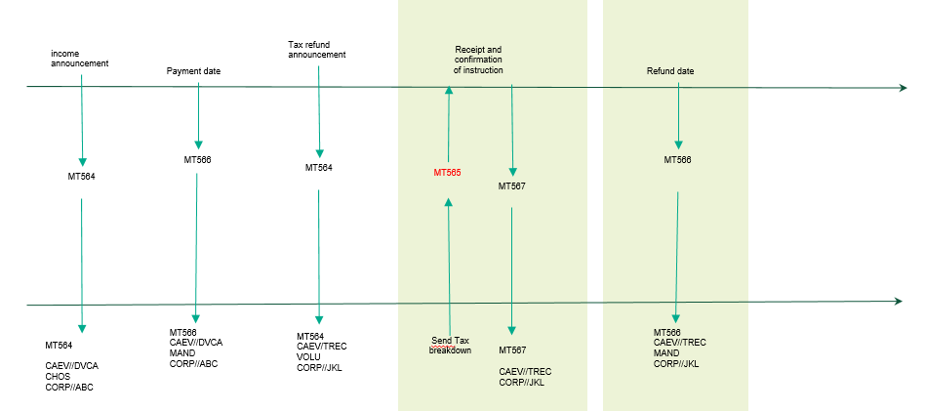

Recommendation for the usage of the new reason codes added to PEND and REJT statuses in the MT567:
TAXI | Incorrect Tax Rate | Tax rate provided is incorrect. It falls outside the acceptable values for that investment country. | It should be used to inform the account owner that any of the tax rate indicated for a beneficial owner in the BENODET sequence is incorrect.  As an example, with reference to our MT565 below, if the account owner reported a rate of 30%.
TAXM | Missing Tax Rate | Tax rate is missing. | It should be used to inform the account owner that any of the tax rate indicated for a beneficial owner in the BENODET sequence is incorrect.  As an example, with reference to our MT565 below, if the account owner had reported no tax rate.
TAXN | Inconsistent Tax Rate | Tax rate is not consistent with the documentation in place. | It should be used to inform the account owner that any of the tax rate indicated for a beneficial owner in the BENODET sequence is incorrect.  As an example, with reference to our MT565 below, if the documentation in place for ABC123 made it entitled to a rate of 0% instead of 15%.

Message templates:
Scenario 1:
  - TREC to announce the mandatory tax refund to all clients
:16R: |  | GENL
:20C:: |  | CORP//TRE3437592
:20C:: |  | SEME//253147815
:23G: |  | NEWM
:22F:: |  | CAEV//TREC
:22F:: |  | CAMV//MAND
:25D:: |  | PROC//COMP
:16S: |  | GENL
:16R: |  | USECU
:35B: |  | ISIN IT0004982242
:16R: |  | ACCTINFO
:97A:: |  | SAFE//98-0112441-05
:93B:: |  | SETT//UNIT/4600,
:16S: |  | ACCTINFO
:16S: |  | USECU
:16R: |  | CADETL
:98A:: |  | RDTE//20YY0325
:16S: |  | CADETL
:16R: |  | CAOPTN
:13A:: |  | CAON//001
:22F:: |  | CAOP//CASH
:11A:: |  | OPTN//EUR
:17B:: |  | DFLT//Y
:16R: |  | CASHMOVE
:22H:: |  | CRDB//CRED
:98B:: |  | PAYD//ONGO
:92A:: |  | TXRC//11,
:16S: |  | CASHMOVE
:16S: |  | CAOPTN
  - WTRC to announce the breakdown event to account owners having an OSA
:16R: | GENL
:20C:: | CORP//WTRC12345
:20C:: | SEME//253147816
:23G: | NEWM
:22F:: | CAEV//WTRC
:22F:: | CAMV//VOLU
:25D:: | PROC//COMP
:16R: | LINK
:13A:: | LINK//564
:20C:: | CORP// TRE3437592
:16S: | LINK
:16S: | GENL
:16R: | USECU
:35B: | ISIN IT0004982242
:16R: | ACCTINFO
:97A:: | SAFE//98-0112441-05
:93B:: | SETT//UNIT/4600,
:16S: | ACCTINFO
:16S: | USECU
:16R: | CAOPTN
:13A:: | CAON//001
:22F:: | CAOP//NOAC
:17B:: | DFLT//Y
:98B:: | RDDT//ONGO
:16S: | CAOPTN
:16R: | CAOPTN
:13A:: | CAON//002
:22F:: | CAOP//OTHR
:17B:: | DFLT//N
:98B:: | RDDT//ONGO
70E:: | ADTX//blablabla
:16S: | CAOPTN

  - MT565 sent by the account owner to instruct the tax breakdown
:16R: | GENL
:20C:: | CORP//WTRC12345
:20C:: | SEME//253147888
:23G: | NEWM
:22F:: | CAEV//WTRC
:16S: | GENL
:16R: | USECU
:35B: | ISIN IT0004982242
:16R: | ACCTINFO
:97A:: | SAFE//98-0112441-05
:93B:: | ELIG//UNIT/4600,
:16S: | ACCTINFO
:16S: | USECU
:16R: | BENODET
:95R: | OWND/SMPG/ABC123
:36B: | OWND//UNIT/2600,
:92A:: | TAXR//15,
:16S: | BENODET
:16R: | BENODET
:95R: | OWND/SMPG/XYZ999
:36B: | OWND//UNIT/2000,
:92A:: | TAXR//26,
:16S: | BENODET
:16R: | CAINST
:13A:: | CAON//002
:22F:: | CAOP//OTHR
:36B: | QINS//UNIT/4600,
:16S: | CAINST

Depending on the tax requirements per source investment country, the breakdown may be:
- Full disclosure breakdown – the account owner should provide (as illustrated in the above MT565 template):
  - details of the beneficial owner (e.g. name and address, tax ID, etc) – it is recommended that either all details are reported by repeating :95P::OWND or a unique reference pre-agreed with the account servicer is used instead,
  - quantity per beneficial owner,
  - applicable tax rate;
- rate breakdown – the account owner should provide (see below template):
  - quantity per tax rate,
  - tax rate:
:16R: | BENODET
:95V: | OWND//NONREF
:36B: | OWND//UNIT/2600,
:92A:: | TAXR//15,
:16S: | BENODET

Scenario 2:
  - TREC to announce the refund with several options depending on the refund rates applicable to that event and security type:
:16R: | GENL
:20C:: | CORP//TRE3437592
:20C:: | SEME//253147815
:23G: | NEWM
:22F:: | CAEV//TREC
:22F:: | CAMV//VOLU
:25D:: | PROC//COMP
:16S: | GENL
:16R: | USECU
:35B: | ISIN IT0004982242
:16R: | ACCTINFO
:97A:: | SAFE//98-0112441-05
:93B:: | SETT//UNIT/4600,
:16S: | ACCTINFO
:16S: | USECU
:16R: | CAOPTN
:13A:: | CAON//001
:22F:: | CAOP//NOAC
:17B:: | DFLT//Y
:98B:: | RDDT//ONGO
:16S: | CAOPTN
:16R: | CAOPTN
:13A:: | CAON//002
:22F:: | CAOP//CASH
:11A:: | OPTN//EUR
:17B:: | DFLT//N
:98B:: | RDDT//ONGO
:16R: | CASHMOVE
:22H:: | CRDB//CRED
:98B:: | PAYD//ONGO
:92A:: | TXRC//11,
:16S: | CASHMOVE
:16S: | CAOPTN
:16R: | CAOPTN
:13A:: | CAON//003
:22F:: | CAOP//CASH
:11A:: | OPTN//EUR
:17B:: | DFLT//N
:98B:: | RDDT//ONGO
:16R: | CASHMOVE
:22H:: | CRDB//CRED
:98B:: | PAYD//ONGO
:92A:: | TXRC//26,
:16S: | CASHMOVE
:16S: | CAOPTN

  - MT565 sent by the account owner to instruct the tax breakdown (under the assumption we need a full disclosure breakdown)
:16R: | GENL
:20C:: | CORP// TRE3437592
:20C:: | SEME//253147888
:23G: | NEWM
:22F:: | CAEV//TREC
:16S: | GENL
:16R: | USECU
:35B: | ISIN IT0004982242
:16R: | ACCTINFO
:97A:: | SAFE//98-0112441-05
:93B:: | ELIG//UNIT/4600,
:16S: | ACCTINFO
:16S: | USECU
:16R: | BENODET
:95R: | OWND/SMPG/ABC123
:36B: | OWND//UNIT/2600,
:92A:: | TAXR//15,
:16S: | BENODET
:16R: | CAINST
:13A:: | CAON//002
:22F:: | CAOP//CASH
:36B: | QINS//UNIT/2600,
:16S: | CAINST

:16R: | GENL
:20C:: | CORP// TRE3437592
:20C:: | SEME//253147899
:23G: | NEWM
:22F:: | CAEV//TREC
:16S: | GENL
:16R: | USECU
:35B: | ISIN IT0004982242
:16R: | ACCTINFO
:97A:: | SAFE//98-0112441-05
:93B:: | ELIG//UNIT/4600,
:16S: | ACCTINFO
:16S: | USECU
:16R: | BENODET
:95R: | OWND/SMPG/XYZ999
:36B: | OWND//UNIT/2000,
:92A:: | TAXR//26,
:16S: | BENODET
:16R: | CAINST
:13A:: | CAON//003
:22F:: | CAOP//CASH
:36B: | QINS//UNIT/2000,
:16S: | CAINST

