CA558 – GM – Update Pagination MP for seev.001, 004, 007 and 008

# 13. Pagination

## Pagination of seev.001 (MENO)

For long MeetingNotification messages for which the length would overcome the maximum network payload size limit (for instance 10K characters on SWIFTNet FIN or 100 KB on SwiftNet Interact or FINplus for the payload), a pagination mechanism is available through the use of the *Pagination* element present at the top of these messages.

The need for pagination could occur for instance in the following cases or a combination of these cases:

* if there are a large number of meeting resolutions (<Rsltn>) communicated in multiple languages;
* if there are a large number of securities (<Scty>) or many positions and rights holders to be communicated;
* If long disclaimer text must be included

In these cases, the set of meeting resolutions, the positions or the disclaimer text could eventually be split amongst several multi-parts linked meeting notification messages.

In order to minimise the need for pagination, the following market practices are recommended:

* Use only one meeting notification per security
* Use only one message per safekeeping account;
* Use one message per client (without any mention of the safekeeping account details (equal to GENR in CA) and without opening the Position block)

In the following guidelines, it is assumed that only one security per message is sent.

The split of the information contents within the meeting notification should follow the following guidelines:

1. In the first page of the notification, the following building blocks should at least be present (if they contain information to be communicated):

* NotificationGeneralInformation
* NotificationUpdate (if required)
* EventsLinkage
* Meeting
* MeetingDetails
* Issuer
* IssuerAgent
* Security (a single security only recommended)
* Vote
* PowerOfAttorneyRequirements

If space remains for additional information, then the following repeatable building block and elements should be populated in the first notification page as well with the following order of priority:

* ***Position and Rights Holders***
* ***Resolution***
* ***Disclaimer***

1. In any of the following pages, only the elements indicated as mandatory in the standards should be repeated. Optional elements should not be communicated more than once.
2. If there are too many resolutions in multiple languages or too many positions or rights holders and too many disclaimer text to report that cannot fit in the first page, then fill in the following paginated meeting notifications with information in the following order or priority:

* ***Position and Rights Holders***
* ***Resolution***
* ***Disclaimer***

1. The Pagination/PageNumber (<Pgntn/PgNb>) element in the seev.001 must start at page “1” and must be incremented by 1 for each subsequent pages.

**Usage of** **the BusinessMessageIdentifier, NotificationIdentification, Previous Notification Identification (PREV reference) & Pagination elements**

1. Each page of the MeetingNotification must must have a different **BusinessMessageIdentifier** (<BizMsgIdr>) in the Business Application Header (BAH -head.001).
2. All pages of the same MeetingNotification must bear the same “NotificationIdentification” reference in the NotificationGeneralInformation building block.
3. All meeting notifications in the multi-parts chain of meeting notification messages must also be linked through the usage of the Pagination (<Pgntn>) element indicating the page number and whether this notification page is the last of the notification message– see brown arrows in the illustration below.
4. In the case of a replacement (REPL) message, only the first page of the replacement notification will link back to the first page of the previous notification using the PreviousNotificationIdentification (<PrvsNtnctnId>) element in the NotificationUpdate building block. This element shall contain the BusinessMessageIdentifier (<BizMsgIdr>) element value contained in the Business Application Header (head.001) of the previous message.All other pages (page 2 and following) notification messages that are part of the multi-parts chain of notifications must NOT link back to the notification message chain sent previously (i.e. the initial NEWM or previous REPL) – see blue arrow in the illustration below.

The way all these messages are linked is illustrated here:

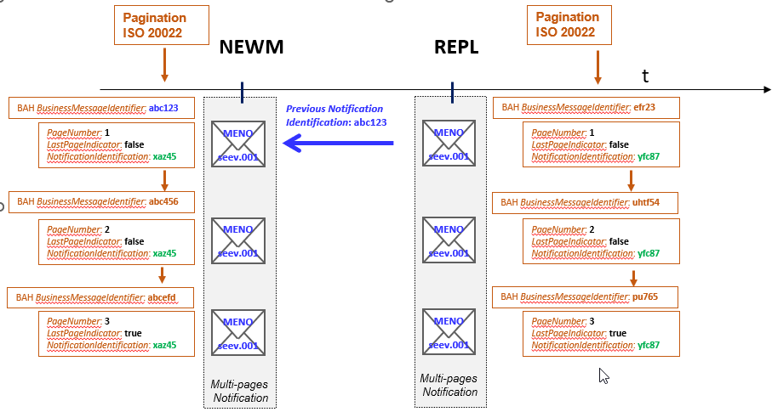

Example:

**New Meeting Notification (page 1/3)**

*BusinessMessageIdentifier:* ***abc123***

*PageNumber: 1*

*LastPageIndicator: false*

*NotificationIdentification:* ***xaz45***

*NotificationType: NEWM*

*Paginated information:*

*- Positions and Rights Holder (full)*

*- Resolutions 1,2,3 (part 1)*

New Meeting Notification (page 2/3)

*BusinessMessageIdentifier: abc456*

PageNumber: 2

LastPageIndicator: false

*NotificationIdentification:* ***xaz45***

*NotificationType: NEWM*

*Paginated information:*

*Resolutions 4,5,6,7,8,9 (Part 2)*

New Meeting Notification (page 3/3)

*BusinessMessageIdentifier: abcefd*

PageNumber: 3

LastPageIndicator: true

*NotificationIdentification:* ***xaz45***

*NotificationType: NEWM*

*Paginated information:*

*Resolutions 10,11 (Final part)*

*Disclaimer (Full)*

**Replacement Meeting Notification (page 1/3)**

*BusinessMessageIdentifier: efr23*

*PageNumber: 1*

*LastPageIndicator: false*

*NotificationIdentification:* ***yfc87***

*NotificationType: REPL*

*Paginated information:*

*- Positions and Rights Holder (full)*

*- Resolutions 1,2,3 (part 1)*

Replacement Meeting Notification (page 2/3)

*BusinessMessageIdentifier: uhtf54*

*PageNumber: 2*

*LastPageIndicator: false*

*NotificationIdentification:* ***yfc87***

*NotificationType: REPL*

*Paginated information:*

*Resolutions 4,5,6,7,8,9 (Part 2)*

Replacement Meeting Notification (page 3/3)

*BusinessMessageIdentifier: pu765*

*PageNumber: 3*

*LastPageIndicator: true*

*NotificationIdentification:* ***yfc87***

*NotificationType: REPL*

*Paginated information:*

*Resolutions 10,11,12 (Final part)*

*Disclaimer (Full)*

## Pagination of seev.004 (MEIN)

For long MeetingInstruction messages for which the length would overcome the maximum network payload size limit (for instance 10K characters on SWIFTNet FIN or 100 KB on SwiftNet Interact or FINplus for the payload), a pagination mechanism is available through the use of the *Pagination* element present at the top of these messages.

The need for pagination could occur when many atomic instructions (repetitions of Instruction building blocks) are populated into the message.

The split of the information contents within the MeetingInstruction message should follow the following guidelines:

1. In the first page of the meeting instruction message, the following building blocks should at least be present (if they contain information to be communicated):

* Meeting Instruction Identification
* Meeting Reference
* Financial Instrument Identification
* Instruction Cancellation Request Identification
* Cancelled Instruction Identification
* Other Document Identification
* and as many Instructions building blocks as possible

1. In any of the following pages, only the elements indicated as mandatory in the standards should be repeated. Optional elements should not be communicated more than once. If there are too many instructions that cannot fit in the first page, then fill in the following paginated meeting instructions with as many Instructions as possible.
2. The Pagination/PageNumber (<Pgntn/PgNb>) element in the seev.004 must start at page “1” and must be incremented by 1 for each subsequent pages.

**Usage of the BusinessMessageIdentifier, MeetingInstructionIdentification, & Pagination elements**

1. Each page of the MeetingInstruction message must have a different **BusinessMessageIdentifier** (<BizMsgIdr>) in the Business Application Header (BAH -head.001).
2. All pages of the same MeetingInstruction must bear the same “MeetingInstructionIdentification” reference.
3. All MeetingInstruction pages in the multi-parts chain of MeetingInstruction message must also be linked through the usage of the Pagination (<Pgntn>) element indicating the page number and whether this MeetingInstruction page is the last of the notification message.

## Pagination of the seev.007 (MECO)

For long MeetingVoteExecutionConfirmation messages for which the length would overcome the maximum network payload size limit (for instance 10K characters on SWIFTNet FIN or 100 KB on SwiftNet Interact or FINplus for the payload), a pagination mechanism is available through the use of the *Pagination* element present at the top of these messages.

The need for pagination could occur when many atomic vote instructions (repetitions of VotingInstructions building blocks) are populated into the messages.

The split of the information contents within the MeetingVoteExecutionConfirmation message should follow the following guidelines:

1. In the first page of the MeetingExecutionConfirmation message, the following building blocks should at least be present (if they contain information to be communicated):

* Vote Execution Confirmation Identification
* Meeting Instruction Identification
* Meeting Reference
* Financial Instrument Identification
* Vote Instructions Confirmation URL Address
* and as many VoteInstructions building blocks as possible

1. In any of the following pages, only the elements indicated as mandatory in the standards should be repeated. Optional elements should not be communicated more than once. If there are too many VoteInstructions that cannot fit in the first page, then fill in the following paginated MeetingVoteExecutionConfirmation with as many VoteInstructions as possible.
2. The Pagination/PageNumber (<Pgntn/PgNb>) element in the seev.007 must start at page “1” and must be incremented by 1 for each subsequent pages.

**Usage of the BusinessMessageIdentifier, VoteExecutionConfirmationIdentification, & Pagination elements**

1. Each page of the MeetingVoteExecutionConfirmation message must must have a different **BusinessMessageIdentifier** (<BizMsgIdr>) in the Business Application Header (BAH -head.001).
2. All pages of the same MeetingVoteExecutionConfirmation must bear the same “VoteExecutionConfirmationIdentification” reference.
3. All MeetingVoteExecutionConfirmation pages in the multi-parts chain of MeetingVoteExecutionConfirmation message must also be linked through the usage of the Pagination (<Pgntn>) element indicating the page number and whether this MeetingVoteExecutionConfirmation page is the last of the MeetingVoteExecutionConfirmation message.
   1. Pagination of the seev.008 (MERD)

For long MeetingResultDissemination messages for which the length would overcome the maximum network payload size limit (for instance 10K characters on SWIFTNet FIN or 100 KB on SwiftNet Interact or FINplus for the payload), a pagination mechanism is available through the use of the *Pagination* element present at the top of these messages.

The need for pagination could occur when many securities and many vote results (repetitions of *Security* and *VoteResult* building blocks) are populated into the messages. In order to minimise the need for pagination, the MeetingResultDissemination message should only contain a single security.

The split of the information contents within the MeetingResultDissemination message should follow the following guidelines:

1. In the first page of the MeetingResultDissemination message, the following building blocks should at least be present (if they contain information to be communicated):

* Meeting Result Dissemination Identification
* Meeting Result Dissemination Type
* Meeting Reference
* Security
* Participation
* and as many VoteResult building blocks as possible

1. In any of the following pages, only the elements indicated as mandatory in the standards should be repeated. Optional elements should not be communicated more than once. If there are too many VoteResult that cannot fit in the first page, then fill in the following paginated MeetingResultDissemination with as many VoteResult as possible.
2. The Pagination/PageNumber (<Pgntn/PgNb>) element in the seev.008 must start at page “1” and must be incremented by 1 for each subsequent pages.

**Usage of the BusinessMessageIdentifier, MeetingResultDisseminationIdentification & Pagination elements**

1. Each page of the MeetingResultDissemination message must must have a different **BusinessMessageIdentifier** (<BizMsgIdr>) in the Business Application Header (BAH -head.001).
2. All pages of the same MeetingResultDissemination must bear the same “**MeetingResultDisseminationIdentification**” reference.
3. All MeetingResultDissemination pages in the multi-parts chain of MeetingResultDissemination message must also be linked through the usage of the Pagination (<Pgntn>) element indicating the page number and whether this MeetingResultDissemination page is the last of the MeetingResultDissemination message.
4. In the case of a replacement (REPL) message, only the first page of the replacement MeetingResultDissemination message will link back to the first page of the previous MeetingResultDissemination using the PreviousMeetingResultsDisseminationIdentification (<PrvsMtgRsltsDssmntnId>) element.

This element shall contain the BusinessMessageIdentifier (<BizMsgIdr>) element value contained in the Business Application Header (head.001) of the previous message. All other pages (page 2 and following) of the MeetingResultDissemination message that are part of the multi-parts chain of notifications must NOT link back to the MeetingResultDissemination message chain sent previously (i.e. the initial NEWM or previous REPL) – Same principle as in the MeetingNotification messages in section A.