Shareholders Identification Disclosure messages
Market Practice

The Securities Market Practice Group is a group of experts that represents local markets or market infrastructures and who devote their time on a voluntary basis to define global and local market practices for the benefit of the securities industry. The time spent is sponsored by the market players. The market practice documentation and recommendations produced by this organisation are intended to solve common problems across the securities industry, from which financial institutions can derive clear benefits, to harmonise business processes and to facilitate the usage of message protocols ISO 15022 and ISO 20022. While the Securities Market Practice Group encourages the implementation of the market practices it develops it is up to the financial institutions within each market to implement the market practices according to their needs and agreements with their business counterparts to support their businesses as efficiently as possible. For more information on the MP release cycle please refer to the SMPG by-laws document section 4 on www.smpg.info.

Status: v2.0
Preparation Date: February 2023
Publication Date: July 2023
Implementation Date: November 2023
Author: SMPG CA WG

Table of Contents

I. Revision Record 3
II. Introduction: 4
III. Scope and definitions: 4
IV. Actors and Roles: 5
V. Activity Diagram: 6
VI. Message Flows illustrations: 7
VII. Shareholders Identification Disclosure Request 12
A. Scope. 12
B. Common mandatory business data requirements. 12
C. Optional business data requirements. 14
VIII. Shareholders Identification Disclosure Request Cancellation Advice 15
A. Scope. 15
B. Common mandatory business data requirements. 15
C. Optional business data requirements. 16
IX. Shareholders Identification Disclosure Response 17
A. Scope. 17
B. Common mandatory business data requirements. 17
C. Optional business data requirements. 19
D. Pagination for the Shareholder Identification Disclosure Response Message 20
X. Shareholders Identification Disclosure Response Cancellation Advice 22
A. Scope. 22
B. Common mandatory business data requirements. 22
C. Optional business data requirements. 23
XI. Shareholders Identification Disclosure Response Status Advice 24
A. Scope. 24
B. Common mandatory business data requirements. 24
C. Optional business data requirements. 25

Revision Record

Version | Publication Date | Sections Affected | Description
SR2023  v2.0 | July 2023 | II, III, IV, VI, VII, XIII, IX | Inclusion of SR2023 changes – New element <PlacOfJur> and <AppLaw>. Changes to extend the usage of these messages to other disclosure requests than those within EU directive (SRDII).
SR2021 v1.0 | 12 October 2021 | IX B. | Detailed Usage information amended for: Account servicer, Shareholding Balance On Own Account, Shareholding Balance On Client Account, Total Shareholding Balance
SR2021 v0.1 DRAFT | 27 July 2021 | VII C.  IX B. | Inclusion of SR2021 changes:  - New element “PreviousDisclosureRequestIdentification”  - Pagination, SafekeepingAccount
SR2020 | 26 June 2020 |  | Initial version for SR2020

Introduction:

Shareholder identification ISO 20022 messages were originally designed to comply with the Shareholders Rights Directive (EU) 2017/828 and Implementing Regulation (EU) 2018/1212 (hereinafter “SRD II”).

Although this market practice is primarily based on SRD II and the SRD II Market Standards for Shareholder Identification, shareholder identification messages could also be used to address other requests to disclose the right holders identity, as long as the flow of information from the right-holder to the issuer follow the message flow described in this document.

The use of the corporate action notifications and instructions messages (in ISO 15022 or ISO 20022 formats) with corporate action event type code DSCL/Disclosure, is not compliant with SRD II, but will remain in the ISO standards for other disclosure processes/purposes.

Scope and definitions:
The scope of this document is to describe the market practice for using the Shareholders Identification Disclosure messages.
The market practices described in this document are meant to be used exclusively with the following ISO 20022 messages and the business application header (BAH) - head.001.001.0x:
MessageDefinition | Abbreviated Name | Message Identifier
ShareholderIdentificationDisclosureRequest | SIDR | seev.045.001.04
ShareholderIdentificationDisclosureRequestCancellationAdvice | SIDC | seev.046.001.01
ShareholderIdentificationDisclosureResponse | SIRE | seev.047.001.02
ShareholderIdentificationDisclosureResponseCancellationAdvice | SIRC | seev.048.001.01
ShareholderIdentificationDisclosureResponseStatusAdvice | SIRS | seev.049.001.01
SecuritiesMessageRejection |  | semt.001.001.004

All documentation related to shareholder identification messages is available in the UHB on-line page on swift.com in the Knowledge Centre: https://www2.swift.com/knowledgecentre/products/Standards%20MX

The 5 new shareholder identification messages and the securities message rejection are available on MyStandard at: https://www2.swift.com/mystandards/#/ISO20022?businessDomain=Securities in the “securities events” section and “securities management” section. Both PDF or Excel or schemas (with an MS license) can be exported. The documentation and schemas are also available on the www.ISO20022.org web site: ISO 20022 Message Definitions | ISO20022 under the “ShareholderIdentificationDisclosure” title.

Actors and Roles:
The main roles involved in this process:
- Issuer

The party that has issued the securities and is requesting the identity of its rights holders.
In SRD II context:
A company which has its registered office in a Member State and the shares of which are admitted to trading on a regulated market situated or operating within a Member State or a third party nominated by such a company for the tasks set out in this Regulation.

- Third party/issuer agent
The third party to whom the issuer has delegated responsibility for sending the request and/or receiving responses. This is an optional role; the issuer may elect to send the request and/or to receive responses itself. Any intermediary, including the issuer’s Central Security Depository (CSD), can act as third party/issuer agent.

- Central Security Depository (CSD)
The issuer CSD is the CSD in which the securities have been issued. The issuer CSD is the primary register for the issuance, unless this function is performed by another party, such as a registrar. A CSD can also have an account with the issuer CSD to enable the cross-system settlement of securities transactions.

- Intermediary
An institution that holds securities on behalf of other institutions and/or end investors (natural or legal persons). A CSD is also an intermediary.

  - Local custodian
The party that acts as CSD member, holding assets on behalf of clients in one or more securities accounts in the books and records of the issuer CSD. The local custodian may be the last intermediary, i.e. a client may be the end investor/shareholder.
  - Global custodian
The party that acts as client of the CSD member, in turn holding assets on behalf of clients in one or more securities accounts in the books and records of the local custodian. The global custodian may be the last intermediary, i.e. a client may be the end investor/shareholder.

There may be additional intermediaries. We will limit the market practice to the main roles and actors.

Activity Diagram:
Possible alternative flow:
Direct disclosure request to Intermediary
Legend
Possible alternative flow:
Response through Chain
Issuer
Request
Response
First
Intermediary
Last Intermediary
Disclosure Request
Initiator / Response Recipient
- Disclosure Request
- Cancellation Advice
Shareholder
- Disclosure Response
- Response Cancellation
- Disclosure Response Status
- Disclosure Response
- Response Cancellation
- Disclosure Response Status
- Disclosure Response
- Response Cancellation
- Disclosure Response Status
- Disclosure Request
- Cancellation Advice
- Disclosure Request
- Cancellation Advice
- Disclosure Request
- Cancellation Advice
- Disclosure Request
- Cancellation Advice
ISO Messaging Solution Scope
Intermediary
X+1
Intermediary X

Note: the Securities Message Rejection message can be used by the first intermediary to reject a shareholder identification request.

SRD II Message Flows illustrations:
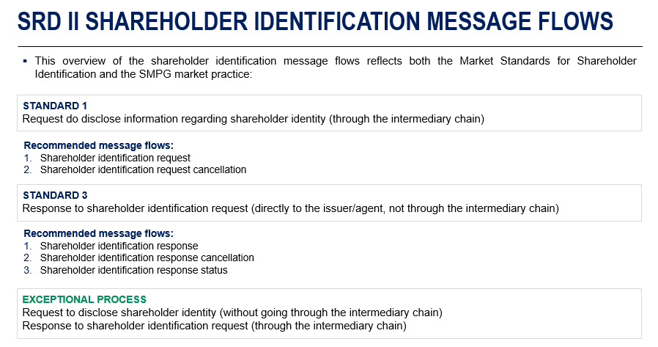

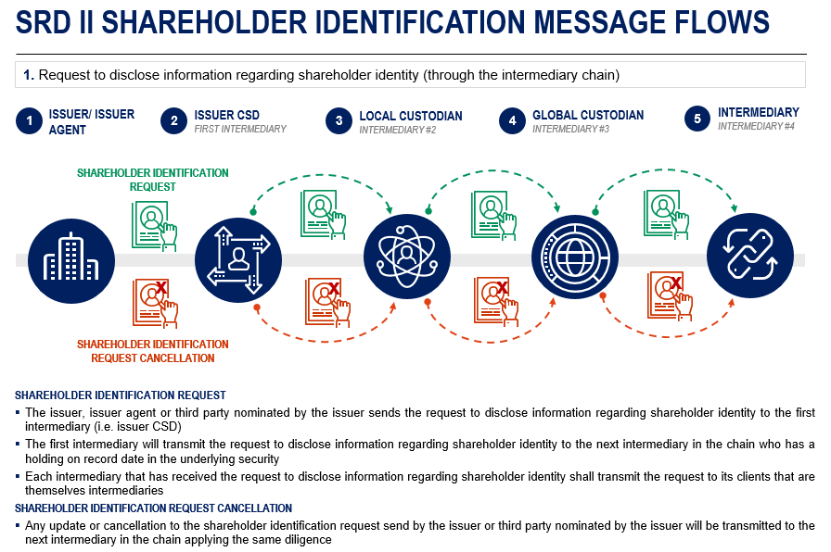

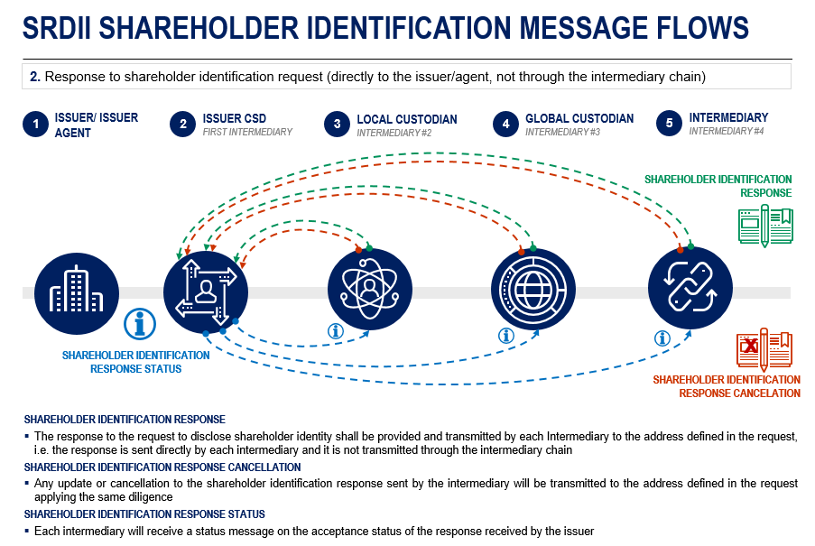

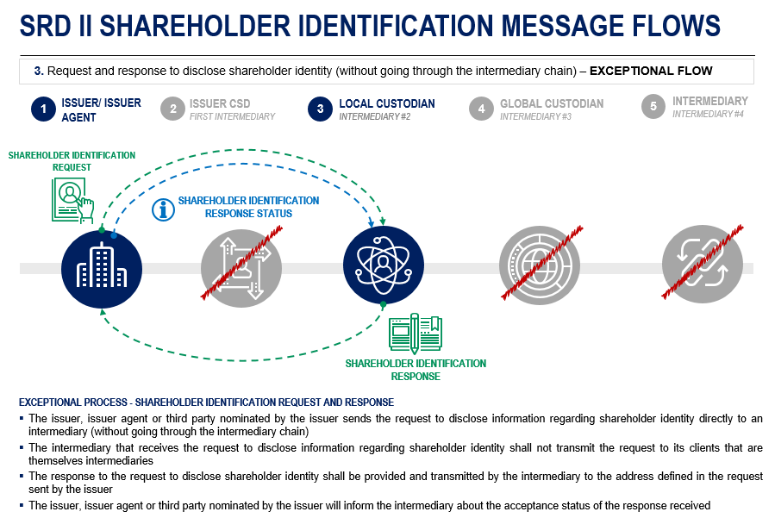

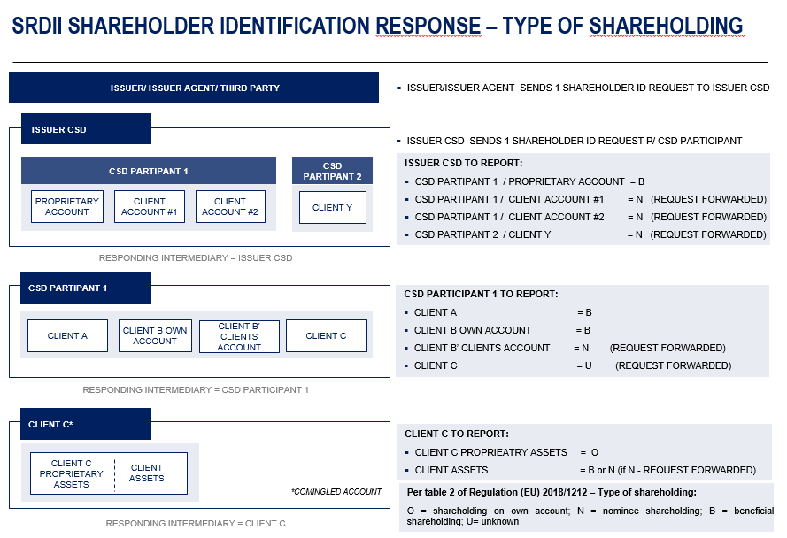

Shareholders Identification Disclosure Request

Scope.
For the above-described different communication needs, the following business data are required. Focus is on the processes described in the MP,

Common mandatory business data requirements.
The SMPG recommends that all the below optional and mandatory elements be present in all Shareholders Identification Disclosure Request messages. M / C / O identifies whether the business data is mandatory, conditional or optional in the ISO 20022 standards.

Common mandatory elements | Place | Detailed usage | M/C/O | SRD II reference
From, <Fr> | BAH | The sender from a business context, which can be different than the actual sender in the transport header (similar to MEOR in MT). BICFI is the preferred format.  Please refer to appendix I for more details. | M
To, <To> | BAH | The receiver from a business context, which can be different than the actual receiver in the transport header (similar to MERE in MT). BICFI is the preferred format.  Please refer to appendix I for more details. | M
BusinessMessageIdentifier, <BizMsgIdr> | BAH | The sender’s unique ID/reference of the message | M
MessageDefinitionIdentifier, <MsgDefIdr> | BAH | Contains the MessageIdentifier that defines the BusinessMessage, e.g. seev.045.001.xx | M
CreationDate, <CreDt> | BAH | Date and time, using ISONormalisedDateTime format | M
Issuer Disclosure Request Identification, <IssrDsclsrReqId> | Document |  | M | Table 1 – A1
Disclosure Request Type, <DsclsrReqTp> | Document | A REPL message should only be sent in case of a change in the issuer deadline of a previously announced request.  In case any other element in the request changes, the request should be withdrawn/cancelled. | M | Table 1 – A2
Forward Request Indicator, <FwdReqInd> | Document | This indicator should always be present to avoid any misunderstanding. | O | Table 1 – A3
ShareholderRightsDirectiveIndicator <ShrhldrRghtsDrctvInd> | Document | This indicator should be used to identify shareholder identification requests issued under SRDII as per its transposition in the local law. This indicator should be set by the issuer CSD or first intermediary. It should be set to YES (value “true”) only when the request is in scope of SRD II and the request has been received from the issuer.  When the indicator is set to NO (value ”false”), the request is to be intended as in scope of SRDII but the issuer CSD or first intermediary did not receive it from the issuer.  Any other intermediary in the chain should report the value of this indicator as per the value received from the previous intermediary.  If the shareholder identification request is outside the scope of SRD II, this indicator should not be populated. | C
Place Of Jurisdiction  <PlcOfJursdctn> | Document | This data element should record the country/jurisdiction of the governing law under which the holder identification request is issued.  It should not be populated for requests issued under SRDII or its transposition laws. | C
Applicable Law  <AplblLaw> | Document | This data element should record the applicable law under which the holder identification request is issued. It should not be populated for requests issued under SRDII or its transposition laws.  A list of such applicable laws, albeit not complete or exhaustive, can be found in appendix II. | O
Financial Instrument Identification, <FinInstrmId> | Document | ISIN is the preferred format | M | Table 1 – A4
Shareholders Disclosure Record Date, <ShrhldrsDsclsrRcrdDt> | Document | Date (YYYY-MM-DD) is the preferred format | M | Table 1 – A5
Disclosure Response Recipient - Identification, <Id> | Document | LEI is the preferred format | M | Table 1 – B1
Disclosure Response Recipient - Recipient Name, <RcptNm> | Document |  | M | Table 1 – B2
Disclosure Response Recipient -Response Recipient Address, <RspnRcptAdr> | Document | AnyBIC is the preferred format. | M | Table 1 – B3
Issuer Disclosure Deadline, <IssrDsclsrDdln> | Document | DateTime in UTC format is the preferred format (YYYY-MM-DDThh:mm:ss.sssZ (Z means Zulu Time ≡ UTC time ≡ zero UTC offset)) | M | Table 1 – A6

Optional business data requirements.
The below optional elements may be provided in a Shareholders Identification Disclosure Request message but are optional. If used, they must be used as described in the “Detailed usage” column. It is to be noted that most of the usage rules are standards rules, not market practice recommendations.
Any other elements not mentioned above or below are considered NOT needed for this specific type of message. If used, they will be market-specific.

Common optional elements | Place | Detailed usage | M/C/O | SRD II reference
Previous Disclosure Request Identification <PrvsDsclsrReqId> | Document | To only be used when sending a REPL message. Provides the identification of a previously sent disclosure request message (Business Message Identifier). | O
Response Through Chain Indicator, <RspnThrghChainInd> | Document | In line with the shareholder identification market standards, the shareholder identification response should be sent directly to the issuer or the third party appointed by the issuer.  This indicator should ONLY be present when the response has to go through the chain. | O
Shares Quantity Threshold, <ShrsQtyThrshld> | Document | If used, it has to be provided by the issuer as a quantity of shares | O | Table 1 – A7
Request Share Held Date, <ReqShrHeldDt> | Document | In line with the shareholder identification market standards, this indicator should NOT be used.  If present, the issuer must also specify the method to be used to calculate the date and the description | O | Table 1 – A8
Date Calculation Method, <DtClctnMtd> | Document | Only to be used if the Request Share Held Date is present | C
Disclosure Response Deadline <DsclsrRspnDdln> | Document | Only to be used if the response is to be sent through the chain as indicated in Response Through Chain Indicator | O
Issuer  <Iss> | Document | In case the issuer wants to provide information beyond the ISIN, they can optionally provide their name and address and the LEI.  LEI is the preferred format. | O
C*: The block is optional, but if the block is included, the element is mandatory.

Once received, it is recommended that each intermediary sends one request per downstream intermediary (N or U) with a holding or pending transaction in the underlying financial instrument, according to the BIC/DN specified for the message type.

The following examples should illustrate which combinations of ShareholderRightsDirectiveIndicator <ShrhldrRghtsDrctvInd>, Place Of Jurisdiction<PlacOfJur> and Applicable Law<AppLaw> are valid.

ShareholderRightsDirectiveIndicator <ShrhldrRghtsDrctvInd> | Place Of Jurisdiction  <PlcOfJursdctn> | Applicable Law  <AplblLaw> | Comments
Y | N | N | The SRD indicator should only be set to true if the request falls within the scope of SRD II.
N | Y | Y

Shareholders Identification Disclosure Request Cancellation Advice

Scope.
For the above-described different communication needs, the following business data are required. Focus is on the processes described in the MP.

Common mandatory business data requirements.
The SMPG recommends that all the below optional and mandatory elements be present in all Shareholders Identification Disclosure Request Cancellation Advice messages. M / C / O identifies whether the business data is mandatory, conditional or optional in the ISO 20022 standards.

Common mandatory elements | Place | Detailed usage | M/C/O | SRD II reference
From, <Fr> | BAH | The sender from a business context, which can be different than the actual sender in the transport header (similar to MEOR in MT). BICFI is the preferred format.  Please refer to appendix I for more details. | M
To, <To> | BAH | The receiver from a business context, which can be different than the actual receiver in the transport header (similar to MERE in MT). BICFI is the preferred format.  Please refer to appendix I for more details. | M
BusinessMessageIdentifier, <BizMsgIdr> | BAH | The sender’s unique ID/reference of the message | M
MessageDefinitionIdentifier, <MsgDefIdr> | BAH | Contains the MessageIdentifier that defines the BusinessMessage, e.g. seev.046.001.01 | M
CreationDate, <CreDt> | BAH | Date and time, using ISONormalisedDateTime format | M
Issuer Disclosure Request Identification, <IssrDsclsrReqId> | Document |  | M
Financial Instrument Identification, <FinInstrmId> | Document | ISIN is the preferred format | M
Shareholders Disclosure Record Date, <ShrhldrsDsclsrRcrdDt> | Document | Date (YYYY-MM-DD) is the preferred format | M
CancellationReason, <CxlRsn> | Document | WITH is ONLY to be used in case of a cancellation triggered by the issuer or the third party appointed by the issuer. For any other scenario, PROC should be used. | M

Optional business data requirements.
The below optional elements may be provided in a Shareholders Identification Disclosure Request Cancellation Advice message but are optional. If used, they must be used as described in the “Detailed usage” column. It is to be noted that most of the usage rules are standards rules, not market practice recommendations.
Any other elements not mentioned above or below are considered NOT needed for this specific type of message. If used, they will be market-specific.

Common optional elements | Place | Detailed usage | M/C/O | SRD II reference
Related – From, <Fr> | BAH | Optional block in the BAH, for the related message: the sender from a business context, which can be different than the actual sender in the transport header (similar to MEOR in MT). BICFI is the preferred format | C*
Related – To, <To> | BAH | Optional block in the BAH, for the related message: the receiver from a business context, which can be different than the actual receiver in the transport header (similar to MERE in MT). BICFI is the preferred format | C*
Related – BusinessMessageIdentifier, <BizMsgIdr> | BAH | Optional block in the BAH, for the related message: the sender’s unique ID/reference of the message | C*
Related – MessageDefinitionIdentifier, <MsgDefIdr> | BAH | Optional block in the BAH, for the related message: contains the MessageIdentifier that defines the BusinessMessage, e.g. seev.045.001.xx | C*
Related – CreationDate, <CreDt> | BAH | Optional block in the BAH, for the related message: date and time, using ISONormalisedDateTime format | C*

C*: The block is optional, but if the block is included, the element is mandatory.

Shareholders Identification Disclosure Response

Scope.
For the above-described different communication needs, the following business data are required. Focus is on the processes described in the MP:

Common mandatory business data requirements.
The SMPG recommends that all the below optional and mandatory elements be present in all Shareholders Identification Disclosure Response messages. M / C / O identifies whether the business data is mandatory, conditional or optional in the ISO 20022 standards.

Common mandatory elements | Place | Detailed usage |  | M/C/O | SRD II reference
From, <Fr> | BAH | The sender from a business context, which can be different than the actual sender in the transport header (similar to MEOR in MT). BICFI is the preferred format.  Please refer to appendix I for more details. |  | M
To, <To> | BAH | The receiver from a business context, which can be different than the actual receiver in the transport header (similar to MERE in MT). BICFI is the preferred format.  Please refer to appendix I for more details. |  | M
BusinessMessageIdentifier, <BizMsgIdr> | BAH | The sender’s unique ID/reference of the message |  | M
MessageDefinitionIdentifier, <MsgDefIdr> | BAH | Contains the MessageIdentifier that defines the BusinessMessage, e.g. seev.047.001.xx |  | M
CreationDate, <CreDt> | BAH | Date and time, using ISONormalisedDateTime format |  | M
Pagination | Document | Recommended to be used even if the response only include one page. The pagination starts at number 1 and is incremented of 1 unit at each new page. |  | O
Issuer Disclosure Request Identification, <IssrDsclsrReqId> | Document |  |  | M | Table 2 – A1
Financial Instrument Identification, <FinInstrmId> | Document | ISIN is the preferred format |  | M | Table 2 – A4
Shareholders Disclosure Record Date, <ShrhldrsDsclsrRcrdDt> | Document | Date (YYYY-MM-DD) is the preferred format |  | M | Table 2 – A5
Disclosure Response Identification, <DsclsrRspnId> | Document |  |  | M | Table 2 – A2
Responding Intermediary – Name, <Nm> | Document |  |  | M | Table 2 – B2
Responding Intermediary – Identification, <Id> | Document | LEI is the preferred format |  | M | Table 2 – B1
Responding Intermediary – Contact Person, <CtctPrsn> | Document | Name and email address are recommended |  | O
Safekeeping Account, <SfkpgAcct> | Document | Safekeeping account that the responding intermediary has with the intermediary up the chain.  The first intermediary should use “N/A”. |  | M | Table 2 – B7
Account Servicer, <AcctSvcr> | Document | Intermediary up the chain from the responding intermediary, i.e. the entity where the responding holds the above safekeeping account. LEI is the preferred format.  The first intermediary should use the “Identification” and “Issuer” fields set to “N/A” in the ProprietaryIdentification sequence. |  | M | Table 2 – B6
Shareholding Balance On Own Account, <ShrhldgBalOnOwnAcct> | Document | Quantity of securities held by the responding intermediary for its own account, as settled position at end of day on Shareholders Disclosure Record Date. May include non-disclosed or below threshold balances. |  | M | Table 2 – B4
Shareholding Balance On Client Account, <ShrhldgBalOnClntAcct> | Document | Quantity of securities held by the responding intermediary on behalf of clients, as settled position at end of day on Shareholders Disclosure Record Date. May include non-disclosed or below threshold balances. |  | M | Table 2 – B5
Total Shareholding Balance, <TtlShrhldgBal> | Document | Sum of the securities quantity held by the responding intermediary for its own account and of securities quantity held on behalf of clients, as settled position at end of day on Shareholders Disclosure Record Date. May include non-disclosed or below threshold balances. |  | M | Table 2 – B3
Non Disclosed Shareholding Quantity, <NonDscldShrhldgQty> | Document | This element is to be used to indicate any securities quantity held by clients of the responding intermediary who have prohibited disclosure.  This element should be used only when the quantity is not zero. |  | O
Below Threshold Shareholding Quantity, <BlwThrshldShrhldgQty> | Document | This element is to be used to indicate any securities quantity held by clients of the responding intermediary having a balance below threshold.  This element should be used only when the quantity is not zero. |  | O
Safekeeping Account, <SfkpgAcct> | Document | The account number at the responding intermediary.  Recommended to be included to facilitate the issuer’s reconciliation.  The account should be a real account (no narrative or institution names).
Account Holder – Legal Person – Name And Address, <NmAndAdr> | Document |  |  | M | Table 2 – C2(a) and C3-9
Account Holder – Legal Person – Identification, <Id> | Document | LEI or national registration number are the preferred formats |  | M | Table 2 – C1(a)
Account Holder – Natural Person – Name And Address, <NmAndAdr> | Document |  |  | M | Table 2 – C2(b) and C3-9
Account Holder – Natural Person – Identification, <Id> | Document | See Appendix III |  | M | Table 2 – C1(b)
Shareholding Type, <ShrhldgTp> | Document |  |  | M | Table 2 – C10
Quantity, <Qty> | Document |  |  | M | Table 2 – C11

Optional business data requirements.
The below optional fields may be provided in a Shareholders Identification Disclosure Response message but are optional. If used, they must be used as described in the “Detailed usage” column. It is to be noted that most of the usage rules are standards rules, not market practice recommendations.
Any other fields not mentioned above or below are considered NOT needed for this specific type of message. If used, they will be market-specific.

Common optional elements | Place | Detailed usage | M/C/O | SRD II reference
Initial Date Of Shareholding, <InitlDtOfShrhldg> | Document | To be reported only if and as requested in the SI request.  Date (YYYY-MM-DD) is the preferred format | C | Table 2 – C12
Third Party – Role, <Role> | Document | To be used with code DECM, to report the details of the third party who is authorised to take investment decisions on behalf of the shareholder | O | Table 2 – C13
Third Party – Name, <Nm> | Document | To be used to report the name of the third party | O | Table 2 – C13
Third Party – Identification, <Id> | Document | To be used to report the ID of the third party  LEI is the preferred format | O | Table 2 – C14

Pagination for the Shareholder Identification Disclosure Response Message
If the amount of shareholding information to be sent to the response recipient in the ShareholdersIdentificationDisclosureResponse (seev.047) message is too large for a single message, the responding intermediary may split the information in several paginated seev.047.
In a set of paginated disclosure response messages, all common mandatory elements must bear the same values across all pages. It is also recommended to repeat all common optional elements in each pages as well.
The “BusinessMessageIdentifier” element in the Business Application Header (BAH) must be different for each paginated message. However, the “DisclosureResponseIdentification” element value in the seev.047 message will be identical for all pages.
Pagination must start at page “1” and incremented by 1 at each subsequent page.

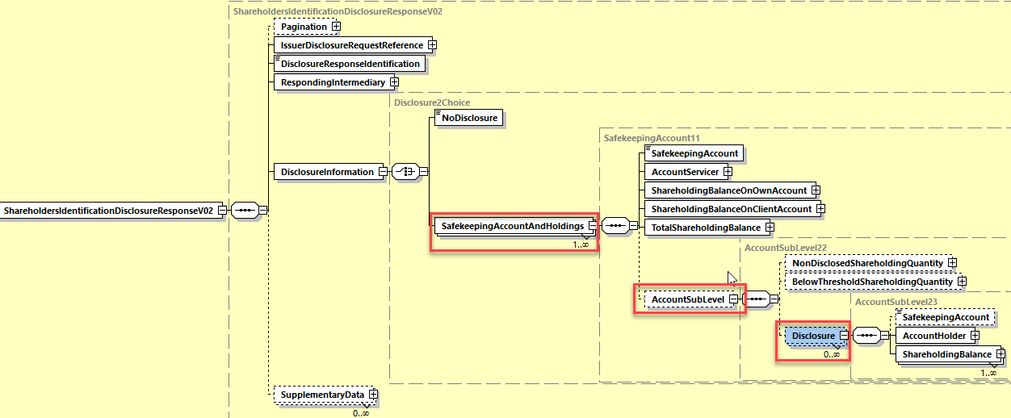

Shareholders Identification Disclosure Response Cancellation Advice

Scope.
For the above-described different communication needs, the following business data are required. Focus is on the processes described in the MP:

Common mandatory business data requirements.
The SMPG recommends that all the below optional and mandatory elements be present in all Shareholders Identification Disclosure Response Cancellation Advice messages. M / C / O identifies whether the business data is mandatory, conditional or optional in the ISO 20022 standards.

Common mandatory elements | Place | Detailed usage | M/C/O | SRD II reference
From, <Fr> | BAH | The sender from a business context, which can be different than the actual sender in the transport header (similar to MEOR in MT). BICFI is the preferred format.  Please refer to appendix I for more details. | M
To, <To> | BAH | The receiver from a business context, which can be different than the actual receiver in the transport header (similar to MERE in MT). BICFI is the preferred format.  Please refer to appendix I for more details. | M
BusinessMessageIdentifier, <BizMsgIdr> | BAH | The sender’s unique ID/reference of the message | M
MessageDefinitionIdentifier, <MsgDefIdr> | BAH | Contains the MessageIdentifier that defines the BusinessMessage, e.g. seev.048.001.01 | M
CreationDate, <CreDt> | BAH | Date and time, using ISONormalisedDateTime format | M
Disclosure Response Identification, <DsclsrRspnId> | Document |  | M
Issuer Disclosure Request Identification, <IssrDsclsrReqId> | Document |  | M
Financial Instrument Identification, <FinInstrmId> | Document | ISIN is the preferred format | M
Shareholders Disclosure Record Date, <ShrhldrsDsclsrRcrdDt> | Document | Date (YYYY-MM-DD) is the preferred format | M
Responding Intermediary – Name, <Nm> | Document |  | M
Responding Intermediary – Identification, <Id> | Document | LEI is the preferred format | M

Optional business data requirements.
The below optional elements may be provided in a Shareholders Identification Disclosure Response Cancellation Advice message but are optional. If used, they must be used as described in the “Detailed usage” column. It is to be noted that most of the usage rules are standards rules, not market practice recommendations.
Any other elements not mentioned above or below are considered NOT needed for this specific type of message. If used, they will be market-specific.

Common optional elements | Place | Detailed usage | M/C/O | SRD II reference
Related – From, <Fr> | BAH | Optional block in the BAH, for the related message: the sender from a business context, which can be different than the actual sender in the transport header (similar to MEOR in MT). BICFI is the preferred format | C*
Related – To, <To> | BAH | Optional block in the BAH, for the related message: the receiver from a business context, which can be different than the actual receiver in the transport header (similar to MERE in MT). BICFI is the preferred format | C*
Related – BusinessMessageIdentifier, <BizMsgIdr> | BAH | Optional block in the BAH, for the related message: the sender’s unique ID/reference of the message | C*
Related – MessageDefinitionIdentifier, <MsgDefIdr> | BAH | Optional block in the BAH, for the related message: contains the MessageIdentifier that defines the BusinessMessage, e.g. seev.047.001.xx | C*
Related – CreationDate, <CreDt> | BAH | Optional block in the BAH, for the related message: date and time, using ISONormalisedDateTime format | C*
C*: The block is optional, but if the block is included, the element is mandatory.

Shareholders Identification Disclosure Response Status Advice

Scope.
For the above-described different communication needs, the following business data are required. Focus is on the processes described in the MP:

Common mandatory business data requirements.
The SMPG recommends that all the below optional and mandatory elements be present in all Shareholders Identification Disclosure Response Status Advice messages. M / C / O identifies whether the business data is mandatory, conditional or optional in the ISO 20022 standards.

Common mandatory elements | Place | Detailed usage | M/C/O | SRD II reference
From, <Fr> | BAH | The sender from a business context, which can be different from the actual sender in the transport header (similar to MEOR in MT). BICFI is the preferred format.  Please refer to appendix I for more details. | M
To, <To> | BAH | The receiver from a business context, which can be different from the actual receiver in the transport header (similar to MERE in MT). BICFI is the preferred format.  Please refer to appendix I for more details. | M
BusinessMessageIdentifier, <BizMsgIdr> | BAH | The sender’s unique ID/reference of the message | M
MessageDefinitionIdentifier, <MsgDefIdr> | BAH | Contains the MessageIdentifier that defines the BusinessMessage, e.g. seev.049.001.xx | M
CreationDate, <CreDt> | BAH | Date and time, using ISONormalisedDateTime format | M
Disclosure Response Identification, <DsclsrRspnId> | Document |  | M
Issuer Disclosure Request Identification, <IssrDsclsrReqId> | Document |  | M
Financial Instrument Identification, <FinInstrmId> | Document | ISIN is the preferred format | M
Shareholders Disclosure Record Date, <ShrhldrsDsclsrRcrdDt> | Document | Date (YYYY-MM-DD) is the preferred format | M
Responding Intermediary – Name, <Nm> | Document |  | M
Responding Intermediary – Identification, <Id> | Document | LEI is the preferred format | M
Response Reception Status, <RspnRcptnSts> | Document | It can only contain the status as “accepted” or “rejected”. In case of a rejection, a rejection reason can be specified | M

Optional business data requirements.
The below optional elements may be provided in a Shareholders Identification Disclosure Response Status Advice message but are optional. If used, they must be used as described in the “Detailed usage” column. It is to be noted that most of the usage rules are standards rules, not market practice recommendations.
Any other elements not mentioned above or below are considered NOT needed for this specific type of message. If used, they will be market-specific.

Common optional elements | Place | Detailed usage | M/C/O | SRD II reference
Related – From, <Fr> | BAH | Optional block in the BAH, for the related message: the sender from a business context, which can be different from the actual sender in the transport header (similar to MEOR in MT). BICFI is the preferred format | C*
Related – To, <To> | BAH | Optional block in the BAH, for the related message: the receiver from a business context, which can be different from the actual receiver in the transport header (similar to MERE in MT). BICFI is the preferred format | C*
Related – BusinessMessageIdentifier, <BizMsgIdr> | BAH | Optional block in the BAH, for the related message: the sender’s unique ID/reference of the message | C*
Related – MessageDefinitionIdentifier, <MsgDefIdr> | BAH | Optional block in the BAH, for the related message: contains the MessageIdentifier that defines the BusinessMessage, e.g. seev.047.001.xx | C*
Related – CreationDate, <CreDt> | BAH | Optional block in the BAH, for the related message: date and time, using ISONormalisedDateTime format | C*

C*: The block is optional, but if the block is included, the element is mandatory.

Securities Message Rejection

Scope.
The first intermediary sends the SecuritiesMessageRejection message to the sender (an issuer, its authorised agent or third party), to reject a previously received message on which action cannot be taken, like the sender doesn’t comply with minimum requirements to allow processing at first intermediary level (for example for seev.045, seev.001, seev.031). The message should be used with the business Application Header.

Appendix I – Usage of From <Fr> and To <To> in the Business Application Header (BAH)

As a way of an example:
- issuer A uses third party α to issue shareholder identification requests and receive/consolidate all shareholder identification responses
- intermediary ABC outsource the processing of shareholder identification requests to provider XYZ
- issuer A sends a shareholder identification for the attention of intermediary ABC
- intermediary ABC provides shareholder details back to issuer A

Shareholder identification request
A seev.045 is issued by third party α to provider XYZ with the details of issuer A in From, <Fr> and the details of intermediary ABC in To, <To>

Shareholder identification response
A seev.047 is issued by to provider XYZ to third party α with the details of intermediary ABC in From, <Fr> and the details of issuer A in To, <To>

Appendix II – List of Applicable Laws

Please note that this table only provide certain applicable laws and it is not meant to be complete or exhaustive. Rightsholders and their intermediaries should take their own legal advice on the matter.

Country | Applicable Law
Ireland | Section 062 of the Companies Act 2014
UK | Section 493 of Companies Act 2006

Appendix III – National client identifiers for natural persons

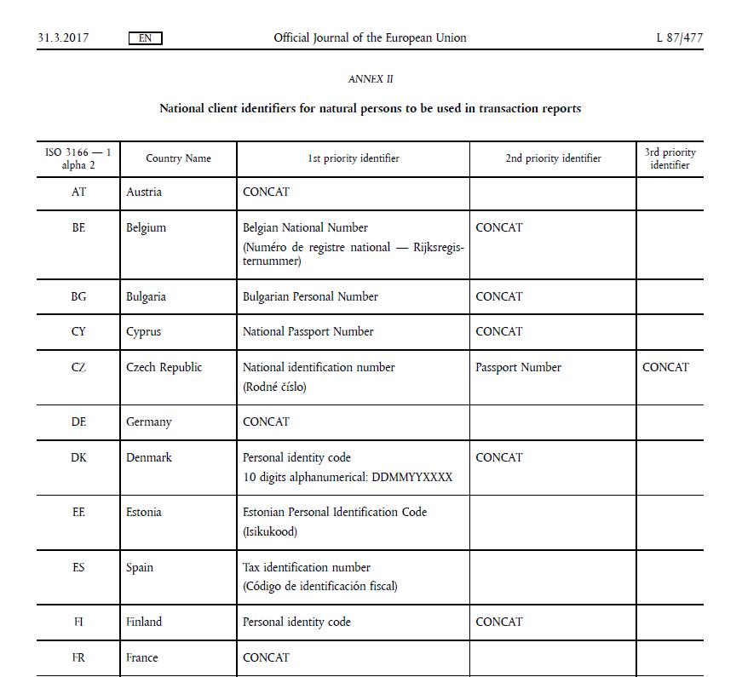

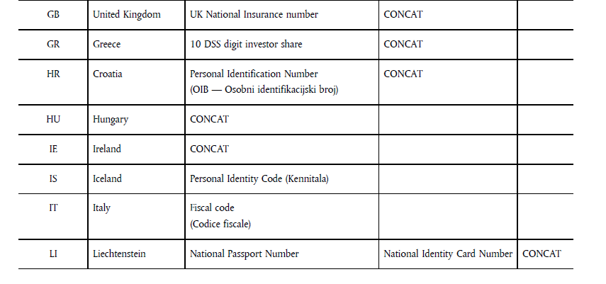
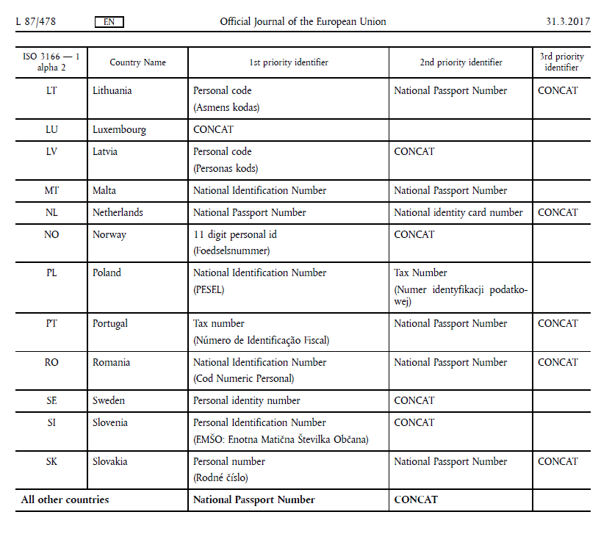

This column map each element in the messages to table I and II in SRDII implementing regulation. Although these messages were originally created to comply with SRD II, they could also be used to address other requests to disclose the right holders identity, as long as the flow of information from the right-holder to the issuer follow the message flow described in this document.

