Change Request
for the update of ISO 20022 financial repository items
Note: the purpose of this document is to give guidelines to parties who want to introduce a request to change an existing ISO 20022 message(s), or update other items of the ISO 20022 financial repository. Such change requests are subject to the approval of the ISO 20022 Standards Evaluation Group(s) in charge of the related message/item or to the approval of the Technical Support Group (TSG), if the requested change relates to the Business Application Header (BAH). Please consult the iso20022.org website for additional details on the maintenance process. Change requests are to be sent to iso20022ra@iso20022.org. All change requests conforming to this template received by June 1st will be considered for development in the following yearly ISO 20022 maintenance cycle which completes with publication of new message versions in April/May of the following year.
- Origin of the request:

Euronext CPH, NMPG Denmark

Submitted by Randi Hattens rmhattens@euronext.com ph: +45 28 44 50 19
- Related messages:

Seev.036* (and FIN 15022 MT566)

- Description of the change request:

The change request to align and clean up 15022 and 20022 msg with regards to market claim indicators

Currently there are ADDB indicators in the ISO 20022 msg seev.036* (and FIN MT566 msg) that should not be used in these msg.
These ADDB indicators are ACLA, CNTR, NAMC for ISO 20022
And ACLA, ACTF, CNTR and NAMC for FIN 15022

Please find below overview of msg. and indicators to be removed:

MT566
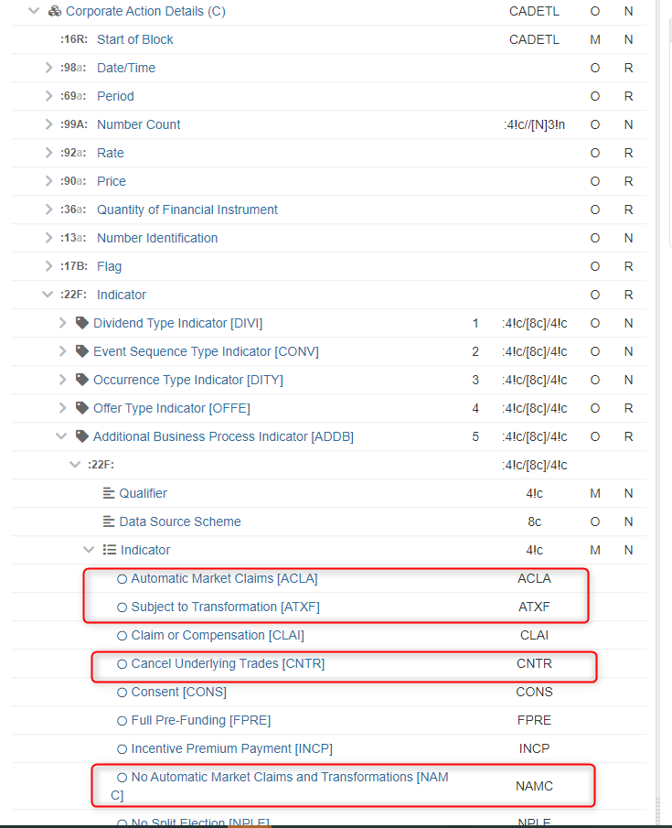

Seev.036

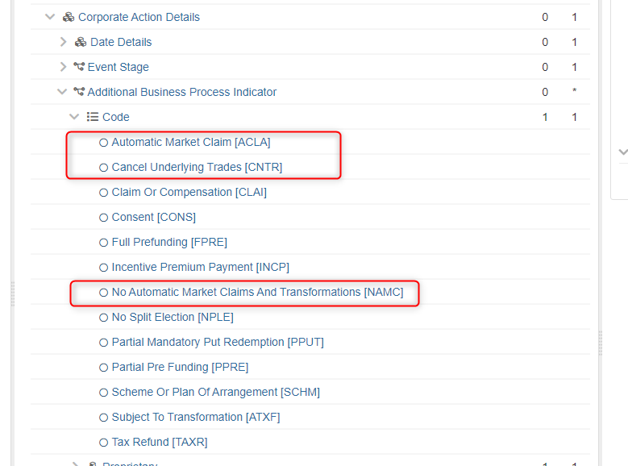

- Purpose of the change:
To align ISO 15022 and 20022 with market claim indicators and remove unused ADDBs in MT566 and seev.036.

- Urgency of the request:
SR2024

- Business examples:
Examples illustrating the change request.
- SEG/TSG recommendation:
This section is not to be taken care of by the submitter of the change request. It will be completed in due time by the SEG(s) in charge of the related ISO 20022 messages or the TSG for changes related to the BAH.

Consider |  |  | Timing
- Next yearly cycle: 2023/2024
(the change will be considered for implementation in the yearly maintenance cycle which starts in 2022 and completes with the publication of new message versions in the spring of 2023)
- At the occasion of the next maintenance of the messages
(the change will be considered for implementation, but does not justify maintenance of the messages in its own right – will be pending until more critical change requests are received for the messages)
- Urgent unscheduled
(the change justifies an urgent implementation outside of the normal yearly cycle)
 |  |  | - Other timing:
Comments:

Reject
Reason for rejection:

