CA525 – CA Pagination for seev.031, 035, 036
Change in GMP1

Pagination and Linkages for multi-parts MT564 (seev.031 / seev.035) & linked MT 568 Announcements

3.7.5.1 Scenario 1 – Multiple Paginated MT 564 (seev.031 / seev.035)
For long notification or movement preliminary advice messages for which the length would overcome the maximum network payload size limit (for instance 10K characters on SWIFTNet FIN or 100 KB on SwiftNet Interact or FINplus for the payload), a pagination mechanism is available through the use of the Pagination element (filed :28E: for ISO 15022) present at the top of these messages.
The need for pagination could occur for instance in the following cases or combination of these cases:
- if there are a large number of options to choose from within a given event;
- if there are a large number of account and account owners that must be provided;
- if very long narrative text must be provided.
In these cases, accounts or options or long narrative information could eventually be split amongst several multi-parts linked notification or movement preliminary advice messages.
In order to minimise the need for pagination, it is recommended to use only one message per safekeeping account i.e. it is recommended to not bulk at account level.
In the case of long narrative text in the MT564 messages, pagination must not be used to paginate narratives as this should be done with the MT 568. Please refer to section 3.7.5.2 for pagination using the MT 568.
In all other cases or for ISO 20020 messages,
the splitting of the information contents within the notification or movement preliminary advice should follow the following guidelines (see section 1.4 for references to ISO 20022 sequences identification):
- In the first page of the notification or preliminary advice, the following information should at least be present (if they contain information to be communicated):
- All Notification General Information and Corporate Action General Information and Linkages (Seq. A)
- Underlying Securities (Seq. B) with AccountDetails (single account information) (Seq. B2)
- Intermediate Security (Seq. C if any)
- All Corporate Action Details (Seq. D)
- All Agent elements (Seq. F - Party field)

Then the following information should be populated in the first notification page as well with the following order of priority:
- All Corporate Action Options Details
- Then all Additional Information (and narrative) if they can be fit into the first page. If not, they should be provided into one or more MT 568 messages.

- In any of the following pages, only the elements indicated as mandatory in the standards should be repeated. Optional elements should not be communicated more than once.

- If they are too many options that cannot fit into the first page, then fill in the following paginated meeting notifications with information the remaining Corporate Action Options Details.

- The Pagination/Page Number element (in :28E:Page Number/Continuation Indicator in MT 564 sequence A or in the seev.031 / seev.035 in the Pagination/PageNumber element) must start at page “1” and must be incremented by 1 for each subsequent pages.

Usage of BusinessMessageIdentifier, Previous Notification Identification (PREV reference) & Pagination field
In ISO 20022, each page must get its own BusinessMessageIdentifier (<BizMsgIdr>) in the Business Application Header (BAH -head.001).
In ISO 15022, each page has its own SEME reference.

In addition, all notification or movement preliminary advice messages in the multi-parts chain of notification or movement preliminary advice messages must link back to the previous notification or movement preliminary advice message in the chain using the Previous Notification Identification (<PrvsNtnctnId> element or PREV reference).
In ISO 20022, the Previous Notification Identification (<PrvsNtnctnId>) element shall contain the BusinessMessageIdentifier (<BizMsgIdr>) element value contained in the Business Application Header (head.001) of the previous message.
In ISO 15022, the PREV reference will contain the SEME value of the previous message.
All notification or movement preliminary advice messages in the multi-parts chain of messages must also be linked through the usage of the Pagination (<Pgntn>) element – see brown arrows in the illustration below.

In the case of a replacement (REPL or REPE) message with the exception of the first notification or movement preliminary advice message in the chain of multipart notification or movement preliminary advice message, all other notifications or movement preliminary advice message (REPL or REPE) messages that are part of the multi-parts chain of notification or movement preliminary advice message must NOT link back to the MT564 chain sent previously.
The way these messages are linked is illustrated here:
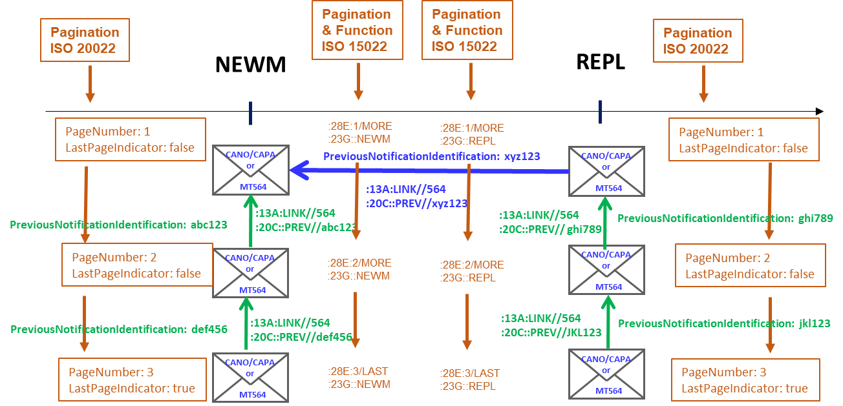

ISO 15022 |  | ISO 20022
MT 564 / A / 28E |  | seev.031 / see.035 – Pagination / PageNumber
Decision Date | Implement. Date |  | Update Date | Open Item Ref.
Aug. 2011 | Nov. 2012 |  | Feb.. 2022 | CA232, CA485, CA525

Scenario 2 - One MT564 with Multiple Linked MT568
Note: This section is not applicable to ISO 20022 since there is no MX messages matching the functionality of the MT 568 Narrative
For long MT568 messages for which the length would overcome the 10K character limit on SWIFTNet FIN, a pagination mechanism is available through the use of the 28E field present at the top of the messages:
The MT564 message and the first MT568 in the chain of multi-parts MT568 must be linked via the CORP reference (i.e. forward link as illustrated below with red arrows) –.
All MT568 messages that are part of the multi-parts MT 568 chain must all be linked via the PREV reference to their linked MT564 (i.e. backward link as illustrated below with green arrows) – as per section 3.7.3 MP.
All MT 568 in the chain of multi-parts MT568 are linked through the use of the Pagination (28E) field (as illustrated below with orange arrows)
A MT564 REPL or REPE must be linked to the previous MT 564 sent via the PREV reference (as illustrated below with a blue arrow) – as per section 3.7.2 MP.
MT 568 REPL or REPE messages that are part of the multi-parts chain of MT568 must NOT link back to the MT568 chain sent previously.
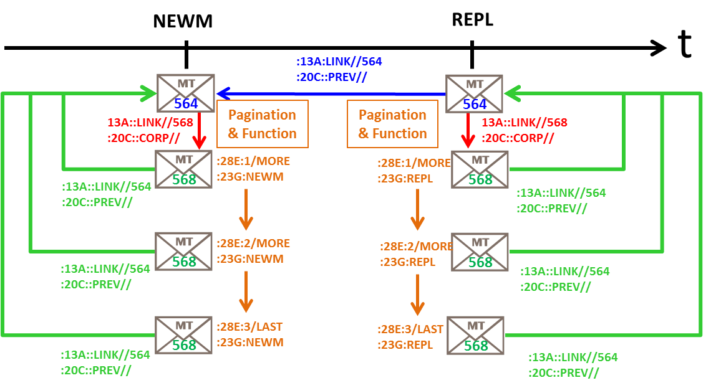

Linkage Scenario 3 – Multiple Linked MT564 with Multiple Linked MT568
Note: This section is not applicable to ISO 20022 since there is no MX messages matching the functionality of the MT 568 Narrative The only difference between this scenario 3 and the previous scenario 2 is the addition of the multi-parts chain of MT564.
All guidelines provided for scenario 1 also apply in this case.

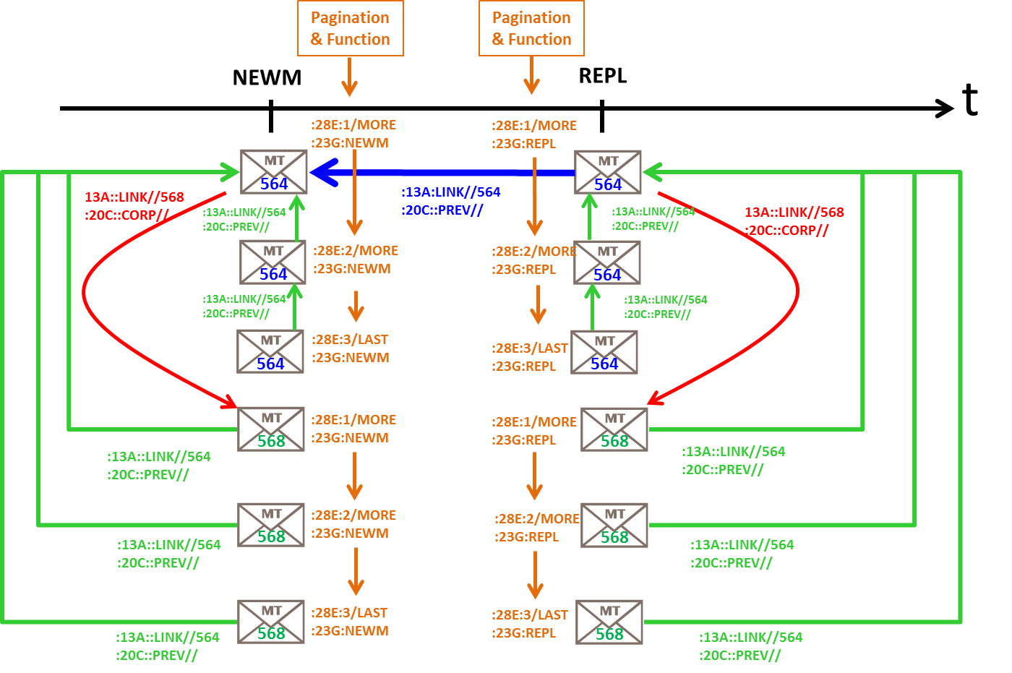
ISO 15022 |  | ISO 20022
MT 564 / A / 28E  MT 564 / A1 / 13A / LINK  MT 564 / A1 / 20C / PREV |  | NA
Decision Date | Implement. Date |  | Update Date | Open Item Ref.
May. 2015 | Nov. 2015 |  |  | CA297

