Change Request
for the update of ISO 20022 financial repository items
Note: the purpose of this document is to give guidelines to parties who want to introduce a request to change an existing ISO 20022 message(s), or update other items of the ISO 20022 financial repository. Such change requests are subject to the approval of the ISO 20022 Standards Evaluation Group(s) in charge of the related message/item or to the approval of the Technical Support Group (TSG), if the requested change relates to the Business Application Header (BAH). Please consult the iso20022.org website for additional details on the maintenance process. Change requests are to be sent to iso20022ra@iso20022.org. All change requests conforming to this template received by June 1st will be considered for development in the following yearly ISO 20022 maintenance cycle which completes with publication of new message versions in April/May of the following year.
- Origin of the request:
A.1 Submitter: SMPG
A.2 Contact person:
Name: Christine Strandberg
Email Address: Christine.strandberg@seb.se
Telephone number: +46 (8) 763 60 74

Name: Mariangela Fumagalli
Email Address: mariangela.fumagalli@bnpparibas.com
Telephone number: +442075954988

Name: Jacques Littré
Email Address: jacques.littre@swift.com
Telephone number: +32 2 655 4335
A.3 Sponsors:
NMPGs members of the SMPG
- Related messages:
Seev.004.001.08 Meeting Instruction

- Description of the change request:
Adding the “Pagination” building block to the instruction message.

The design proposal for adding the Pagination building blocks in the seev.004 message is as follows:
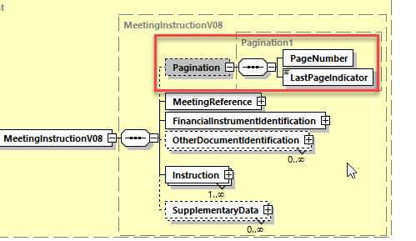
The proposed definitions for the building block is similar as the pagination element in the other seev messages i.e.:
“Page number of the message and continuation indicator to indicate that the multi-part instruction is to continue or that the message is the last page of the multi-part instruction.”
- Purpose of the change:
In case a lot of agenda resolutions (up to 1000) must be voted upon or in case a huge number of rights holders must be listed (up to 250), the maximum size allowed of the message on a specific network service might be reached and therefore the message should be split in multi pages similarly to the MeetingNotification message.

Urgency of the request:
For SR 2023
- Business examples:
Examples illustrating the change request.
- SEG/TSG recommendation:
This section is not to be taken care of by the submitter of the change request. It will be completed in due time by the SEG(s) in charge of the related ISO 20022 messages or the TSG for changes related to the BAH.

Consider |  |  | Timing
- Next yearly cycle: 2022/2023
(the change will be considered for implementation in the yearly maintenance cycle which starts in 2022 and completes with the publication of new message versions in the spring of 2023)
- At the occasion of the next maintenance of the messages
(the change will be considered for implementation, but does not justify maintenance of the messages in its own right – will be pending until more critical change requests are received for the messages)
- Urgent unscheduled
(the change justifies an urgent implementation outside of the normal yearly cycle)
 |  |  | - Other timing:
Comments:

Reject
Reason for rejection:

