Change Request
for the update of ISO 20022 financial repository items
Note: the purpose of this document is to give guidelines to parties who want to introduce a request to change an existing ISO 20022 message(s), or update other items of the ISO 20022 financial repository. Such change requests are subject to the approval of the ISO 20022 Standards Evaluation Group(s) in charge of the related message/item or to the approval of the Technical Support Group (TSG), if the requested change relates to the Business Application Header (BAH). Please consult the iso20022.org website for additional details on the maintenance process. Change requests are to be sent to iso20022ra@iso20022.org. All change requests conforming to this template received by June 1st will be considered for development in the following yearly ISO 20022 maintenance cycle which completes with publication of new message versions in April/May of the following year.
- Origin of the request:
A.1 Submitter: SMPG
A.2 Contact person:
Name: Christine Strandberg
Email Address: Christine.strandberg@seb.se
Telephone number: +46 (8) 763 60 74

Name: Mariangela Fumagalli
Email Address: mariangela.fumagalli@bnpparibas.com
Telephone number: +442075954988

Name: Jacques Littré
Email Address: jacques.littre@swift.com
Telephone number: +32 2 655 4335
A.3 Sponsors:
NMPGs members of the SMPG

- Related messages:
Seev.001.001.09 (meeting notification)

- Description of the change request:

In the seev.001.001.09, when the issuer or its agent must indicate the conditions for voting, they use the VOTE section to do so.
In this section you have the Vote Methods that specify the different methods that can be used to vote/send meeting instructions.

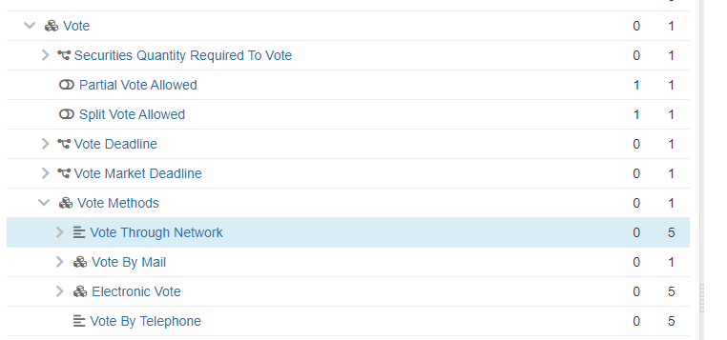

The function of Vote Methods / Vote Through Network is described as follows:
Network address through which a voting party can cast its vote via a structured message.
This means that it can only be used when all parties can cast their votes by sending an seev.004 message to the network address provided. This is only one of the three possible scenarios for which the element may currently be used. Please see the scenarios below:
- Meeting instructions are to be sent via the chain of intermediaries, as each party in the chain will only accept instructions from a known party. Hence each account holder (or its agent) is to send instructions to the account servicer that sent the meeting notification. The element should not provide a specific address, but the information that instructions should be sent via structured messages is still relevant as that is likely the most common method.
- Meeting instructions are not to be sent via the chain of intermediaries; instead, the issuer/registrar/agent will accept meeting instructions, if sent as structured messages, from all parties. (Entitlement information may have been provided via other messages or means.)
- Meeting instructions should be sent to the common depository, but this information is only valid for certain parties. (This scenario may already be covered by the addition of <PrcgTxtForNxtIntrmy> in seev.001.001.09.)
The Vote Method / Vote Through Network element needs to be amended to allow issuers, their agents and/or account servicers to include the relevant information for each scenario above - and only the relevant information - when forwarding/sending meeting notifications. Currently account servicers may forward an address which cannot be used by the receiver, but this cannot be determined by the account servicer except by manually checking with the party from which it received the notification.
This could be accomplished by different means. One possibility is to create additional Vote Method elements, by e.g. keeping the existing Vote Through Network for scenario 2 and add a new method, e.g. Vote Through Chain for scenario 1. This assumes that scenario 3 does not require further changes than that provided by <PrcgTxtForNxtIntrmy>.
Another possibility could be to add some form of ‘Applicable for all’ flag/indicator, thus stating whether all parties can send instructions to the specified address, plus an ‘Address to be changed by each intermediary’ flag/indicator.

- Purpose of the change:
The Vote Method / Vote Through Network element needs to be amended to allow issuers, their agents and/or account servicers to include the relevant information, and only the relevant information, when forwarding/sending meeting notifications.
It needs to allow for the different scenarios outlined in section C.
This could be accomplished by different means, again as outlined in section C.

- Urgency of the request:
For SR2023.

- Business examples:
Examples illustrating the change request: None. Please see section C.

- SEG/TSG recommendation:
This section is not to be taken care of by the submitter of the change request. It will be completed in due time by the SEG(s) in charge of the related ISO 20022 messages or the TSG for changes related to the BAH.

Consider |  |  | Timing
- Next yearly cycle: 2022/2023
(the change will be considered for implementation in the yearly maintenance cycle which starts in 2022 and completes with the publication of new message versions in the spring of 2023)
- At the occasion of the next maintenance of the messages
(the change will be considered for implementation, but does not justify maintenance of the messages in its own right – will be pending until more critical change requests are received for the messages)
- Urgent unscheduled
(the change justifies an urgent implementation outside of the normal yearly cycle)
 |  |  | - Other timing:
Comments:

Reject
Reason for rejection:

