**CA514 - GM - seev.004 Linkages**

Design proposal for linking the seev.004 to a single instructions in a previous Instruction message or in a previous InstructionCancellationRequest (seev.005) message:

Adding 2 new building blocks in the seev.004.

* The first one to refer to the individual instruction(s) from the Instruction cancellation message itself and
* The second one to refer to the individual instruction(s) from the original instruction message.

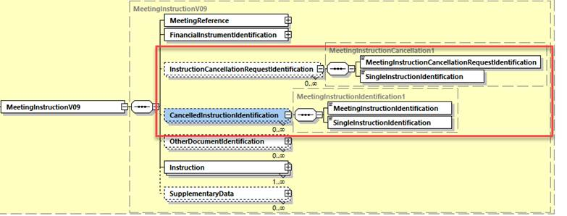

The proposed definitions for these elements are:

InstructionCancellationRequestIdentification: Identification of the cancellation request message requesting cancellation of individual instruction(s).

* MeetingInstructionCancellationRequestIdentification: Identification of the meeting instruction cancellation request message containing the individual instruction(s) for which the cancellation was requested.
* SingleInstructionIdentification: Identification of the individual instruction for which the cancellation was requested.

CancelledInstructionIdentification: Identification of the message and individual instruction(s) for which the cancellation was requested.

* MeetingInstructionIdentification: Identification of the previous meeting instruction message containing the individual instruction(s) for which the cancellation was requested.
* SingleInstructionIdentification: Identification of the individual instruction for which the cancellation was requested.