**CA513 reversal / repayment process in ISO020022**

Could you have a look at the below and let me know if I correctly interpret the standard / recommendation ?

1. Scenario 1 : After payment and confirmation of an event, the payment needs to be reversed (and won’t be repaid)
2. seev.036 has been sent to confirm the original payment
3. (no need to send a seev.039)
4. **seev.035 ADDB//REVR must be sent** to indicate entitlement reversal
5. **seev.037 must be sent** to  confirm the reversal once booked
6. Scenario 2: After payment and confirmation of an event, the payment needs to be reversed and repaid (e.g. change of rate)
7. seev.036 has been sent to confirm the original payment
8. **seev.031 REPL must be sent** to notify the update of the event (with the new rate)  - assumption : we do not create a separate event for the repayment but just update the original one
9. **seev.035 ADDB//REVR must be sent** to indicate entitlement reversal of the original payment
10. **seev.035 REPL** **must be sent** to report the new entitlement (based on the new rate)
11. **seev.037 must be sent** to  confirm the reversal of the original payment once booked
12. **seev.036 must be sent** toconfirmthe new payment (based on the new rate) once booked

-

**UK Feedback:**

If the terms of the event change to the point they impact the eligibility (e.g. change of event type, ex date, record date), the payments should be reversed, the event should be cancelled, a new event should be created and new payments processed under the new event.

If we only have a change of paydate/dividend rate, the reversal and new payments should be processed under the existing event.

As mentioned, I think we also need to look at the reason codes associated to the reversal:

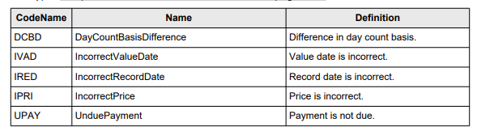

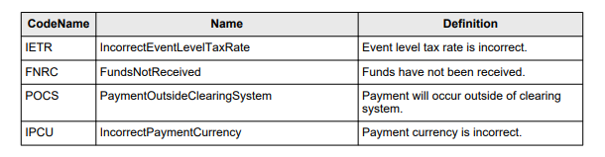

and see if we need to make some changes. As a way of an example, I don’t see any reason code applicable in case I am reversing because the client has asked for a tax adjustment.