# CA488   SID - Shareholder identification / Clarifications (Jean-Paul)

Shareholder identification : some clarifications proposal in the market practices we received from intermediaries.

**Seev.045**

cid:image001.jpg@01D72490.93B2AD10

We should recommend the issuer to not use spaces in the id because some intermediaries remove or replace the spaces with “_” or “-“ which results in multiple ids for the same request.

**Seev.047**

cid:image002.jpg@01D72490.93B2AD10

We should add that pagination should start at 1 (not 0)

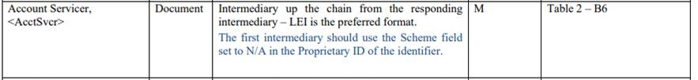

Some intermediaries do not populate this field correctly and put their own LEI. Could we make the definition even more explicit by adding for instance “i.e. the entity where the responding intermediary holds its account” ?

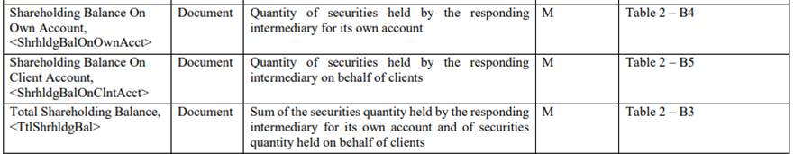

Some intermediaries do not include in those subtotals the “Non disclosed shareholding quantity” and “Below threshold shareholding quantity”. So, the totals above do not match with the sum of positions listed in the AccountSubLevel part of the message. I think we should make explicit in the table above that those totals can include non-disclosed or below threshold Balances.

cid:image005.jpg@01D72490.93B2AD10

Shouldn’t we specify this is the settled quantity? (some intermediaries use trade date balances)

 Joint shareholding

 Clarification are required in case of joint shareholding (currently, instead of reporting a position of 15 held by Mr X & Ms Y, some intermediaries report 7.5 on Mr X and 7.5 Ms Y). Proposal  : “In case of joint shareholder, the whole balance on the account should be reported once with the list of co-owners.”