**CA377 – WITH / CANC / REPL Functions Clarification**

Our info. on CANC, WITH or REPL

**CANC, WITH or REPL need a fresh up**

In the description below it is unclear when you should use CANC and when you should use WITH.

In the SMPG material, Market Practices & Documents, Final Market Practices, Global Market Practices there is a description of how and when to use CANC, WITH or REPL. However, we have experienced that some of our clients find it hard to know exactly when to use what code. We believe that if they find it hard to understand others might also find it hard too which means that we should have another look at it. And furthermore, the text written in the SMPG material does not have the same wording as what is written in the material from the user handbook, CODES from function of the message (564) (Data field dictionary).

Take for instance the first sentence from SMPG material:

**WITH (withdrawal) should be used to void a previously sent message or in case the issuer has cancelled the event. This implies that the corporate event number (CORP) will not be re-used.**

vs. material from user handbook format specifications:

**WITH: Withdrawal**

**Message sent to void a previously sent notification due to the withdrawal of the event or offer by the issuer.**

In the SMPG material it sounds as if any sender of the message can void a previously sent message by using WITH OR an issuer can do so if the event is being cancelled.

We propose that SMPG material have the same wording as used in the user handbook, in which it gets quite clear that an entire event is cancelled by the issuer which is why WITH is used. Alternatively, just delete the “or” in the SMPG material and it gets clear why a WITH message should be sent.

**Now then, the next step is to sort out CANC or REPL**

*In the SMPG document the below information is to be found on CANC vs REPL*

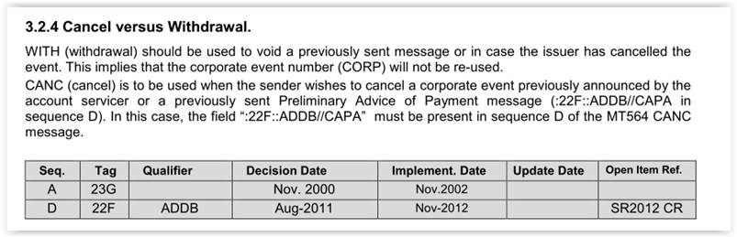

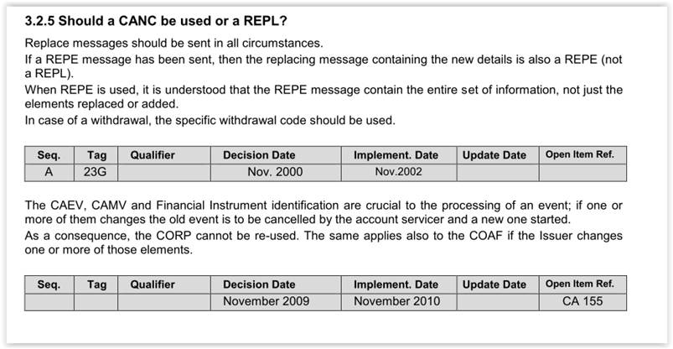

And the following is to be found in the USER HANDBOOK:

*CANC*

*CANC Cancellation Advice Message to cancel a corporate action event previously announced by the account servicer or a previously sent Preliminary Advice of Payment message (:22F::ADDB//CAPA in sequence D).*

*REPL Replacement Message replacing a previously sent message.*

*USAGE RULES*

*To cancel or withdraw a previously announced corporate action event, Function is respectively CANC or WITH. The presence of the Sender's reference of the message to be cancelled (PREV) is not required in the linkages sequence. A copy of at least the mandatory fields of the message to be cancelled must be present; optional fields need not be present for SWIFT validation.*

*To cancel a previously sent Preliminary Advice of Payment message (:22F::ADDB//CAPA in sequence D), Function is CANC and the field :22F::ADDB//CAPA must be present in sequence D of the MT 564 CANC message. The reference in the linkages sequence must contain the Sender's reference of the message to be cancelled (PREV). A copy of at least the mandatory fields of the message to be cancelled must be present; optional fields need not be present for SWIFT validation.*

*REPL is used to replace a previously sent message that was reported as preliminary or complete, for example, processing status was :25D::PROC//PREU, PREC or COMP.*

*REPE is considered as simply a confirmation of an eligible balance when :22F::ADDB//CAPA is not present in sequence D and is considered as a movement preliminary advice when :22F::ADDB//CAPA is present in sequence D.*

The SMPG material gets rather confusing. Starting of with a question “Should a CANC be used or a REPL?” and then replying that REPL should be used in all circumstances leads us to ask, “Why have a CANC?”

Maybe an illustration would give a better overview of when to use what!

Furthermore, in the USER HANDBOOK material it is stated that *”The presence of the Sender's reference of the message to be cancelled (PREV) is not required in the linkages sequence.” Why not link back to the senders reference? After all, our work is to clarify issues and to standardize. If we link back to senders references in other events, then why not also do so in the CANC message?*

The above issue is primarily an issue when it comes to MT messages, however there are certain issues to be raised in MX messages as well ie. when cancelling a message due to processing error there is no linkages back to the previous message, in which case it is difficult to know which message is actually being cancelled. Unless the below information from the user handbook is valid. In that case there is no difference between WITH and CANC, **so why then have both?**

Seev.039 cancellation advice description in the user handbook

Scope:

An account servicer sends the CorporateActionCancellationAdvice message to an account owner or its designated agent to cancel a previously announced corporate action event in case of error from the account servicer or in case of withdrawal by the issuer.