CA 360. Taxation on security distributions
During our conference call held on 15 September ZA raised an enquiry with regards to tax on security distributions and cash fractions. Please some detail in that regard below.
1. Currently all rate and amount codes/qualifiers to withhold taxes are available in the cash movement blocks (sequence E2 and D2) of the MT564 and MT566. Therefore in instances where tax is applicable to security entitlement the effects thereof are being communicated in narrative fields. Resultantly, due to the narrative, STP is affected thereby possibly requiring manual invention. ZA will appreciate it if we could investigate the possibility of making the tax codes/qualifiers for rates and amounts available in the securities movement blocks (sequence E1 and D1) the MT564 and MT566.
We are of opinion that this will improve communication and possibly increase STP.
2. Similarly there is also a challenge in communication when the cash fraction (CINL) is taxable.
An example would in a DVOP, whilst the security entitlement in itself is not taxable the cash fraction is still considered to be a dividend and thus withholding taxes become applicable. We are not aware of a market practice or standard in this regard and the context is communicated in narrative fields. We will appreciate guidance in this regard and also efforts to possibly improve communication and automation.

Discussions during Dec 15th call :
Why not in sequence E? Sanjeev explained that, in sequence E, it would be impossible to show the Tax calculated on the entitlement.
Delphine suggested to use the Cashmove to indicate the Tax to debit.
Another proposal is to use the Taxation indicator : 22F : TXAP and the price 90a – CAVA (Cash Value for Tax)
Gabriel explained that, in the UK, the issuers are used to advise about the taxability of an event and then the tax is applied when the distribution of the securities is performed.
Sanjeev explained that there is the same taxation applied to all beneficiaries, it could be OK but how does it work if the rate is different ? Gabriel explained that, in the UK, it is a 1 for 1
Please see below example from the UK Market.

Sanjeev also provided 2 examples: one with tax on cash fractions and another with tax on shares.
- Mediclinics International Limited – Scheme of arrangement
Company made a scheme of arrangement to shareholders.
Shareholders afforded an option to elect for the repurchase option or an exchange option to receive Al Noor shares.
Repurchase option was subject to dividends withholding tax, issue price of the stock was utilised to determine the dividend rate and shareholders had to pay DWT on the stock they received even though they did not receive cash.
Withholding of tax (DWT) on security entitlement was processed manually and reported to the tax authority accordingly.
- Brait Se (BAT) – Bonus Share Issue with a Cash Dividend Alternative (dividend with option)
Issuer declared bonus issue however shareholders could elect to receive cash option.
Receipt of stock is of capital nature thus is not taxable.
Fractions arising out of share entitlements are rounded down thus fractional cash entitlements are payable.
Fractional rate is different from dividend rate however the fraction is taxable.
Withholding of tax (DWT) on fractional cash payouts, currently not possible via system.
Comments during January call:
Rate will depend on the client taxation. The maximum rate is always announced in the MT564 and MT566 depends on the client => to see how it works in South Africa and if case applicable

UK and IE Examples
The below is the market announcement on a SCRIP dividend with currency election on an Irish stock.
Undocumented clients are subject to 20% Irish DWT. Stock outturn has two different ratios, a gross (for documented) and a net (for undocumented).
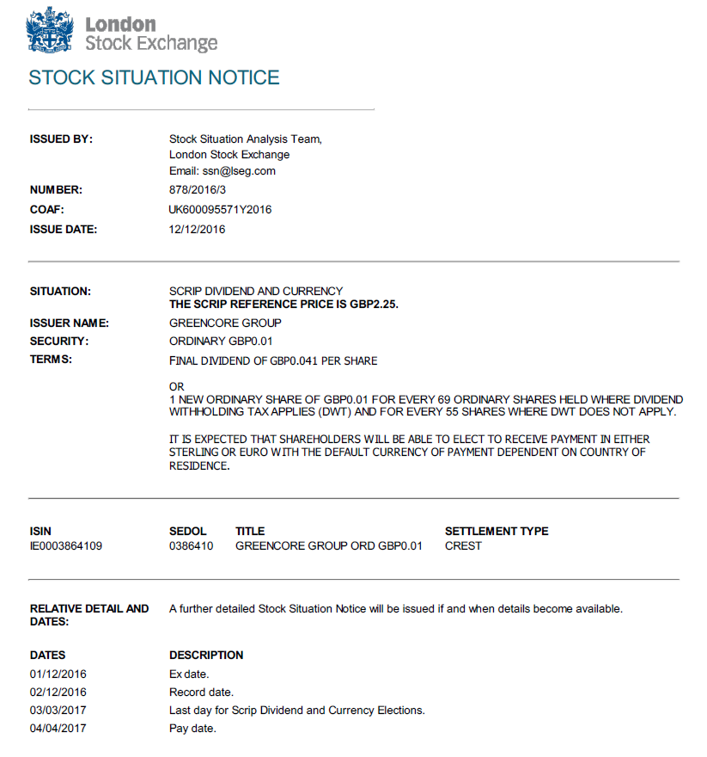
Below is how the relevant options is reported in the 564, the tax reporting on the stock option has been highlighted, namely TAXR for the Irish DWT and the NETT ratio.
As mentioned, in the UK/IE, we do not credit gross stock entitlement and debit the tax equivalent in cash. Rather we will inform the paying agent of the tax status of the account. If gross, the gross rate will apply to the stock distribution, if taxable, the net rate will apply to the stock distribution, this removes the need to have a separate cash debit.
16R CAOPTN
13A :CAON//001
22F :CAOP//CASH
11A :OPTN//GBP
17B :DFLT//Y
98C :MKDT//20170303120000
98C :RDDT//20170303100000
98B :BORD//UKWN
92A :TAXR//20,
16R CASHMOVE
22H :CRDB//CRED
98A :PAYD//20170404
92F :GRSS//GBP0,041
16S CASHMOVE
16S CAOPTN

16R CAOPTN
13A :CAON//002
22F :CAOP//CASH
11A :OPTN//EUR
17B :DFLT//N
98C :MKDT//20170303120000
98C :RDDT//20170303100000
92A :TAXR//20,
16R CASHMOVE
22H :CRDB//CRED
98A :PAYD//20170404
98A :EARL//20170411
92K :GRSS//UKWN
16S CASHMOVE
16S CAOPTN

16R CAOPTN
13A :CAON//003
22F :CAOP//SECU
11A :OPTN//GBP
17B :DFLT//N
98C :MKDT//20170303120000
98C :RDDT//20170303100000
92A :TAXR//20,
16R SECMOVE
22H :CRDB//CRED
35B ISIN IE0003864109
35B Greencore Group ord GBP0.01
90B :PRPP//ACTU/GBP2,25
92D :ADEX//1,/68,59756098
98A :PAYD//20170404
98A :AVAL//20170404
16S SECMOVE
16S CAOPTN

The following announcement is a DRIP on a UK real estate investment trust, which can distribute property income distributions subject to 20% UK income tax on both cash and stock.
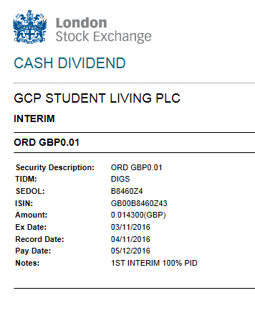
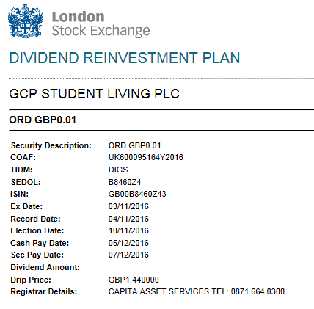
The logic in the MT564 is the same as above.
16R CAOPTN
13A :CAON//001
22F :CAOP//CASH
11A :OPTN//GBP
17B :DFLT//Y
98C :MKDT//20161110150000
98C :RDDT//20161110120000
98B :BORD//UKWN
92A :TAXR//20,
16R CASHMOVE
22H :CRDB//CRED
98A :PAYD//20161205
92J :GRSS//REES/GBP0,0143
16S CASHMOVE
16S CAOPTN
16R CAOPTN
13A :CAON//002
22F :CAOP//SECU
11A :OPTN//GBP
17B :DFLT//N
98C :MKDT//20161110150000
98C :RDDT//20161110120000
98B :BORD//UKWN
92A :TAXR//20,
16R SECMOVE
22H :CRDB//CRED
35B ISIN GB00B8460Z43
35B GCP Student Living Plc Ordinary Sha
90B :PRPP//ACTU/GBP1,44
92D :ADEX//1,/127,7622378
92A :CHAR//1,
92A :FISC//0,5
98A :PAYD//20161207
16S SECMOVE
16S CAOPTN

Here is the MT566 that shows the net ratio used for the credit of the stock.
16R CACONF
13A :CAON//002
22F :CAOP//SECU
16R SECMOVE
22H :CRDB//CRED
35B ISIN GB00B8460Z43
35B GCP Student Living Plc Ordinary Sha
36B :PSTA//UNIT/53,
90B :PRPP//ACTU/GBP1,44
92D :ADEX//1,/127,7622378
92A :CHAR//1,
92A :FISC//0,5
98A :POST//20161207
98A :PAYD//20161207
16S SECMOVE
16S CACONF

