CA SMPG – Input file for CA 270
(J. Littré – SWIFT)

CA 270 - ISO 20022 Instruction Status Reason Code lists
- Corrections to be made for the alignment with SMPG MP on reason codes
This item is a follow up from the SR 2014 CR 606 (Delete Reason Codes ADEA & LATE from PACK Qualifier in MT567 – seev.034)
Context
The reverse engineering exercise from 15022 to ISO20022 had decided to implement the SMPG MT567 status and reason codes market practices directly in the ISO 20022 messages. When analysing the CR 606 change request, it appeared that there were a number of implementation mistakes in the reason codes lists of the InstructionStatusAdvice (seev.034) and InstructionCancellationRequestStatusAdvice (seev.041) messages in the sense that for some statuses, the MX messages implement the full reason code list of the ISO 15022 standards and not the SMPG restricted reason code lists.
It is proposed to correct those mistakes in the change request and in that case, the following changes should be done to comply with the SMPG MP:
- In the seev.034.001.05 (Corporate Action Instruction Status Advice), delete the 3 code values “Instruction Irrevocable” (INIR), “Rejected Since In Progress” (DPRG) and “Rejected Since Already Cancelled” (DCAN) in the sequence: InstructionProcessingStatus/Rejected/Reason/ReasonCode/Code in the data type RejectionReason42Code.
- In the seev.034.001.05 (Corporate Action Instruction Status Advice), delete the 4 code values “Payment Not Made” (NPAY), “Securities Not Delivered” (NSEC) and “Valid For Tax Authorities” (VLDA); “Send to Tax Authorities” (AUTH) in the sequence: InstructionProcessingStatus/Pending/Reason/ReasonCode/Code in the data type PendingReason11Code.
- In the seev.041.001.04 (Corporate Action Instruction Cancellation Request Status Advice) replace the data type code list AcceptedStatus1Choice in the sequence InstructionCancellationRequestStatus/Accepted by the component “NoSpecifiedReason1” so that the Accepted status has no longer reason codes ADEA, LATE, NSTP, OTHR associated as in the SMPG MP.
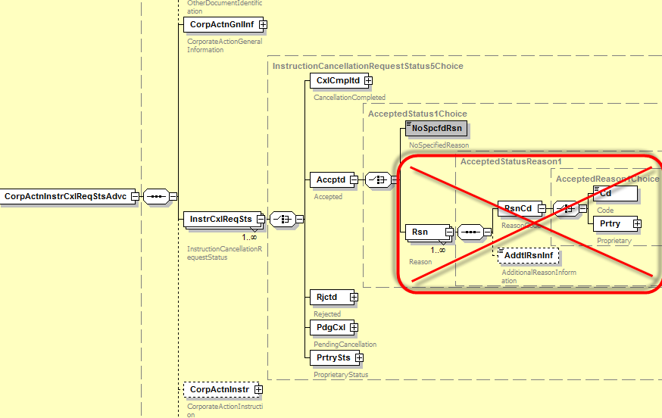

- In the seev.041.001.04 (Corporate Action Instruction Cancellation Request Status Advice) delete the 3 code values “Cancelled By Another Party” (CANO) and “Cancelled By System” (CANS) and “Cancelled By Subcustodian” (CSUB) in the sequence InstructionCancellationRequestStatus/CancellationCompleted/Reason/ReasonCode/Code in the data type CancelledStatusReason11Code.
- In the seev.041.001.04 (Corporate Action Instruction Cancellation Request Status Advice) delete the 13 code values CANC, DQUA, DSEC, EVNM, INTV, INVA, LACK, NMTY, OPNM, OPTY, REFT, SAFE, CERT (and leave only ULNK, ADEA, NARR, DCAN, DPRG, INIR, LATE) in the sequence InstructionCancellationRequestStatus/Rejected/Reason/ReasonCode/Code in the data type RejectionReason17Code.

In the seev.032.001.04 (CorporateActionEventProcessingStatusAdviceV04) - Full alignment with SMPG GMP Part 3 is OK

