SMPG - Corporate Actions
Telephone Conference Minutes
22 November, 2016

FINAL Version v1.0 – December 13, 2016
Table of Contents
1. Approval of Zurich meeting & October 25 Conference Call Minutes 3
2. CA203 SR2017 - Yearly GMP Part 1,2,3 and samples alignment and yearly summary of changes to MPs (Action: All NMPGs) 4
3. CA279 Claims and Transformations in the T2S context (Action: All NMPGs) 5
4. CA315 Extending CA MPs to ISO 20022 (Action: Bernard) 5
5. CA338 Create a more robust MP on narrative update information and update date for ISO 20022 seev.031 (Action: All NMPGs) 6
6. CA341 Clarification of CLAI & ACLA market claim related codes (Action: Jacques/Veronique) 6
7. CA344 Analyse impact of creating new "Interest Period Inclusive" element besides INPE (Action: Mike) 6
8. CA345 Create new MP for the usage of the new QCAS "Instructed Amount" field in MT 565 (Action: Matthew) 6
9. CA350 Usage of AFFB/UNAF balances for DRAW ? (Action: GMP1 SG) 6
10. CA353 New Rolling mode (MR) & Accounting mode (MA) for capital increases in Italy (Paola) 6
11. CA354 Market usage of "QINS//QALL" on field 36a of MT565 (Action: Jacques) 7
12. CA355 How to confirm a credit of proceeds to a collateral giver after the proceeds were initially credited to the collateral taker ? (Action: All NMPGs) 7
13. CA356 How to report the actual Interest rate used for payment (INTP) in another currency than the issuing currency ? (Action: Bernard) 7
14. CA357 ) Usage of the :22F::OPTF//BOIS and :22F::CETI//FULL codes in the MT567 (Action: Bernard) 7
Attendees
NMPG |  | First Name | Last Name | Institution | = Present
AT | Mr. | Stefan | Ribisch | Unicredit
AT | Ms. | Karin | Wachter | Unicredit
BE | Ms. | Véronique | Peeters | BNY Mellon
CH | Mr. | Michael | Blumer | Credit Suisse
DE | Mr | Schaefer | Daniel | HSBC
DK | Ms | Ravn | Charlotte | VP Securities A/S
ES | Ms. | Cinta | Cristobal | BBVA
ES | Mrs | Diego | Garcia | DB
FI | Ms | Rask | Sari | Nordea Bank Plc | Excused
FR | Mr | Jean-Pierre | Klak | Statestreet
GR | Ms. | Angela | Katopodi | Eurobank
IL | Mr. | Gilad | Grayevsky | Bank Leumi
IT | Ms | Deantoni | Paola | SGSS spa
JP | Mr | Hideki | Ito | Mizuho Bank
JP | Mr | Hisashi | Hotta | Mizuho Bank
LU | Mr. | Bernard | Lenelle | Clearstream
MDPUG | Mr. | Peter | Hinds | MDPUG / Interactive Data | Excused
MDPUG | Ms. | Laura | Fuller | Telekurs
NL | Mr | van der Velpen | Ben | ING Bank N.V. | Excused
NO | Mr. | Alexander | Wathne | Nordea
PL | Mr. | Michal | Krystkiewicz | CSD of Poland (KDPW S.A.)
RU | Ms | Elena | Solovyeva | ROSSWIFT
RU | Ms | Sofia | Prokofeva | Rosbank
SE | Ms. | Christine | Strandberg | SEB
SG | Mr. | Jyi-Chen | Chueh | SC
UK & IE | Ms. | Mariangela | Fumagalli | BNP Paribas | Excused
UK & IE | Mr. | Matthew | Middleton | LSE | Excused
US ISITC | Mr. | Paul | Fullam | Sungard | Excused
XS | Ms | Haillez | Delphine | Euroclear
ZA | Mr. | Sanjeev | Jayram | First National Bank | Excused
ZA | Mr. | Ridhwaan | Williams | Strate
ZA | Mr. | Nita | David | Strate
SWIFT | Mr. | Jacques | Littré | SWIFT
SWIFT | Ms. | Mieko | Morioka | SWIFT APAC

Approval of Zurich meeting & October 25 Conference Call Minutes
Open Items CA 341 and CA 356 have been updated in the draft Zurich minutes. Those minutes are now final and have been posted on www.smpg.info.
No comments have been received for the October call minutes. Those minutes are now approved.

CA203 SR2017 - Yearly GMP Part 1,2,3 and samples alignment and yearly summary of changes to MPs (Action: All NMPGs)
Status:
- Templates: Input received from Christine only.
Actions 1: CA Templates updates should be sent to Jacques for December 2.
The following changes/ validations actions must also be applied on all samples systematically:
a) Change RDDT and MKDT to 98C in all templates
b) Ensure templates are aligned with EIG+
c) Validate that the description of the event is fully aligned with the actual template.
CA templates updates are assigned to: Alexander, Ben, Bernard, Delphine, Christine, Daniel, Delphine, Jean-Pierre, Mari, Matthew, Peter, Sanjeev, Sari, Paul and Véronique. Please refer to the “CA Event Template list” tab in the “Open Items” file.
- EIG+ CC: Input received from JP and South KR so far.
Action 2: NMPGs to send their EIG+ Country Column updates to Jacques for December 2.
- Review Voluntary Rolling Event GMP1 Section 2.2.5:
The objective is to clarify this section in terms of the messages elements and also values to be used to make the distinction with other scenarios (typically DITY indicator – see section also 8.26).
Christine’s Input document received:
Christine explains the document. We can distinguish two types on ongoing events:
a) Voluntary events for which the instruction phase equals the entire lifetime of the security and for which the payment confirmation follows the instruction received. In this case, DITY should be ONGO and the PAYD date value should be ONGO as well.
b) Voluntary events for which several instruction phases each with fixed payment dates are scheduled in advance and in this case, the DITY should be ROLL and the PAYD date value should be the next scheduled pay date.
It seems however that in the input document, Rolling events are presented rather as a subset of the Ongoing events which makes the rolling event definition it a bit confusing.
It is not clear either whether, when a PAYD of an event is ONGO, the event itself should be considered as “Ongoing” as well or whether it can be used for non-rolling and non-ongoing events as well ?
Action 3: NMPGs are requested to review the draft document and revert by the next call.
4) Add AVAL to EIG+ relevant events:
The GMP1 SG has decided not to add AVAL in the EIG+ as it depends rather on whether a new security (ISIN) is distributed in the frame of the event and this often depends upon the terms and references of the event.
Therefore GMP1 SG proposes to rather add a new section in GMP1 on the usage of the AVAL date (also known as “first trading/dealing date”).
AVAL would be used only for newly issued securities (with new ISIN) received in a distribution or re-organisation event with option SECU.
Action 4: NMPGs are requested to review the proposal and revert by the next call.
5) New EXWA MAND event template
Véronique is not attending the call.
Action 5: Creation of an EXWA template
6) Add Partial Redemption scenario to GMP: Done in GMP2 in the “Redemption” sheet.

CA279 Claims and Transformations in the T2S context (Action: All NMPGs)
Survey inputs have been received so far from ES, NL and JP. They will be forwarded to Bernard for a first consistency check.
Bernard reminds that the document should first be filled in with the point of view of the CSD and eventually after with the individual institution point of view.
In Italy, the CSD has taken a different approach than the (global) custodians, then it is difficult more difficult to fill it in from the CSD point of view.
Action: NMPGs/CSDs/CCPs joining T2S to fill in the document based on how the CSD/CCP will act once they join T2S. To be filled in as soon as possible (preferably before end of year).

CA315 Extending CA MPs to ISO 20022 (Action: Bernard)
Bernard has formed the groups and those have been distributed last month.
A few changes have taken place (changed group leaders: Jacques will lead group 3. Jean-Pierre will lead group 4) and the final groups are now formed as follows:
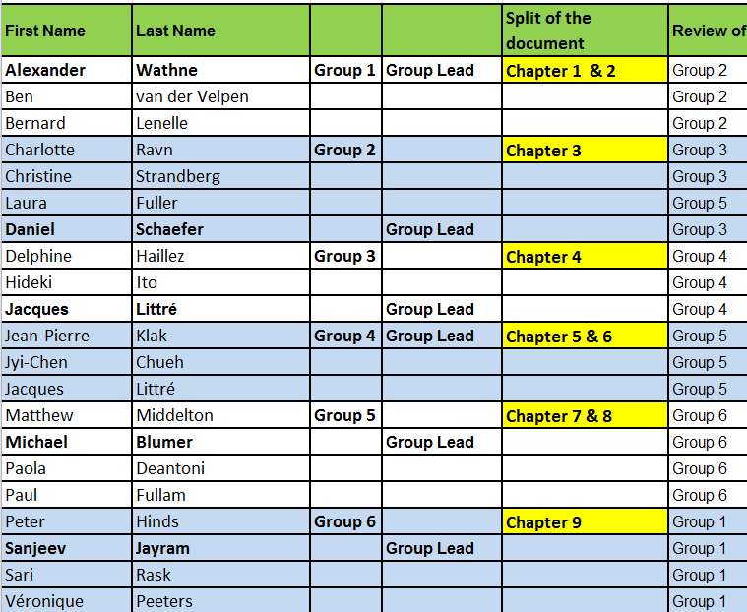
Progress Status
Apart from Group 2, no much progress so far as most of us are very busy in this end of year period.
Action: Groups to progress in the review of their assigned chapters.

CA338 Create a more robust MP on narrative update information and update date for ISO 20022 seev.031 (Action: All NMPGs)
No NMPGs comments yet received for the proposed change from ‘recommended’ to ‘optional’ for the MT text in section 3.15 of GMP1 reading as follows:
“In case of a narrative being updated in the MTs, it is recommended optional to indicate the change and the date at the top of this narrative.
In case of a narrative being updated in the ISO 20022 seev.031 (Notification) and seev.035 (Movement Preliminary Advice) messages, although these elements are optional, it is not recommended to fill in the “Update Description” and “Update Date” elements.”
Action postponed to next conference call.
Action: NMPGs are requested to review the proposed MT change and revert by next conference call.

CA341 Clarification of CLAI & ACLA market claim related codes (Action: Jacques/Veronique)
For the three market claim related codes ATXF, CNTR, NAMC, the GMP1 SG have reviewed the codes and see no need for clarification.
Action: Close item

CA344 Analyse impact of creating new "Interest Period Inclusive" element besides INPE (Action: Mike)
Mike’s action is still pending.
Action: Mike to find a multi-deposited bond and show how INPE is used for it in different markets

CA345 Create new MP for the usage of the new QCAS "Instructed Amount" field in MT 565 (Action: Matthew)
The UK market is late with the new MP. Matthew hopes to have a draft ready for circulation by the end of next week.
Action: Matthew to create a draft and circulate it to the CA-WG.

CA350 Usage of AFFB/UNAF balances for DRAW ? (Action: GMP1 SG)
The following proposal copied from the DRAW template will be added to GMP1 as section 3.10.2:
“Please note that the qualifiers UNAF (Unaffected balance) and AFFB (Affected balance) are specific to the lottery events such as drawing.
The affected balance is the position that was drawn in the lottery.
Unaffected balance is the position that was not chosen in the lottery.”
Action: Close Item.

CA353 New Rolling mode (MR) & Accounting mode (MA) for capital increases in Italy (Paola)
Input Provided by Paola:
Paola explains the new market practice proposed for the IT market by the global custodians and would like to know whether there is nothing inconsistent in principles in it.
Bernard proposed that this is kept as a local market practice.
Action: NMPGs to provide feedback (if any ?).

CA354 Market usage of "QINS//QALL" on field 36a of MT565 (Action: Jacques)
Usage of the QINS/QALL code in instruction has been checked by Jacques.
In Q1 201’, the usage was 0,2% in the MT565 message.
JP explains that they would like either that the QALL code be deleted or alternatively that we clarify the definition of the code itself in the standard.
Action 2: Jacques has written an email to SWIFT Standards to ask on behalf of the SMPG whether regular retrieval of anonymised data from the network is feasible and when.
Actions: NMPGs are requested to review usage of QALL (what the meaning is, and when positions are struck?) and provide input by the next conference call.

CA355 How to confirm a credit of proceeds to a collateral giver after the proceeds were initially credited to the collateral taker ? (Action: All NMPGs)
The question is whether a “claim” related to collateral is to be processed and confirmed with an MT566 or another message?
No NMPGs provided input, but a discussion was held, with several different views/concerns/answers depending on the legal context and collateral agreement.
Decision: Since this question is very much dependent upon the local market practices, it is decided not to create a global market practice for this. Item can be closed.

CA356 How to report the actual Interest rate used for payment (INTP) in another currency than the issuing currency ? (Action: Bernard)
Action: Bernard to check his Zurich notes and revert to Jacques if the template contains errors.

CA357 ) Usage of the :22F::OPTF//BOIS and :22F::CETI//FULL codes in the MT567 (Action: Bernard)
Bernard’s input proposal:
Action: All NMPGs to review Bernard’s input and provide feedback for next call.

------------------------ End of the Meeting Minutes ---------------

