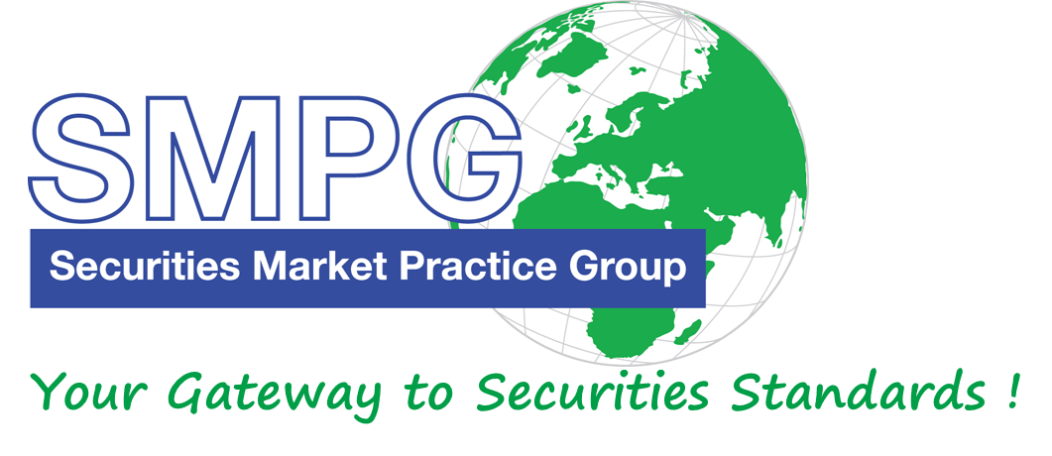
SMPG
20th Anniversary
Warsaw
Global SMPG Meeting
April 18 – 20, 2018

Hosted and sponsored by:
Meeting Venue:
KDPW premises
4 Książęca Street
6th floor
PL – 00-498 Warsaw
Poland
Dress Code: Business casual

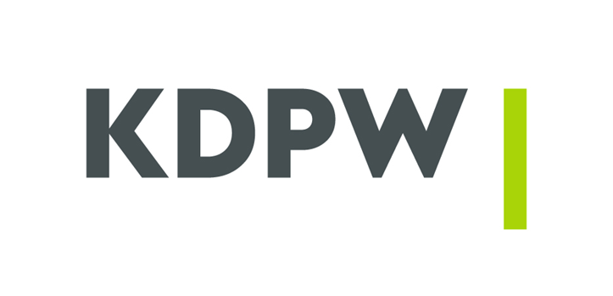

Meeting Global Agenda

Wednesday 18th of April
 |  | 9:00 – 9:30 |  |  |  | Arrival & Check-in and Welcome Coffee
 |  | 9:30 |  |  |  | Plenary Session Opening
 |  | 9:30 – 11:00 |  |  |  | - SMPG Welcome Address (Karla Mc Kenna, SMPG Chair, ISITC) – 5’  - Welcome Address by Host – (Slawomir Panasiuk, Vice-President of KDPW & Michal Stepniewski, Vice-President of KDPW) - 5’  - Global Meeting Schedule (SMPG General Secretary or Program Director) – 5‘  - International Standards - The foundation of the KDPW post-trade services portfolio (Michael Lukac, KDPW) - 30‘  - Global Recipe With a Local Flavour - Financial system in Poland and its infrastructure (Dr. Dobiesław Tymoczko, National Bank of Poland) - 30’
 |  | 11:00 – 11:30 |  |  |  | Coffee Break
 | 11:30 – 13:00 |  |  |  |  | - EMEA Regional Updates – (EMEA Regional Directors) - 15’  - Americas Regional Updates (Americas Regional Directors) – 15’  - APAC Regional Updates (APAC Regional Directors) – 15’  - ISO 20022 Migration Study Industry Consultation Status (Charles Boniver, SWIFT) – 20’  - SMPG Steering Committee Members Elections – 15’  - SMPG 20th Anniversary Celebration – 15’
 | 13:00 |  |  |  |  | End of Plenary Session
 | 13:00 – 14:00 |  |  |  |  | Lunch
 |  |  | Afternoon Session
 |  |  |  | 14:00 – 15:30 |  |  | Corporate Action WG | Investment Funds WG | Settlement and Reconciliation WG
 |  |  |  | 15:30 – 16:00 |  |  | Coffee Break
 |  |  |  | 16:00 – 17:30 |  |  | Corporate Action WG | Investment Funds WG | Settlement and Reconciliation WG
 |  |  | Evening
Free evening
See: V. Tourist Information

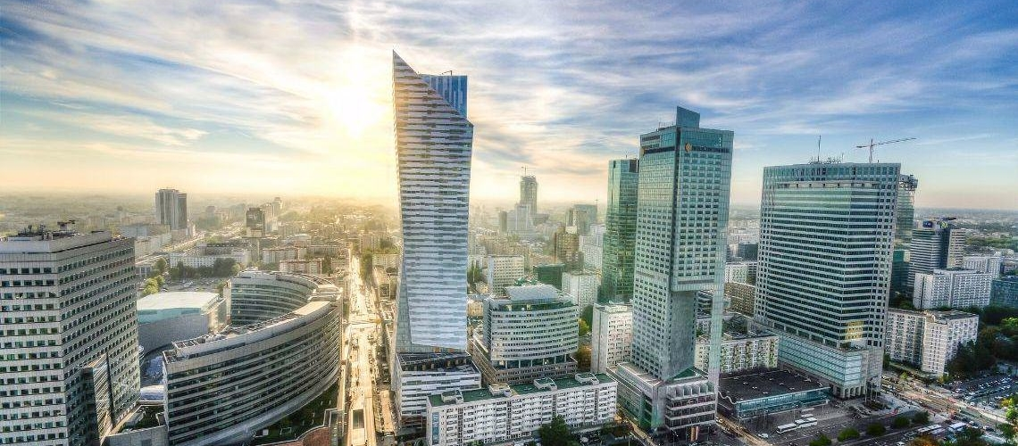

 | Thursday 19th of April
 |  |  | 8:30 – 9:00 |  |  | Arrival & Check-in at DKPW Premises
 | Morning Session
 |  |  | 09:00 – 10:45 |  |  | Corporate Action WG | Investment Funds WG | Settlement and Reconciliation WG
 |  |  | 10:45 – 11:00 |  |  | Coffee Break
 |  |  | 11:00 – 12:30 |  |  | Corporate Action WG | Investment Funds WG | Settlement and Reconciliation WG
 |  |  | 12:30 – 13:30 |  |  | Lunch
 | Afternoon Session
 |  |  | 13:30 – 15:30 |  |  | Corporate Action WG | Investment Funds WG | Settlement and Reconciliation WG
 |  |  | 15:30 – 15:45 |  |  | Coffee Break
 |  |  | 15:45 – 17:30 |  |  | Corporate Action WG | Investment Funds WG | Settlement and Reconciliation WG
Evening Event
 |  |  |  | 18:00 – 23:00 | SMPG Evening event and 20th Anniversary Celebration  - Starts at 6:00 PM from KDPW building

Friday 20th of April
Morning session
 |  |  |  | 09:00 – 10:45 | Corporate Action WG |  | Investment Funds WG |  | Settlement and Reconciliation WG
 |  |  | 10:45 – 11:00 |  | Coffee Break
 |  |  | 11:00 – 12:30 |  | Corporate Action WG | Investment Funds WG |  | Settlement and Reconciliation WG
Optional Light Lunch
(Please indicate in the registration form if you stay for lunch)
 | End of meeting

SMPG Corporate Actions WG Detailed Agenda – April 18 - 20, 2018

Item No | Short Description | Description and Pending Actions | Owner | Comment
Wednesday April 18 PM / Thursday April 19 / Friday April 20
1 | Note taker assignment |  | Christine/ Jacques
2 | 2018 meeting dates | Schedule Conference calls for Q3 / Q4 2018 | Christine
3 | March meeting Minutes Approval | Comments / Approval of March 27 webex conf. call Minutes | Jacques
4 | Poll on Sydney meeting Attendance | Action: NMPG representatives to indicate whether they will  - certainly attend or  - certainly not attend or  - eventually attend the Sydney meeting | Christine/ Jacques
5 | Election of the CA WG co-Chair | Action: Full SMPG WG members to vote for the candidate | Jacques
CA375 | SR2018 - GMP Part 1 2 3 Samples Updates & MPs Summary of Changes | Actions:  1. Christine to have a quick look at Ben’s assigned Event Samples and provide updates input to Jacques if any.  2. Narelle: to review the AU EIG Country Column input for PPMT and provide more information on the PPMT usage in AU.  3. WG: PCAL EIG and Template Update to be reviewed in Warsaw. | Christine/Jacques | Telco March 27, 2018:  Remaining NMPG’s feedback on the use of the PPMT event: NO, US, JP, UK&IE do not have PPMT events.  Christine and Narelle will provide input fort the actions 1 & 2 listed below for the Warsaw meeting.  The PCAL EIG+ event entry and template should be reviewed as well in order to take into account the change of ISIN for a reorganisation.event as per the CA JWG standard. A note needs to be added in the EIG and movements of debit of old ISIN and credit of new ISIN should be illustrated in the PCAL template.  Jacques will publish the Final Version of the SR2018 MP documents this week.  Telco February 20, 2018:  Input on the SMPG samples is still missing from Ben (DRIP CHOS with Interim, REDM CHOS).  NMPG’s feedback on the use of the PPMT event:  • Véronique has never seen PPMT MAND, only VOLU events have been actually found in events in the past.  • CH has PPMT MAND from the Swiss Central Bank to request to pay for shares that are not yet fully paid and is also used for private equity investment.  • AU has some usage of the PPMT and will provide more info on the usage for next call. However, the AU PPMT lines in the EIG+ do not make sense. Narelle will try to review them  • SE has no usage.  • FR has some usage of PPMT MAND as well.  • DK, Randi thinks that the PPMT event definition in the standard is not very good and does not seem to reflect really what it is. However, as the event is not widely used, and it has various purposes, it is agreed that the definition should rather remain as is.  • DE: We don't have PPMT CHOS in Germany and according to the EIG the only market where it is relevant would be Australia. PPMT MAND must remain. We want to update this in our EIG column, because we have the same cases as CH (but extremely rarely).
CA279 | Market Claims New Messages Development – Build Business Case | Actions:  1. Véronique: to start already a draft business justification document for new ISO 15022 / ISO 20022 messages.  2. Christine to follow up on EACH and EBF endorsement. | Christine/Véronique | Telco March 27, 2018:  Endorsements of the SMPG white paper have been received so far from ECSDA, CA JWG, T2S CASG and SWIFT.  As per Mari, the endorsement from AFME is effective and should be notified to us shortly.  Jacques has already drafted a global project plan for MT/MX over a 3 years period (see Minutes) and it shows that the change request (business case) for the new MT messages should be approved by the SWIFT Board at the June meeting.  Therefore the business case would need to be ready by end of April or early May at the latest. The contents can then be reused to submit a Business Justification to the ISO 20022 RA around the same time.  The GMP1 SG is responsible for the business justification and for the request for SSC approval. Véronique on behalf of the GMP1 SG had already volunteered to start writing the business case.  Those who want to participate to the writing of the business case can join the GMP1 SG and contact Christine or Jacques.
CA372 | Reporting Issue with Reverse Market Claims | In CH, Most Swiss banks have legacy systems communicating with CSD for both market claims and reverse market claims. Client reporting is for market claims only.  Action: Mike to raise a CR to add a field/code to differentiate between standard and reverse market claims in the MT566 in the next release. | Mike | Luxembourg - October 4 - 6, 2017:  Mike presented the situation using the input documents above. There is a need to tell the clients whether or not a claim is a forward or a reverse market claim! Should this be in a MT564 or MT566?  After some discussion, the WG agreed with the business need to have an additional flag to differentiate between a “reverse” and a “forward“ market claim in the MT 566.
CA378 | TNDP MP and TNDP Indicator DSS Usage | (Follow up of SR2018 CR1317)  1) US and AU TNDP market practice to be reviewed by SMPG when ready.  2) New MP for TNDP Indicator DSS Issuer Name/code values.  DSS could be more generic and instead of stating the name of the tax department in a given country use a more general code (e.g. USTX, FRTX, DETX).  Action: Steve and Narelle to coordinate on this and submit input for the Warsaw meeting. | Narelle/Steve/Paul & Daniel | Telco February 20, 2018:  The US NMPG has not yet finalized a draft MP at the moment. Steve still hopes to have something ready for the Warsaw meeting. Steve and Narelle will coordinate offline.  It is still not yet clear whether there should be a local or global DSS.  Telco January 23, 2018:  ISITC has been busy in the last 2 months working on an MP for the new TNDP event and on the usage of the TNDP indicator. Once ISITC has finalized a draft MP document, Steve will set up a call with Narelle so as to have a common input for the next CA WG calls in February/March.  For the TNDP indicator, the question remains whether we should use a global Issuer name like “SMPG” and have a list of global indicator codes or rather have country specific issuer name.  This needs to be discussed further at the next calls / meeting.
CA388 | Round-Up Quantity related to the French DVOP warrants exercise and convertible bonds | French CR to validate fopr SR2019  Action: Remaining NMPGs to provide feedback for next calls. | Jean-Pierre | Telco March 27, 2018:  The CA JWG has confirmed at their March meeting that the FR buy-up MP is compliant with the market standard.  The draft CR prepared by the FR NMPG is ready for review at Warsaw.  No other NMPG provided feedback, but Narelle provided some additional feedback on the AU practice of rounding down for omnibus. US will provide feedback at the Warsaw meeting.  Hendrik provided additional feedback from DE: rounding up is very uncommon in DE, just about 5 events per year. Buying additional rights can be used instead for this event to avoid getting fractions and rounding up. DE is not in favor of such a standards change for such a complex process.  Telco February 20, 2018:  Jean-Pierre introduces the topic and Jean-Paul presents the input slides (see minutes) and the basis of the proposed change request to the group. The change request is about adding a new “Buy Up” Quantity qualifier BUYQ to the MT 565 to be used with the DISF//BUYU indicator.  Christine asked if this had been already discussed with the CAJWG to check if it is compliant with the European standards. Jean-Paul responded that some discussion had been started, but nothing formal yet.  Narelle commented that similar issues exist in AU, but custodians round down. She asked if the issuer will issue new shares, when buy-up is requested. Jean-Pierre responded that the issuer will indeed issue more shares.  Mike asked if/how this would affect also the MT567 and MT566. And why not use the BUYA option?  Christine added that the buy-up part may fall under the MiFID 2 TRS directive. If the DVOP event is deemed to fall under the dividend reinvestment exemption from reporting, will this still apply to the buy-up part as well? Compare it with EXER and OVER in a rights exercise.  Veronique asked Steve how DTC is working with round-up. Steve responded that DTC is not using ISO messages for this yet, but Steve will provide input on that at the next call.  In DE, the first impression is that there was a lot of push back by everyone who I talked to about this in the German market. This solution seems far too complex, especially for long chains of custodians. Either, the rounding method should be simplified or a breakdown of beneficial owners should be provided. This would also help in cases where the ratio will only be determined at a later stage.  This will be discussed at our NMPG meeting next Tuesday March 20.
CA382 | CAST Message enhancements to provide Options Instructions Details | (Follow up of SR2018 CR1358)  Analysis of the scenarios and of the related messages flows so as to provide guidance on how to fit the information in line with the Standards and market practices.  Action: US to provide input to be discussed at a next call or in Warsaw. | Steve | Luxembourg - October 4 - 6, 2017:  This open item is a follow up of the SR2018 ISITC rejected CR 1358 which requested the creation of new options details elements in the CAST message.  This Open Item postponed due to lack of time. This needs to be discussed thoroughly, probably in a workshop mode at the Warsaw meeting. Nonetheless, the item can be started in a conference call if the US provides the input.
CA389 | Brazilian Distributions | The issue is to have the ability to identify the different types of distributions in the MT564. The different types are:  Dividendos, Rendimento do Dividendos, Juros Sobre Capital Proprio, Rendimento do Juros  Action: Laura to provide more input from Anbima (if any) at the Warsaw meeting. | Laura & Ana Abidor | Telco March 27, 2018:  Input from MDPUG - Summary of the issue and partial answers to MDPUG questions (see minutes)  Ana Abidor from Anbima has been contacted by Laura and has already provided most of the answers to the questions posed by Bernard at the January call (see above summary from Laura).  The situation is still not yet fully clear. The BR market will have a meeting on April 3 to discuss the issue again, including the questions asked by Laura.  Both of the event types seem to be DVCA. Some BR market participants have used INTR for the juros, which surely creates more problems than it tries to solve. Could the BR market use other fields, other than the CAEV code, to distinguish between the different events?  It is not really seen as a problem for the local market, but rather for international clients of data providers.  The rendimento is an inflation adjustment. It is announced separately from the dividend amount per share in the market, but Laura did not know if the two rates are then combined into one payment.  Ana Abidor will attend the Warsaw meeting in the IF WG, therefore we could ask her to join us in Warsaw when we discuss this item.
CA391 | Identify which line of Multi-listed Securities on a Notification | We have a global custodian that for a multilisted security ( ie same ISIN in several markets) are using the  :94F::SAFE//NCSD/ CSD BIC  To tell us where the securities is held, and that’s fine.However they are then adding the PLIS, not for the listing we hold, but they state primary Stock Exchange from the Stock is field 94B:  The justification for the case is due to the implementation of T2S (where is possible to hold foreign securities in Euronext markets), but that’s fine for the holders of the XNYS stock however we hold another line.  Is there a MP on the usage of SAFE and PLIS or combination of this to identify mulitilisted securities? The above process poses a problem with the multilisted in Crest and XDUB and XLON.  And also what combinations not to use. | Alexander
CA392 | CR on Foreign Dividend Indicator | New | Sanjeev
CA366 | Voluntary Rolling Event – Review new CONV definition CR | Action:  CR on the :22F::CONV definition update to be prepared for SR2019. | Christine/Jacques
CA387 | MT566 and Tax breakdown for Omnibus account | If a client has an omnibus account for which he provided a breakdown ending in several tax rates applicable, we are booking the credit for the full account in one movement i.e. a single MT566 should be reported.  Can we report several cash moves to be able to provide the breakdown?  Action:  Remaining NMPGs to provide feedback on that use case for next calls. | Tax Subgroup | Telco March 27, 2018:  NO does not use omnibus account.  Telco February 20, 2018:  The key issue is to follow the general rule of having the same movements on the cash account and in the CA confirmations so as to be able to reconcile the 949/950 with the 566 – but there can be several confirmations.  NMPG’s feedback:  SE: Some (majority) members send one MT566 per account and tax rate; other members send one MT566 per account.  ES: the confirmation is done at BO level. No MT566 sent at omnibus account level.  CH: No relief at source.  DE: several MT566 are sent (from January’s call). The majority of banks will send separate MT566s or even use segregated accounts per tax rate.  Further feedback is requested for the March call.  Telco January 23, 2018:  Delphine introduces the new open item CA 387 (that was raised at the Tax Subgroup November Call):  If a client has an omnibus account for which he provided a breakdown ending in several tax rates applicable, we are booking the credit for the full account in one movement i.e. a single MT566 should be reported. Can we report several cash moves in the confirmation message to be able to provide the breakdown?  In DE it seems that several MT566 are sent while Euroclear is sending a single MT566.
CA390 | Moratorium Interest in RU | Which event to use ? | Elena | Telco March 27, 2018:  Christine (via email to Elena): We have events like this sometimes in Norway, usually due to an issuer of corporate bonds having financial difficulties. If the event cannot be called an INTR (which is the preferred code), and it is not a PINK event, it often winds up as an OTHR event. But the ‘release from obligation’ seems more as a partial default or debit of the bonds, so a PCAL or PRED may also come into play. We would need specific examples in order to provide a response, and the response may well be different for different examples.
CA315 | Extending GMP Part 1 in ISO 20022 – remaining issues | Actions:  1. Tax SG to look at how to tax cash dividend events and reinvest on cash dividend events in the context of an omnibus account  2. CA WG to look at when the PV SG could start working on ISO 20022 PV MPs | Véronique / Jacques | Telco March 27, 2018:  The new GMP1 document fully ISO20022-enabled is currently under review by the GMP1 SG (Chapter 5 to 10).  Jacques has already received the comments from most of the reviewers in view of the GMP1 SG call scheduled on April 3 to review all comments.  Telco February 20, 2018:  The new fully ISO 20022-enabled version of the GMP1 document has been distributed to the GMP1 SG for final review of the changes.  Jacques will propose to the GMP1 SG a division of the review work with a list of chapters and of the assigned reviewers. Véronique will schedule a GMP1 SG call before the Warsaw meeting.  The section 11 on Proxy Voting in 15022 was not updated by Jacques as it cannot be as easily adapted to ISO 20022 due to the fact that the messaging solution is completely different and much more complete than ISO 15022. The CA WG PV subgroup should think about creating brand new MPs for the ISO 20022 solution.  For the action 1, Jean-Pierre confirms that the Tax SG would like to look at the entire process flow.  Telco January 23, 2018:  The SR2108 Draft version of the MP Part 1 Document has been published on December 22 with the first 4 chapters ISO20022-enabled.  During the Xmas/ New Year period, Jacques has fully reviewed the rest of the Part 1 document and has adapted chapters 5 to 12 for ISO 20022.  The new ISO 20022-enabled version of the document has been distributed to the GMP1 SG for a final review of the changes. Jacques hopes that it can be published in February as the final version of the SR2108 GMP1 document.
CA393 | GMP Part 1 Section 6.6 - Total Eligible Balance usage in the Confirmation message | Should there be a statement that Total Eligilble balance on a MT566 for voluntary events should be considered eligible for payment and not the same value as eligible for instruction (Steve Sloan) | GMP1 SG | New
CA394 | GMP1 Section 8.5 - Linking using the same CORP | Second paragraph of section 8.5 is not acceptable. The CORP cannot be used when linking. | GMP1 SG | New
CA395 | GMP1 - Remove PRII reference in the whole Part 1 document |  | GMP1 SG | New
CA396 | GMP1 section 9.7 Adjustment of Interest rate | Clarify the MP. | GMP1 SG | New
CA397 | GMP1 – Remove CERT (Certification/Breakdown) flag in MT566 | Should we have a CR to remove CERT flag in the MT566 sequence CADETL? Does not seem useful in 566. | GMP1 SG | New
CA398 | GMP1 – Full revamp of section 10 on Market Claim | Most of the section needs to be rewritten as the recommendations seem sometime inconsistent or outdated. | GMP1 SG | New
CA399 | SR2019 ISITC CRs | Review of 3 new ISITC CRs | Steve Sloan | New
CA400 | Scheme of Arrangement | Creation of new event ? | Jean-Paul | New
CA401 | SHRD2 Proxy Voting Minimum Requirements | Check that the ISOO 20022 PV messages are compliant with the Minimum requirements for SHRD2 | Daniel | New
 | Local NMPG Market News | Exchange of information about local market news in CA or settlement (Tour de table). | All NMPGs representatives

