SMPG Zurich meeting
September 21 – 23, 2016

Hosted and sponsored by:
Sponsored by:
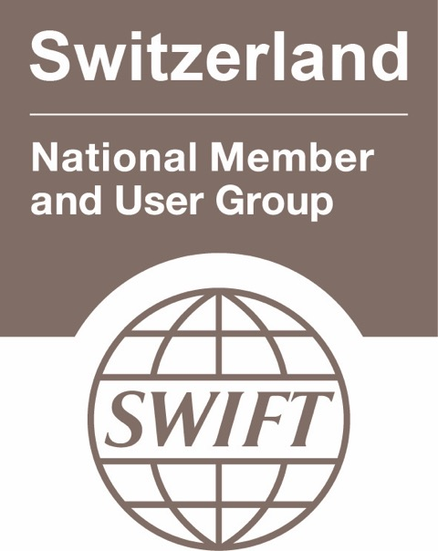

Meeting Venue:
Zürcher Kantonalbank
Josefstrasse 222
8005 Zurich, CH
Dress Code:
Meeting: Smart Business casual
Wednesday LBA Event: Business Attire !

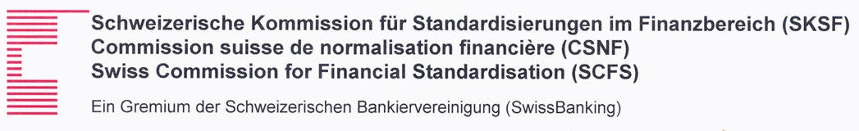

Wednesday 21st of September
 |  |  | 9:00 – 9:30 |  |  | Arrival & Check-in at Zürcher Kantonalbank premises and Welcome Coffee
Morning Session
 |  |  | 9:30 |  |  | Plenary Session
 |  |  | 9:30 – 11:00 |  |  | Plenary Session Agenda  - SMPG Welcome Address (Karla Mc Kenna, SMPG Chair, ISITC) – 5’  - Welcome Address by Host (Carlos Philippen, Head of Operations, Zürcher Kantonalbank) – 5’  - Global Meeting Schedule (Jacques Littré, SMPG General Secretary) – 5‘  - T2S Migration and Funds Market Claims Challenges (Felix Hubert, CEO, Incentage) – 25’  - Accelerating Switzerlands position as a leading FinTech hub (Dr Thomas Puschmann, Head of Swiss Fintech Innovations Lab, Zurich University, Swiss Fintech Innovations) – 25’  - Presentation Title (Speaker Name, Title, ESMA) – 25’ - TBC
 |  |  | 11:00 – 11:30 |  |  | Coffee Break
 |  |  | 11:30 – 12:30 |  |  | - Presentation Title (Adrien Treccani, Blockchain Expert, Swiss Finance Institute) – 45’
 |  |  | 12:30 – 13:30 |  |  | Lunch
Afternoon Session
 |  | 13:30 – 14:00 |  |  | 9. ISO 20022 Harmonisation Framework Update (Evelyne Piron, SWIFT) – 30’
 |  | 14:00 |  |  | End of Plenary Session
 |  | 14:00 – 15:00 |  |  | Corporate Action WG |  | Investment Funds WG | Settlement and Reconciliation WG
Evening
 | 15:00 – 22:30 |  |  | Liechtenstein Bankers Association – Banking Congress  Leave Zurich in bus/coach to Liechtenstein and attend LBA Banking Congress  Please indicate your participation in the meeting registration form !  Dress Code: Business attire
 | 22:30 |  |  | Back at the hotels

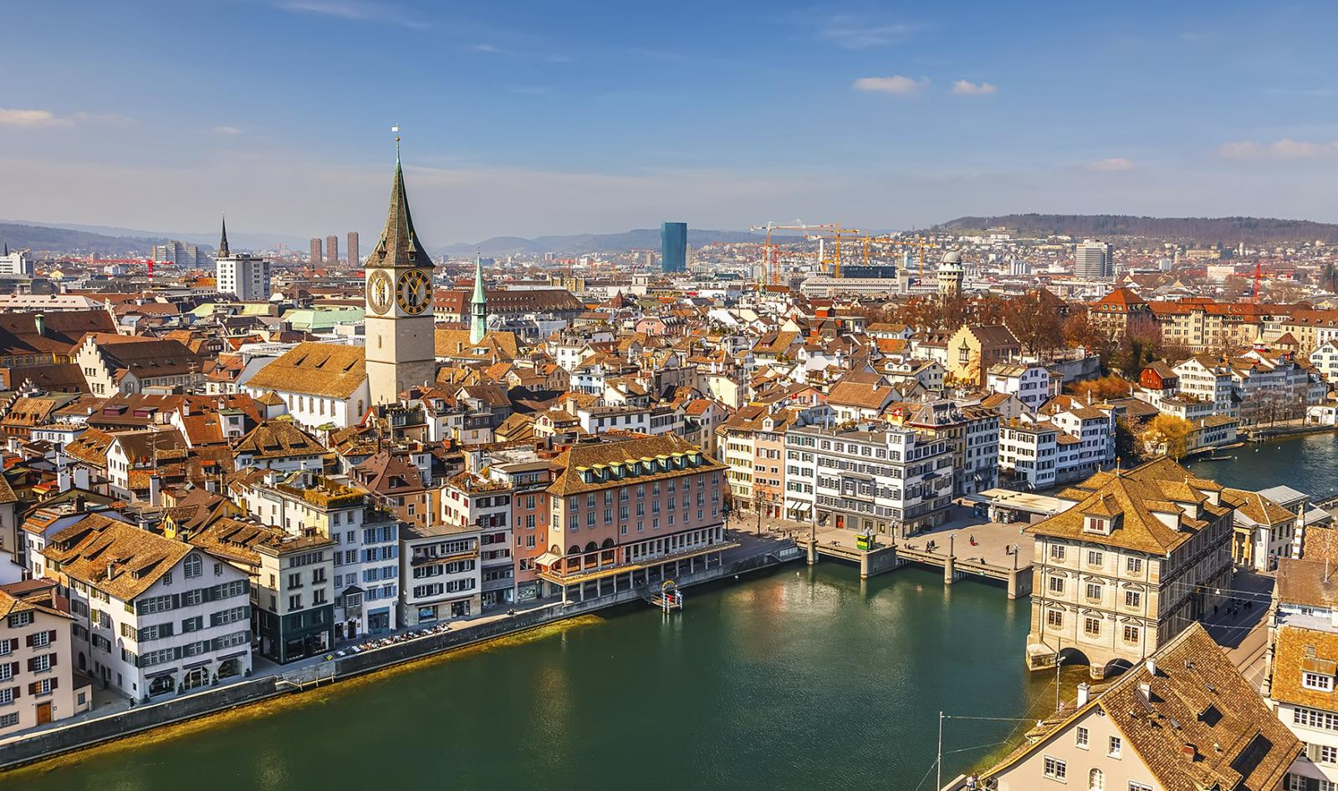

Thursday 22nd of September
 | 8:30 – 9:00 | Arrival & Check-in at Zürcher Kantonalbank premises
Morning Session
 | 09:00 – 10:45 | Corporate Action WG | Investment Funds WG | Settlement and Reconciliation WG
 | 10:45 – 11:00 | Coffee Break
 | 11:00 – 12:30 | Corporate Action WG | Investment Funds WG | Settlement and Reconciliation WG
 | 12:30 – 13:30 | Lunch
Afternoon Session
 | 13:30 – 15:30 | Corporate Action WG | Investment Funds WG | Settlement and Reconciliation WG
 | 15:30 – 15:45 | Coffee Break
 | 15:45 – 17:15 | Corporate Action WG | Investment Funds WG | Settlement and Reconciliation WG
Evening
 | 17:30 – 22:30 | SMPG Event  Meeting Point: Entrance of the meeting venue  Please indicate your participation in the meeting registration form !
 | 22:30 | End of Event

Friday 23rd of September
 |  | 8:30 – 9:00 | Arrival & Check-in at Zürcher Kantonalbank premises
Morning Session
 |  | 9:00 – 9:30 |  | Presentation Title (Simon Tribelhorn, CEO LBA, Liechtensteiner Bankers Association) – 30’
 |  | 9:30 – 10:45 |  | Corporate Action WG | Investment Funds WG | Settlement and Reconciliation WG
 |  | 10:45 – 11:00 |  | Coffee Break
 |  | 11:00 – 12:30 |  | Corporate Action WG | Investment Funds WG | Settlement and Reconciliation WG
 |  | 12:30 – 13:30 |  | Lunch (Please indicate in the registration form if you stay for lunch)
 | 13:30 |  |  | End of meeting

SMPG Corporate Actions WG Detailed Agenda – September 21 - 23, 2016

Item No | Short Description | Description and Pending Actions | Owner | Comment
 |  | Wednesday September 21
1 | Next meetings | Schedule Conference calls for 2017 | Christine
2 | Meeting Minutes | Comments / Approval of July 26 conf. Call Minutes | Jacques
CA221 | Tax Certification Process - (SR2012 MWG Minutes - SMPG Follow up) | Conclusions of the Tax Subgroup on this topic | Jean-Pierre / Jyi-Chen
CA341 | Clarification of CLAI & ACLA market claim related codes | Proposal for update in section 10 (p.87) of GMP1:  - Add this in section 10.1:  In MT564, the code ACLA indicates that market claims will be raised automatically for the event announced.  The code CLAI in MT564/MT566 indicates that the message relates to a specific market claim.  - Move the sentence “The message to be used is the MT 566 corporate action confirmation” from section 10.1 to section 10.1.1?  Action: Véronique to proposed reviewed definitions for, ATXF, , CNTR and NAMC. | Veronique | Telco July 26, 2016:  Some of the ADDB codes related to claims and transformations are not defined clearly in the Standards, and some of those codes are not relevant either for the MT566. Follows a discussion on the usage of those codes in the MT564 for market claims in general.
CA279 | Claims and Transformations in the T2S context | As we are close to the implementation of T2S and following some CRs that were part of SR2014, there seem to be confusion on how claims should be reported to clients (MT54X vs MT56X).  Action:  1. GMP1 SG to address the issue before the Zurich meeting. | Mari | See New input file  Telco July 26, 2016:  The topic started to be raised again, both by some T2S CSDs/markets and by the Nordic CSDs as part of the Nordic Securities initiative. Bernard, Véronique and Christine discussed this earlier in July, and the problems caused by the lack of market claim messages will only intensify during the next 6-12 months.  The GMP1 SG will try to discuss this in August, but the item will also be included in the Zurich meeting agenda.
 |  | Thursday September 22
 | 11:30 – 12:30 | Presentation by Victor Abbeloos, Senior Manager - SWIFT Standards  MT/ MX Coexistence / Migration Update for SWIFT December Board Paper – Questions and answers |  | The Board requested SWIFT to continue to monitor ISO 20022 progress over the next year, re-evaluate its assumptions on co-existence and re-establish a position by December 2016.  When the SWIFT community last debated the issue of co-existence vs migration of (MT/ISO 15022 and ISO 20022 MX) standards, it concluded that for the foreseeable future, co-existence of both (where MT/ISO 15022 had already become established) was preferable to any of the alternatives (re IR 535 CoExistence update dated June 2010).  SWIFT wants to actively involve customers, both at institutional and at community level, in an update of this discussion, in order to ensure that our strategy and planning remains aligned with the views of the community.
CA315 | Extending CA MPs to ISO 20022 | How to extend our MPs to ISO 20022 CA MX messages ?  Action: Véronique to set up a GMP1 conference call to be held before the Zurich meeting to define a new structure for the revised document. | Christine
CA338 | Create a more robust MP on narrative update information and update date for ISO 20022 seev.031 | Follow up of SR2016 CR978 and CA321 item  Action: Jacques to revert to Steve Sloan and ask if DTCC uses “Update Date” if sending a REPL CANO without narrative changes as well ? | Jacques | Telco July 26, 2016:  Jacques reports that DTCC for the ISO20022 CANO message is only using the “Update Date” element and not the “Update Description”.
CA342 | Issue with the MT Implementation of Stock Lending Deadline (BORD) repeatability (SR2016 CR 00776) | The SR2016 implementation of the BORD deadline is different in MT and MX since it should not be repeatable except for format options J and K.  Action: Jacques to draft a text for GMP1 stating the BORD should not be repeated when used with format options A, B, C and E. | Jacques | Telco July 26, 2016:  Jacques raised an issue re how Stock Lending Deadline (BORD), has been implemented in the MT564 in SR2016. In 15022 (but not in ISO 20022), the repeatability affects all format options whilst it should only affect 98J or 98K format options (not format options A, B, C and E).  The implementation should be fixed for SR2018 by a SWIFT CR as the deadline for SR2017 is already passed.
 | MyStandards CA UGs Review | Review some of the 40 new CA SMPG UGs that have been published in September 2016 on MS. | Jacques
CA351 | Usage of REPE for multiple accounts ? | Mieko for IN - NO REPE for multiple Accounts | Jacques | New Open Item
CA203 | SR2017 - Yearly GMP Part 1,2,3 and samples alignment and yearly summary of changes to MPs | Schedule  • September: Based on the MWG minutes, start with the draft “MP’s Summary” document & start MP’s discussions.  • October – November: Update GMP Parts & Event Templates  • Mid-December: Preliminary summary of MP changes  • End December: Draft GMP documents & event templates for review by NMPG's  • End February: Publish final version of GMP docs & templates.  Actions:,  1. Bernard (EXWA) to provide input on Event Templates  2. Bernard to answer to Christine’s question on EXWA CHOS [LAPS or NOAC]  3. Jacques: to add Partial Redemption scenario comparison illsutration in GMP1 or GMP2 (recommendation of CA MWG in CR 001128. | Jacques/Christine
CA343 | How to handle "Deemed Distribution Payments" ? | See SR2017 CR 001113 from AU - Analyse the different possible use cases in different countries and resubmit CR for SR2018 | AU/ISITC/UK | New Open Item
CA344 | Analyse impact of creating new "Interest Period Inclusive" element besides INPE | See SR2017 CR 001091 from XS - Assess the impact of creating a second Interest Period element. | XS | New Open Item
CA345 | Create new MP for the usage of the new QCAS "Instructed Amount" field in MT 565 | See SR2017 CR001108 from UK - Create new MP to avoid abuse of the new Instructed Amount | UK | New Open Item
CA346 | New element for supporting for the AU "Conduit Foreign Income" income type. | See SR2017 CR 001112 from AU - The tax subgroup to analyse the AU business case and propose solution | Tax SG/ AU | New Open Item
CA347 | Create New MP to enable Tax on Difference between Issue price and redemtion Price | See SR2017 CR 001099 from BE - Propose a new market practice to support BE business case. | BE | New Open Item
CA348 | Repeatability of ADTX in MT 564 Seq. E ? | See SR2017 CR 001114 from DE - Discuss DE business case. | DE | New Open Item
CA349 | Extend coverage of 98a::CERT in MT 564 Seq. D? | See SR2017 CR 001098 from LU - restricted coverage of the CERT Date Time qualifier definition in sequence D which confines CERT into a simple deadline for beneficial ownership whilst it should rather be defined as a deadline for the certification paperwork more generally. Is it an opportunity to fix that definition issue within this CR ? | Tax SG | New Open Item
CA350 | Usage of AFFB/UNAF balances for DRAW ? | Create new MP on AFFB / UNAF for DRAW | NO | New Open Item
CA352 | Redemption Message Flow for Negative Interest rates in DK | Validate the flow and usage of balances | DK | New Open Item – See input file from DK
 | QINS//ALL in 565 Usage |  | JP

