Taiwan Corporate Actions
Market Practice for Rights Issue Event

Status: Version 2
Preparation date: August 2017
Update date: August 2017 Update impl. date: August 2017
Author: TW SMPG

- SCOPE: 3
- KEY INFORMATION OF RIGHTS ISSUE EVENT IN MESSAGES: 3

Changes to previous versions
Version 1  October 2016 | New | Illustrate Taiwan right issue event practice | Page 1
Version 2  August  2017 | Revision | Further clarification on scope, added available codes

- Scope:

This document is applicable for Taiwan rights issue event because the arrangement of this kind of event has no intermediary financial instrument issued until the exercise of the rights. To get parties involved in the processing of rights issue handle Taiwan style similar as other markets, this market practice document only illustrates the characteristics of what we need to compose messages.

Please note that this market practice is not fully compliant with the global SMPG market practice for single rights distribution events (RHTS).

In order to accommodate the TW local market requirements for rights distributions where no intermediary security is distributed, a Data Source Scheme (DSS) indicated by /TWCA/RHTS is used in the :22F::CAEV indicator field.

Other major deviations from global SMPG RHTS market practice include:
- The event is announced as a “Voluntary” event instead of a “Choice” event.
- In MT 564 Notification message (announcement advice) message in the Options sequence E, both “ADEX” and “NEWO” rates are allowed to represent “right distribution rate” and “new stock distribution rate” respectively.
- In MT 566 Confirmation message (payment advice of new stock) message in the Underlying Securities sequence B, the confirmed balance “CONB” is used to represent the confirmed balance of the instructed rights.

Key information of rights issue event in messages:
Corporate Action Event related to Rights Issue. It will be indicated by /TWCA/RHTS, where TWCA is the Data Source Scheme provider code of Trust Association of R.O.C.

- Type of Event: Voluntary Event
Exercise of the RHTS by the holder against the payment, voluntary. The exercise period ranges mostly for one month. Financial instrument is transferable but non-tradable in Taiwan market.

- Message type used:

MT564: Corporate Action Notification
Notification is sent on the date of issuers’ announcement and on the record date.

MT564: Reminder
A reminder is sent before market deadline for subscribing new shares.

MT565: Instruction to Custodian
Subscription instruction is sent to custodian.

MT567: Acknowledge
An acknowledgement of receiving a client’s instruction.

MT566: Confirmation
- Confirmation is sent upon debit of subscription cost.
- Confirmation is sent upon credit of new shares.

- Dates:

  - Record Date: The date on which eligible balance is recorded on shareholders record book of the issuing company and entitlement of rights issue is fixed.

  - Subscription Period: The period when application for rights issue allotment from entitled shareholder is accepted by issuer.

  - Debit Date: The date when custodian debits the customer’s account with the subscription cost.

  - Script Payment Date: The date when custodian actually receives new shares and credits them to customer’s account.

- Corporate Action Chronology of Event:

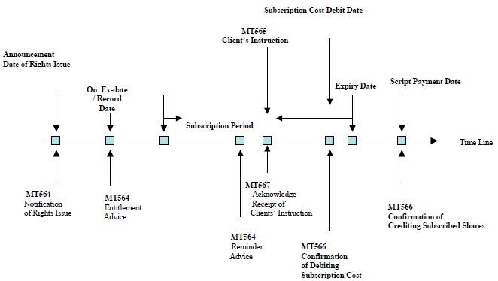

- Balances:

Eligible balances on Record Date signify the entitled balances to receive the rights. The requisite to become ‘Eligible’ is that the relevant shares are settled on or before the Record Date, being recorded on the shareholders record book of issuing company. Unsettled balances or balances with street name are not recorded as Eligible balances.

- Example of used Event Codes by types of message:

The following Event Details and Event Codes for Optional details (excluding Mandatory details) are example of event codes advised from custodians in the Taiwan Market.

MT564: Notification / Reminder

Sequence A General Information:
98a / Preparation Date PREP

Sequence B Underlying Securities: Subsequence B2 Account Information
93a / Balance ELIG or SETT

Sequence D Corporate Action Details
(or Sequence E Corporate Action Option)
98a / Date Time ANOU, RDTE, XDTE, MKDT (E), RDDT (E), SUBS (E), EXPI (E), PAYD (E1, E2)
69A/ Period of Action PWAL (E)

Sequence E Corporate Action Options
35B/ ID of the Financial Instrument (ISIN Code is commonly used for the ID) (E1)
36B/ Quantity of Financial Instrument MAEX (E), ENTL (E1)
90B/ Price PRPP (E1)
92D/ Rate ADEX (E1)
92D/ Rate NEWO (E1)

MT565 Instruction to Custodian

Sequence A General Information:
98a / Preparation Date PREP

Sequence B Underlying Securities: Subsequence B2 Account Information

35B / Identification of the Financial Instrument ISIN (B) 97a / Account Safekeeping Account SAFE (B2)
93a / Balance ELIG or SETT (B2)

Sequence D Corporate Action Instruction

22H /Indicator CAOP

MT567 Acknowledgement

Sequence A General Information:
98a / Preparation Date PREP

Sequence B Corporate Action Details
97a / Account Safekeeping Account SAFE
36B /Quantity of Financial Instrument STAQ

MT566: Confirmation of Account Posting

Sequence A General Information:
98a / Preparation Date PREP

Sequence B Underlying Securities:
35B / ID of the Financial Instrument (ISIN Code is commonly used for the ID)
93B / Balance CONB, ELIG

Sequence C Corporate Action Details:
98a / Date Time ANOU, XDTE, RDTE

Sequence D Corporate Action Confirmation:
90B/Price PRPP (D1)
98a/Date Time RDDT (D), SUBS (D), PAYD (D1), AVAL (D1), POST (D1, D2), EXPI (D)

