Corporate Action:

Co-chairs: Bernard Lenelle, Karla McKenna and SWIFT Standards
Documents:
- Madrid SMPG 2005 CA Minutes

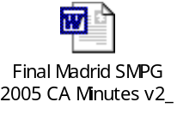

- Post-Madrid SMPG to do list

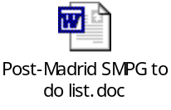

- Working documents (see www.smpg.info)

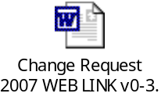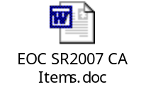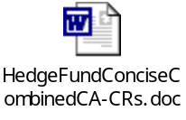
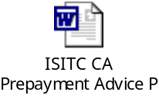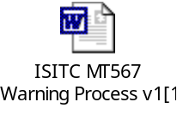

Open items and minutes:
See Madrid SMPG 2005 CA Minutes and Post-Madrid SMPG to do list.
ID | Brief Description | Owner | Status | Date
CA06 | Event Interpretation Grid  Actions: Many country actions. Please see section D of 20051017-19 minutes | ALL | CLOSED | Implementation of the EIG planned for November 2006.
CA10 | D vs E  Action: NMPGS to comment on the global document by next SMPG meeting / SMPG telephone conference. | ALL | ON-GOING | Before next SMPG meeting
CA10 | D vs E  Action: SWIFT Securities Standards Development Team to update the Corporate Action message examples on www.smpg.info | SWIFT | CLOSED
CA22 | Action: DE to see if it is possible for WM not to enforce the ‘no holding, no notification’ rule for right issues | DE | OPEN | Before next SMPG meeting
CA22 | Action: NMPGs to review the list of information about the second event. Note the deadline for SR2007 is mid 2006 | ALL | OPEN | Before next SMPG meeting
CA22 | Action: UK&IE and US to explain exactly WHEN the messages are sent when processing as two events (rather than the content) | UK&IE and US | OPEN | Before next SMPG meeting
CA22 | Action: Co-chairs to raise an agenda item for a future telco or SMPG CA WG meeting in order to determine a date to mandate rights to be processed as two (or more) events, and subsequent deletion of CAEV//RHTS | Co-Chairs | OPEN | Before next SMPG meeting
CA36 | Dutch Auction  The US provide maximum and minimum values for the increments, in the UK&IE (because of limitations at the CSD) a maximum of 19 increments are provided as separate options (this may be fewer than theoretically possible in the issuer’s information)  Action: Co-chairs to contact Michael Kempe of Euroclear to determine if the Euroclear harmonisation will remove the dependency on the increment maximum on the UK&IE CSD | Co-chairs | OPEN | Before next SMPG meeting
CA53 | Corporate Action Event Examples  Action: SWIFT Securities Standards to publish examples on www.smpg.info and www.swift.com. The initial version will be posted once remaining issues are resolved. | SWIFT | OPEN | Before next SMPG meeting
CA53 | In the confirmation message the VALUe date is optional, this is because a CSD initiates the payment, it does not make the payment, this is done by the Central Bank to the sub-custodian, thus a CSD is not able to give information value date (clears DK new item CA055)  Action: SWIFT Securities Standards to amend section 5.2 of the SMPG CA Global Document to reflect this | SWIFT | OPEN | Before next SMPG meeting
CA56 | PRII (Interest Payment with Principle)  The interest and principal payments may be announced by the issuer as a single payment or as two payments  Action: UK&IE to progress with the Association of Global Custodians (AGC) with a view to announce as separate payments and thus allow processing as two events | UK&IE | OPEN | Before next SMPG meeting
CA56 | Agreed to raise a CR for SR2007 for a partial redemption event where the nominal does not change – an amendment of PRII  Action: UK&IE to raise the SR2007 CR | UK&IE | OPEN | Before next SMPG meeting
CA57 | Stock Split, NEWO versus ADEX  Resolved at a recent (US) ISITC meeting. Details to be circulated  Action: US to provide details of the ISITC discussion | US | CLOSED
CA58 | Build an Amount Country Usage document for CA as S&R is currently doing. | All | OPEN

New items:

Market practice needed to support upcoming SR 2006.
For example:
- General principles of the CPNR issue
- Clarification of use of the SR 2006 status code 25D::PROC//ENTL - should use be restricted to 23G:NEWM?
- MT 567 usage table, to be aligned with SR 2006.

‘Review of SR2007 Significant Changes Submitted’
- MT 564 Function of Message clarification/redefinition, especially use of NEWM;
- Payments 'pre-advice'
- Extension of character set in security identifier (to include '%' and '&') and WEBB narrative (to include '=');
- Update on SWIFT proposal to accredit institutions by assessing the compliance of their CA messaging with SMPG guidelines, specifically the EIG. Discuss whether this could be extended to validate compliance with DvEvE1vE2.
- Hedge fund operations to be covered by the messages
- Euroclear proposals (see separate document)

Update of US DvsE matrix in light of the DvsE Guidelines.
Cross-referenced with CA10, the review of the NMPG comments on the DvsE guidelines.

Query Committee - small representative group to be consulted on (difficult) CA MP queries.

Market Claims for securities
NMPGs to assess how applicable the Market Claims for cash are to securities in their market.

Any Other Business

Review of CA Event Samples


_______________________________________________________________________________

