BE NMPG: agenda
Corporate Action Meeting

June 27th, 2008

Table of content

1) Remarks from last meeting (8:30 → 8:45) 3
2) Review of SMPG minutes from Paris: (8:45 → 10:15) 3
3) SMPG Conference call: minutes (10:30 → 10:45) 4
4) BVG Update: (10:45 → 11:45) 4
5) Other Topic: (11:45 → 12:00) 4
6) Next meeting 4

Remarks from last meeting (8:30 → 8:45)
All the BE NMPG comments have been sent to SWIFT.

Review of SMPG minutes from Paris: (8:45 → 10:15)

CA Reverse Engineering: 

Consolidated Feedback EIG Date_Period_Price_Rate: 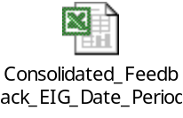

EIG V4.16: 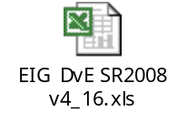

Paris’ minute: 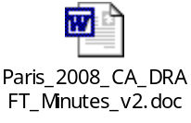

Rates, Amounts Reconciliation Results: 

SWIFT’s Simulation Testing and Qualification System (STaQS): 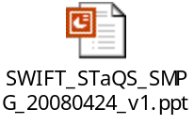

SMPG Conference call: minutes (10:30 → 10:45)
- Minutes from SMPG conference call:

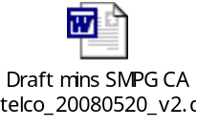

BVG Update: (10:45 → 11:45)
Olivier will give us a quick update of the BVG meeting that took place on June 24 & 25.

Other Topic: (11:45 → 12:00)
TBD

Next meeting

Proposal:

February 1st, 2008 at 9 am
April 11th, 2008 at 9 am
June 27th, 2008 at 8:30 am
September 5th, 2008 at 8:30 am
October 31st, 2008 at 8:30 am
December 12th, 2008 at 8:30 am

