BE NMPG: agenda
Corporate Action Meeting

September 21st, 2007

Table of content

1) SMPG Boston: (9 am → 10:50 am) 3
2) Open items from Sabine (11:00 am → 12 pm) 5
3) Annex 5
4) Next meeting 6

SMPG Boston: (9 am → 10:50 am)
Item No | Description | Comment
CA06 | Event Interpretation Grid (EIG) | Any further updates to the EIG.
CA06.05 | Event Interpretation Grid (EIG) | SWIFTStandards and Clearstream to integrate search function into the next version of the EIG.
CA06.07 | Event Interpretation Grid (EIG) | NMPGs to determine the date & period and rate & price information for the ‘global grid’ for the events assigned during the March 2007 global SMPG meeting and reassigned during the 21 June 2007 telco.  The latest file should be sent during the week.
CA06.11 | Event Interpretation Grid (EIG) | NMPGs to check EIG entries for events where 'n/a' occurs and if the event does not occur at all ensure that 'n/a' is entered for each CAMV occurrence. At present a single 'n/a' entry is made for the event. The action is a clarification … for automation of the EIG.  Click here for the latest file.
CA10.3 | DvE | NMPGs to look at all qualifiers with the purpose of deleting qualifiers that fall outside the D vs E guidelines. If a country wants to keep a qualifier in another sequence than recommended in the guidelines they should submit a strong business case.  The D vs E spreadsheet is part of the EIG file. The latest D vs E document can be found here.
CA78.2 | CORP Reference | NMPGs to continue research into the identity of the ‘official’ body in their market.
CA86.3 | US Bulk paper | Paper circulated post-Amsterdam to be reviewed giving countries the opportunity to discuss, understand and ask for clarity on this market practice, working toward an evaluation as to whether this can be adopted as a global market practice.  Click here for the latest file.
CA97 | ISO 20022 Proxy Market Practice | Update on ISO 20022 proxy voting messages.
CA109 | Independent use of MT 568 | It was agreed in Amsterdam that the Global SMPG CA document should indicate that the function of the message of the MTs 564 and 568 should match.  However, NMPGs still to give feedback on whether the MT 568 can be used independently.
III.10.1 & III.10.2 (SR2008) | Event Status in MT 564 vs MT 567 | Outcome of SR2008 discussion on event status in MT 564 vs MT 567.
III.19 (SR 2007) | Changed elections – SMPG to discuss use of WITH linkage | "MWG reject the Change Request. However, the business case is valid and accepted by the group. A possible solution (possibility to use WITH in linkage section in MT 565) is to be clarified at the next SMPG.”  Sydney 200610  Discussion Points:  • SMPG agree that cancellation of an instruction and its resubmission may be carried out by the use of the ‘WITH’ qualifier in the linkage sub-section in both messages.  • Use of WITH recommended for any changes close to the deadline.  • This applies particularly to an event where instructions are irrevocable. Agreed that from SR2007 the indicator agreed in III.20 must be supplied with the appropriate code WITH.  NMPGs to confirm what is documented in the discussion points above.  Click here for the latest file.
III.35.1 (SR2007) | Market Deadline Date | FR NMPG to document use and meaning of RDDT.

Open items from Sabine (11:00 am → 12 pm)
Open items to discuss in the BE NMPG meeting: 

Comments on the D versus E document: 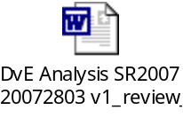

Comments on event interpretation grid: 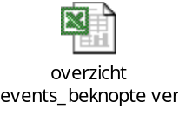

ESES : French optional dividend/dividend reinvestment : how to announce? What about the possibility of rounding up?

Annex
- EIG v4.8:



- Consolidated Feedback EIG Date_Period_Price_Rate:

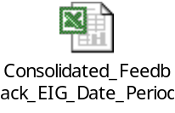

- D vs E Word document:

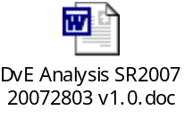

- US Bulk paper

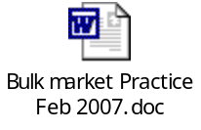
- III20 With

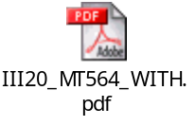

- Pre-advice of reversal:

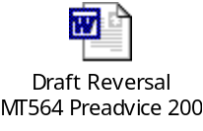

- Minutes of the Amsterdam meeting

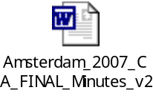

- Conference Call

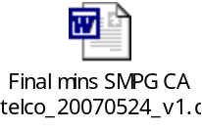

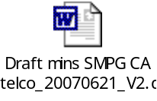
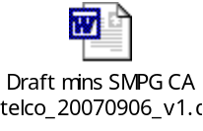

Next meeting

21 September at 9h00
26 October at 9h00 Do we need a meeting in October?
30 November at 9h00
28 December at 9h00

