Brussels
Global SMPG Meeting
September 18 – 20, 2019

Meeting Venue:
Euroclear
1, Boulevard du Roi Albert II 1210 Brussels
Belgium
Dress Code: Business casual

Sponsored by:

Meeting Global Agenda

Wednesday 18th of September
 |  | 09:00 – 09:30 |  |  |  |  | Arrival & Check-in at Euroclear Premises
 |  | 09:30 |  |  |  |  | Plenary Session Opening
 |  | 09:30 – 10:40 |  |  |  |  | - Global Meeting Schedule ( Jacques Littré, SMPG General Secretary)  - SMPG Welcome Address (Armin Borries, SMPG Chair, DE NMPG)  - Welcome Address by Euroclear (TBD, Euroclear)  - Business Presentations (TBD)
 |  | 10:40 – 11:00 |  |  |  |  | Coffee break
 |  | 11:00 – 12:30 |  |  |  |  | - Business Presentations (TBD)
 |  | 12:30 – 13:30 |  |  |  |  | Lunch
 | Afternoon Session
 |  | 13:30 – 16:30 |  |  |  |  | Corporate Action WG |  |  |  | Investment Funds WG |  | Settlement and Reconciliation WG
Evening
 |  | 16:30 – 22:00 |  |  |  |  | SMPG Networking event (more details to follow)
 |  |  | Thursday 19th of September
 |  |  |  |  | 8:30 – 9:00 |  |  |  | Arrival & Check-in at Euroclear premises
 |  |  | Morning Session
 |  |  |  |  | 09:00 – 10:45 |  |  |  | Corporate Action WG | Investment Funds WG |  | Settlement and Reconciliation WG
 |  |  |  |  | 10:45 – 11:00 |  |  |  | Coffee Break
 |  |  |  |  | 11:00 – 12:30 |  |  |  | Corporate Action WG | Investment Funds WG |  | Settlement and Reconciliation WG
 |  |  |  |  | 12:30 – 13:30 |  |  |  | Lunch
 |  |  | Afternoon Session
 |  |  |  |  | 13:30 – 15:30 |  |  |  | Corporate Action WG | Investment Funds WG |  | Settlement and Reconciliation WG
 |  |  |  |  | 15:30 – 16:00 |  |  |  | Coffee Break
 |  |  |  |  | 16:00 – 17:30 |  |  |  | Corporate Action WG | Investment Funds WG |  | Settlement and Reconciliation WG
Evening
 |  |  |  |  |  |  |  | Free evening

 | Friday 20th of September
 |  |  | 8:30 – 9:00 |  | Arrival & Check-in at Euroclear Premises
 | Morning session
 |  |  |  | 09:00 – 10:45 | Corporate Action WG | Investment Funds WG | Settlement and Reconciliation WG
 |  |  | 10:45 – 11:00 |  | Coffee Break
 |  |  | 11:00 – 12:00 |  | Corporate Action WG | Investment Funds WG | Settlement and Reconciliation WG
 |  |  |  | 12:00 – 13:00 | Light Lunch
 |  | Afternoon Session
 |  |  | 13:00 – 16:00 |  | SMPG Joined Securities / Payment Task Force Meeting  (A request to register for this TF meeting must be sent to  Charles-Raymond.BONIVER@swift.com)
End of meeting

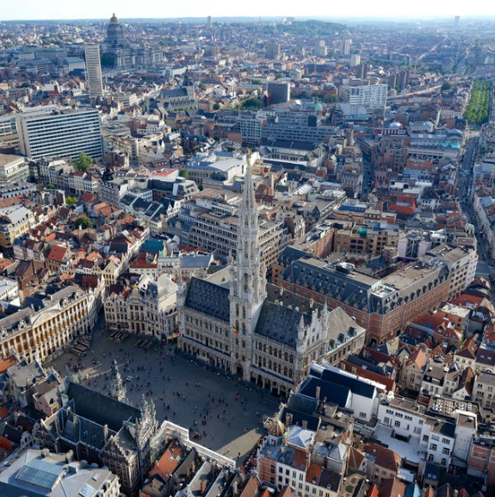

Meeting Registration
The attendees must fill in the registration form attached to the invitation email that you have received and send it back duly filled in to the email address info@smpg.info for September 6, 2019 at the latest.
You will then receive a confirmation of your registration back via email (in the next couple of days).
Late registration will be subject to approval by the host (due to the logistical aspects of the organisation).
Remark about having more than one NMPG representative per WG:
NMPGs may send a second representative per Working Group and the local NMPGs are allowed to send “observers” to the SMPG (in addition to the official NMPG representatives) in so far as the meeting room capacity allows it.
In those cases, the registration of the second representative and of the observers will be subject to approval by the SMPG General Secretary or Program Director at registration time based on the capacity of meeting rooms provided by the host.

Accommodation - Hotel Information
Euroclear provides a list of four recommended hotels located nearby the meeting location and with preferential prices for Global SMPG Meeting participants.

Booking to one of these hotels can be done directly on the following web page:

https://secure.hotel.visitbrussels.be/event/euroclear/congress/search
Deadline for booking with guaranteed price: August 31, 2019

Investment Funds WG - Agenda
Please refer to the specific WG agenda sent by the WG Facilitator

Corporate Action WG - Agenda
Please refer to the specific WG agenda sent by the WG Facilitator

Settlement And Reconciliation WG - Agenda
Please refer to the specific WG agenda sent by the WG Facilitator

SMPG payment task force
Please refer to the specific WG agenda sent by the WG Facilitator

